**Project description**

Each group has 4 deliverables: (**Phase2:** 50 grades)

* Total grades for the project should be **20 grades**. So, the grades will be scaled.
* The templates for your deliverables and your cover page are provided.
* Your deliverables will be submitted on **https://forms.gle/5tsks6cZURf1cwNUA**.
* This form is used to submit your different deliverables in course IS332 in the academic year (2022-2023)
* Please submit your file named T<Team number>-D<Deliverable number>.docx or .pdf. Example: T7-D2.docx
  + Do not add spaces in the filename.
  + Avoid zipping the file unless it is larger than 10 MB.
* Deliverable 2 **Firm Deadline is 26-11-2022**.

**Note that**

* Only one team member (**team leader**) can submit the project.
* Don’t submit multiple times.
* Cheating policy: Any copies will be graded zero.
* Clearly state your assumptions (only required ones).
* No handwritten reports and/or models are accepted [graded zero].
* You need to use any UML tool to depict your models and please mention the used tool(s) in your report.

[**Hint**: Review Chapters 4 - 5: domain class diagram & CRUD]

[**Tip**: Split the work among team members to help with time management]

**Project Details**

|  |  |
| --- | --- |
| Project number | *28* |
| Project title | *Megastore cooperation* |
| Corresponding TA\LA | *Eng. Lamia Atef* |
| Deliverable | *2* |

**Team Details**

|  |  |
| --- | --- |
| **Student name** | **Lab Group** |
| Mirette Shenouda Maher | Lab 8 S1,S2 |
| Monica Saeed Habib | Lab 8 S1,S2 |
| Nervana anwar mansour | Lab 3 S8 |
| Catherine Ramy Mikhail | Lab 8 S1,S2 |
| Youstina Sadawy Thabet | Lab 8 S1,S2 |
| Samuel milad younan | Lab 3 S8 |

# **Guidelines for Deliverable 2**

1. Apply the CRUD technique
2. Domain Class Diagram [Complete system]

* Domain Class Diagram based on the Noun technique.
* You need to follow the steps of the NOUN technique to identify the domain classes and document information using Tabular representations whenever possible. Please REFER to CHAPTER 4 in the book.
* You need to make use -as much as you can- of complex association types, i.e., generalization, aggregation, and composition.
* Your class diagram should also include multiplicities.
* Please specify the name of the associations in your model to increase readability.

1. State machine diagram (single object is enough). Please justify your selection.
2. Activity diagram(s) (at least 3 use cases)
3. System Sequence diagram(s) (for the same use cases in activity diagrams)

Please **clearly state** the name of the use case related to each model in steps 4 and 5.

**Tabular representations of the NOUN technique:**

|  |  |
| --- | --- |
| **IDENTIFIED NOUN** | **NOTES ON INCLUDING NOUN AS A THING TO STORE** |
| Corporation | A synonym we saved it in another noun. Exclude |
| Megastore | It is a unique and importan thing, so I have to store it. Include |
| Retail | Yes, it can differ from one store to another, so I have to store it. Include |
| Wholesaling services | Yes, it can differ from one store to another, so I have to store it. Include |
| Hypermarkets | The categories can change accordingly. Include |
| Groceries stores | The categories can change accordingly. Include |
| Convenience stores | The categories can change accordingly. Include |
| Stores | A synonym we saved it before. Exclude |
| countries | A synonym we saved it before. Exclude |
| Types of stores | We already saved these types. Exclude |
| Hypermarkets | A synonym we saved it before. Exclude |
| Supermarkets | A synonym we saved it before. Exclude |
| Convenience | A synonym we saved it before. Exclude |
| Country | A synonym we saved it in another noun. Exclude |
| Number of stores | It’s a unique attribute for each country in our scope. Include |
| Size | It’s a unique thing for each country we have to store it. Include |
| Population | It’s a unique thing for each country we have to store it. Include |
| Categories | A synonym we saved it before. Exclude |
| Fruits and vegetables | Type of category which is One piece of information about a product item. We will save it as food. Include |
| dairy products | Type of category which is One piece of information about a product item. We saved it before as food. Exclude |
| Meat and poultry | Type of category which is One piece of information about a product item. We saved it before as food. Exclude |
| Grocery | Type of category which is One piece of information about a product item. We saved it before as food. Exclude |
| Beverages | Type of category which is One piece of information about a product item. We saved it before as food. Exclude |
| Cooking ingredients | Type of category which is One piece of information about a product item. We saved it before as food. Exclude |
| TVs and appliances | Type of category which is One piece of information about a product item. Include |
| Laundry and detergents | Type of category which is One piece of information about a product item. Include |
| cleaning essentials | Type of category which is One piece of information about a product item. Include |
| personal care | Type of category which is One piece of information about a product item. Include |
| baby care | Type of category which is One piece of information about a product item. Include |
| frozen food | Type of category which is One piece of information about a product item. We saved it before as food. Exclude |
| bakery and pastry | Type of category which is One piece of information about a product item. We saved it before as food. Exclude |
| healthy food | Type of category which is One piece of information about a product item. We saved it before as food. Exclude |
| best prices | Just an output I don’t have to save it. Exclude |
| categories | A synonym we saved it before. Exclude |
| deals | We know what they are. No need to store. Exclude |
| various suppliers | Yes, a key thing with lots of details required. Include. |
| products | Yes, a key thing with lots of details required. Include. |
| suppliers | A synonym we saved it before. Exclude |
| cities per country | We need to save it as attribute because it is peace of information for each supplier. Include |
| mega store | A synonym we saved it before. Exclude |
| Owned warehouses | We need to save it as attribute because it is peace of information for the store. Include |
| rented warehouses | We need to save it as attribute because it is peace of information for the store. Include |
| country | A synonym we saved it before. Exclude |
| Offers | We have different offers that change according to events, and we need to recall them. Include |
| Occasions | An output that can be produced from event date, Not stored |
| Categories | We have different categories, so we need to recall them. Include |
| products | Included in categories. No need to store |
| payment | We have different methods that we need to store. Include |
| Country | An input resulting in assigning offers |
| Preference | An input resulting in enhancing services |
| Policy for return | Details needed to apply return function. Included |
| Store | Yes, a key thing with lots of details required. Include. |
| Physical defect | Input required for return function (in appliance) |
| Technical defect | Input required for return function (in appliance) |

1. **CRUD technique:**

**\*Note: The following use cases which are colored in yellow are the new ones added to the use case diagram**

Verify use cases using CRUD technique (e.g. Fig 5-12)

|  |  |  |
| --- | --- | --- |
| Domain Class | CRUD | Verified Use case |
| 1-Offers | Create | Set offers |
|  | Read/report | view offers |
|  | Update | update offers |
|  | Delete | update offers |
| 2-Customer | Create | create account |
|  | Read/report | Pay for product/update account |
|  | Update | update account/pay for product |
|  | Delete | update account |
| 3-Points | Create | Buy special bags/pay for products |
|  | Read/report | Pay for products |
|  | Update | Gain points/set points |
|  | Delete | Pay for products/set points |
| 4-Products | Create | Add product |
|  | Read/report | Select product/return product |
|  | Update | Pay for products/return product/update product |
|  | Delete | Update product |
| 5-Payment | Create | Pay for product |
|  | Read/report | Return product/pay using packages/pay lump sum |
|  | Update | Return product/ pay using packages/pay lump sum |
|  | Delete | Return product |
| 6-Managers | Create | Create staff account |
|  | Read/report | Set offers/set points |
|  | Update | Update staff account |
|  | Delete | Update staff account |
| 7-Categories | Create | Create category |
|  | Read/report | Search |
|  | Update | Update category |
|  | Delete | Update category |
| 8-Countries | Create | Set stores |
|  | Read/report | Set offers/adjust services |
|  | Update | Update stores |
|  | Delete | Update stores |
| 9-Suppliers | Create | Set stores |
|  | Read/report | Add product |
|  | Update | Update stores |
|  | Delete | Update stores |
| 10-Warehouses | Create | Set stores |
|  | Read/report | Add product |
|  | Update | Add product/update stores |
|  | Delete | Update stores |
| 11-Stores | Create | Set stores |
|  | Read/report | Search/view offers |
|  | Update | Update stores |
|  | Delete | Update stores |

CRUD table showing use cases and corresponding domain classes (e.g. Fig 5-13)

|  |  |  |  |  |  |  |  |  |  |  |  |
| --- | --- | --- | --- | --- | --- | --- | --- | --- | --- | --- | --- |
| UC\CD | Offers | Customer | Points | Products | Payment | Managers | Categories | Countries | suppliers | Warehouses | Stores |
| Set offers | C |  |  |  |  | R |  | R |  |  |  |
| view offers | R |  |  |  |  |  |  |  |  |  | R |
| Update offers | U/D |  |  |  |  |  |  |  |  |  |  |
| create account |  | C |  |  |  |  |  |  |  |  |  |
| Pay for product |  | R/U | C/R/D | U | C |  |  |  |  |  |  |
| update account |  | R/U/D |  |  |  |  |  |  |  |  |  |
| Buy special bags |  |  | C |  |  |  |  |  |  |  |  |
| Gain points |  |  | U |  |  |  |  |  |  |  |  |
| Set points |  |  | U/D |  |  | R |  |  |  |  |  |
| Add product |  |  |  | C |  |  |  |  | R | R/U |  |
| Select product |  |  |  | R |  |  |  |  |  |  |  |
| return product |  |  |  | R/U | R/U/D |  |  |  |  |  |  |
| Update product |  |  |  | U/D |  |  |  |  |  |  |  |
| pay using packages |  |  |  |  | R/U |  |  |  |  |  |  |
| pay lump sum |  |  |  |  | R/U |  |  |  |  |  |  |
| Create staff account |  |  |  |  |  | C |  |  |  |  |  |
| Update staff account |  |  |  |  |  | U/D |  |  |  |  |  |
| Create category |  |  |  |  |  |  | C |  |  |  |  |
| Search |  |  |  |  |  |  | R |  |  |  | R |
| Update category |  |  |  |  |  |  | U/D |  |  |  |  |
| Set stores |  |  |  |  |  |  |  | C | C | C | C |
| adjust services |  |  |  |  |  |  |  | R |  |  |  |
| Update stores |  |  |  |  |  |  |  | U/D | U/D | U/D | U/D |

1. **Domain Class Model**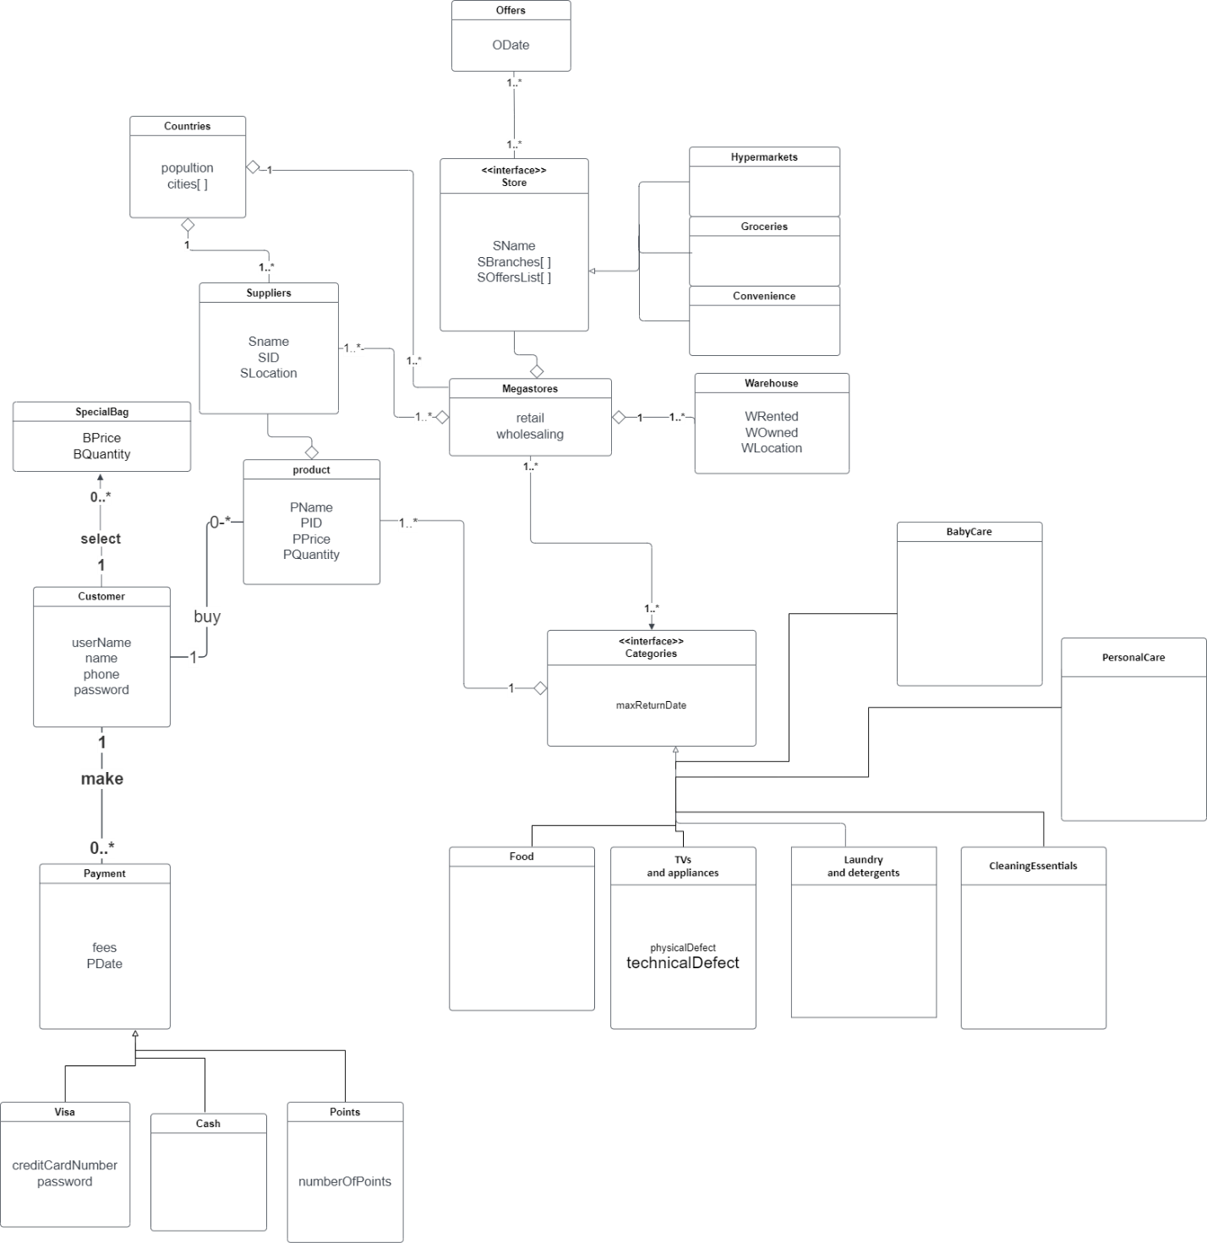
2. **State Machine Model**

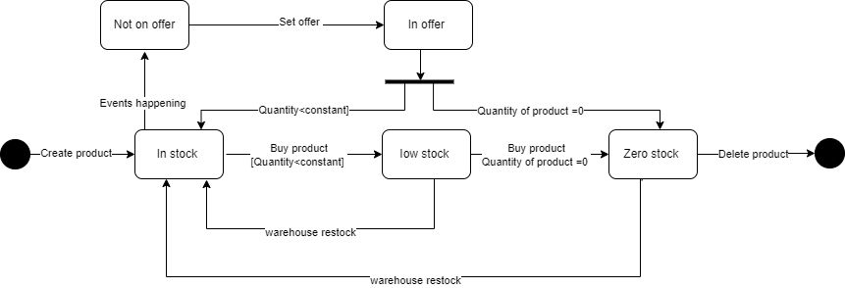

1. **Diagrams**
2. **Buy product:**

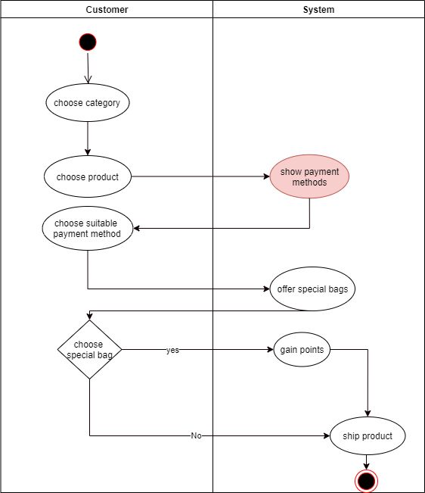

1. **Payment**

**3. Return Product**

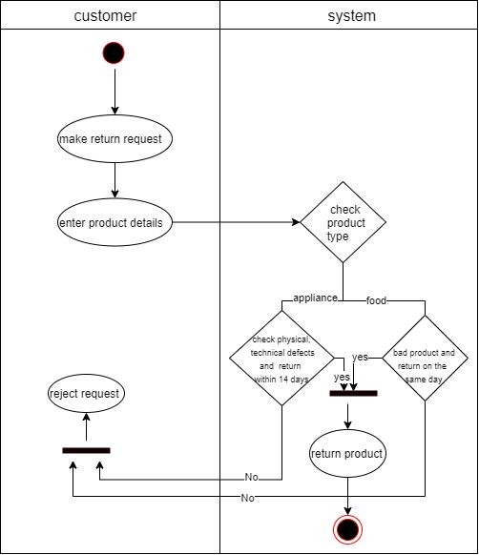

**4.Set Offers**

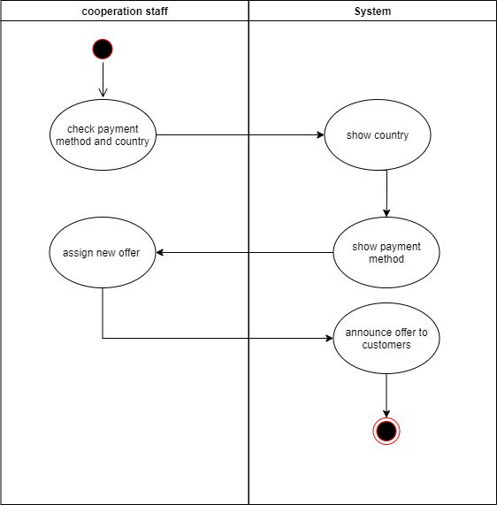

1. **System Sequence Diagrams**
2. **Buy and pay for product**

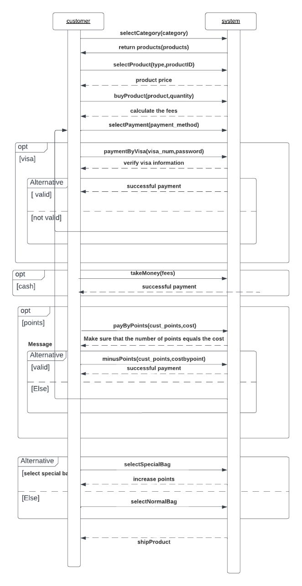

1. Return Product

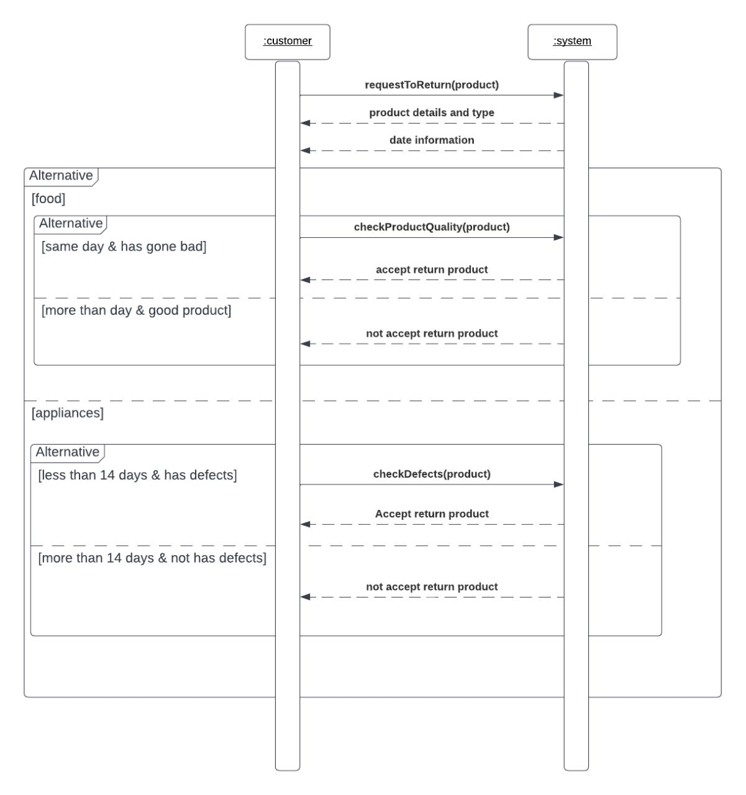

1. 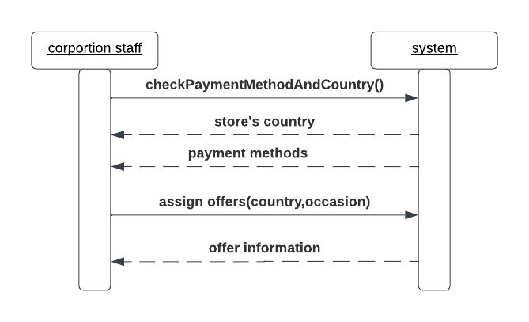Set Offers