**Project Details**

|  |  |
| --- | --- |
| Project number | *28* |
| Project title | *Mega store corporation* |
| Corresponding TA\LA | *Eng. Lamia Atef* |
| Deliverable | *1* |

**Team Details**

|  |  |  |
| --- | --- | --- |
| **Student ID** | **Student name** | **Lab Group** |
| 20200575 | Mirette Shenouda Maher | Lab 8 S1,S2 |
| 20200567 | Monica Saeed Habib | Lab 8 S1,S2 |
| 20200596 | Nervana anwar mansour | Lab 3 S8 |
| 20200386 | Catherine Ramy Mikhail | Lab 8 S1,S2 |
| 20200686 | Youstina Sadawy Thabet | Lab 8 S1,S2 |
| 20210561 | Samuel milad younan | Lab 3 S8 |

1. DESIGN THE ENVIRONMENT:
2. **With what external systems and databases will the system under development interact?**
3. **Write all external systems that will deal with your system.**
4. **Write all the table names and columns in your database either internally [your system] or externally [ external system].**
5. **No need to answer the questions in lectures, just identify the above.**

External systems: bank system, shipping system, external suppliers

**Databases**: warehouse database, customer database

Warehouse database: rented, ownerName

Customer database: CustomerName, CustomerMobileNumber, CustomerAddress, CustomerPoints,customerCreditCard.

1. **What devices will be used for automated inputs and outputs?**
2. **Write all devices needed as input devices and output devices**
3. **Example: Bar code reader, keyboard,....**

Devices such as tablets and smartphones, Keyboards, bar-code reader, megastore touch screens,mouse

**c. What user-interface technology will be used?**

**a) Where will users be located?**

Various countries around the world.

**b) What hardware device(s) will users use?**

Mobile phones, tablets, or laptops

c) What operating systems will run on “smart” user-interface devices?

Windows, linux , ios and android

d) On what other user device software will the system rely (e.g., browsers, plug-ins, and software utilities embedded in the device)?

e) What protocols will format and encode data flowing to or from user devices?

Http, Https, TCP/IP-GSM.

f) What are the security requirements of each inflow and outflow?

g) What security methods and protocols will be used to satisfy the security requirements?

1. THE USER & SYSTEM INTERFACES:

**a. Identify the various screens and forms that may be needed for the user interface.**

**Customer screens:**

1. Sign up
2. Sign in
3. Customer profile
4. View offers
5. Buy product
6. Payment
7. Return product
8. shopping cart order report (Detailed report)

**Corporation staff: all user screens +**

1. Set offers
2. Set point
3. Set products details
4. inventory report (Internal Detailed Report)

**3. From use case diagrams developed during the analysis phase of your project which related to the screens and forms identified in (2.a):**

**a. Create a good menu design by following the principles you studied. This should start by defining how use case are grouped inside a menu in a tabular format, which is followed by the actual menu design and define which menu style will be used?**

- **which menu style will be used**? Stander horizontal menu.

use cases grouped by Actor and Subsystem

|  |  |  |
| --- | --- | --- |
| **subsystem** | **use case** | **Users/actors** |
|  | search | Customer |
|  | View offers | Customer |
|  | Buy special bags | Customer |
| sales | Select product | Customer |
|  | Pay for product | Customer |
|  | Return product | Customer |
|  | Set offers | Corporation staff |
|  | Set points | Corporation staff |
|  | Pay by visa | Customer |
| Payment service provider | Pay by cash | Customer |
|  | Pay by points | Customer |

**b. For the screens and forms identified in (2.a) create a Storyboard that captures the sequences of event involved during the user’s interaction based on your application type (custom, stand-alone, browser-based) identified in (2.b). Storyboards may be designed using wireframe tool or any low-fidelity paper sketches, e.g. pencil tool, power points, etc.**

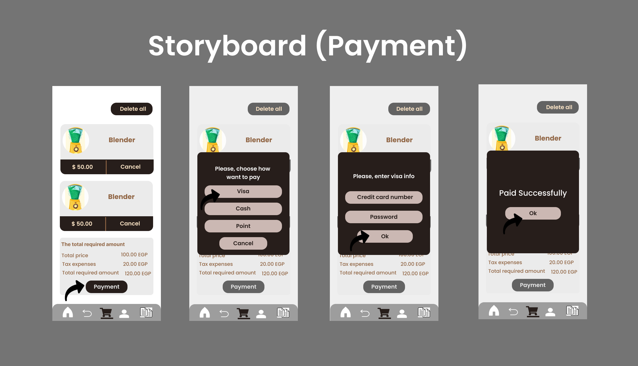

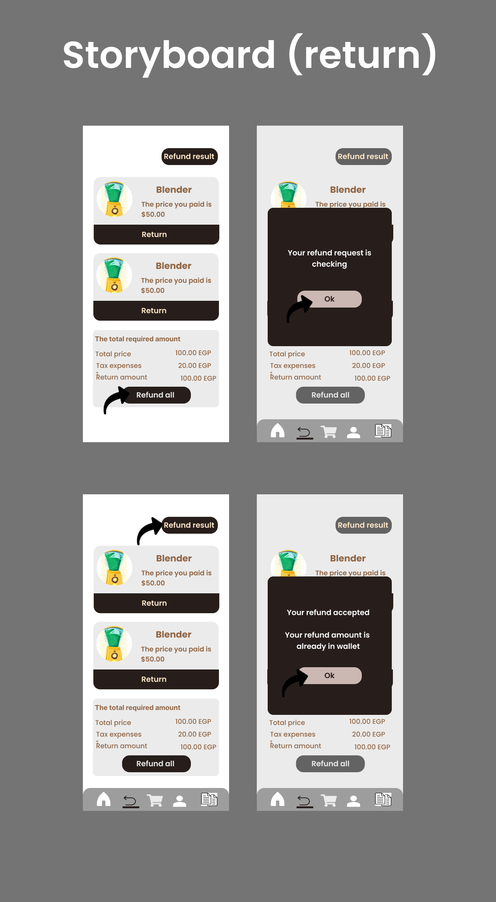

**c. Design a web-based user interface (screen) and mobile/tablet interface for one of the screens from (2.a).**

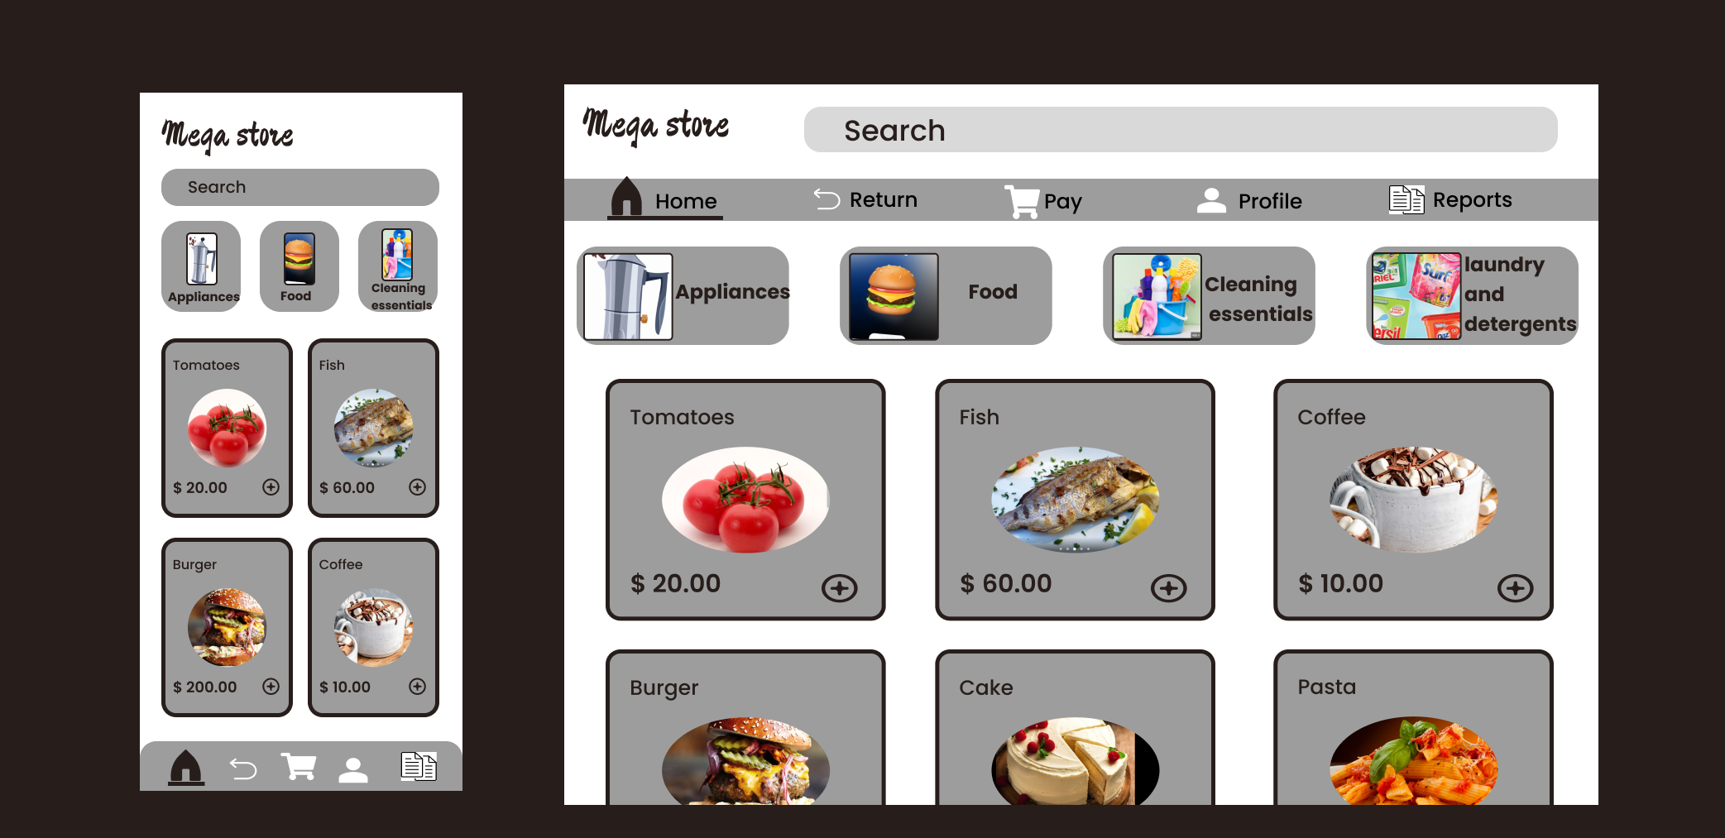

**4-Consider all User Interface Design Guidelines you studied and show how they addressed in your screens Reports:**

**• Design One electronic internal output reports of your choice.**

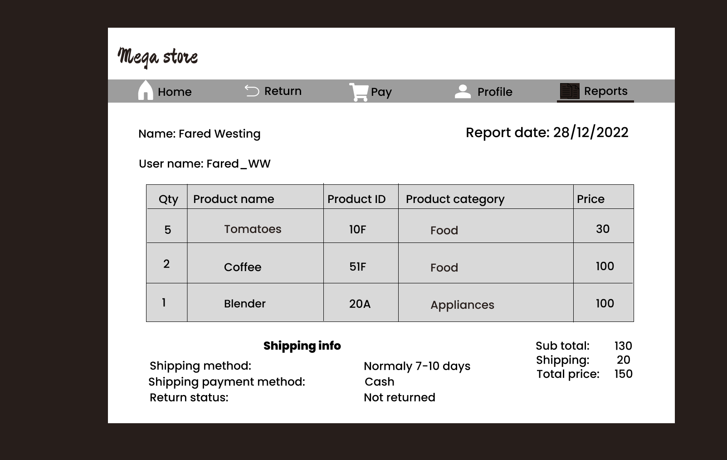**• Design One electronic external output reports of your choice**.