CS 499 Module One Assignment

Complete this template by replacing the bracketed text with the relevant information.

- Self-Introduction: Address all of the following questions to introduce yourself.

  - How long have you been in the Computer Science program?
I have been in the Computer Science program at SNHU for nearly 10 years, having entered in the fall of 2016.

  - What have you learned while in the program? List three of the most important concepts or skills you have learned.
Throughout the CS program at SNHU, I have learned techniques to become an effective software developer. The three most important concepts and skills I have learned are as follows:
- Software architecture and design patterns and their application in projects. Learning about architectures and design patterns such as the Model View Controller helped me conceptualize how systems can be built, expanded upon, and maintained.
- The concept of the Software Development Lifecycle was important to learn as it helped me understand the different phases of software development, what is involved in each stage, and what to expect out of released projects.
- Coding style standards, such as PEP 8 for Python, were important to learn as they help me write clean, readable code that adheres to industry-standard conventions to help me work better with established teams.

  - Discuss the specific skills you aim to demonstrate through your enhancements to reach each of the course outcomes.
- For employing strategies for building collaborative environments, I plan to adhere to best practices for software development design, include helpful and detailed in-code comments to aid in code review, as well as provide descriptive summaries of components of the project to aid in creating a collaborative and informed team environment.
- For visual communications, I will deliver professional-quality visual elements to illustrate project enhancements to technical and non-technical members of a team, as well as code review videos to discuss enhancements.
- For computing solutions, I plan to evaluate enhancement approaches and coding languages for porting projects made in one language to another, as well as the trade-offs of these new approaches.
- For demonstrating innovative techniques, skills, and tools in computing practices, I plan to leverage modern development practices and iterative testing methods to port a graphics-focused application to Python while integrating a relational database to track user progression.
- For security, I plan to outline potential risks for exploitation of my software as well as mitigation strategies to ensure user privacy and security.

  - How do the specific skills you will demonstrate align with your career plans related to your degree?
The skills I demonstrate in this capstone course align with my career plans to continue my work in professional software development, primarily in visualization-focused applications. I currently work in software development, but I would like to expand my focus into Python-focused environments and database system integration, which I plan to demonstrate throughout this course.

  - How does this contribute to the specialization you are targeting for your career?
I plan to merge my visualization development specialization with my desire to expand my knowledge of Python and databases. This course will allow me to demonstrate that specialization with my new focus.

- ePortfolio Set Up:

  - Submit a screen capture of your ePortfolio GitHub Pages home page that clearly shows your URL.
    - You already have a repository in GitHub where you uploaded projects in previous courses. Your ePortfolio will reside in GitHub but can link to work at other sites, such as Bitbucket.

  - Use the GitHub Pages link in the Resource section for directions on:
    - How to create your GitHub website and publish code to GitHub Pages
    - Issues, such as adding links to other sites

  - Paste a screenshot of your GitHub Pages home page with your URL clearly showing in the space below.

[Screenshot GitHub Pages home below. URL: https://samuelneblett.github.io/]
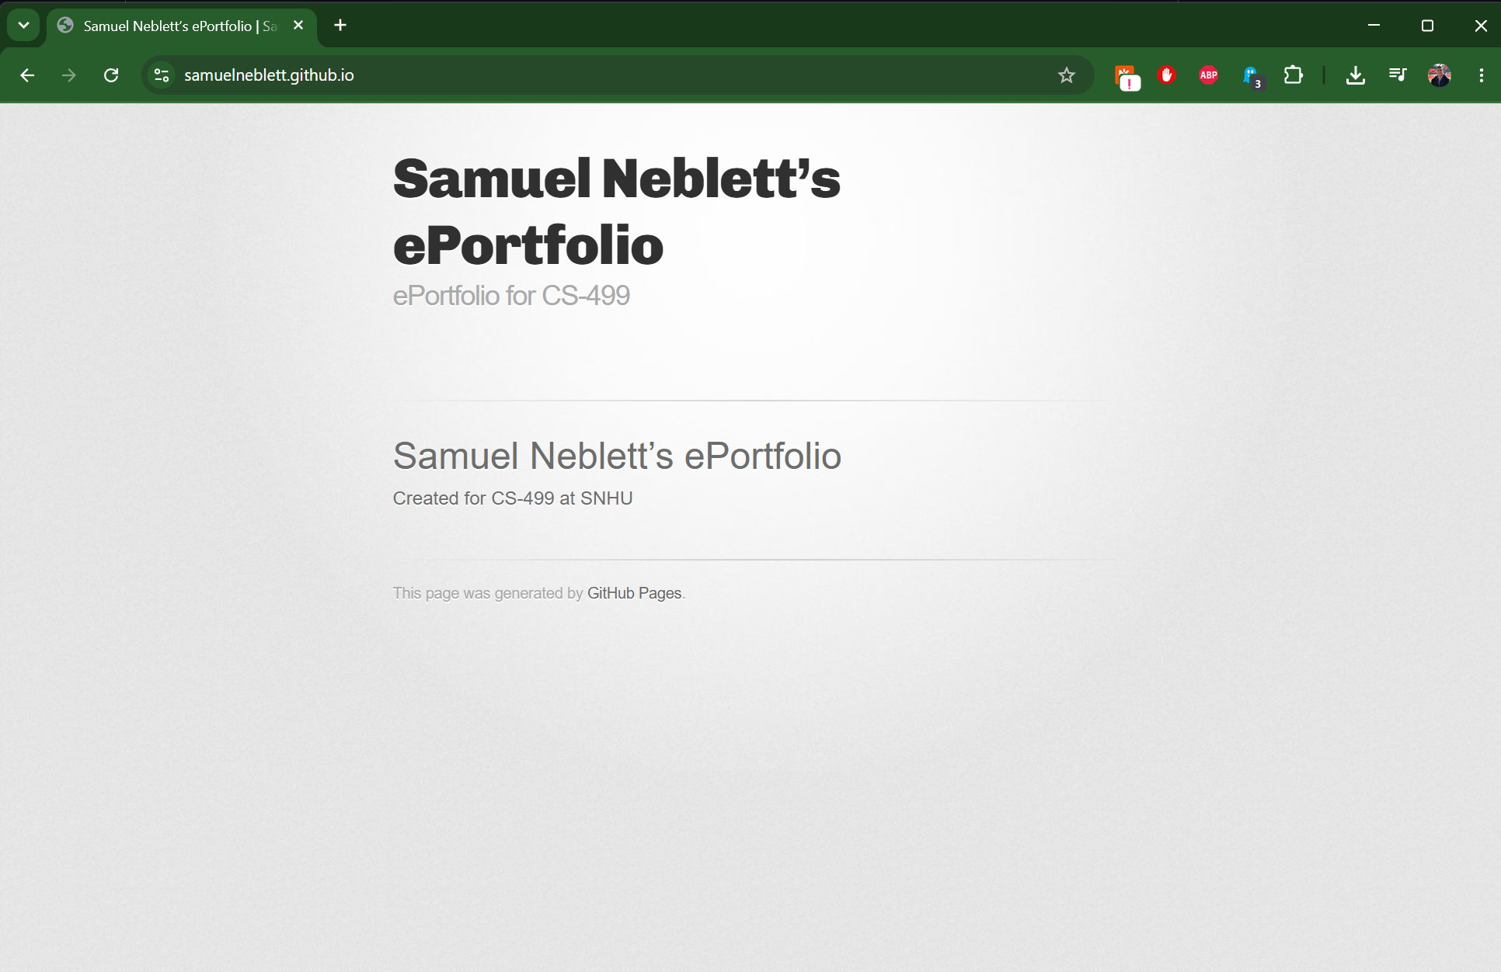

[Screenshot GitHub Pages repo below. URL: https://github.com/SamuelNeblett/samuelneblett.github.io]

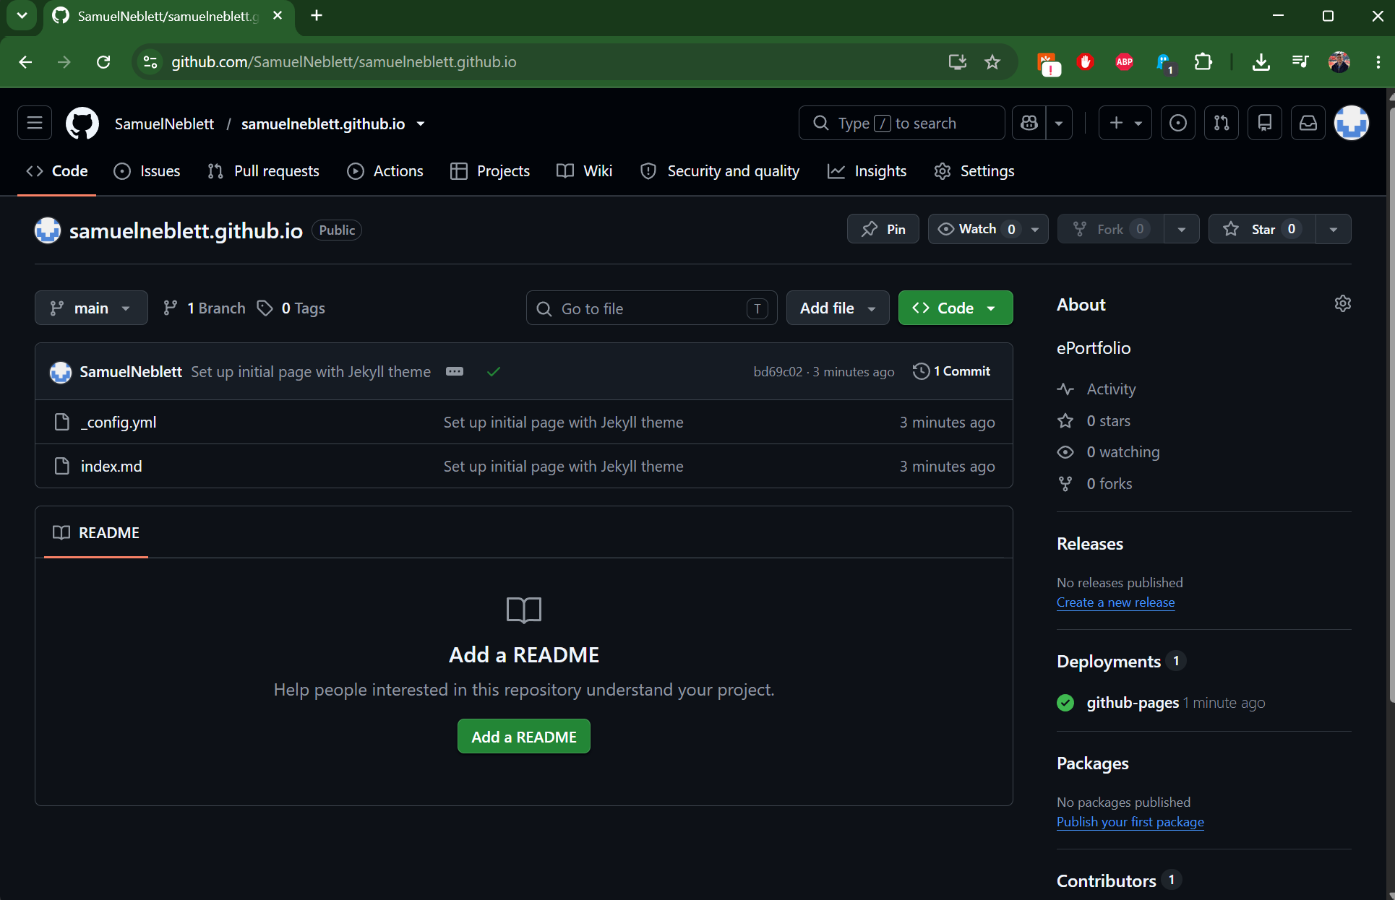

- Enhancement Plan:

  - Category One: Software Engineering and Design
    - Select an artifact that is aligned with the software engineering and design category and explain its origin. Submit a file containing the code for the artifact you choose with your enhancement plan.

The artifact selected for the Software Engineering and Design category is “MainCode.cpp”, part of the full Neblett_8-2_Assignment.zip project (contains the .sln and a playable .exe file), both submitted along with this document. This project was originally developed for the CS 330: Computational Graphics and Visualization course at SNHU. This project was written in C++ and uses OpenGL to visualize a playable brick-breaking application. To meet the criteria for the Software Engineering and Design category, this artifact will be ported from C++ to Python, along with API calls, and new gameplay enhancements will be added.

Note: Your artifact may be work from the following courses:

- IT 145: Foundation in Application Development
- CS 250: Software Development Lifecycle
- CS 260: Data Structures and Algorithms
- IT 315: Object Oriented Analysis and Design
- CS 320: Software Testing, Automation, and Quality Assurance
- CS 330: Computational Graphics and Visualization
- CS 340: Advanced Programming Concepts
- CS 350: Emerging Systems Architectures and Technologies
- CS 360: Mobile Architecture and Programming
- IT 365: Operating Environments
- IT 380: Cybersecurity and Information Assurance
- CS 405: Secure Coding
- CS 410: Reverse Software engineering
- IT 340: Network and Telecommunication Management
- IT 380: Cybersecurity and Information Assurance

    - Describe a practical, well-illustrated plan for enhancement in alignment with the category, including a pseudocode or flowchart that illustrates the planned enhancement.

The planned enhancement for the Software Engineering and Design category is to port all existing functionality from the original C++ OpenGL application to a new architecture written in Python. This architectural change involves the translation of C++ syntax, logic, and API calls to Python equivalents such as pyGLFW for OpenGL. Further enhancements will be made to improve gameplay, such as level progression with varying brick layouts, new brick behavior, new GUI screens, and score tracking.

Pseudocode:

START
Initialize menu GUI window

MENU Loop
Display option to start game
Display high scores fetched from database
Display option to wipe high scores from database

IF User presses Start Game button
Set Lives to 5
Set Score to 0
Set Level to 1
Enter Game Loop

IF User presses Escape keyboard key
Exit application
END

GAME Loop
Render Score GUI text
Render Brick layout for Level
Process physics and trajectory for Ball
Process Paddle input

IF User presses Escape keyboard key
Exit application
END

WHILE Lives is greater than 0
IF User presses Space keyboard key and canLaunch flag is TRUE
Launch Ball from center of Paddle

IF Ball collides with Brick
IF Brick is type Destructible
IF Ball hits a Brick AND Brick has 0 Hits Remaining
Destroy Brick
Reflect Ball
Increment current score
ELSE
Decrement 1 from Hits Remaining
Reflect Ball
ELSE IF Brick is type Reflective
Reflect Ball

IF Ball touches Screen Bounds
IF Screen Bounds is bottom of the window
Destroy Ball
Decrement 1 from Lives
SET canLaunch flag that user cannot launch a new Ball from center of Paddle
ELSE
Reflect ball

Add score to high scores database
GO TO Menu Loop
END

For this category of enhancement, consider improving a piece of software, transferring a project into a different language, reverse engineering a piece of software for a different operating system, or expanding a project’s complexity. These are just recommendations. Consider being creative and proposing an alternative enhancement to your instructor.

Think about what additions to include to complete the enhancement criteria in this category. Since one example option is to port to a new language, that is the kind of scale that is expected. This does not mean you need to port to a new language but instead have an equivalent scale of enhancement. Underlying expectations of any enhancement include fixing errors, debugging, and cleaning up comments, but these are not enhancements themselves.

    - Explain how the planned enhancement will demonstrate specific skills and align with course outcomes.

      - Identify and describe the specific skills you will demonstrate that align with the course outcome.

These enhancements demonstrate my ability to work in multiple programming languages, port complex logic from one language to another, use state machines to control application flow, and architect a playable application with object-oriented programming.

      - Select one or more of the course outcomes below that your enhancement will align with.

“Design, develop, and deliver professional-quality oral, written, and visual communications that are coherent, technically sound, and appropriately adapted to specific audiences and contexts.” This outcome aligns with the frontend enhancements for this application, including the new GUI score display and high score list. Scores in this application will be stored in a secure database and visually communicated to players in the context of an ongoing game or on the high score screen.

“Demonstrate an ability to use well-founded and innovative techniques, skills, and tools in computing practices for the purpose of implementing computer solutions that deliver value and accomplish industry-specific goals.” The enhancements of porting the C++ application to Python and adding additional functionality aligns with this course outcome because it represents utilization of a modern framework, Python, and a fully playable, delivered application for end-users.

Course Outcomes:

- Employ strategies for building collaborative environments that enable diverse audiences to support organizational decision-making in the field of computer science.
- Design, develop, and deliver professional-quality oral, written, and visual communications that are coherent, technically sound, and appropriately adapted to specific audiences and contexts.
- Design and evaluate computing solutions that solve a given problem using algorithmic principles and computer science practices and standards appropriate to its solution while managing the trade-offs involved in design choices.
- Demonstrate an ability to use well-founded and innovative techniques, skills, and tools in computing practices for the purpose of implementing computer solutions that deliver value and accomplish industry-specific goals.
- Develop a security mindset that anticipates adversarial exploits in software architecture and designs to expose potential vulnerabilities, mitigate design flaws, and ensure privacy and enhanced security of data and resources.

  - Category Two: Algorithms and Data Structures

- Select an artifact that is aligned with the algorithms and data structures category and explain its origin. Submit a file containing the code for the artifact you choose with your enhancement plan. You may choose work from the courses listed under Category One.

The artifact selected for the Algorithms and Data Structures category is “MainCode.cpp”, part of the full Neblett_8-2_Assignment.zip project (contains the .sln and a playable .exe file), both submitted along with this document. This project was originally developed for the CS 330: Computational Graphics and Visualization course at SNHU. This project was written in C++ and uses OpenGL to visualize a playable brick-breaking application. These are the same artifacts as originally described under Category One and the intent for the final project is to create a full-stack application that covers all three categories. To meet the criteria for the Algorithms and Data Structures category, algorithms and logic in this artifact will be updated to reflect more accurate and expected behaviors to improve gameplay and data structures will be changed to improve the modularity of code and make this project easier to understand for a broader audience.

- Describe a practical, well-illustrated plan for enhancement in alignment with the category, including a pseudocode or flowchart that illustrates the planned enhancement.

The planned enhancement for the Algorithms and Data Structures category is to rewrite the current physics and collision system to improve the trajectory of the ball as it moves around the screen and collides with other objects. The current system in C++ relies on simplified speed and direction parameters, which these refactors will modernize and improve with dynamic trajectory calculations. Additionally, the data structure for the paddle and bricks will be expanded upon to better track collision events and health to enable blocks to require multiple hits to be destroyed.

Pseudocode:

START
CLASS Ball
Replace current integer-based direction and float-based speed with a vector for Velocity
Vector2 Velocity for X and Y axis

CLASS Brick
Integer HitsRemaining to track health of bricks and determine hits required to destroy

CLASS Paddle
Current Paddle relies on Brick class. Refactor this into its own class.

GAME Loop
FUNCTION CheckCollision
CALCULATE Ball intersections with other objects using bounding box (AABB) relative to Ball
closestX = Clamp(Ball.X, OtherObject.MinX, OtherObject.MaxX)
closestY = Clamp(Ball.Y, OtherObject.MinY, OtherObject.MaxY)

CALCULATE the hit distance to determine the proper angle of reflection
(C++ code currently applies a random angle of reflection)
distanceX = Ball.X – closestX
distanceY = Ball.Y – closestY

Use the Pythagorean theorem to determine hit and reflection angle (de Vries, n.d.)
distanceLength = SquareRoot(distanceX^2 + distanceY^2)
IF (distanceX^2 + distanceY^2) < (Ball.Radius^2)
normalX = distanceX / distanceLength
normalY = distanceY / distanceLength

CALCULATE reflected trajectory by velocity (de Vries, n.d.)
dotProduct = (Ball.Velocity.X * normalX) + (Ball.Velocity.Y * normalY)
Set X Velocity trajectory with Ball.Velocity.X = Ball.Velocity.X – (2 * dotProduct * normalX)
Set Y Velocity trajectory with Ball.Velocity.Y = Ball.Velocity.Y – (2 * dotProduct * normalY)
IF Brick is Destructible
Decrement 1 from HitsRemaining
IF HitsRemaining is less than or equal to 0
Destroy Brick
ELSE
Update brick color as a visual indicator that it was hit but not destroyed
END

For this category of enhancement, consider improving the efficiency of a project or expanding the complexity of the use of data structures and algorithms for your artifact. These are just recommendations. Consider being creative and proposing an alternative enhancement to your instructor. Note: You only need to choose one type of enhancement per category.

Think about what additions to include to complete the enhancement criteria in this category. Since one example option is to port to a new language, that is the kind of scale that is expected. Perhaps you might increase the efficiency and time complexity of an algorithm in an application and detail the logic of the increased time complexity. Remember, you do not need to port to a new language but instead have an equivalent scale of enhancement. Underlying expectations of any enhancement include fixing errors, debugging, and cleaning up comments, but these are not enhancements themselves.

- Explain how the planned enhancement will demonstrate specific skills and align with course outcomes.

  - Identify and describe the specific skills you will demonstrate to align with the course outcome.

This enhancement demonstrates expanded complexity of the project, particularly with math, as it represents a move from simplified handling of speed and trajectory to accurate trajectory calculations and collision checking. These enhancements come with the tradeoff that they are slightly more complex to calculate than the simple functionality in the original C++ artifact, but the result is a significantly more accurate and engaging gameplay experience. Additionally, data structures were expanded to expand functionality of bricks, and logic for the paddle was moved to a new data structure to better encapsulate functionality.

  - Select one or more of the course outcomes listed under Category One that your enhancement will align with.

“Design and evaluate computing solutions that solve a given problem using algorithmic principles and computer science practices and standards appropriate to its solution while managing the trade-offs involved in design choices.” This enhancement addresses this outcome due to the replacing of simplified trajectory and collision logic within the existing application with more accurate movement logic and expanded functionality for collision elements.

  - Category Three: Databases

    - Select an artifact that is aligned with the databases category and explain its origin. Submit a file containing the code for the artifact you choose with your enhancement plan. You may choose work from the courses listed under Category One.

The artifact selected for the Databases category is “MainCode.cpp”, part of the full Neblett_8-2_Assignment.zip project (contains the .sln and a playable .exe file), both submitted along with this document. This project was originally developed for the CS 330: Computational Graphics and Visualization course at SNHU. This project was written in C++ and uses OpenGL to visualize a playable brick-breaking application. These are the same artifacts as originally described under Category One and the intent for the final project is to create a full-stack application that covers all three categories. To meet the criteria for the Databases category, this artifact will be expanded upon to include a score tracking and management system in a relational database.

    - Describe a practical, well-illustrated plan for enhancement in alignment with the category, including a pseudocode or flowchart that illustrates the planned enhancement.

The planned enhancement for the Databases category is to create a relational database with MySQL for the Python application’s backend, which the Python application will utilize to track user performance metrics. Scores tracked in the SQL database will populate a new high score table in the Python application, viewable as a new GUI element. The Python application will interact with the backend database using CRUD operations to create, read, update, and delete entries through SQL queries. The top ten highest scores in the database will be displayed on the high score screen in the Python application. Additionally, a “Delete All Scores” function will be available on the high score screen to allow players to clear high scores if desired.

Pseudocode:

START
SET Database name to breakout_db
SET table name to playerscores

FUNCTION InitDatabase
IF playerscores table DOES NOT EXIST
CREATE table playerscores with columns
id, playerName, playerScore, highestLevel, date

FUNCTION SavePlayerScore
SET date (using system clock)
SANITIZE playerName to prevent SQL exploits (security mindset capstone requirement)
QUERY playerscores table for existing SQL entry for playerName
IF playerName DOES NOT EXIST in playerscores table
INSERT SQL new entry for playerScore into playerscores table
ELSE IF playerScore is greater than playerName’s last retrieved score from the database
UPDATE SQL entry for playerScore in playerscores table with latest score, highestLevel, date
SAVE changes to database

FUNCTION GetHighScores
SELECT SQL entries in playerscores table
SORT SQL entries in playerscores by score value in descending order with limit of 10
RETURN top 10 rows of scores from playerscores table to display on GUI screen

FUNCTION DeleteAllScores
DELETE all rows in SQL playerscores table
SAVE changes to database
RETURN empty scores to display on GUI screen
END

For this category of enhancement, consider adding more advanced concepts of MySQL, incorporating data mining, creating a MongoDB interface with HTML/JavaScript, or building a full stack with a different programming language for your artifact. These are just recommendations; consider being creative and proposing an alternative enhancement to your instructor. Note: You only need to choose one type of enhancement per category.

Think about what additions to include to complete the enhancement criteria in this category. Since one example option is to port to a new language, that is the kind of scale that is expected. Perhaps you might increase the efficiency and time complexity of an algorithm in an application and detail the logic of the increased time complexity. Remember, you do not need to port to a new language but instead have an equivalent scale of enhancement. Underlying expectations of any enhancement include fixing errors, debugging, and cleaning up comments, but these are not enhancements themselves.
    - Explain how the planned enhancement will demonstrate specific skills and align with course outcomes.

      - Identify and describe the specific skills you will demonstrate that align with the course outcome.

This enhancement demonstrates skill in database design, integration within Python-based systems, and secure data handling. Creating a relational database backend with MySQL and enabling CRUD operations from a Python application frontend creates a functional full-stack application that can be played by end-users or expanded upon and utilized within a collaborative work environment. Secure data handling is demonstrated with SQL data sanitization to demonstrate a security mindset and attention to privacy.

      - Select one or more of the course outcomes listed under Category One that your enhancement will align with.

“Employ strategies for building collaborative environments that enable diverse audiences to support organizational decision-making in the field of computer science.” By creating a database to hold player scores and data, multiple teams across a work environment can contribute to and benefit from this application as well as player data saved into the database. Usage data contributed to the database can also influence organizational decision-making by highlighting number of players, frequency of play, and scores players were able to achieve.

“Develop a security mindset that anticipates adversarial exploits in software architecture and designs to expose potential vulnerabilities, mitigate design flaws, and ensure privacy and enhanced security of data and resources.” By creating a database backend that sanitizes input, this application can operate securely and prevent malicious use.

- ePortfolio Overall Skill Set

  - Accurately describe the skill set to be illustrated by the ePortfolio overall.
    - Skills and outcomes planned to be illustrated in the code review

The skills I will illustrate in the code review include my ability to discuss and review an existing codebase, MainCode.cpp (artifact attached to this submission), perform code quality analysis, and discuss improvement suggestions. During the code review, I will discuss the current state of the application, identify flaws, and discuss preferred approaches that will be implemented in future updates.

The code review will illustrate course outcome 2: “design, develop, and deliver professional-quality oral, written, and visual communications that are coherent, technically sound, and appropriately adapted to specific audiences and contexts.” This will be illustrated through a high-level overview intended for general audiences, oral discussion of the goal of the project, and a visual walkthrough of the code.

This code review will also illustrate course outcome 4: “demonstrate an ability to use well-founded and innovative techniques, skills, and tools in computing practices for the purpose of implementing computer solutions that deliver value and accomplish industry-specific goals.” This will be illustrated through technical discussion, architectural discussion for the upcoming port to Python, and discussion on decisions for technical approach.

    - Skills and outcomes planned to be illustrated in the narratives

The skills I will illustrate in the narratives include my ability to describe the project, my ability to justify my work and the significance of it, and my ability to reflect on the development process.

The narratives section of my ePortfolio will illustrate course outcome 3: “design and evaluate computing solutions that solve a given problem using algorithmic principles and computer science practices and standards appropriate to its solution while managing the trade-offs involved in design choices.” This will be illustrated through detailing how the current C++ project handles trajectory calculations and how they can be improved, as well as the trade-offs of both approaches.

Additionally, the narratives section will illustrate course outcome 5: “develop a security mindset that anticipates adversarial exploits in software architecture and designs to expose potential vulnerabilities, mitigate design flaws, and ensure privacy and enhanced security of data and resources.” This will be illustrated through analysis of the project’s database creation, implementation, and proactive security measures taken to ensure security and data privacy.

    - Skills and outcomes planned to be illustrated in the professional self-assessment

The skills I will illustrate in the professional self-assessment include my ability to express myself as a professional by giving an overall assessment of my capstone and my experience in the Computer Science program at SNHU. This will demonstrate my ability to communicate technical expertise and writing skills to industries aligning with my interests in visualization.

The professional self-assessment section of my ePortfolio will illustrate course outcome 1: “Employ strategies for building collaborative environments that enable diverse audiences to support organizational decision-making in the field of computer science.” This will be illustrated by detailing my experiences in the capstone course and CS program, strategies I utilized to collaborate effectively, and how I approached decision-making to enable diverse audiences to engage with my work.

References
de Vries, J. (n.d.). Collision detection. Retrieved from Learn OpenGL: https://learnopengl.com/In-Practice/2D-Game/Collisions/Collision-detection

