**Quillionz –API management**

**(Developers Version)**

*V.1.0*

**Contents**

**Summary** 3

**API access for developers** 4

**Dev Portal** 6

**API Subscription** 8

**Key Generation** 9

**Try Out** 11

**SDKs** 12

# **Summary**

The document provides a brief of how Quillionz APIs can be accessed by different users for the integration of Quillionz platform with the external applications over the secure channel using RESTful APIs. Along with a brief on each modules and features.

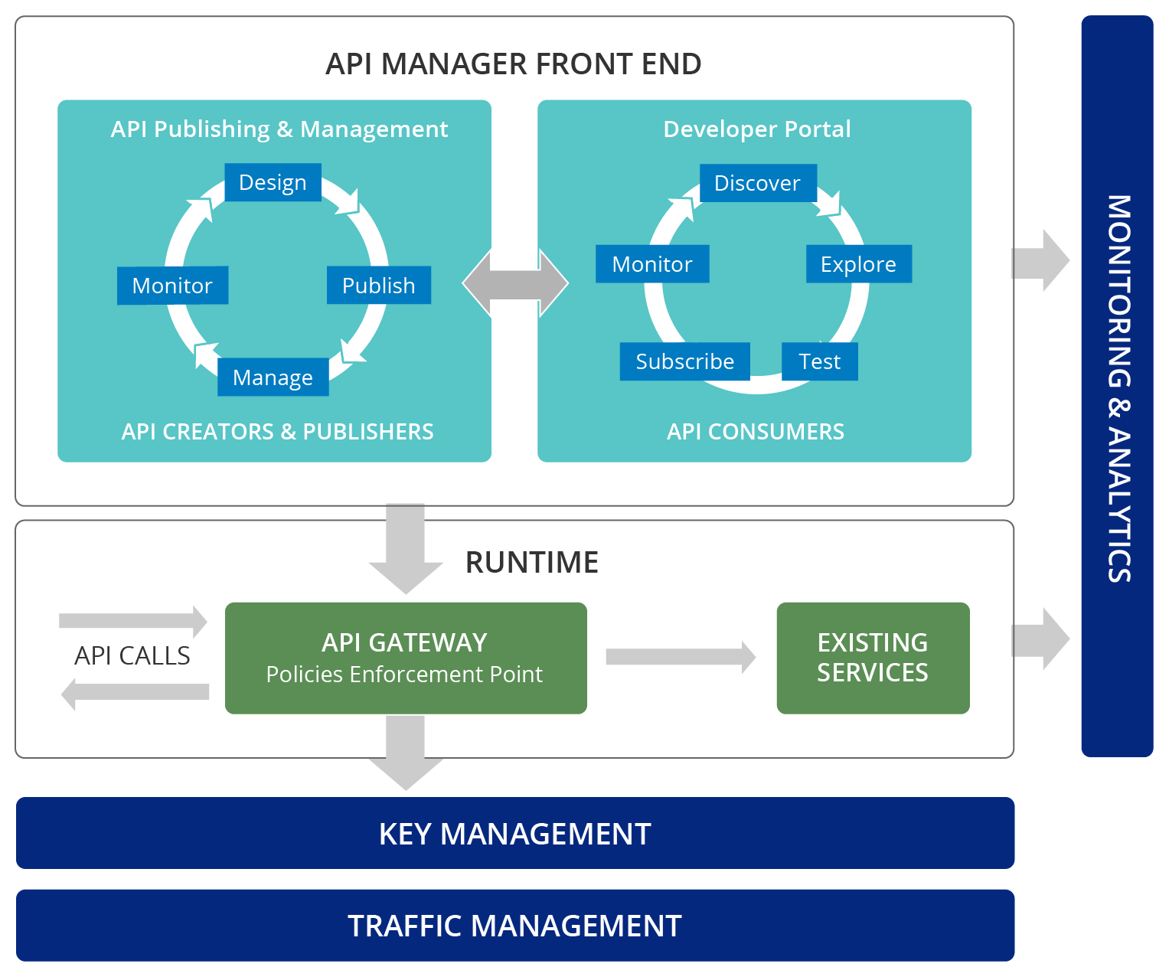

# **API access for developers**

1. Go to [https://www.quillionz.com](https://www.quillionz.com/)

Click on Developer menu from the menu options

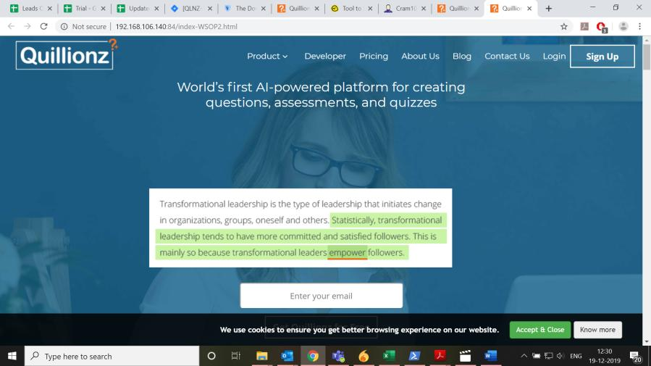

1. You will be redirected to the API details section.

* Click on Know more about Quillionz API
* You will be redirected to the API store i.e. the Devportal store of Quillionz.

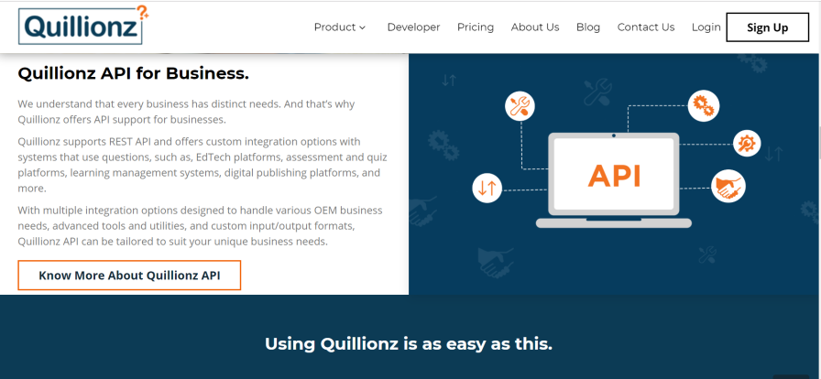

# **Dev Portal**

1. Quillionz API store – Dev Portal

All the Quillionz APIs are listed on this portal or store from where you can subscribe to Quillionz APIs and start integrating your applications with Quillionz.

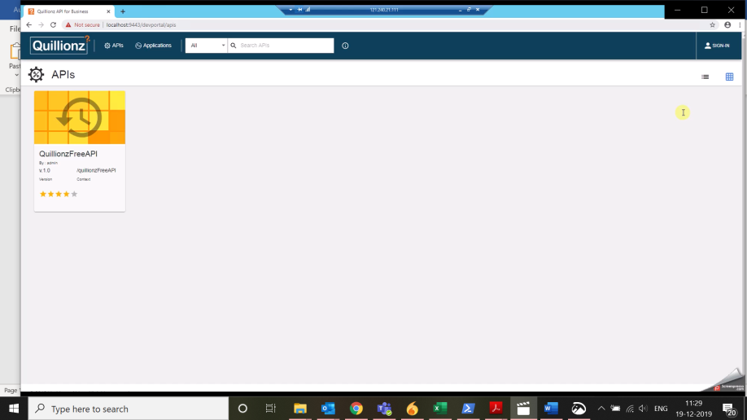

1. SIGN IN or Register to create new account

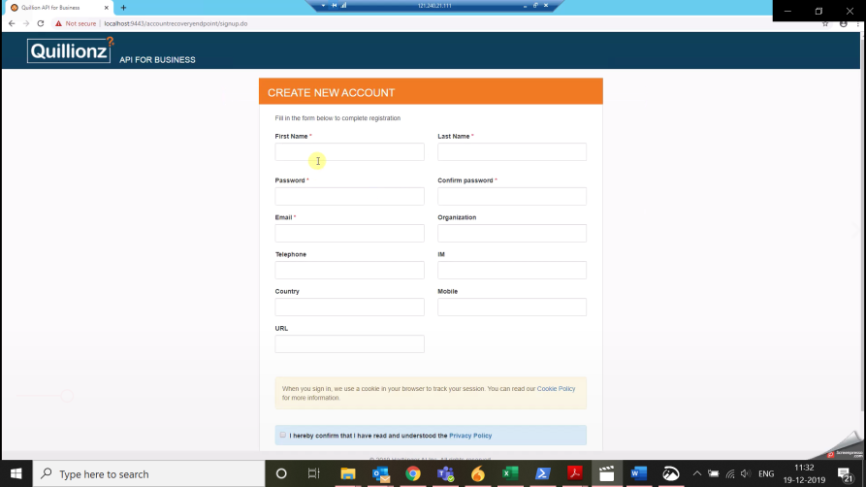

1. Login on the portal to access APIs

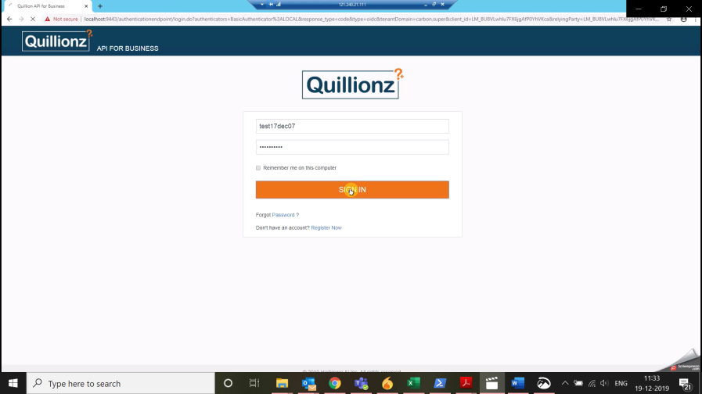

1. API subscription – Once signed into the portal, click on the API.

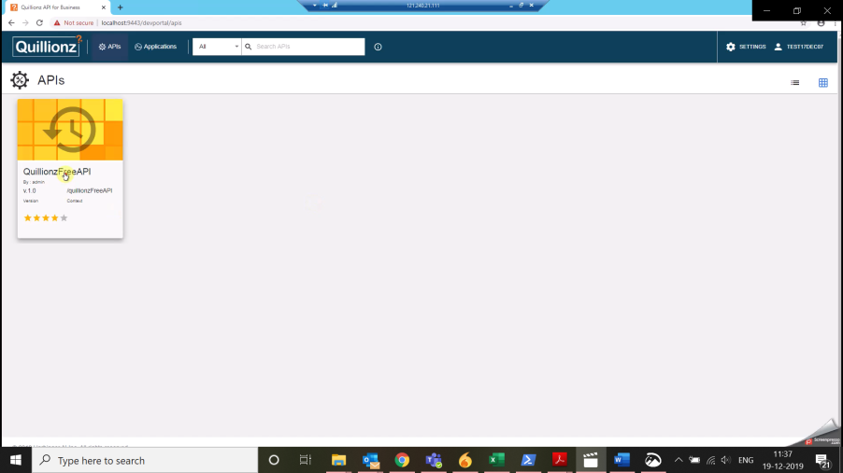

# **API Subscription**

1. From the overview section, click on SUBSCRIBE TO AN APPLICATION

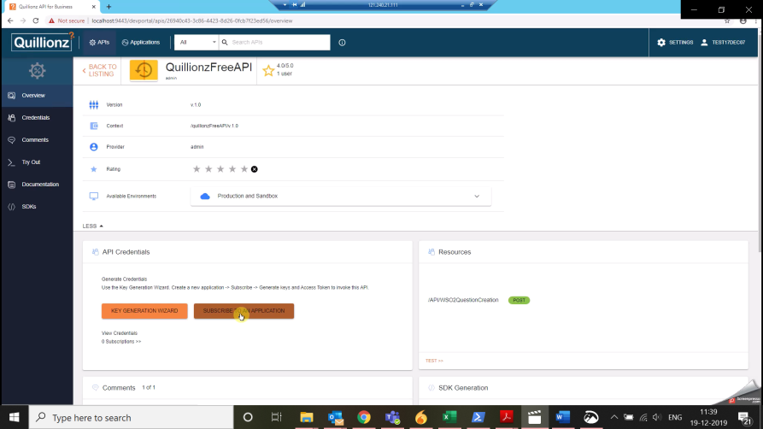

1. You will now need to select an existing application if you have added any or subscribe using a new application.

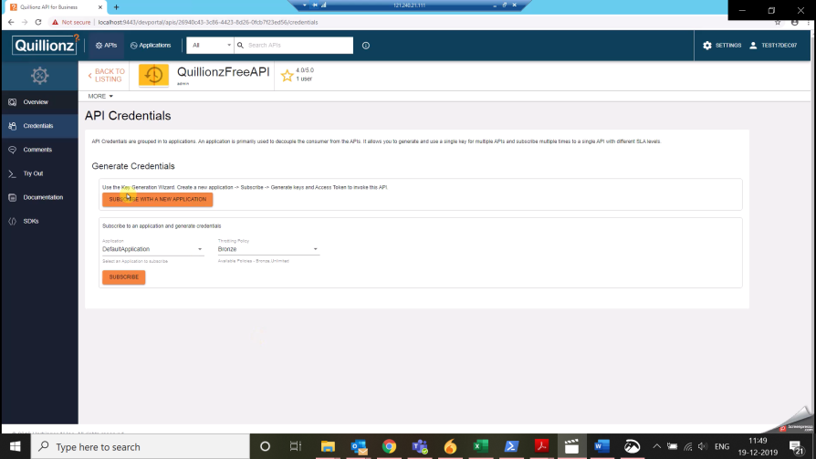

# **Key Generation**

1. Create a new application (this application will act as proxy of your application in the portal)

Give name of the application, for the naming convention, you should name the application to your business application. Example if you are integrating with Raptivity.com then name the application to Raptivity.

Select the per Token Quota – This will help in setting up the number of requests coming up from your application.

Token Type – You can choose JWT or OAUTH depending upon your own application framework support type. Most of the application frameworks will allow OAUTH and JWT both.

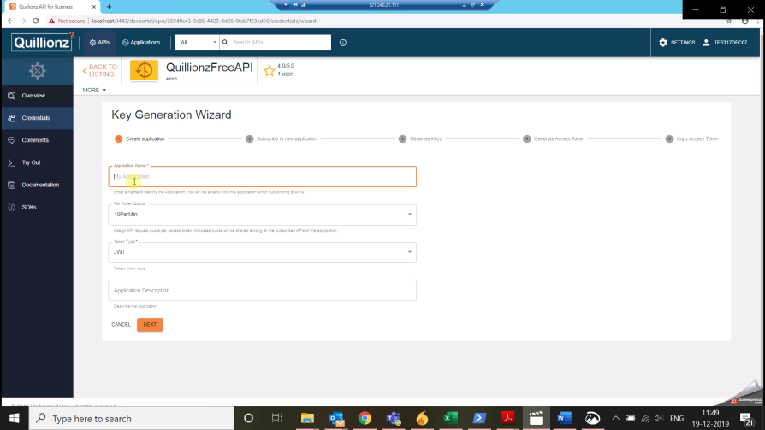

1. Subscribe to APIs using the newly created application.

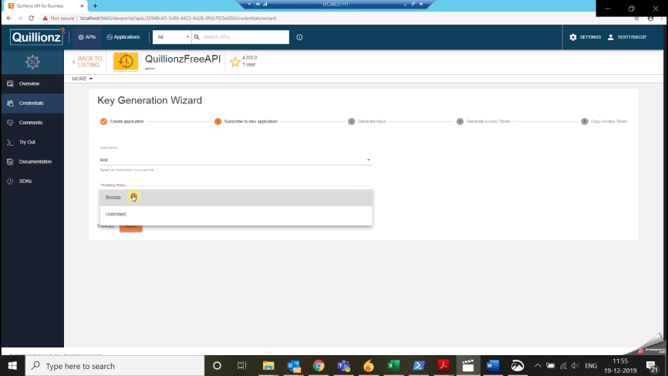

1. Click next to generate the Access token keys (You can select the type of keys support; this is typically how you would like to use the Access token keys through your code base)

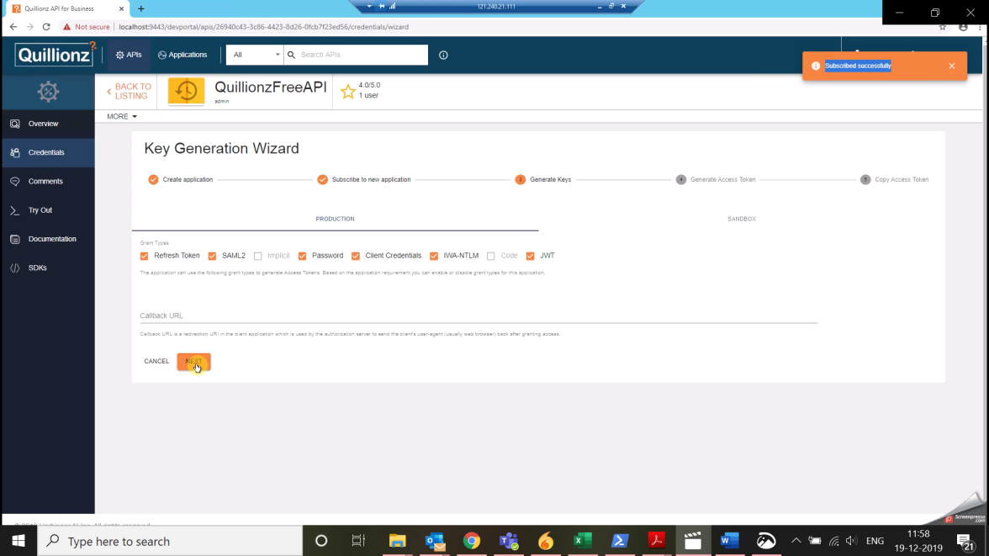

1. Save the Access Token keys by copying them into a notepad file or at the location of your choice for later use.

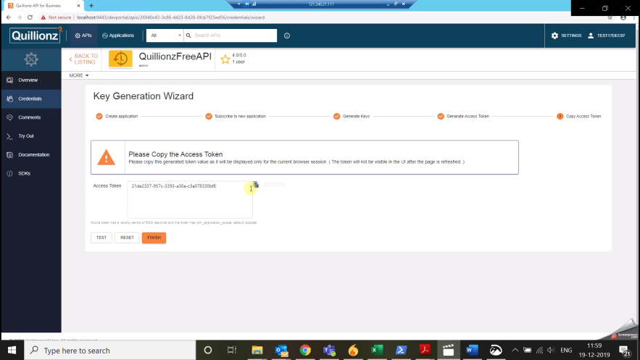

Your access token keys and subscription to the Quillionz API is ready.

You can now try out the APIs through Try out menu.

# **Try Out**

1. Click on >_Try out

Select the application you have added and subscribed to the APIs from the previous steps.

There will be two keys generated for you by default Production and Sandbox for testing and production purpose to keep the track of which requests are coming from your sandbox application while you test, and which requests are coming through the production application.

Access Token: Enter the access token you have saved in Step 9. By default all the Access Keys are automatically populated for every application subscription which are saved against your application and its subscriptions so that you do not need to worry or keeping track of the access token keys.

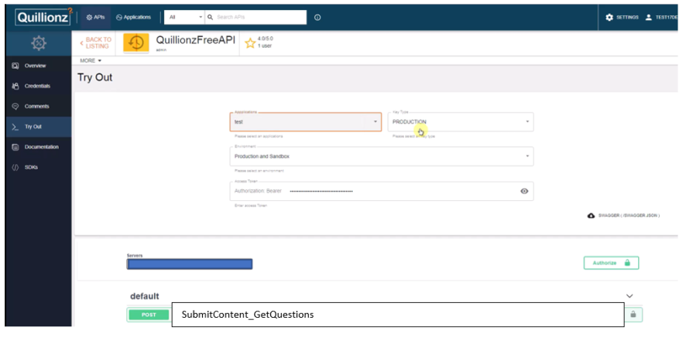

1. Choose the API of endpoint in this case, SubmitContent_GetQuestions API endpoint

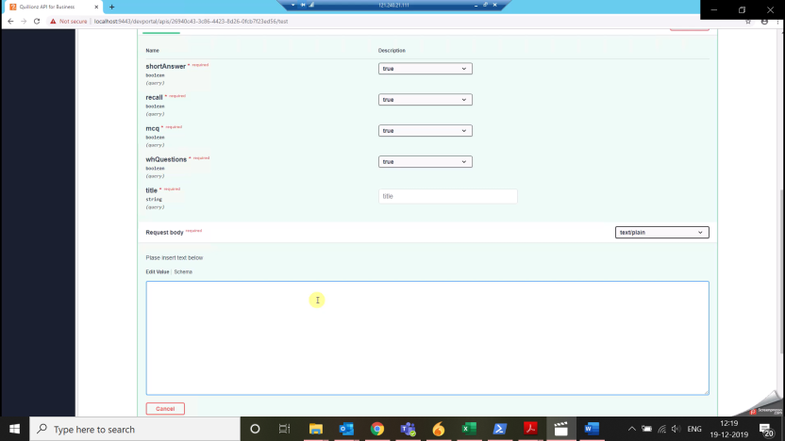

SubmitContent_GetQuestions API end point is a POST request API where you will have to input Content title and content as an input along with selecting the types of questions of your choice and in turn this will return you a JSON of Question and Answers of different types.

Question types are divided into four different types i.e.

**Short Answer**: This include explain why, describe and define type of questions.

**Recall**: These are Fill the blank type of questions.

**MCQs (Multiple Choice Questions)**: These are either multiple choice questions, True or False questions.

**Wh Questions**: This includes the plain Wh questions and interpretive questions.

Attached is the reference JSON output containing all the Question type tags for rendering and reading.



# **SDKs**

1. Download SDKs i.e. Software Development Kits.

Also, you can download the SDK of your API subscription containing your application keys and bundled files to be used straight from your code base and application.

The SDKs are made available for 16 different programming languages like Android, Java, JavaScript, .Net, Python, Scala, and many other popular frameworks.

