Lifting a tree using a servo motor

Samuel Nösslböck

March 2024

# Introduction

The basic task is to find a servo motor and equipment that can lift a tree from a certain start height at its centre of mass to an upwards vertical position.

Figure 1.1.1 – Basic buildup

For this problem, the following constants and parameters play a relevant role:

* , the upper diameter of the tree,
* , the lower diameter of the tree,
* , the height of the tree,
* , the desired lifting time of the tree,
* , the wood density of the tree and
* , the start height of the tree, measured from its centre of mass to the ground.

Notice that the tree is expected to have a truncated cone as shape in this example.

# Basic calculations

To get a quick overview of the dimensions required for the equipment, the following simple but efficient calculations can be used.

## Volume, mass, and centre of mass

The volume of a truncated cone can be calculated as follows

Where:

* is the upper radius of the cone, so ,
* is the lower radius of the cone, so and
* is the height of the tree, so

Once the volume is calculated, the mass is resulting out of the volume times the density:

The centre of mass however requires a series of integral calculations, which have been carried out on attachment #1. The final formula results in

## Total lifting energy and average power

The minimum lifting energy required can be calculated rather simple, as it just measures the difference in potential energy between the starting height and the vertical height of the tree.

Using this energy, a rough approximation for the average power consumption can be made:

## Geometrical shape

To resolve the differential equations ahead, the geometrical shape of the lifter must be defined with conversions between lengths of the cylinder and angles (see Figure 1.1.1). First, the law of cosines can be applied to solve for and vice versa.

The motor is connected to the spindle with a coupling, so the cylinder extension depending on the motor angle simply depends on the spindle pitch.

The unit for the specific pitch here is required to be meters per radian.

## Lifting speed

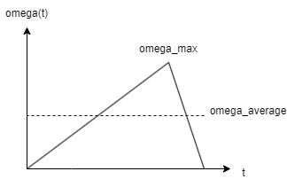The lifting speed over time shapes a triangular graph with its centre being rather on the right side, as more force is available for decelerating the tree. This triangle can be very well described using the average velocity.

Figure 2.4.1 – Velocity triangle

# Motor torque and differential equation problem

As the motor torque depends on the current speed ( ), the following differential equation forms.

with , the inertia of the motor being: