Lifting a tree using a servo motor

Samuel Nösslböck

March 2024

# Introduction

The basic task is to find a servo motor and equipment that can lift a tree from a certain start height at its centre of mass to an upwards vertical position.

Figure 1.1.1 – Basic buildup

For this problem, the following constants and parameters play a relevant role:

* $d_{T}$, the upper diameter of the tree,
* $D_{T}$, the lower diameter of the tree,
* $h_{t}$, the height of the tree,
* $t_{L}$, the desired lifting time of the tree,
* $ρ_{T}$, the wood density of the tree,
* $h_{s}$, the start height of the tree, measured from its centre of mass to the ground and
* $T_{E}$, the environment temperature

Notice that the tree is expected to have a truncated cone as shape in this example.

# Theoretical calculations

To get a quick overview of the dimensions required for the equipment, the following simple but efficient calculations can be used.

## Volume, mass, and centre of mass

The volume of a truncated cone can be calculated as follows

$$V_{TC}=\frac{hπ}{3}\left(r^{2}+rR+R^{2}\right)$$

Where:

* $r$ is the upper radius of the cone, so $r=\frac{d_{T}}{2}$,
* $R$ is the lower radius of the cone, so $R=\frac{D_{T}}{2}$ and
* $h$ is the height of the tree, so $h=h_{T}$

Once the volume is calculated, the mass is resulting out of the volume times the density:

$$m_{TC}=V_{TC}⋅ρ_{T}$$

The centre of mass however requires a series of integral calculations, which have been carried out on attachment #1. The final formula results in

$$h_{COM}=h_{T}\frac{\begin{aligned}\frac{R^{2}}{2}+R\left(r-R\right)\frac{2}{3}+\frac{{\left(r-R\right)}^{2}}{4} \\ \end{aligned}}{R^{2}+R\left(t-R\right)+\frac{{\left(r-R\right)}^{2}}{3}}$$

## Total lifting energy and average power

The minimum lifting energy required can be calculated rather simple, as it just measures the difference in potential energy between the starting height and the vertical height of the tree.

$$E_{pot0}=m_{T}gh_{S}$$

$$E_{potv}=m_{T}gh_{COM}$$

$$E_{lift}=E_{potv}-E_{pot0}$$

Using this energy, a rough approximation for the average power consumption can be made:

$$\overline{P_{th}}=\frac{E_{lift}}{t_{L}}$$

## Geometrical shape

To resolve the differential equations ahead, the geometrical shape of the lifter must be defined with conversions between lengths of the cylinder and angles (see Figure 1.1.1). First, the law of cosines can be applied to solve $α$ for $s$ and vice versa.

$$α\left(s\right)=arccos\left(1- \frac{2s^{2}}{h_{COM}^{2}}\right)$$

$$s\left(α\right)=h_{COM}^{}\sqrt{\frac{\left(1-\cos\left(α\right)\right)}{2}}$$

The motor is connected to the spindle with a coupling, so the cylinder extension depending on the motor angle simply depends on the spindle pitch.

$$s\left(ϕ\right)=ϕ⋅\hat{p}$$

The unit for the specific pitch here is required to be meters per radian.

## Lifting speed

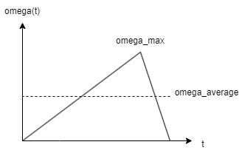The lifting speed over time shapes a triangular graph with its centre being rather on the right side, as more force is available for decelerating the tree. This triangle can be very well described using the average velocity.

Figure 2.4.1 – Velocity triangle

$$β_{T}=\frac{π}{2}-β_{0}=α(t=0)$$

$$\overline{ω}=\frac{β_{T}}{t_{L}}$$

## Differential equation problem of the motor

As the motor torque depends on the current speed ( $T_{M}(ω_{M})$), the following differential equation forms.

$$\frac{dω_{M}}{dt}=\frac{T_{M}\left(ω_{M}\right)}{I_{M}}$$

with $I_{M}$, the inertia of the motor being:

$$I_{T}=\frac{h_{T}^{2}m_{T}}{3}$$

$$I_{C}= \frac{{4I}_{T}}{h_{COM}^{2}}$$

$$I_{M}=I_{C}⋅\hat{p^{2}}$$

This differential problem makes a numerical solution very suitable for this task, which will be carried out in section three.

## Optimal motor and spindle

The optimal motor for this task has been calculated numerically in section three and has the following characteristics:

Source: <https://shop.jpmotorsanddrives.com/products/SGMGV-44ADA6S>

## Temperature development

When calculating the heat produced and distributed by the motor, the following things must be considered:

* The loss of heat to the motor environment
* The heat produced by the motor due to the difference between mechanical output and electrical input power

Taking both effects and assigning them constants gives:

$$\frac{dT}{dt}=α⋅ΔT+β⋅\left(P_{el}\left(t\right)-P_{mech}\left(t\right)\right)$$

With $α$ being a constant for heat distribution to the environment, depending on material, surface area, etc. and $β$ being another constant for the conversion rate between power loss to Kelvin, depending on the motor material.

If the motor is not running, the differential equation simply results in

$$T\left(t\right)=T_{0}e^{αt}$$

# Numerical calculation

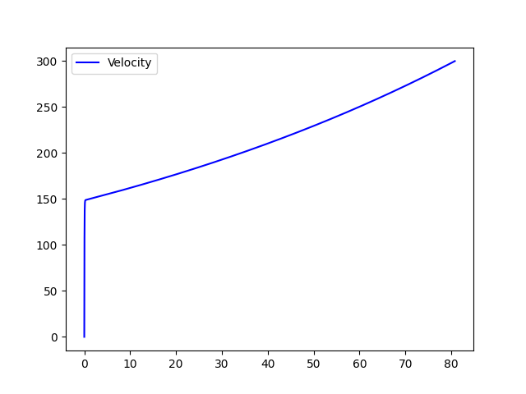The numerical calculation is done by a simple python console script, which allows fast adjustment of the start values and more experimentation. The calculation does not include slowing the tree down, as it is a matter of regulation and does not require high specifics for the motor, as most of the torque is required at the beginning of the lifting.

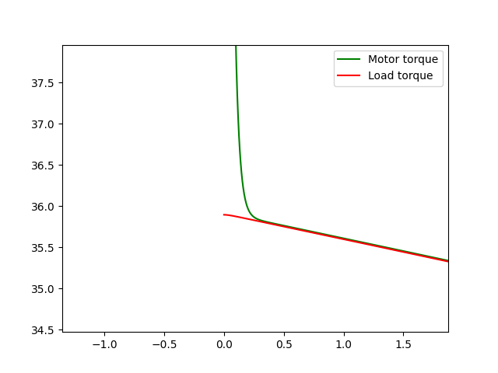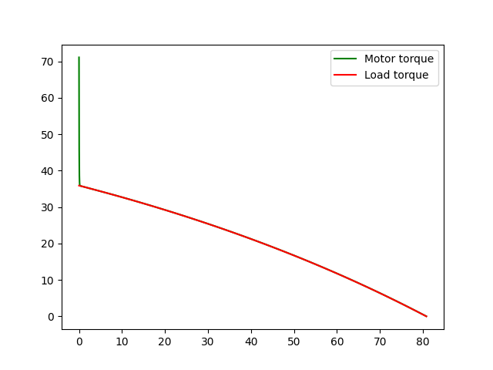The motor and load torque create an interesting image, as very soon into the movement process, most of the motor acceleration has been done and it is adjusting to the load it has been applied. The amperage of the motor looks like the motors torque curves, as it has been calculated using the manufacturer's RMS torque constant.

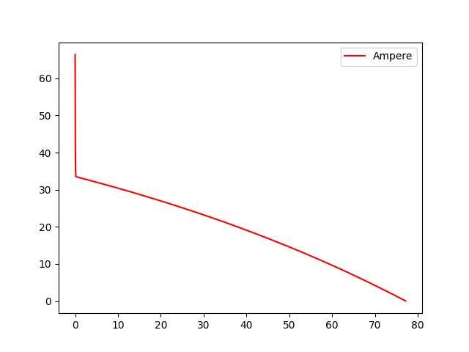

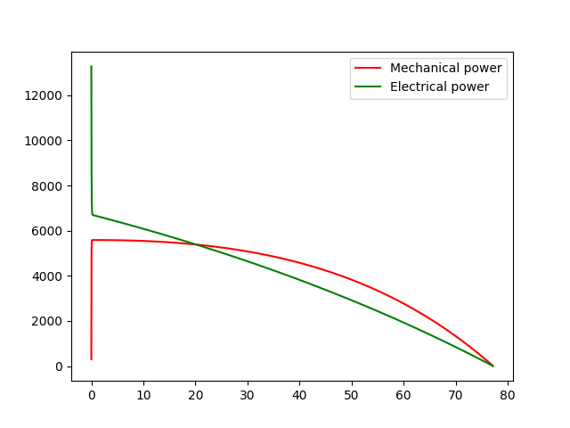As the powers have been assumed theoretically, there is a small area where the mechanical power is higher than the electrical power, which is due to the linearization of the motor torque.

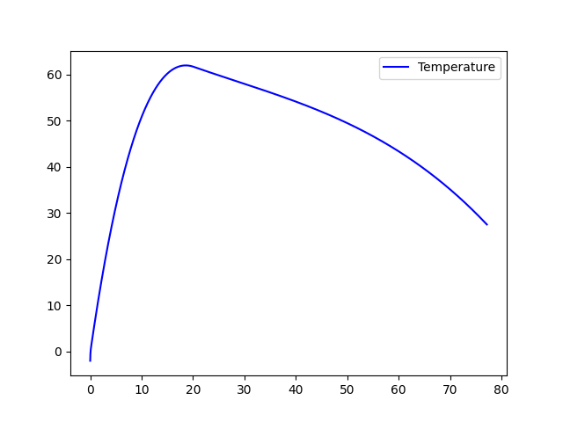Approximate values for alpha and beta have been calculated using the thermal resistance of copper and the surface heat distribution of common aluminium.

As shown below, the motor peaks at 60°C, which perfectly fits the maximum operating temperatures. Using a break of 10 minutes will allow the motor to fully cool down. So, a second iteration will only have negligible differences to the first one shown here.