Done by Samuel Rodriguez

UNIT 15. PAGE 63

Exercise 1

1. False. You need at least 700MHz
2. False. You should always back up your data.
3. True
4. True
5. True

Exercise 2

1. B
2. C
3. E
4. A
5. D

Exercise 4

1. Partition
2. Back up
3. 5GB
4. Version
5. Reboot

Exercise 5

1. E
2. C
3. F
4. B
5. A
6. D

Exercise 6

1. Pre-installed
2. Crash
3. BIOS
4. Bit
5. Prerequisite

Exercise 7

1. Distro 🡪 patch
2. Kernel 🡪 screen resolution
3. Infrastructure 🡪 distro
4. Screen resolution 🡪 segment
5. Environment 🡪 kernel
6. Patch 🡪 infrastructure
7. Segment 🡪 environment

Exercise 8

1. B
2. C
3. D
4. E
5. F
6. A

WORKBOOK

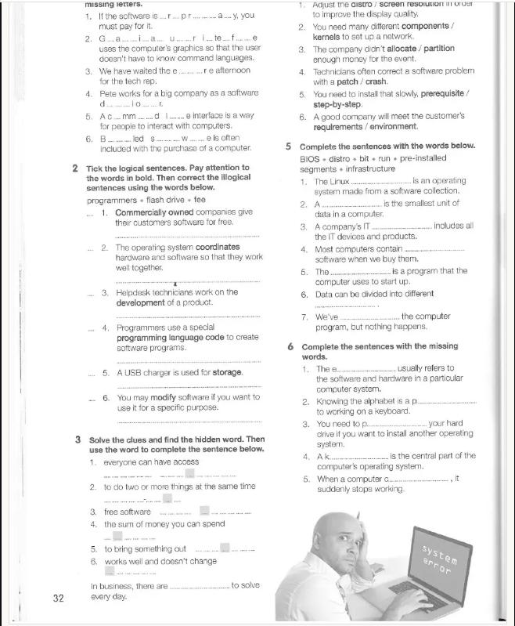

Ex 1.

1. propietary
2. Graphical user interface
3. Entire
4. Developer
5. Command line
6. Bundled software

Ex 2

1. Commercially owned companies offer software for a fee.
2. Correct
3. Developers work on the development of a product
4. Correct
5. A flash drive is used for storage
6. Correct

Ex 3

1. Freely available
2. Multitask
3. Open source
4. budget
5. Release
6. Stable
7. Issues

Ex4

1. Screen resolution
2. Components
3. Allocate
4. Patch
5. Step-by-step
6. Requirements

Ex 5

1. Distro
2. Bit
3. Infrastructure
4. Pre-installed
5. BIOS
6. Segments
7. Run

Ex 6

1. Environment
2. Prerequisite
3. Partition
4. Kernel
5. crashes

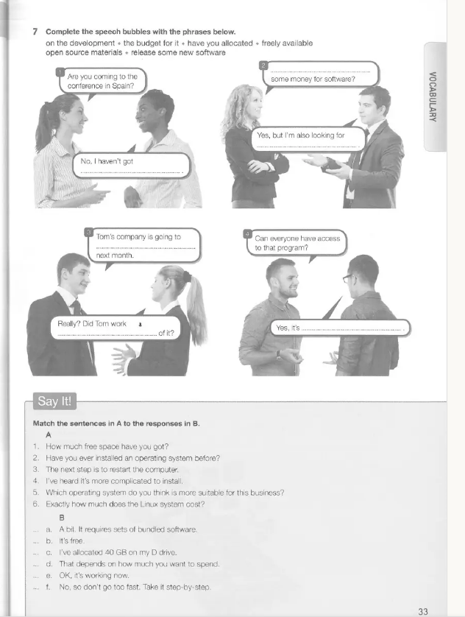

Ex 7

1. the budget for it
2. Have you allocated, Open source materials
3. Release new software, on the development
4. Freely available

Say it!

1. C
2. F
3. E
4. A
5. D
6. B

Page 74 & 75

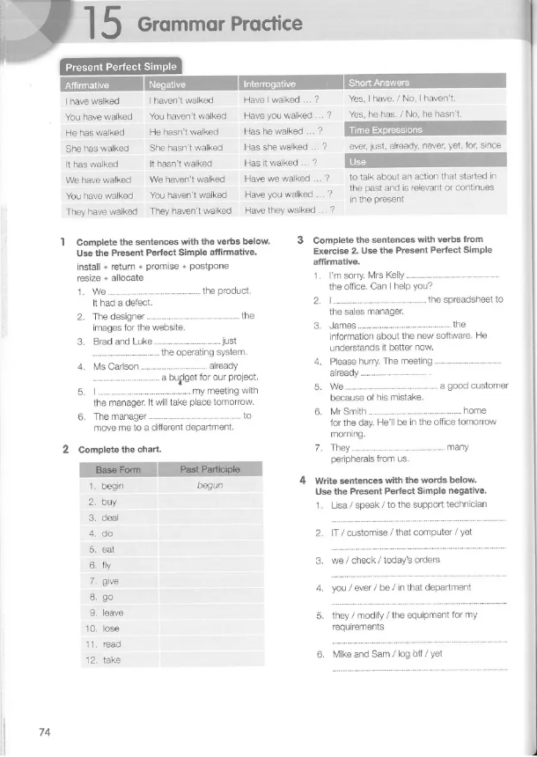

Ex 1

1. Have returned
2. Has resized
3. Have just installed
4. Has already allocated
5. Have postponed
6. Has promised

Ex 2

Bought, dealt, done, eaten, flew, given, gone, left, lost, read, taken

Ex 3

1. Has just left
2. Have given
3. Has read
4. Has already begun
5. Have lost
6. Has gone
7. Have bought

Ex 4

1. Lisa has spoken to the support technician
2. IT hasn’t customized that computer yet.
3. We have checked today’s orders
4. Have you ever been in that department?
5. They have modified the equipment for my requirements.
6. Mike and Sam haven’t logged off yet.

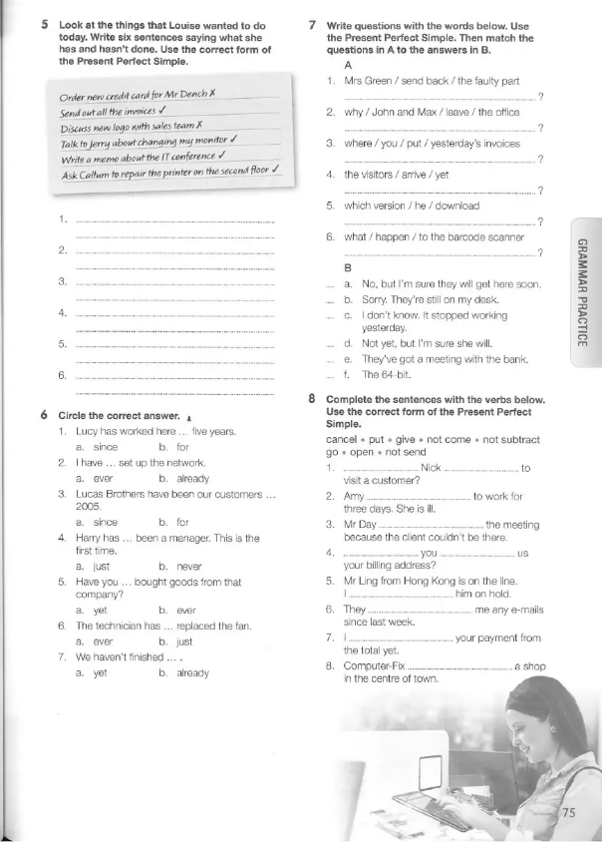

Ex 5

Lois hasn’t ordered a new credit card for Mr Dench.

She has sent out all the invoices.

She hasn’t discussed the new logo with the sales team.

She has talked to Jerry about changing her monitor.

She has written a memo about the IT conference.

She has asked Callum to repair the printer of the second floor.

Ex 6

1. For
2. Already
3. Since
4. Never
5. Ever
6. Just
7. Yet

Ex 7

1. Has Mrs Green sent back the faulty part? D
2. Why have John and Max left the office? E
3. Where have you put yesterday’s invoices? B
4. Haven’t the visitors arrived yet? A
5. What has happened to the barcode scanner? C

Ex 8

1. Has Nick gone
2. Hasn’t come
3. Has cancelled
4. Have you given
5. Have put
6. Haven’t sent
7. Haven’t substracted
8. Has opened