Early Literature Review
This literature review inspects existing academic research papers relevant to the study of using an artificial intelligence model (AI) and remote sensing technologies for detection of forestation changes. This study will focus on comparing the density of vegetation and land cover changes over time within Il-Miżieb and L-Aħrax tal-Mellieħa. Satellite Imagery and deep-learning-based classification will be used for this study.
In recent years, monitoring vegetation has become more reliant on AI models for the means of automation and accuracy. This review will emphasize on five academic sources that make use of AI, temporal models and remote sensing techniques to land use and vegetation change detection. All sources in this review will be critically analysed in terms of its aim, datasets implemented, algorithms applied, evaluation methods, limitations and relevance to the area of study.
Source 1 – Pelletier et al (2019)
Title – Temporal Convolutional Network for the classification of Satellite Image Time Series
Link - https://www.mdpi.com/2072-4292/11/5/523
Pelletier et al. (2019) aimed to develop a deep learning model capable of effectively implementing temporal satellite imagery to improve land coverage accuracy. This study introduced a Temporal Convolutional Neural Network (TempCNN), which applies 1D convolutional filters across time so that temporal patterns can be extracted from image sequences. The produced model was trained and tested using Sentinel-2 and Landsat satellite data across various regions and different land coverage types.
When comparing this to traditional classifiers such as Random forests and recurrent neural networks (RNNs), TempCNN achieved a substantial better accuracy, and it also took less time to train the model. Evaluation metrics, such as overall accuracy confirmed its advantage when it came to handling temporal variability. Pre-processed imagery and complete time series is where the effectiveness of the model is reliant on, making it less effective in the presence of clouds. This study recommended future research into combining temporal and spatial mechanisms to further improve model performance.
For this current study, this model offers a strong foundation for detecting vegetation changes over a period of time in il-Mizieb and L-Ahrax tal-Mellieha, mainly due to the fact that it emphasizes on learning temporal features from satellite imagery.

Source 2 – Zhang et al. (2022)
Title: Deep Learning-Based Change Detection in Remote Sensing Images: A Review
Link: https://www.mdpi.com/2072-4292/14/4/871
Zhang et al. (2022) conducted a broad review of deep learning approaches to alter multi-temporal remote sensing image detection. The main objective of this review was to evaluate the capabilities and limitations of supervised, semi-supervised and unsupervised deep leaning techniques that detect environmental and land cover changes. Multiple benchmark datasets including CDD (Public) and LEVIR-CD (Public) were among the multiple numerous datasets the paper covered, which include urban and vegetation-related transformation captured over time. Convolutional Neural Networks (CNNs), Siamese Networks and Generative Adversarial Networks (GANs) were among the wide range of models assessed during this study., each of which offered different advantages for change detection.
This review highlighted that supervised model performed significantly better than unsupervised models in terms of accuracy. F1-score and Intersection-over-Union (IoU) were taken into consideration when it came to the evaluation. One limitation was noted which was the difficulty in generalizing models across diverse geographical regions due to data variability and spectral differences. The authors also gave importance to obstacles such as lack of good-quality datasets, shadows and inconsistent atmospheric conditions. They recommended exploring self-supervised learning and hybrid frameworks that integrate spatial-temporal attention which would produce better generalisation.
This review is relevant to the research project since it provides a clear picture of the deep learning models and points out potential strategies for heightening model accuracy in multi-temporal forest monitoring

Source 3 – Gong et al. (2017)
Title – Change Detection in Synthetic Aperture Radar Images based on Deep Neural Networks
Link - https://ieeexplore.ieee.org/document/7870683
Gong et al. (2017) proposed a deep neural network-based change detection framework in synthetic aperture radar (SAR) imagery aimed at overcoming traditional pixel-wise and statistical methods. In this paper, an architecture of a Deep Belief Network (DBN) has been suggested that was trained layer-wise with unsupervised pertaining followed by supervised fine-tuning. for multispectral forestation monitoring. To confirm the performance of the model, two SAR datasets were used, which varied from urban to rural areas. The results obtained confirmed that the DBN based model worked significantly better than conventional change detection methods such as Change Vector Analysis (CVA) and Principle Component Analysis, especially regarding speckle noise handling and complicated terrain. Standard accuracy measures were used to carry out the evaluation however, this approach is very limited due to its exclusivity to SAR imagery, which differs in texture and spectral characteristics from optical imagery like that of Sentinel-2 or from the data of thee Planning Authority. A disadvantage of this study is how reliant the model is on handcrafted pre-processed steps. Despite this, this paper contributes a deep-learning-based methodology for environmental change detection.
For this project, this study is useful as a reference for noise-resistant deep learning architectures that might be adapted to multispectral forestation monitoring

Source 4 – Lyu et al. (2016)
Title - Learning a Transferable Change Rule from a Recurrent Neural Network for Land Cover Change Detection.
Link - https://www.mdpi.com/2072-4292/8/6/506
Lyu et al. (2016) worked towards developing a neural network model, which was taught using transferable change rules to detect land cover change in remote sensing. This study introduced a Long Short-Term Memory (LSTM) architecture, which was designed to acquire temporal dependencies in multi-temporal satellite data. This model was trained using time-series Landsat Imagery from two different geographical regions, which allowed the author to test this general model across different landscaped, which vary in geographical diversity. The approach taken in this paper (LSTM) gave a strong result, where it successfully managed to distinguish between changed and unchanged areas, outperforming traditional classifiers and showing its capacity to transfer learned change rules to new, different scenes.
For this study: accuracy, recall and F1-score metrics is what was taken into account when the evaluation was noted. Inconsistencies in temporal resolution and the presence of missing data is were the models performance struggled, which limited its’ robustness. The author recommended the combination of CNNs and RNNs to capture better spatial and temporal data.
For the current research project, this study is very useful as it provides a possible strategy for tracking vegetation and forestation over a period of time which aligns well with the objective for detecting forestation and vegetation changes in L-Ahrax and Il-Mizieb.

Source 5 – Hussain et al. (2013)
Title - Change Detection from Remotely Sensed Images: From Pixel-Based to Object-Based Approaches
Link - https://www.sciencedirect.com/science/article/pii/S0924271613000038
Hussain et al. (2013) presented a thorough review of change detection methodologies in remote sensing, were the focal point was on the evolution from the traditional pixel-based approached to more advanced object-based image analysis (OBIA). The target was to value how these methods perform in identifying land cover and environmental changed with respect to high-resolution remote sensing imagery.
The study mentions how OBIA which implements not only spectral but also spatial, textural, and contextual information, yielded better accuracy and a better representation of vegetation or urban blocks. Though this paper does not introduce any new experimental data, it is derived from a wide range of past case studies to represent the strengths and weaknesses of each approach taken. OBIA is dependent of one key factor which is accurate image segmentation, which can vary depending on the complexity of the landscape and dimensions of the imagery.
The authors suggested combining OBIA with machine learning, to promote generalizability and automation. This study is relevant due to it supporting the methodological framework of this project by suggesting the potential integration of object-based-segmentation and AI classification when utilising the Planning Authorities high resolution satellite imagery.

Overall, the sources examined in this document provides a general knowledge for developing an AI and satellite image-based forestation change detection model. From TempCNN's robust temporal learning to LSTM's transferable rule modelling, each method demonstrates the evolving role of deep learning in remote sensing. The inclusion of object-based classification and temporal features also improves spatial precision and contextual perception, which is necessary in detecting subtle changes in vegetation in Maltese woodland habitats like Il-Miżieb and L-Aħrax tal-Mellieħa. While some studies utilize proprietary or non-accessible datasets, others utilize publicly accessible sources, providing a good basis for further studies. Collectively, the subsequent papers form the technical foundation and the research focus of this research, warranting multi-temporal AI classification in monitoring long-term environmental trends.

Literature Map:
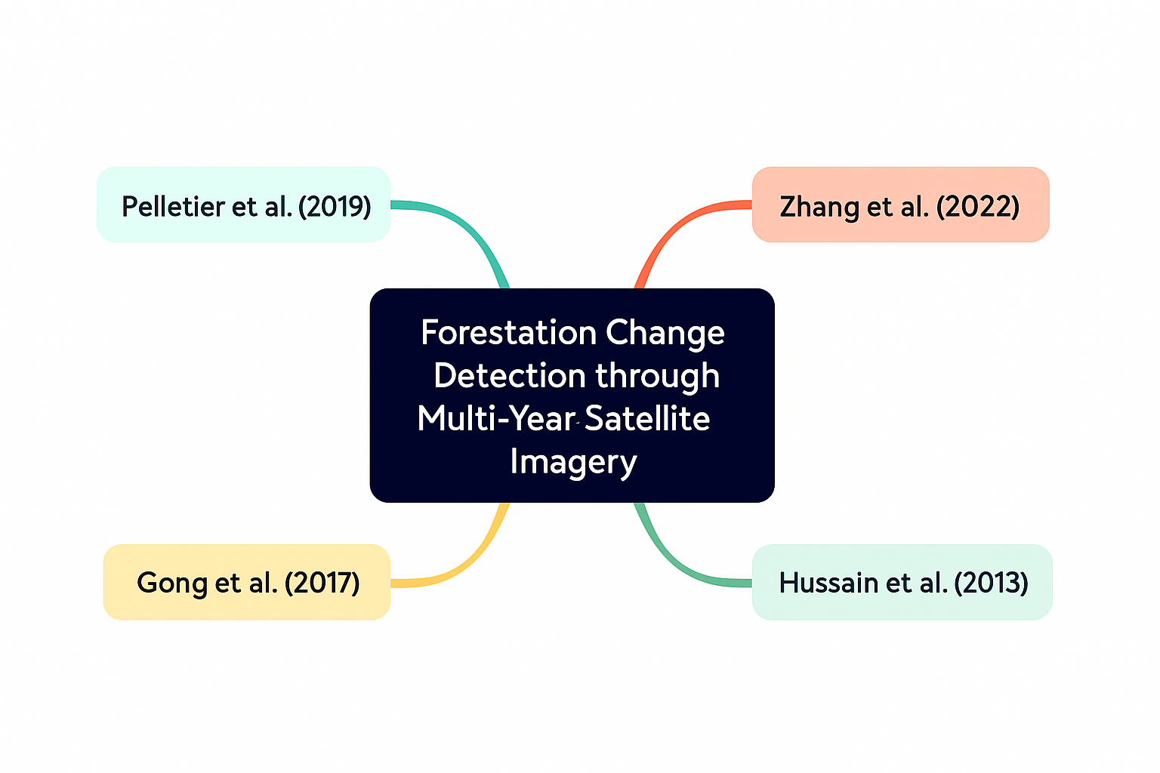

Comparison Table:
Literature Review Comparison Table
Source | Research Aim | Dataset Used | Algorithm/Model | Evaluation Metrics | Limitations | Recommendations
Pelletier et al. (2019) | Improve land cover classification using TempCNN | Sentinel-2 and Landsat time-series | TempCNN (1D CNN) | Accuracy, Kappa | Needs complete time-series | Add spatial-temporal fusion
Zhang et al. (2022) | Review DL methods for change detection | Multiple public RS datasets | CNNs, Siamese, GANs | F1, IoU, Precision | Limited labeled data, generalization | Use self-supervised/hybrid models
Gong et al. (2017) | Improve SAR CD with DNNs | Two SAR image pairs | DBN | Accuracy, Kappa | SAR-only, handcrafted preprocessing | Test on multi-modal datasets
Lyu et al. (2016) | Learn transferable change rule with LSTM | Landsat time-series | LSTM | Accuracy, Recall, F1 | Sensitive to missing data | Hybrid CNN-LSTM for spatial-temporal learning
Hussain et al. (2013) | Compare pixel- vs object-based CD | Various case studies | OBIA | Qualitative | Segmentation sensitivity | Combine OBIA with ML/ensembles

