Steven Zuelke

CSCD 212

Team: Refactor

1. Created Factories for Hero and Monster (Steven Zuelke)

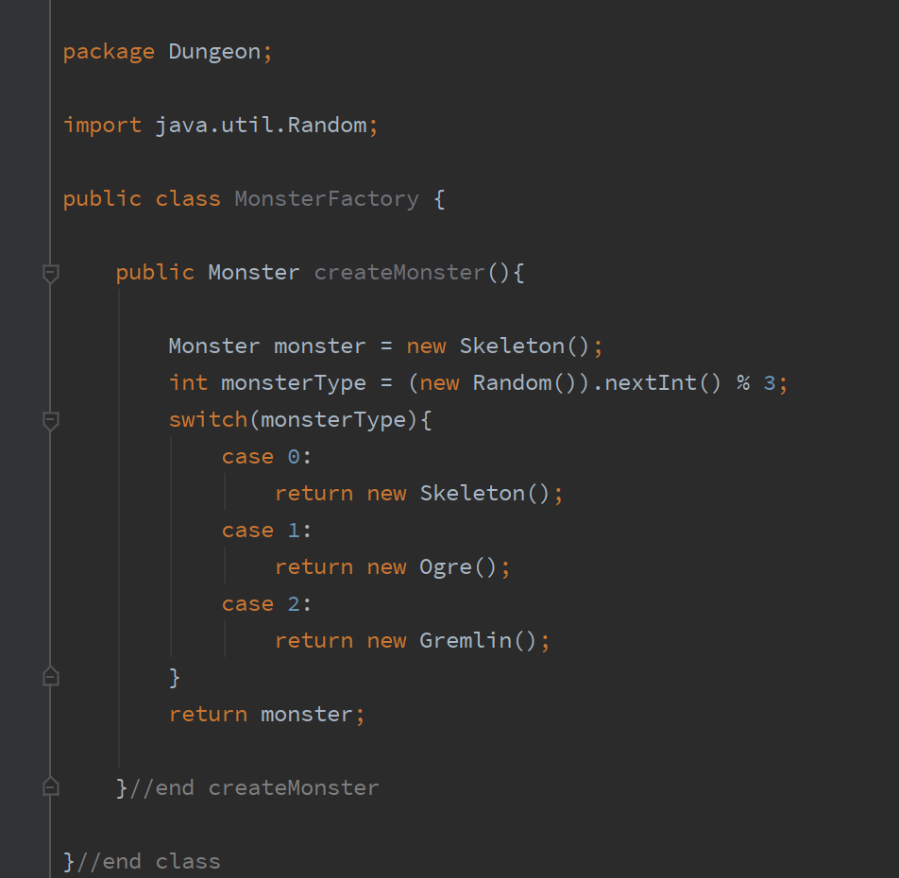

1. Added flyweight pattern for attacks, created attack classes and flyweight factory

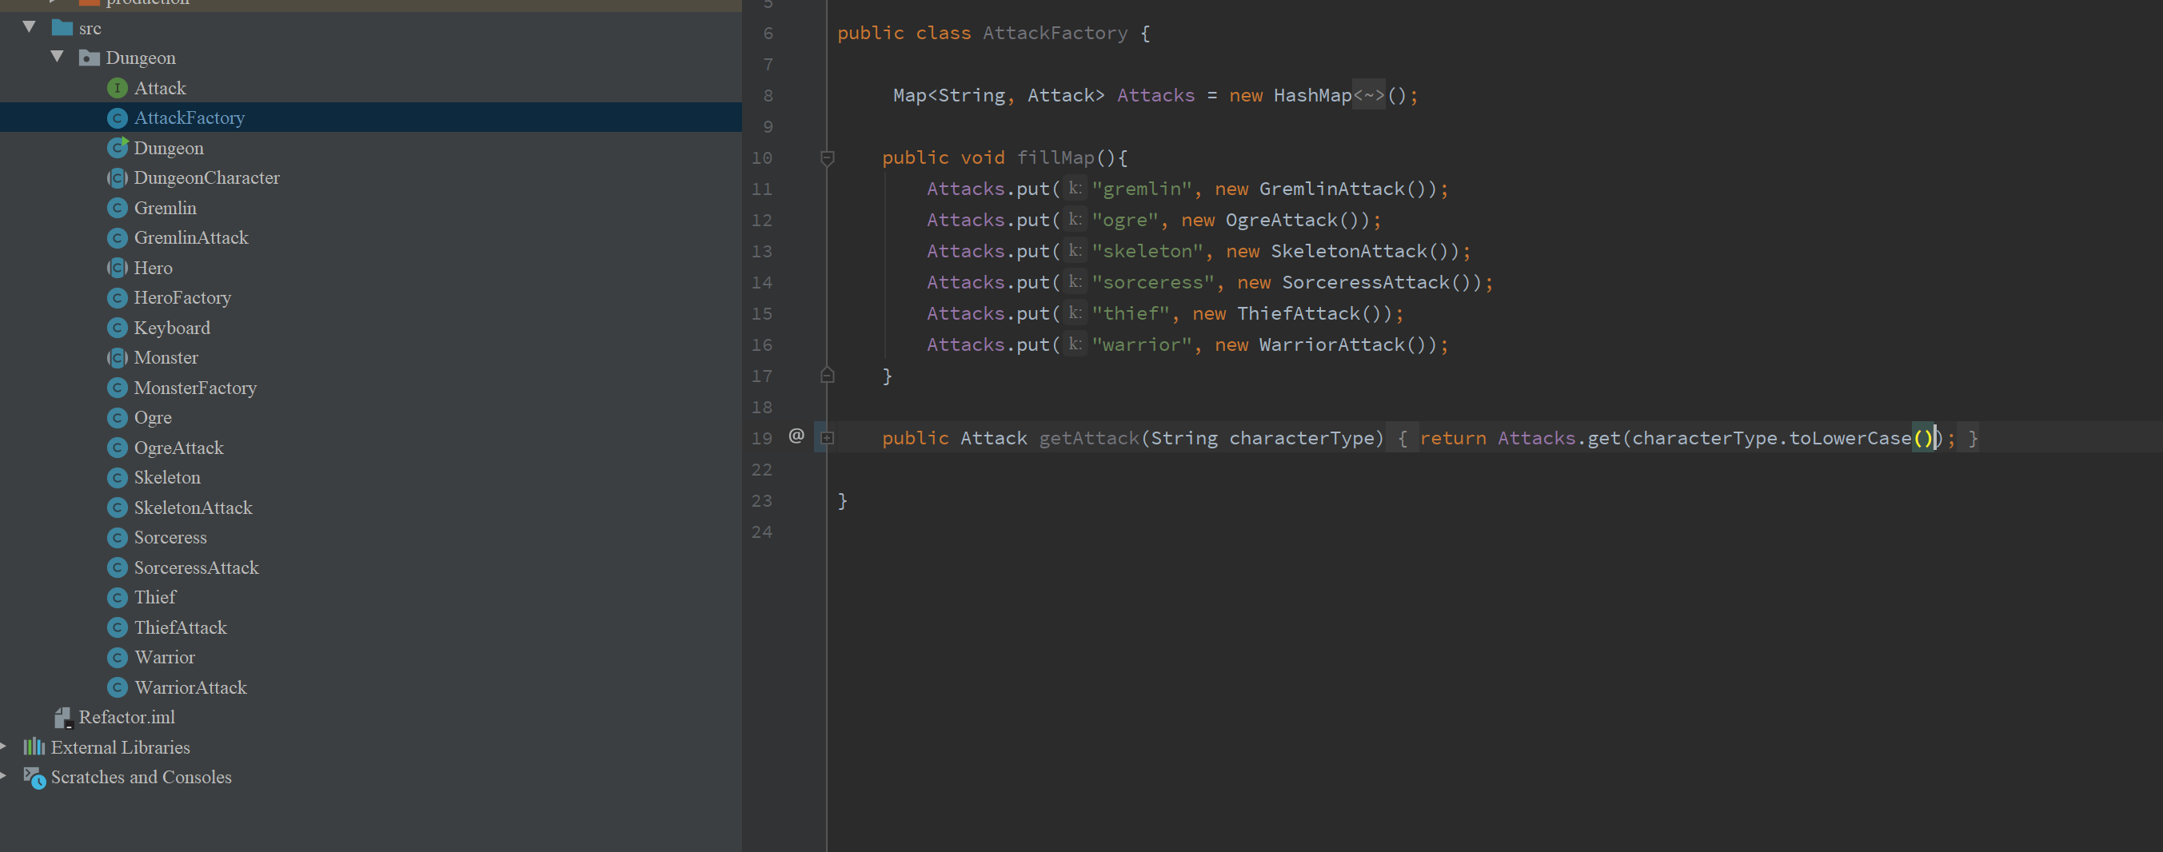

3.