**Analysis** ends 25th September 2018

**Background to the problem**

For my A-level Project, I am developing a popular card game called ‘Rummy’. This game involved the standard set of 52 cards, where two players hold seven cards each to try to use these cards to make the most amount of points through different scoring rules of the game. There are four ways of scoring in the game, this involves:

Four cards Run (where the player needs to have four cards which are in the same suit and which are consecutive with each other). Three-card run (This is the same as the four card run but there is three cards consecutively instead of four cards).

Four of a kind (where the player has four cards, which have the same number on their face but different suits). Three of a kind (which instead of four cards for the same suit, they have three of the same suit).

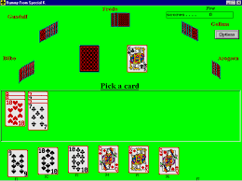In the typical game of Rummy, it is between two and six players, the scores work as the picture cards are worth ten points each. In the current system, each player has ten cards each, the player 1 then picks up a card from the face down deck, the player then can either swap the card for a card in the players hand or place the card in the second deck (which is face up). Then player 2 plays their turn taking the card from the secondary stack and swapping it with one of their cards or pick up another unknown card from the face down deck. This continues until one-player calls at which point the opposing player plays their last turn and the game is over. The player with the most amount of points wins the game. This program ‘looks’ for the potential combinations, which the player 2 has been given at the start, and to see if the player can spend the least amount of moves to win against the other players. The Program does not learn from experience but only tries to find the fastest way to call and to win against the other players with the cards, which it has at the start of the game. This could serve as a problem as the program (player 2) does not seek for high profile cards but instead seeks for the fastest way to win at rummy. The current solution to playing rummy is to look at all the possible ways in which the program or player 2 can get the most amount of points through the starting cards. My initial ideas for the card game also featured this way of playing, however this has a drawback if the starting cards will give a low number of points as a yield. How the current game of rummy is played could be improved to maximize the chances of the player 2 winning or losing (depending if the user could change the difficulty of the opposing player). However, for now the user only has the option of playing a program which can do these things but there will seem to have not strategy in how they play (other than fastest to get points).

Research (Interviews/Observations/Surveys/Emails)

I have currently sent 4 emails explaining the program to 4 companies who specialise in areas in and around the topic of Rummy the card game. They will get back to me with more details about what they would like to see. So, I will be able to react in how they as clients and their users may like the program and how I could improve upon this to make it even better by either making the designs more ‘flashy’ or by making the programs interface more user friendly. These companies are:

1) Rummy Circle.com

2) Ace2Three.com

3) VerveLogic.com

4) Pokerstars.com

Awaiting their responses…

I have talked to many people around my school and sixth form and many people have agreed that the preliminary designs for the control panel on the right side is the easiest way of using buttons to control and play the game of rummy. The control panel is easy to read and to understand by all the interviews in which I have conducted (look at the questions below). In my spare time I like to play rummy with many people at school as well as online, the designs which I have made are what I as a player would like to use this makes it more compact and more user friendly as it appears to my tastes as well as the designs and contributes to the more immersive effect of the card game, this is compared to online Rummy games as shown above for the design inspiration. This is shown by their conclusions shown later in in this documentation.

Identification of Client, Users and Audience

This Program is designed for meeting the needs of three different people:

Clients – In this situation the card game’s clients are the company who would buy/use this program to satisfy the needs of their customers. This would be a company which would have an interest in the online gaming industry for card games, alongside some world-famous popular games such as Poker and Blackjack.

Users – The users are the people who have hired the game out to gain a financial benefit. They may be the Client in this situation, but they may be researchers who user the results to research the risk verses reward situation which the audience may find them selves in.

Audience – Is the types of people who would use this program for entertainment purposes, they can be people who just want to play for the fun (similarly to the types of people who would play other card games on a machine for fun such as poker as a form for calming down and relaxing). Or they could be the professional players who play for winning and as a financial gain.

The reasons for the change are that the Current programs which the card games rummy are currently running of are outdated and there are new developments in the field of Machine learning to increase the potential of the program to learn and perfect the design of the perfect Computer system playing Rummy. The new system uses multiple Artificial Neural Networks which are the starting point for Artificial Intelligence, this would show and add another example to the forever increasing list that Neural Networks may be the answer to Machine Learning, so this could also show what ANN’s are capable of and that if more research went into exploring neural networks our knowledge of this subject would increase. Thus, understanding it more.

Requirements of what the end program should do

The end program should have three pages: One the menu; the how to play section including the changes in the scoring system, and the controls of how to play; The page which has the game of rummy, which will play a game with the user and NN’s (opposing player) taking turns in playing a game of rummy.

The ‘Rummy’ page should have the controls in an easily understandable format where the form is user friendly, with an immersive effect with the background and the gameplay of the cards. The game will play a game of rummy with the participant taking turns against the player 2. The rummy game has different controls simulating the options which the player can make. The first option which the player can make is either taking a card from the deck or from the stack. This will allow the player to have a card which isn’t in their hand, but they must choose one of the now 8 cards to put on the up turned stack. This brings us to the next set of buttons and decision making, the combo box and the put card on stack (Up turned deck). This next set allows the user to pick a card which they don’t want to keep in their hand and it will if it was one of the cards in your hand the limbo card will take its place, but if it was the limbo card then it will go onto the stack (up turned deck). The last decision-making button/ section is the call button which allows the player to call to end the game, the points are counted and the player with the most amount of points will be the winner. This will be calculated with the modified rules which are above.

**Analysis of the problem**

Constraints and limitations

The limitations of the program are that I don’t have enough time to complete the game of rummy and giving the option to change the difficulty of the opposition for the user. I have a limitation as the card animations aren’t fluid and just move from one area to another, this is partially since the program has a timed deadline and I will not have enough time to do this. The other reason is that I don’t have the resources and the time to learn how to use Unity effectively and with good skill (it also doesn’t run on the school desktop computers. Which is where I do much if my programming).

Scope of the problem

In the program I will be putting a twist on rummy by changing some of the scoring rules this is because I believe that this balances out the overall game out, these will be:

The points given to the player who has one or multiple of the card groups scoring shown above. The number on the cards awards the points, if the cards are picture cards then they will increase by one point each, so a Jack will be 11 points, Queen will be 12 points etc. The Ace is different if it is part of a run (Ace, Two, Three, for example) then the Ace will only award one point, where as if it is in a three or four of a kind then it will be worth 10 points each.

The program will be fully operational as a one player game of rummy where the opposing player is a neural network, which has learned to play the game of rummy with it can devise a strategy for gaining the most amount of points possible with the least number of moves made. Showing the technique which, it wasn’t programmed specifically for but to find the most effective way between the number of points gained and the number of moves made.

I will create multiple Neural Networks which will through the process of Machine learning can be able to create a strategy from the start of the game, to maximize points and reduce the number of moves which the opposition will be able to gather enough points to beat the user/ audience. This is because it will show the that the use of Neural Networks can be increased and researched even more to increase our knowledge. This will show new techniques in how the Neural Network functions and learns from previous games and this could show a great level of intuition and decision-making.

Model the system

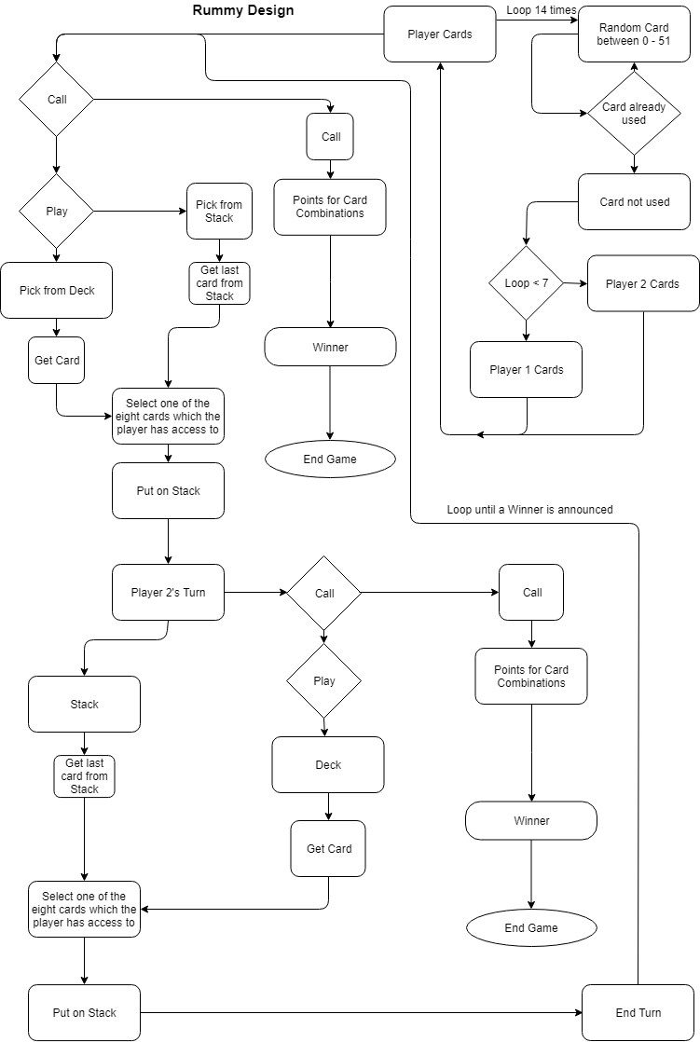

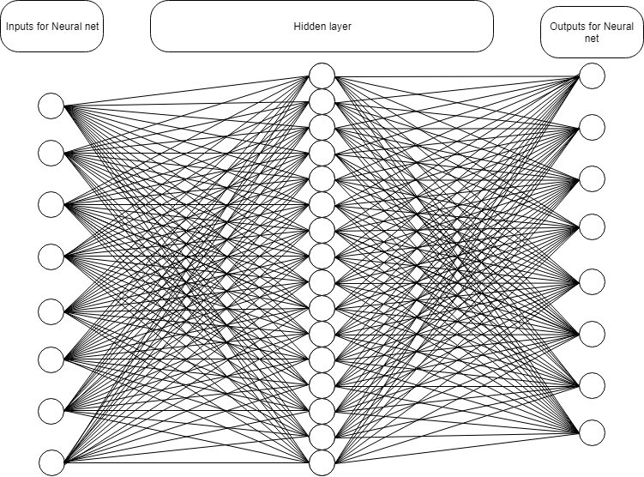

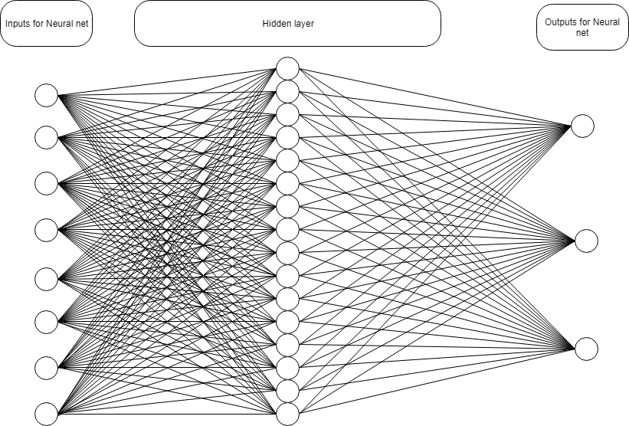

Interviews with sixth form students

Design of the Rummy game interface.

Date of Interview: 19/09/18

Question 1) this program design are you able to understand and play this game with relative ease.

This programs interface is minimalistic which is a good design of I, it allows you as the user to understand the objectives of the game, (if you don’t understand the rules and scoring then you can read the page just off the main menu.) the game is simple but effective in its design. The game shows the essence of how Rummy should be made on a computer, compared to other Rummy games which I have found on the internet. I am really hoping to play this game when you have completed coding this game. I think it is a cool program to make and can function as a solution to playing it as a single player game (if you are alone, it can also serve as an alternate method to help people understand this variation of rummy instead of reading the rules).

Question 2) Compared to other online computer played rummy games what makes the designs of my interface stand out and what if any improvements can be made.

I’m my experience of playing rummy online I would like to say that this interface is one of the least confusing interfaces currently in circulation, this has dramatically changed my perspective on online rummy as they have too many things going on in the background and too many options which aren’t necessary to the game which I am currently playing. This is why this interface stands out because it designed to be simplistic but in the sense that the player/user would know what button they should press and what it will do, it demonstrates that if a computer game’s interface is mare simplistic it looks overall less crammed of unnecessary items and thus more professional.

Source for picture:

https://qpdownload.com/indian-rummy-card-game-from-special-k/