

CSE 323 Programming with Data Structures

Project Report By:

Richard Edmon Abdelshahid 33749  
Nariman NagUI Kamel 33848  
Samuel Antoun Wilson 33764

third year.

Ain Shams University,

Faculty of Engineering,

Computer and Systems Department

Contents

Problem Statement 1

Use Cases 2

Use-Case Diagram 4

Technical Details 5

# Problem Statement

The increase in everyday banking needs calls for crafting a versatile methodology to handle that increase. Online banking has increased vastly in recent years, and banks intercontinental branches have to develop a fast and secure system to handle all clients requests across the globe.

Having time as a critical manner nowadays; storing clients’ information, processing their transactions and keeping up with their needs must be done efficiently using computerized systems. Thus calling for designing software with maximum efficiency.

# Use Cases

|  |  |
| --- | --- |
| Title | Create a bank account |
| Actor | Client |
| Scenario | If a client is logged in, a request to create a new bank account can be initiated by the client. The clerk then validates the data and if they are no errors, the clerk shall create the account. Upon any errors, the clerk shall not create the account and shall instead inform the client about the error(s) and ways to fix them. |
| Title | **Delete a bank account** |
| Actor | Client |
| Scenario | If a client is logged in, a request to close a new bank account can be initiated by the client. The clerk then validates the data and if they are no errors, the clerk shall delete the account. Upon any errors, the clerk shall not delete the account and shall instead inform the client about the error(s) and ways to fix them. |
| Title | **Login/Logout** |
| Actor | Client |
| Scenario | The client can log in by entering his username and password. Both the username and password are generated by the bank. If the information provided by the client is correct, he/she can then initiate requests that shall be handled by clerks/cashiers depending on the type of requests.  The client can then later logout. Any pending operations linked to that client will still be carried out. The client cannot initiate any request while logged out. |
| Title | **Withdraw money from account** |
| Actor | Client |
| Scenario | If a client is logged in, a request to withdraw money from a bank account can be initiated. The cashier then validates the data and if they are no errors, the clerk shall withdraw money from the corresponding account. Upon any errors, the cashier shall do nothing to the current account and shall instead inform the client about the error(s) and ways to fix them. |
| Title | **Deposit money to account** |
| Actor | Client |
| Scenario | If a client is logged in, a request to deposit money to a bank account can be initiated by the client. The cashier then validates the data and if they are no errors, the cashier shall deposit money to the account. Upon any errors, the cashier shall do nothing to the current account and shall instead inform the client about the error(s) and ways to fix them. |
| Title | **Check balance of account** |
| Actor | Client |
| Scenario | If a client is logged in, a request to check the balance of bank account can be initiated by the client. The cashier then validates the data and if they are no errors, the cashier shall check the balance of that account and report the information back to the corresponding client. Upon any errors, the cashier shall do nothing to the current account and shall instead inform the client about the error(s) and ways to fix them. |
| Title | **Make a transaction** |
| Actor | Client |
| Scenario | If a client is logged in, a request to make a transaction between two accounts can be initiated. The cashier then validates the data and if they are no errors, the cashier shall complete the transactions and notify both account holders by that transaction. Upon any errors, the cashier shall refuse the transaction and shall instead inform the client about the error(s) and ways to fix them. |

# Use-Case Diagram

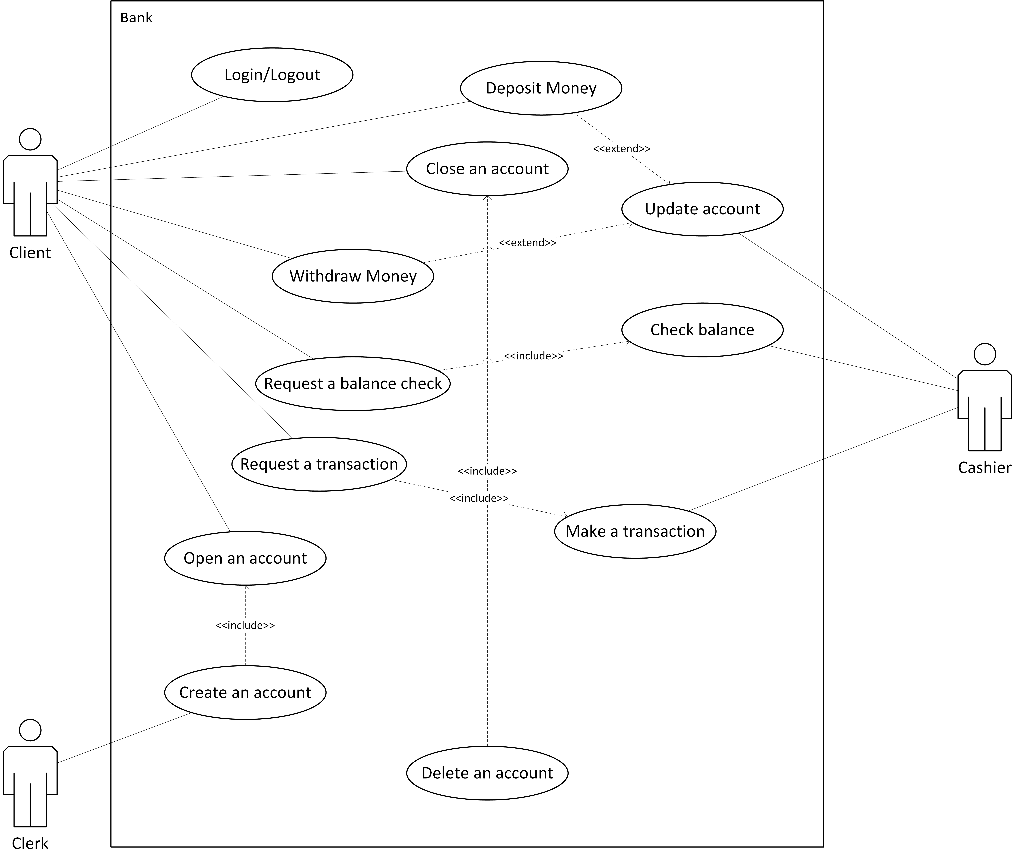

# Technical Details

## Data Structures Used

* Queue: Clients are served according to FCFS method.
* Linked List: Clients can have multiple bank accounts, storing them in a linked list increases the versatility of removing account data from index. Moreover, with multiple clients logged in the same time, using arrays/dynamic arrays requires the memory locations to be sequential which can be hard to achieve.

Decisions are made during the execution phase, thus the above decisions can be

altered later

## Algorithims Used

* At the current time, no definite algorithm is in mind to be used as data processing is done in FCFS manner which doesn’t require any special algorithms to be used/applied.