CREATE TABLE Customer (

custno VARCHAR(8),

custname VARCHAR(50) NOT NULL,

address VARCHAR(50) NOT NULL,

Internal CHAR(1) DEFAULT ‘Y’,

contact VARCHAR(35) NOT NULL,

phone VARCHAR(11) NOT NULL,

city VARCHAR(30) NOT NULL,

state CHAR(2) NOT NULL,

zip CHAR(10)DEFAULT ‘80202’,

CONSTRAINT custnoPK PRIMARY KEY(custno)

);

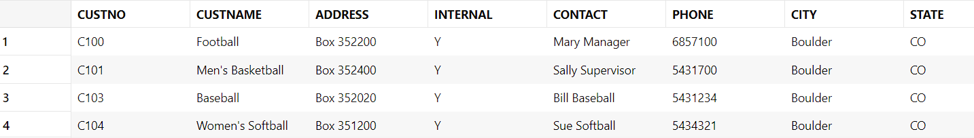

CREATE TABLE Facility

(

FacNo VARCHAR(8),

FacName VARCHAR(30) CONSTRAINT FacNameNotNull NOT NULL,

CONSTRAINT PK_FACILITY PRIMARY KEY (FacNo),

CONSTRAINT Unique_FacName UNIQUE(FacName)

);

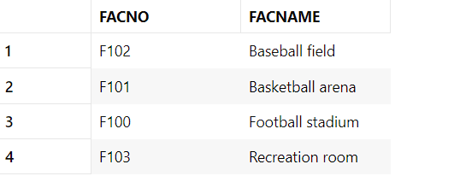

CREATE TABLE Location

(

LocNo VARCHAR(8),

FacNo VARCHAR(8) CONSTRAINT FacNoFKNotNull NOT NULL,

LocName VARCHAR(30) CONSTRAINT LocNameNotNull NOT NULL,

CONSTRAINT PK_LOCATION PRIMARY KEY (LocNo),

CONSTRAINT FK_FACNO FOREIGN KEY (FacNo)

REFERENCES FACILITY (FacNo)

);

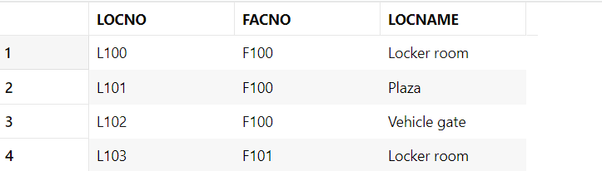

CREATE TABLE EventRequest (

EventNo VARCHAR(8),

Dateheld DATE NOT NULL,

DateReq DATE DEFAULT CURRENT_DATE,

CustNo VARCHAR(8) NOT NULL,

FacNo VARCHAR(8) NOT NULL,

DateAuth DATE,

Status VARCHAR(8) DEFAULT 'PENDING',

EstCost DECIMAL(7,2) NOT NULL,

EstAudience INTEGER NOT NULL CHECK(EstAudience > 0),

Budno VARCHAR(8),

CONSTRAINT valid_status CHECK(Status IN ('Pending', 'Approved', 'Denied')),

CONSTRAINT PK_eventno PRIMARY KEY (EventNo),

CONSTRAINT FK_custno FOREIGN KEY (CustNo) REFERENCES Customer (CustNo),

CONSTRAINT FKfacno FOREIGN KEY (FacNo) REFERENCES Facility (FacNo)

);

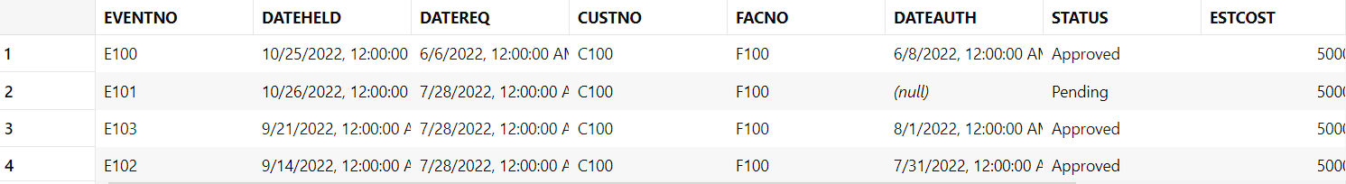

CREATE TABLE Employee (

EmpNo VARCHAR(8),

EmpName VARCHAR(50) NOT NULL,

Department VARCHAR(25) NOT NULL,

Email VARCHAR(30) UNIQUE NOT NULL,

Phone VARCHAR(11) NOT NULL,

MgrNo VARCHAR(8),

CONSTRAINT PK_EmpNo PRIMARY KEY (EmpNo),

CONSTRAINT fk_mgr FOREIGN KEY (MgrNo) REFERENCES Employee (EmpNo)

);

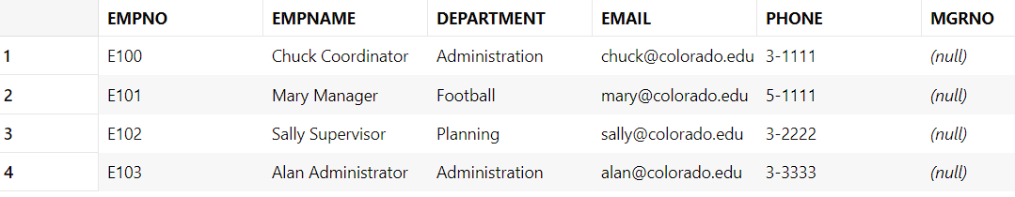

CREATE TABLE ResourceTbl (

ResNo VARCHAR(8),

ResName VARCHAR(30) NOT NULL UNIQUE,

Rate DECIMAL(7,2) DEFAULT 1,

CONSTRAINT PK_RestNo PRIMARY KEY (ResNo));

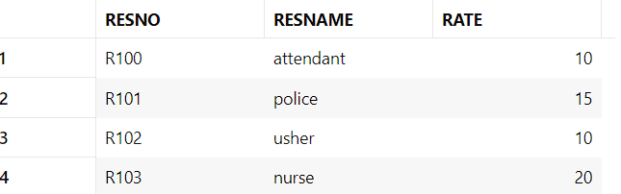

CREATE TABLE EventPlanLine (

PlanNo VARCHAR(8),

LineNo INTEGER,

TimeStart TIMESTAMP NOT NULL,

TimeEnd TIMESTAMP NOT NULL,

ResourceCnt INTEGER NOT NULL,

LocNo VARCHAR(8) NOT NULL,

ResNo VARCHAR(8) NOT NULL,

CONSTRAINT PK_epl PRIMARY KEY (PlanNo, LineNo),

CONSTRAINT fk_planno_epl FOREIGN KEY (PlanNo) REFERENCES EventPlan (PlanNo) ON DELETE CASCADE,

CONSTRAINT fk_locno_epl FOREIGN KEY (LocNo) REFERENCES Location (LocNo),

CONSTRAINT fk_resno_epl FOREIGN KEY (ResNo) REFERENCES Resourcetbl (ResNo)

);

