1 SELECT DISTINCT City, State, Zip FROM Customer;

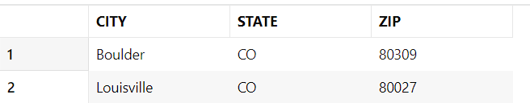

2 SELECT EmpName, Department, Phone, Email FROM EMPLOYEE WHERE Phone LIKE '3-%';

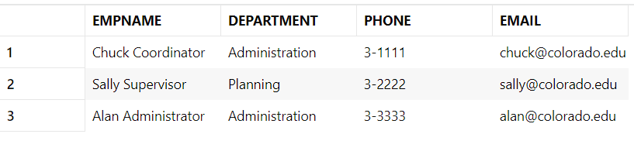

3 SELECT \* FROM RESOURCETBL WHERE RATE BETWEEN 10 AND 20 ORDER BY Rate;

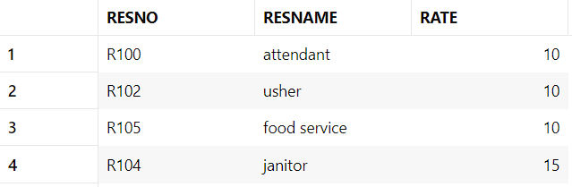

4 SELECT EventNo, Status, DateAuth FROM EVENTREQUEST WHERE DATEAUTH BETWEEN '01-Jul-2022' AND '31-Jul-2022';

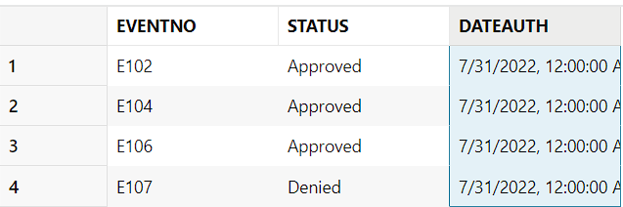

5 SELECT LocNo, LocName FROM LOCATION

JOIN Facility ON Facility.FacNo = Location.FacNo

WHERE FacName LIKE 'Basketball%';

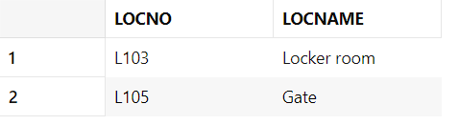

6 SELECT EventPlan.PlanNo, COUNT(EVENTPLANLINE.PlanNo) AS "Plan Lines", SUM(ResourceCnt) AS "Resources" FROM EVENTPLAN

JOIN EVENTPLANLINE ON EVENTPLANLINE.PlanNo = EventPlan.PlanNo

GROUP BY EVENTPLAN.PlanNo;

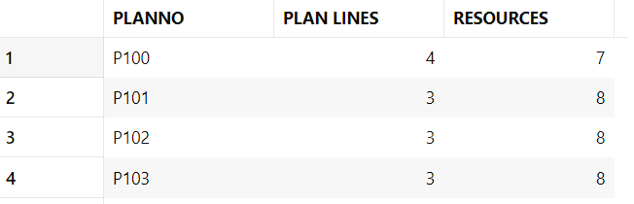

7 SELECT EventPlan.PlanNo, COUNT(EVENTPLANLINE.PlanNo) AS "Plan Lines", SUM(ResourceCnt) AS "Resources" FROM EVENTPLAN

JOIN EVENTPLANLINE ON EVENTPLANLINE.PlanNo = EventPlan.PlanNo

WHERE Timestart BETWEEN '01-Oct-2022' AND '31-Oct-2022'

GROUP BY EVENTPLAN.PlanNo Having "Resources" >= 10;

