1 SELECT EventPlan.EventNo, EventRequest.DateHeld, COUNT(EventPlan.PlanNo) AS "Event Plans" FROM EVENTREQUEST

JOIN EventPlan ON EventPlan.EVENTNO = EVENTREQUEST.EVENTNO

WHERE WorkDate BETWEEN '01-Dec-2022' AND '31-Dec-2022'

GROUP BY EventPlan.EventNo, EventRequest.DateHeld Having "Event Plans" > 1;

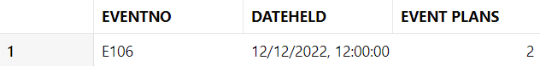

2 SELECT PlanNo, EventPlan.EventNo, WorkDate, Activity FROM EVENTPLAN

JOIN EventRequest ON EventRequest.EVENTNO = EVENTPLAN.EVENTNO

JOIN FACILITY ON FACILITY.FACNO = EventRequest.FACNO

WHERE (WorkDate BETWEEN '01-Dec-2022' AND '31-Dec-2022') AND FacName LIKE 'Basketball%';

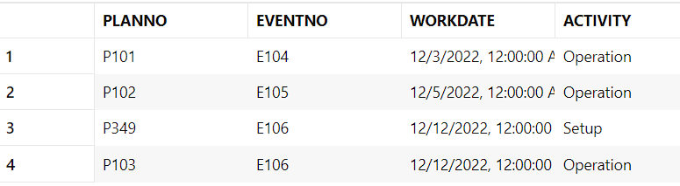

3 SELECT EventRequest.EventNo, DateHeld, Status, EstCost FROM EVENTREQUEST

JOIN EventPlan ON EventPlan.EVENTNO = EVENTREQUEST.EVENTNO

JOIN Employee ON Employee.EmpNo = EventPlan.EMPNO

JOIN FACILITY ON FACILITY.FACNO = EventRequest.FacNo

WHERE (Facility.FacName LIKE 'Basketball%') AND (Employee.EMPNAME = 'Mary Manager') AND (DateHeld BETWEEN '01-Oct-2022' AND '31-Dec-2022');



4 SELECT EventPlanLine.PlanNo, LineNo, ResName, ResourceCnt, LocName, TimeStart, TimeEnd FROM EVENTPLANLINE

JOIN EventPlan ON EventPlan.PlanNo = EventPlanLine.PlanNo

JOIN RESOURCETBL ON RESOURCETBL.RESNO = EventPlanLine.ResNo

JOIN Location ON Location.LOCNO = EVENTPLANLINE.LOCNO

WHERE Activity = 'Operation' AND (WorkDate BETWEEN '01-Oct-2022' AND '31-Dec-2022') AND (Location.FacNo = (SELECT FacNo FROM FACILITY WHERE FacName LIKE 'Basketball%'));

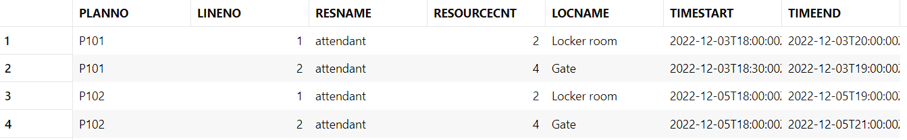

5 SELECT EventNo, SUM(ResourceCnt * Rate) AS "Resource Cost" FROM EVENTPLAN

JOIN EVENTPLANLINE ON EVENTPLANLINE.PLANNO = EVENTPLAN.PLANNO

JOIN RESOURCETBL ON RESOURCETBL.RESNO = EventPlanLine.ResNo

WHERE WorkDate BETWEEN '01-Dec-2022' AND '31-Dec-2022'

GROUP BY EventNo HAVING "Resource Cost" > 50;

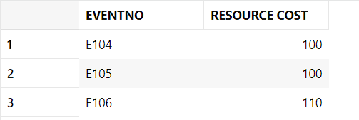

**Modification statements**

1 INSERT INTO FACILITY (FacNo, FacName)

VALUES('F104', 'Swimming Pool');

2 INSERT INTO Location (LocNo, FacNo, LocName)

VALUES('L107', (SELECT FacNo FROM FACILITY WHERE Facname = 'Swimming Pool'), 'Door');

3 INSERT INTO Location (LocNo, FacNo, LocName)

VALUES('L108', (SELECT FacNo FROM FACILITY WHERE Facname = 'Swimming Pool'), 'Locker Room');

4 UPDATE LOCATION SET LocName = 'Gate' WHERE Locname = 'Door';

5 DELETE FROM LOCATION WHERE FacNo = (SELECT Facno FROM FACILITY WHERE FacName = 'Swimming Pool');

**Poor SQL formatting**

1 SELECT eventrequest.eventno, dateheld, status, estcost

FROM eventrequest, employee, facility, eventplan

WHERE estaudience > 5000

AND eventplan.empno = employee.empno

AND eventrequest.facno = facility.facno

AND eventrequest.EVENTNO = eventplan.EVENTNO

AND facname = 'Football stadium'

AND empname = 'Mary Manager';

2 SELECT DISTINCT eventrequest.eventno, dateheld, status, estcost

FROM eventrequest

WHERE estaudience > 4000;

3 SELECT DISTINCT eventrequest.eventno, dateheld, status, estcost

FROM eventrequest, facility

WHERE estaudience > 5000

AND eventrequest.facno = facility.facno

AND facname = 'Football stadium';

4 SELECT DISTINCT EventRequest.eventno, dateheld, status, estcost

FROM eventrequest, employee, eventplan

WHERE estaudience BETWEEN 5000 AND 10000

AND eventplan.empno = employee.empno

AND eventrequest.eventno = eventplan.eventno

AND empname = 'Mary Manager';

5 SELECT eventplan.planno, lineno, resname, timestart, timeend

FROM eventrequest, facility, eventplan, eventplanline, resourcetbl

WHERE estaudience = 10000

AND eventplan.planno = eventplanline.planno

AND eventrequest.facno = facility.facno

AND facname = 'Basketball arena'

AND eventplanline.resno = resourcetbl.resno

AND eventrequest.eventno = eventplan.eventno;