1

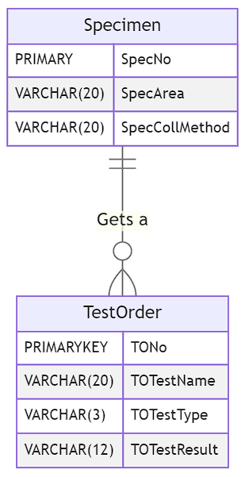

2

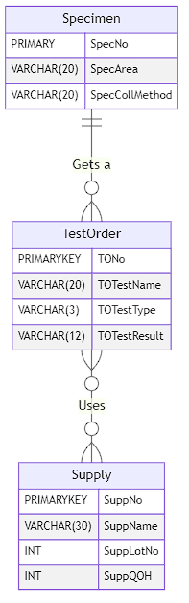

3

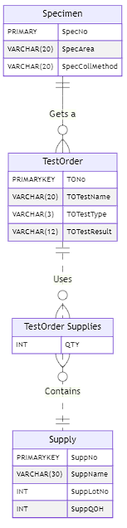

4

Identification consistency rule