Objectives

* Electronic medical records
* Inventory control
* Patient Registration
* Billing & Revenue Cycle Management
* Doctor Schedule & Appointments
* In-patient Management System
* Lab Information System
* Radiology & Imaging Information System, PACS Support
* Hospital Support Function System
* Pharmacy with Inventory
* Billing System
* Medical Equipment Maintenance

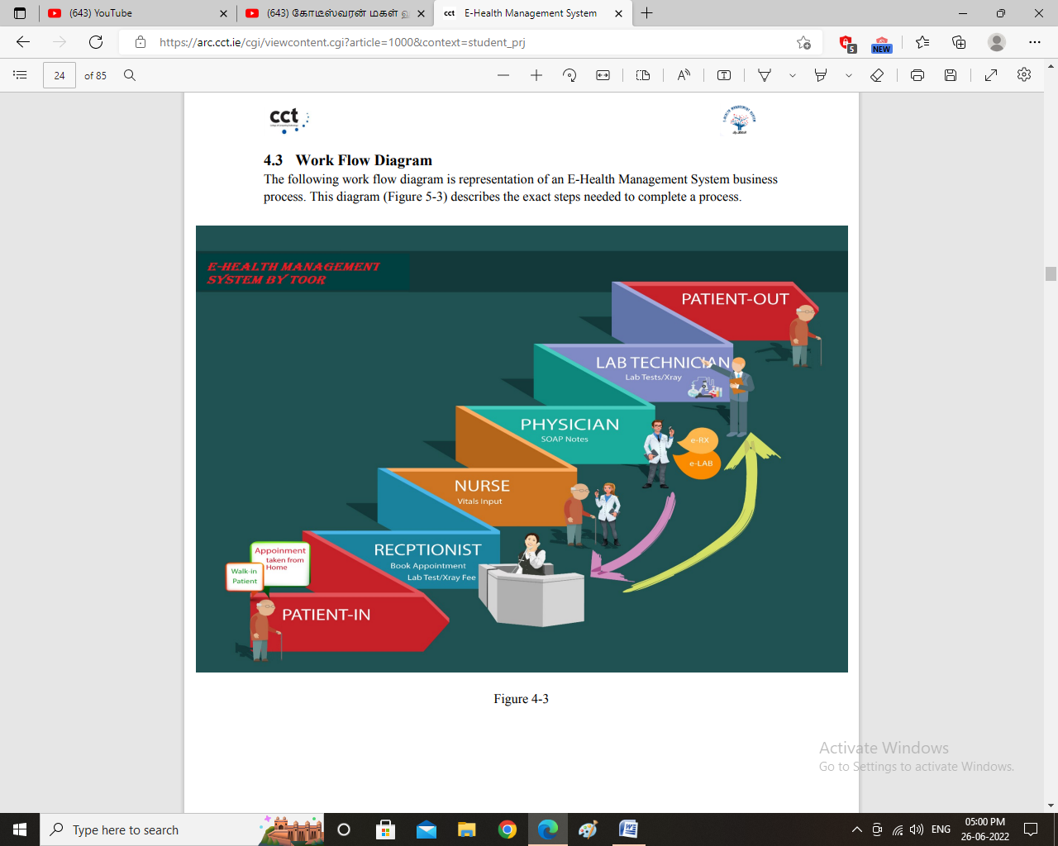

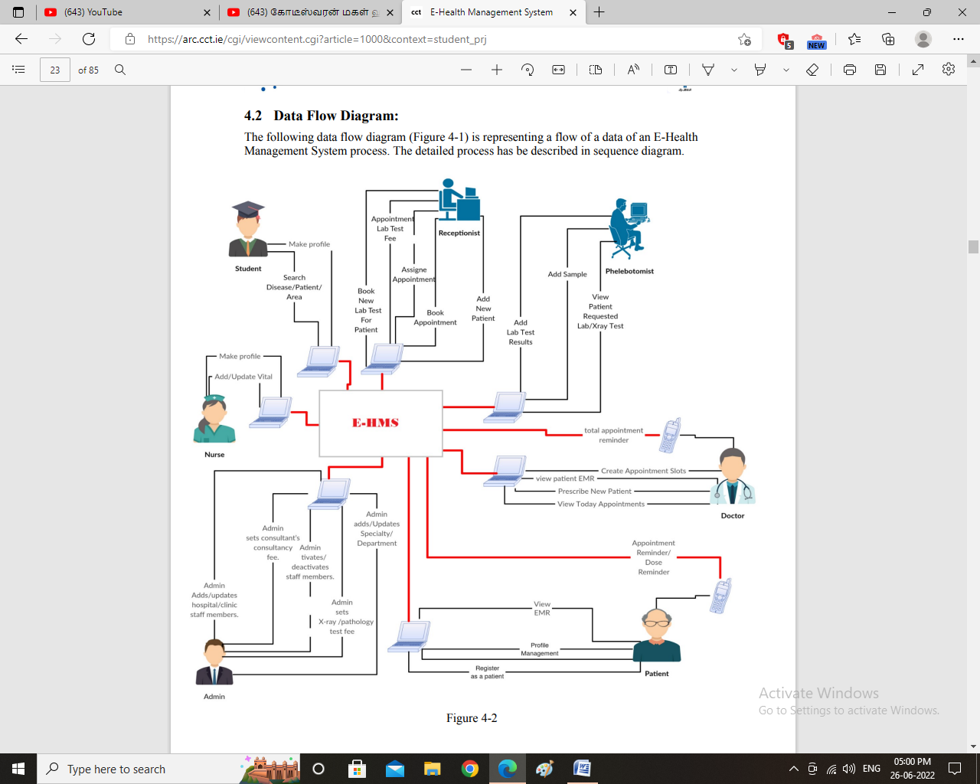

Book Appointment:

1. The patient selects an option to book an appointment. 2. List of doctors with their details will be displayed. 3. The system Display the doctor appointment slots with times. The patient select the appointment time and click on submit button. 4. The system displays the message “appointment book successfully” and System sends an alert message to the patient mobile device to confirm his/her appointment by coming to the hospital “Reception” before half hour on the selected time slots. (phase I SMS gateway is not integrated)
2. The doctor select option for prescribing to patient 2. Doctor search for the readymade prescription (Typhoid Fever, Food Poisoning, Diarrhea, Viral hepatitis, Tuberculosis, Cardiovascular, lung cancer, Diabetes). 3. The System display the prescription form having (Symptoms, Suggest medicine, and medicine frequency, suggest Test, Notes). 4. The doctor select the symptoms of searched ready made prescription. 5. The Doctor Select the option for save patient’s Symptoms. 6. System save the patient Symptoms and give confirmation message “Record save Successfully” 7. The doctor select the medicine that he wants to medicate his patients. 8. The system adds the medicine in Prescription report list with parameters frequency dosage etc. 9. Doctor enter the frequency against tab or syrup i.e. (Once time in a day, two times in a day, Three times in a day) and select an option to submit records 10. System save the records and with alert message “Patient record save successfully”

For Lab test

Doctor select an option to Recommend Lab test to his option 2. System Display All medical Test. 3. Doctor Select the test that he wants to recommend his patient and select an option to save the Pathology’s test. 4. Doctor select an option to search the select’s test Component. 5. The system displays the Component of medical test (Pathology’s test Component). 6. Doctor select the Component (Pathology’s test Component) and select on option to save the component 7. System save the record and display message “Record save successfully”

Patient Registration

Receptionist selects the option for register patient. 2. The system displays patient registration page. 3. Receptionist enters the username and selects an option to register the patient.

Nurse eneral Vitals

Nurse add the Patient General vitals (Heart rate, Plus BPM, Blood pressure, Respiration rate, Temperature) and select an option to save the patient’s vitals. 6. System save the record by giving alert message “Record save successfully”

Add Staff (Doctors, Nurse, Phlebotomist, Receptionist)

Admin select an option to add staff (doctor, Nurse, Phlebotomist, Receptionist ) into EHealth Managment 2. The system opens the page for add staff (doctor, Nurse, Phlebotomist, Receptionist). 3. Admin enter the User Name of Staff 4. Admin select an option to submit records

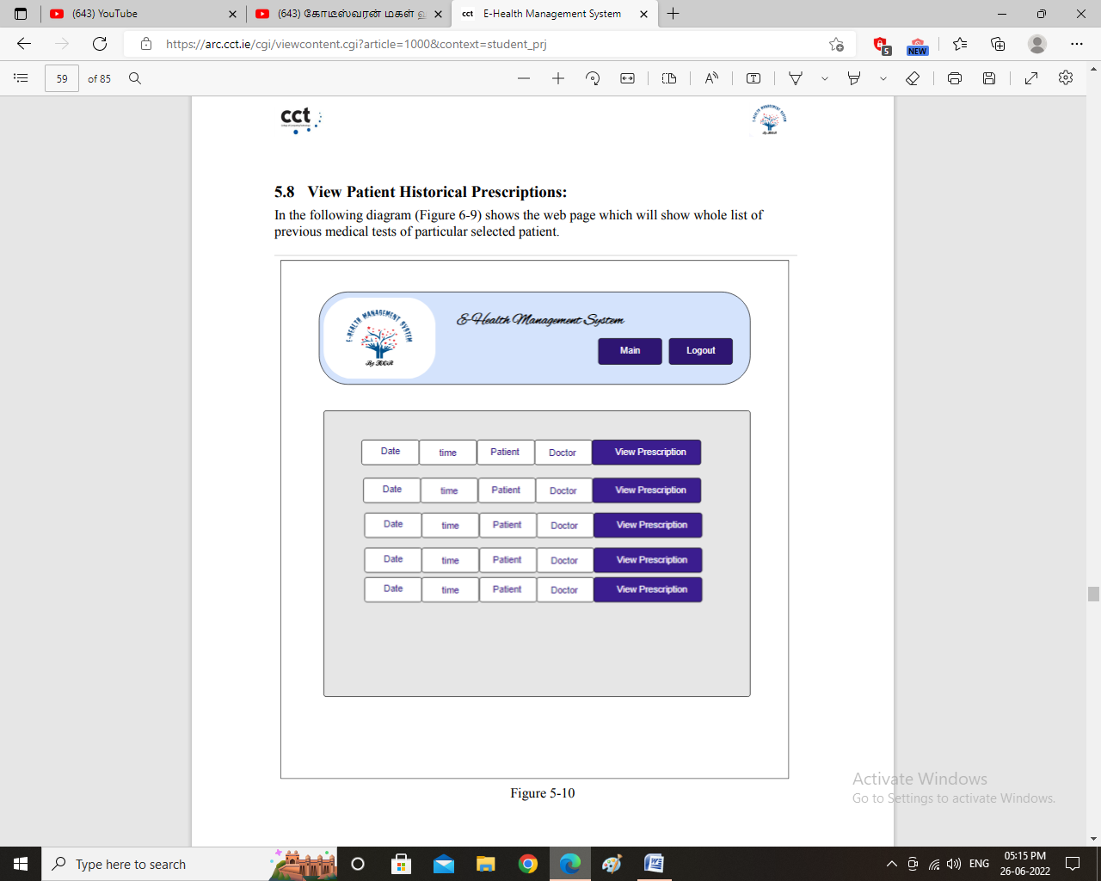

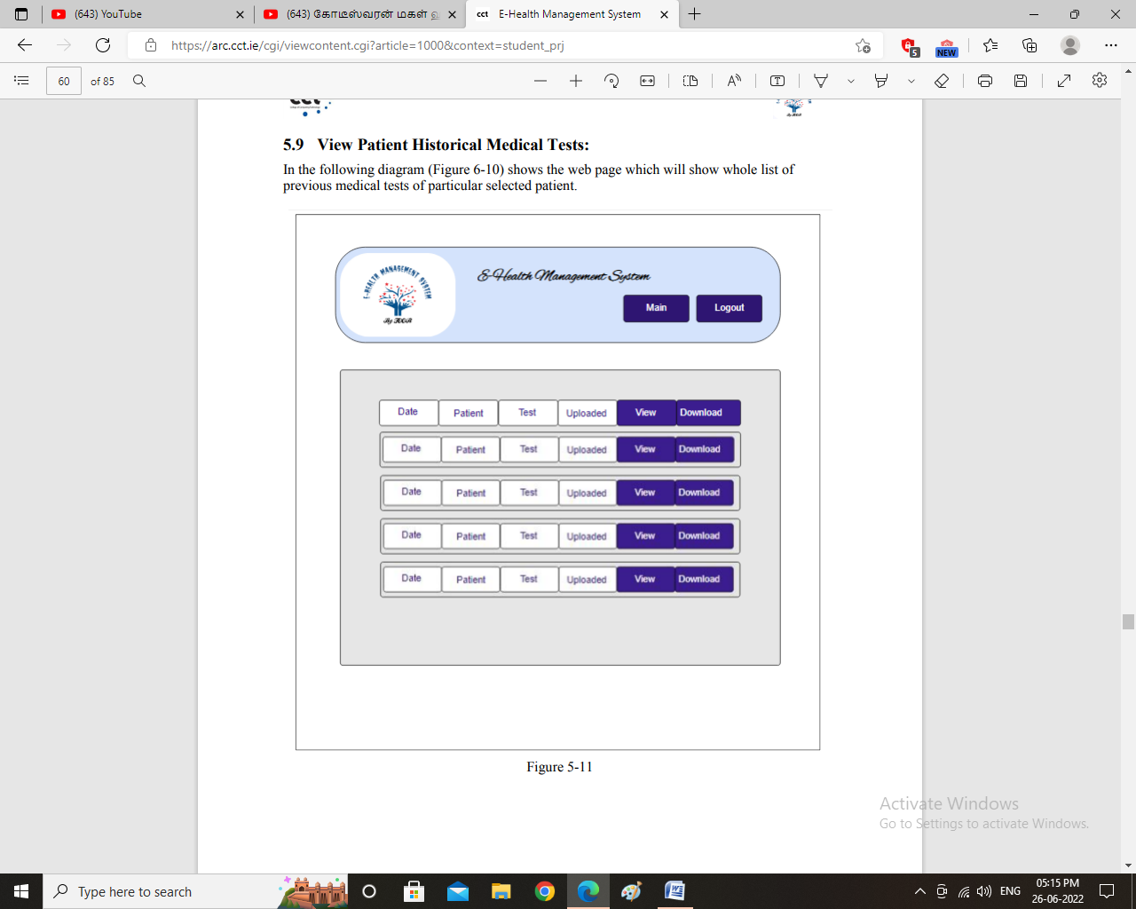

For In-Patient administration - Objectives

* To optimize bed occupation.
* To improve the use of operating theaters, avoiding the cancellation of operations.
* To know how emergencies affect to the administration of the hospital departments or services (cancellation of operations etc.).
* To optimize the allocation of human and material resources to wards and shifts.

