**Coimbatore Institute of Technology**

**Department of AI and DS**

**21AD21 Fundamentals of Industry Revolution 4.0**

**Patient Care App**

**Team members**:

Samuela Abigail Mathew - 71762108039

Nivetha S S – 71762108030

**Introduction:**

We have created an android application for a hospital to store patient details and patient history, which consists of login page for patients, doctors, admin, registration page for patients, doctors, appointment booking, etc using Android studio. All data is stored in Firebase database.

**Problem statement:**

Patient usually don't remember their previous doctor visits, previous symptoms and medications taken. So it takes time for the doctor to diagnosis the patient and it is possible that diagnosis is not accurate, so patient treatment is less efficient. And there’s also lack of patient data in research field.

**Objective**:

It is easier to identify what the patient is suffering from and make accurate diagnosis quickly. The doctor does not have to spend time asking how frequent the patient has been experiencing these symptoms, when it happened, what medications were taken, etc.

This data can also be used for research purposes by keeping the patient’s identity confidential, thereby helping to identify effective treatment, monitor safety of medications, and get new knowledge on causes of diseases and illness, etc.

Patient can also book and cancel appointments with ease, and doctors can get a clear view of their schedule. When more patients use this app, the hospital also generates more revenue.

**System requirements:**

Android studio, Firebase, Smart phone/Emulator

**Design:** 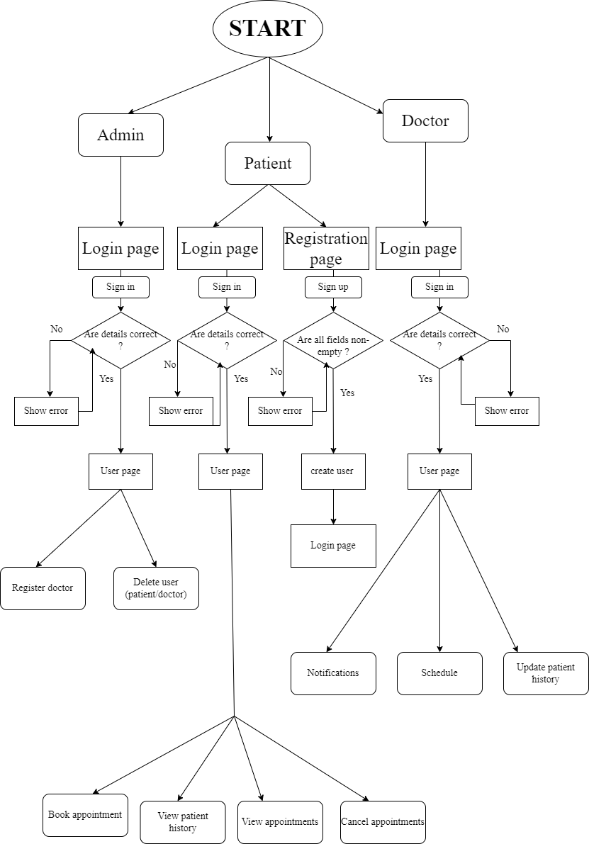

**Implementation and Results:**

1. **Database**

This is the database where everything will get stored, and any modifications done via app like adding new users, deleting users, booking appointments, etc will be reflected here.

1. **Login page for patients, doctors, admin and registration for patient**

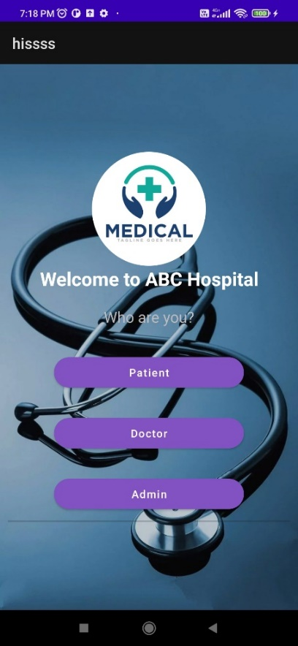 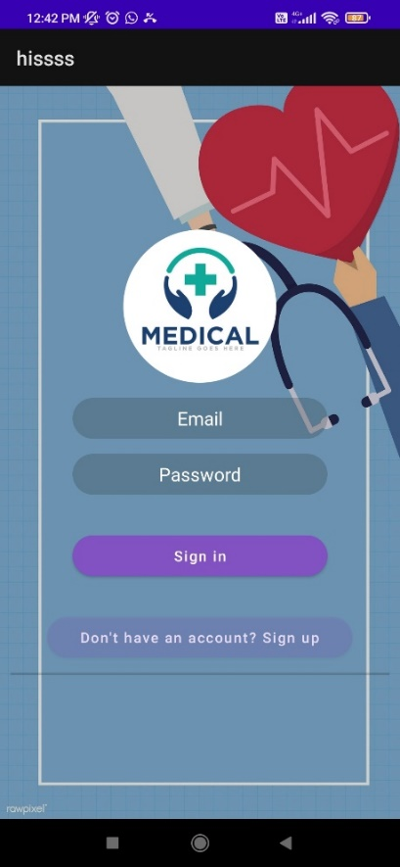

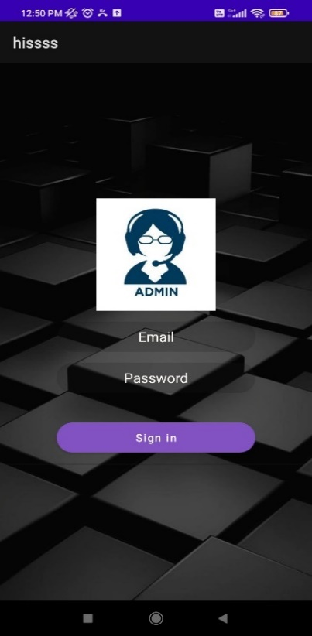

Person has to enter correct email and password to log into their account. Only admin can register new doctors. Patients can sign up if they don’t have account. More than 1 account with same email can’t be created as Firebase will show error message. While registering or logging in, if any column is left empty, it’ll show warning message. And if details entered are wrong while logging in, it’ll show error message.

**3.User pages for doctor, patient, admin**

After entering correct login details, it’ll take user to user page where relevant action buttons are available.

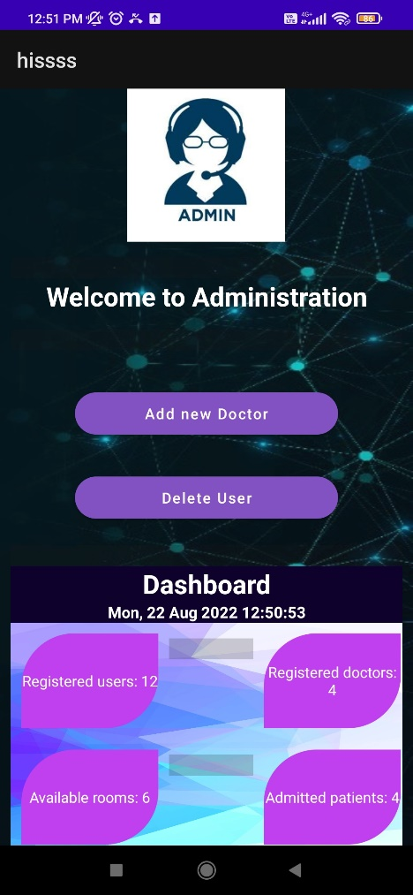 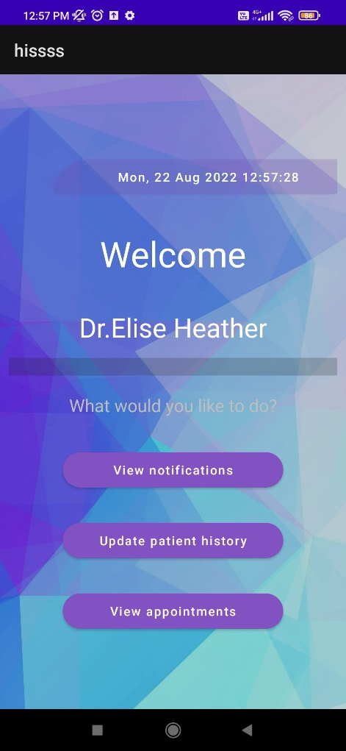

**4.Admin actions**

Admin can register new doctors and delete account of users (both patient and doctors). For deleting user, they have to mention if they are patient or doctor, and then enter email of user to be deleted. The list of all users will be displayed and their status- “Patient” or “Doctor” will be mentioned.

**5.Patient actions**

Patients can book appointments by selecting doctor and the date.

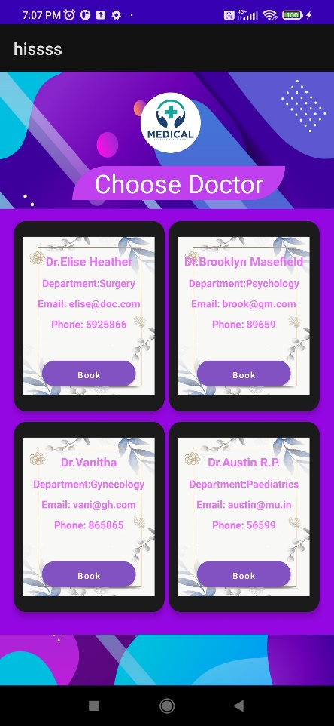 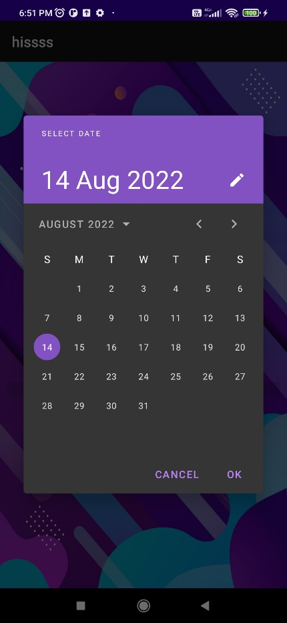

They can also see patient history, status of booked appointments, and can cancel appointments. If they cancel appointment, then the doctor will be notified.

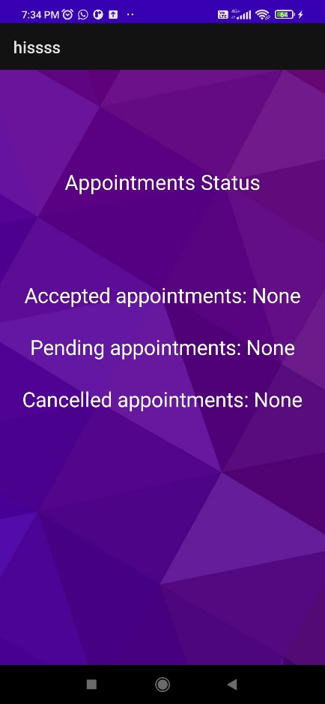 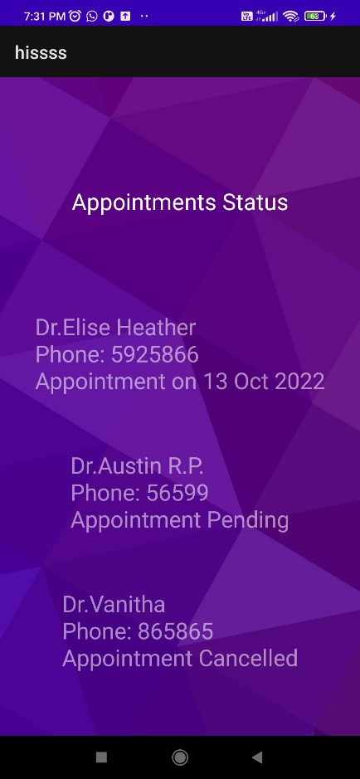 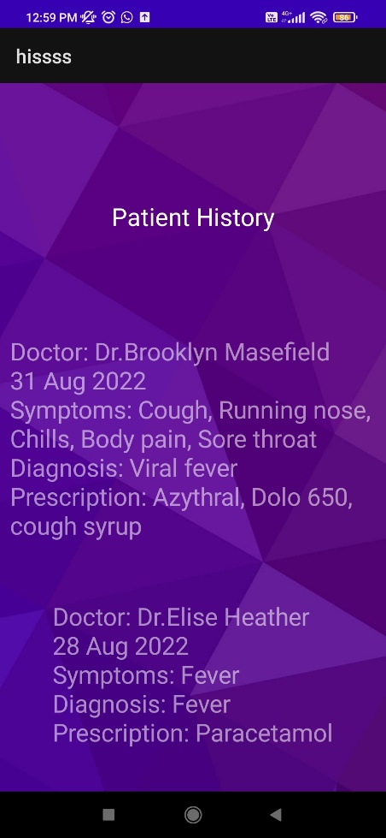

**6.Doctor actions**

Doctors can see pending appointments in notification section where they can either reject or accept patient appointments. For this they have to enter email of patient from the displayed list along with date of appointment, and if they accept appointment then they have to enter time of appointment. Then they can press either accept or reject button and the patient will be notified.

Doctors can update patient history only for the appointments which he has accepted, and after updating patient history the appointment is considered as finished and will be deleted from the database.

**7.Input validation and Pop-up’s**

Everywhere input validation is done. For example, this is how it’ll show error when a required field is left empty-

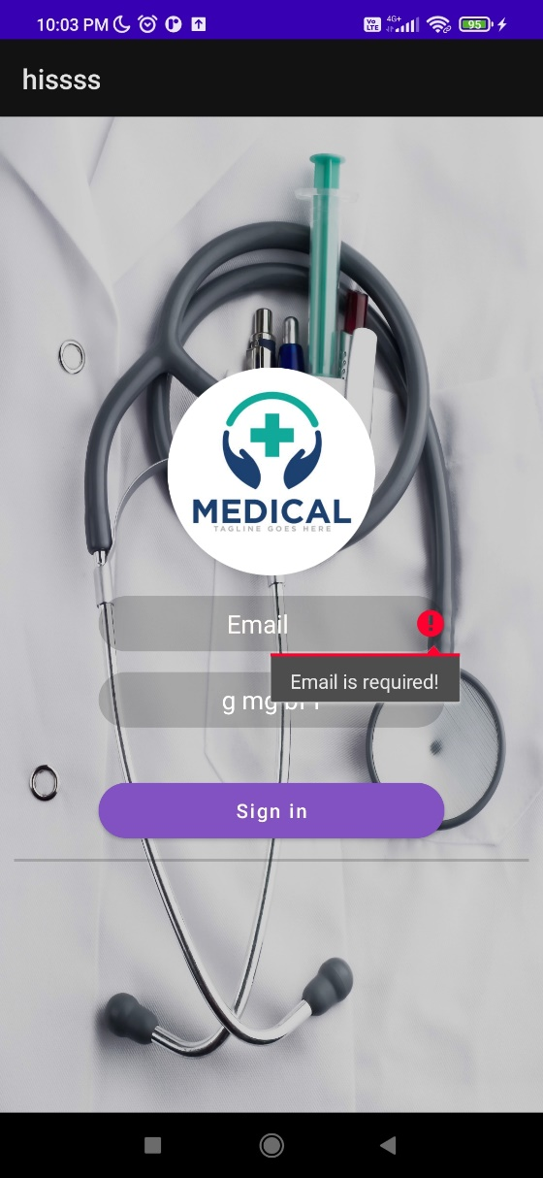

Similarly when an action is done successfully or unsuccessfully, it’ll show pop up messages like “Registered successfully”, “Appointment booked”, “Enter correct details!”, etc.

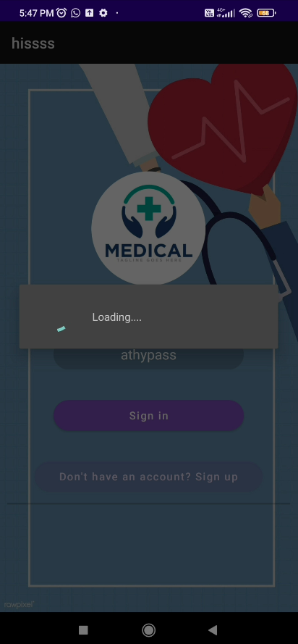 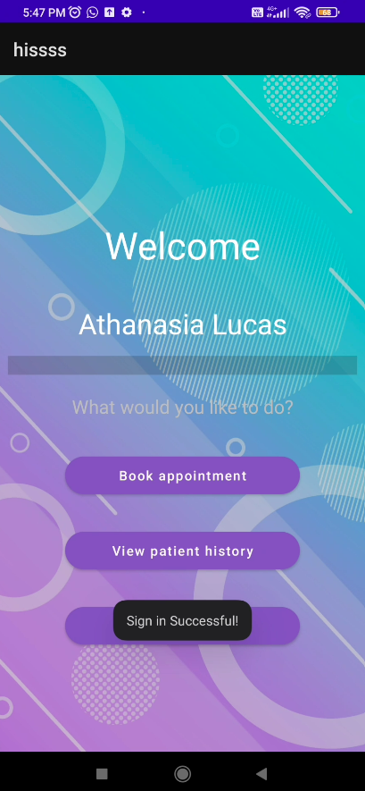

**Conclusion:**

In future we will add new features like details and data about laboratory, pharmacy access , payments etc through this app and we can create a website.