ELEC 4700 Assignment 4 - Circuit Modeling 1
Q1 2
Q2 8
Q3 8
Q3 a) Formulation 8
Q3 b) Programing i. 9
Q3 b) ii. 10
Q3 b) iii. 12
Q4 Transient Circuit Simulation 15
Q4 a) 15
Q4 b) 15
Q4 c) 15
Q4 d) 15
Q4 d) Input signal A: 15
Q4 d) Input signal B: 17
Q4 d) Input signal B (few other frequencies): 19
Q4 d) Input signal C 22
Q4 d) v 24
Q4 d) v Comment 26
Q5 Circuit with Noise 26
Q5 vi 29
Q5 vi. Comment 33
Q5 vii 33
Q5 vii Comment 36
Q6 Non-linearity 36
Q6 Implementation 36
Helper functions 39

ELEC 4700 Assignment 4 - Circuit Modeling
Student: Samuel (Wendi) Zhu
Student Number: 101088968
Date: 4/7/2022
% Clear all
clear
clearvars
clearvars -global
close all
format shorte
% Make plot pretier
% set(0,'DefaultFigureWindowStyle','docked')
set(0,'defaultaxesfontsize',14)
set(0,'defaultaxesfontname','Times New Roman')
set(0,'DefaultLineLineWidth', 1);

Q1
Using a fixed bottled neck value and the simulation code for assignment 3, do a voltage sweep of the device from 0.1V to 10V and model the current-voltage characteristics.
% Global variables
global Const % constants module that holds all the constants
global x y % arrays for the current electrons positions: 1 row, colum for current position
global xp yp % arrays for the previous electrons positions: 1 row, column for previous position
global vx vy % arrays for current electrons velocities: 1 row, column for current velocity
global ax ay % scalars for electron acceleration in x and y direction
global limits % Limits for the plot
global boxes; % matrix for the boxes: n rows, and 4 columns for [x y w h]
% Initalize global constants
% Electron charge
Const.q_0 = 1.60217653e-19; % C
% Rest mass
Const.m0 = 9.1093837015e-31; % KG
% Effective mass of electrons
Const.mn = 0.26*Const.m0; % KG
% Boltzmann constant
Const.kb = 1.38064852e-23; %m^2 * kg * s^-2 * K^-1
% Initialize the region size 200nm X 100nm
Region.x = 200e-9;
Region.y = 100e-9;
limits = [0 Region.x 0 Region.y]; % plot limit
% Initialize the temperature
T = 300; % K
% Initialize the mean time between collision
Tmn = 0.2e-12; % 0.2ps
% Define the dimension
L = Region.x * 10^9; % Length in nm
W = Region.y * 10^9; % Width in nm
boxLF = 0.3; % Fraction of the length of the box
boxWF = 0.4; % Fraction of the width of the box
Lb = boxLF*L; % Length of the box in nm
Wb = boxWF*W; % Width of the box in nm
deltaXY = 0.02*L; % Assume deltaX = deltaY in nm
% Calculate the dimension of solution matrix
nx = (L/deltaXY);
ny = (W/deltaXY);
% Number of sweep points for the voltage
nSweep = 10;
vecVoltage = linspace(0.1, 10, nSweep); % Generate the voltage vector
vecCurrent = zeros(1, nSweep); % vector for holding the current
% vector for different deltaT to adjust the time to reach steady state
vecDeltaT = linspace(12e-14,3e-14, nSweep);
% Loop through the different voltages
for iVolt = 1:length(vecVoltage)
% Define the voltages
voltageX0 = vecVoltage(iVolt); % Voltage at X=0
voltageX1 = 0; % Voltage at X=L
% Define deltaT to reach steady state sooner
deltaT = vecDeltaT(iVolt);
% Step 1: Calculate the E field
% Calculate the meshgrid
[X,Y] = meshgrid(linspace(0,L,nx), linspace(0,W,ny));
% Declare the matrix for conductivity: Sigma(y,x)
matrixSigma = ones(ny, nx); % Dimension: ny times nx
xIndexBox = ceil((L-Lb)/(2*deltaXY)); % Find the starting x index for the box
LbIndexRange = ceil(Lb/deltaXY); % Index range for the length of the box
WbIndexRange = ceil(Wb/deltaXY); % Index range for the width of the box
% Assign the region for the box
matrixSigma(1:WbIndexRange, xIndexBox:xIndexBox+LbIndexRange) = 10^-2;
matrixSigma(ny-WbIndexRange:ny, xIndexBox:xIndexBox+LbIndexRange) = 10^-2;
% Declare the matrix for voltage V(y,x)
matrixV = zeros(ny, nx); % Dimension: ny times nx
% Declare the G matrix and F vector: GV = F
G = zeros(nx*ny, nx*ny);
F = zeros(nx*ny, 1);
% Construct the G matrix and F vector
for ix = 1:nx
for iy = 1:ny
% Calculate the index
n = mappingEq(ix, iy, ny);
% Check for the boundary
if ix==1 || ix==nx || iy ==1 || iy==ny
G(n,n) = 1;
% Boundary condition for x
if ix == 1
F(n,1) = voltageX0; % V at x = 0
elseif ix == nx
F(n,1) = voltageX1; % and V at x = L
elseif iy == 1
nyp = mappingEq(ix, iy+1, ny); % dV/dy=0 at y=0
G(n,nyp) = -1;
elseif iy == ny
nym = mappingEq(ix, iy-1, ny); % dV/dy=0 at y=W
G(n, nym) = -1;
end
else
% Calculate the sigma
sigmaxp = (matrixSigma(iy,ix) + matrixSigma(iy,ix+1))/2;
sigmaxm = (matrixSigma(iy,ix) + matrixSigma(iy, ix-1))/2;
sigmayp = (matrixSigma(iy,ix) + matrixSigma(iy+1, ix))/2;
sigmaym = (matrixSigma(iy,ix) + matrixSigma(iy-1, ix))/2;
% Calculate mapping index
nxp = mappingEq(ix+1, iy, ny); % index for V(i+1,j)
nxm = mappingEq(ix-1, iy, ny); % index for V(i-1,j)
nyp = mappingEq(ix, iy+1, ny); % index for V(i,j+1)
nym = mappingEq(ix, iy-1, ny); % index for V(i,j-1)
% Setup the G matrix
G(n,n) = -(sigmaxp+sigmaxm+sigmayp+sigmaym)/deltaXY^2;
G(n, nxp) = sigmaxp/deltaXY^2;
G(n, nxm) = sigmaxm/deltaXY^2;
G(n, nyp) = sigmayp/deltaXY^2;
G(n, nym) = sigmaym/deltaXY^2;
end
end
end
% Solve for V from GV = F
V = G\F;
% Map back to the 2D region
for iMap = 1:nx*ny
% Calculate the index for the 2D region
ix = ceil(iMap/ny);
iy = mod(iMap, ny);
if iy == 0
iy = ny;
end
% Assign the value
matrixV(iy, ix) = V(iMap);
end
% Solve the electric field
[Ex, Ey] = gradient(-matrixV);
Ex = Ex/(deltaXY * 10^-9); % convert to V/m
Ey = Ey/(deltaXY * 10^-9); % convert to V/m
% Step 2: Calculate the acceleration field
% Initialize the number of "super" electrons
numE = 1000;
% Number of simulation steps
numSim = 1000;
% Boudary mode: specular(0) or diffusive(1)
boundaryMode = 0;
% Add the boxes
numBox = AddObstacles(boxLF, boxWF, Region);
% To find the current, the following steps are performed:
% 1) Calculate the total area
areaA = Region.x * Region.y; % m^2
areaA = areaA * 100^2; % cm^2
% 2) Calculate the total electrons in the area assuming electron
% concentration is 10^15 cm-2
totalE = 10^15 * areaA; % total electrons
% 3) Find the charge per "Super Electron", where "Super Electron" is the
% particle in this simulation
numEPerSuperE = totalE/numE; % number of electron per super electron
superECharge = -Const.q_0 * numEPerSuperE; % Charge per super electron
% 4) The current can be found by counting the net number of super electrons
% Initialize acceleration for each electron
ax = zeros(1, numE); % Acceleration in x
ay = zeros(1, numE); % Acceleration in y
% Calculate the acceleration field: a = Force/mass = q*E/mass
accFieldX = -Const.q_0 * Ex / (Const.mn);
accFieldY = -Const.q_0 * Ey / (Const.mn);
% Add the electrons
AddElectrons_WithBox(numE, Region, T, numBox);
% Calculate the scattering probability
Pscat = 1-exp(-deltaT/Tmn);
% Super electron count for current calculation
% Count on left side x=0. +1 flow right, -1 flow left
countECurrent = 0; % Hold the super electron count
% Step 3: Loop for simulation
for iSim = 1:numSim
% Store the current positions
xp = x;
yp = y;
% Calculate the future positions: x = x0 + vx*t + 1/2*ax*t^2
x = x + vx * deltaT + 1/2 * ax *deltaT^2;
y = y + vy * deltaT + 1/2 * ay * deltaT^2;
% Calculate the future velocity: vx = ax*t
vx = vx + ax*deltaT;
vy = vy + ay*deltaT;
% Reset the super electron count
countECurrent = 0;
% Loop through all the particles
for iE=1:numE
% flag for invalid position
bInvalid = false;
% Step 1 - Check for boundary
% Check for invalid x position
if x(iE) <= 0
x(iE) = Region.x; % Appear on right
xp(iE) = x(iE);
bInvalid = true;
% Update the electron count for current calculation
countECurrent = countECurrent-1; % -1 flow left
elseif x(iE) >= Region.x
x(iE) = 0; % Appear on left
xp(iE) = x(iE);
bInvalid = true;
% Update the electron count for current calculation
countECurrent = countECurrent+1; % +1 flow right
end
% Check for invalid y position
if y(iE) <= 0
bInvalid = true;
y(iE) = 0;
% Check for boundary mode
if boundaryMode == 0 % Specular boundary
vy(iE) = -vy(iE);
else % Diffusive boundary
vy(iE) = abs(sqrt(Const.kb*T/Const.mn).*randn()); % positive vy
end
elseif y(iE) >= Region.y
y(iE) = Region.y;
bInvalid = true;
% Check for boundary mode
if boundaryMode == 0 % Specular boundary
vy(iE) = -vy(iE);
else % Diffusive boundary
vy(iE) = -abs(sqrt(Const.kb*T/Const.mn).*randn()); % negative vy
end
end
% Step 2: Check for boxes
for iBox = 1:numBox
% Retrieve box info
boxX1 = boxes(iBox, 1);
boxX2 = boxes(iBox, 1)+boxes(iBox, 3);
boxY1 = boxes(iBox, 2);
boxY2 = boxes(iBox, 2)+boxes(iBox, 4);
% Check if the particle is inside a box
if (x(iE)>=boxX1 && x(iE)<=boxX2 && y(iE)>=boxY1 && y(iE) <= boxY2)
bInvalid = true; %Invalid position
% Check for x position
if xp(iE) <= boxX1 % Coming from left side
x(iE) = boxX1;
% Check for boundary mode
if boundaryMode == 0 % Specular boundary
vx(iE) = -vx(iE);
else % Diffusive boundary
vx(iE) = -abs(sqrt(Const.kb*T/Const.mn).*randn()); % negative vx
end
elseif xp(iE) >= boxX2 % Coming from right side
x(iE) = boxX2;
% Check for boundary mode
if boundaryMode == 0 % Specular boundary
vx(iE) = -vx(iE);
else % Diffusive boundary
vx(iE) = abs(sqrt(Const.kb*T/Const.mn).*randn()); % positive vx
end
end
% Check for y position
if yp(iE) <= boxY1 % Coming from bottom
y(iE) = boxY1;
% Check for boundary mode
if boundaryMode == 0 % Specular boundary
vy(iE) = -vy(iE);
else % Diffusive boundary
vy(iE) = -abs(sqrt(Const.kb*T/Const.mn).*randn()); % negative vy
end
elseif yp(iE) >= boxY2 % Coming from top
y(iE) = boxY2;
% Check for boundary mode
if boundaryMode == 0 % Specular boundary
vy(iE) = -vy(iE);
else % Diffusive boundary
vy(iE) = abs(sqrt(Const.kb*T/Const.mn).*randn()); % positive vy
end
end
% Break the loop for box
break;
end
end
% Step 3: Check for scattering
if ~bInvalid && Pscat > rand()
% Rethermalize
vx(iE) = sqrt(Const.kb*T/Const.mn).*randn();
vy(iE) = sqrt(Const.kb*T/Const.mn).*randn();
end
% Step 4: Find acceleration
% Find the corresponding index for the acceleration field
indexX = ceil(x(iE)/(deltaXY*10^-9));
indexY = ceil(y(iE)/(deltaXY*10^-9));
% Check for invalid index
if indexX <= 0
indexX = 1;
end
if indexY <= 0
indexY = 1;
end
% Assign the acceleration of the electron
ax(iE) = accFieldX(indexX);
ay(iE) = accFieldY(indexY);
end
end
% Calculate the current
vecCurrent(iVolt) = superECharge*countECurrent/deltaT;
end
% Plot the current versus voltage characteristics
figure(1)
plot(vecVoltage, vecCurrent, "-b.")
title("Current - Voltage Characteristics")
xlabel("Voltage (V)")
ylabel("Current (A)")
% Do the linear fit for determining resistance value of the device
slopeRfit = vecVoltage(:)\vecCurrent(:);
Rfit = vecVoltage(:)*slopeRfit;
hold on;
plot(vecVoltage, Rfit, "r-.")
legend("Simulation Data", "Linear Fit Line", "Location","southeast")
grid on
snapnow

Q2
Use a linear fit to determine the resistance value pf the device and use this value as R3
% Calculate the R3 value
R3 = 1/slopeRfit; % Ohm
% Print the linear fitted value
fprintf("Resistance value from linear fit: R3 = " + R3 + " Ohms.\n")
Resistance value from linear fit: R3 = 11.6555 Ohms.

Q3
Report on the work done in PA 9 (PA 7).
% Declare some component values
R1 = 1; % Ohm
C = 0.25; % F
R2 = 2; % Ohm
L = 0.2; % H
alpha = 100;
R4 = 0.1; % Ohm
RO=1000; % Ohm
% Declare the vectors
vectorV = zeros(9, 1); % solution vector: [N1, N2, N3, N4, N5, I1, IL, I3, I4]
vectorF = zeros(9, 1); % F vector: F(1) = VIN

Q3 a) Formulation
Please see the Appendix A for the differential equations that represent the network and the derivation for the C and G matrix.
% Create the C, G matrices
% Declare the C matrix
matrixC = [0, 0, 0, 0, 0, 0, 0, 0, 0;
C, -C, 0, 0, 0, 0, 0, 0, 0;
-C, C, 0, 0, 0, 0, 0, 0, 0;
0, 0, 0, 0, 0, 0, -L, 0, 0;
0, 0, 0, 0, 0, 0, 0, 0, 0;
0, 0, 0, 0, 0, 0, 0, 0, 0;
0, 0, 0, 0, 0, 0, 0, 0, 0;
0, 0, 0, 0, 0, 0, 0, 0, 0;
0, 0, 0, 0, 0, 0, 0, 0, 0];
% Declare the G matrix
matrixG = [1, 0, 0, 0, 0, 0, 0, 0, 0;
1/R1, -1/R1, 0, 0, 0, 1, 0, 0, 0;
-1/R1, 1/R1+1/R2, 0, 0, 0, 0, 1, 0, 0;
0, 1, -1, 0, 0, 0, 0, 0, 0;
0, 0, 0, 0, 0, 0, -1, 1, 0;
0, 0, -1/R3, 0, 0, 0, 0, 1, 0;
0, 0, 0, 1/R4, -1/R4, 0, 0, 0, 1;
0, 0, 0, 1, 0, 0, 0, -alpha, 0;
0, 0, 0, -1/R4, 1/R4+1/RO, 0, 0, 0, 0];

Q3 b) Programing i.
DC sweep input voltage from -10V to 10V and plot V0 and V3 (N3).
simStep = 21; % Simulation steps
V1 = linspace(-10, 10, simStep); % vector for input voltages
Vo = zeros(simStep, 1); % vector for holding the output voltage
V3 = zeros(simStep, 1); % vector for holding the voltage at V3
% Loop for the DC simulation
for iSim = 1:simStep
% Setup the F vector
vectorF(1) = V1(iSim); % Stepup the input voltage
% Find the solution
vectorV = matrixG\vectorF;
% Save answers
Vo(iSim) = vectorV(5); % Save Vout
V3(iSim) = vectorV(3); % Save V3
end
% Plot the DC simulation
figure(2)
plot(V1, Vo, "-b.")
hold on
plot(V1, V3, "-r.")
title("DC simulation")
xlabel("Vin (V)")
ylabel("Vout and V3 (V)")
legend("Vout", "V3")
grid on;
snapnow
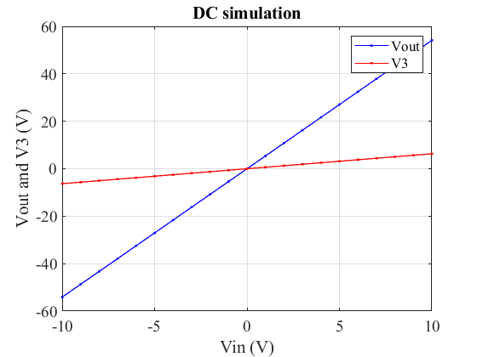

Q3 b) ii.
AC case plot Vo as a function of omega also plot the gain vo/v1 in dB.
simSteps = 100; % Simulation steps
Vin = 1; % Value for input voltage
vectorF(1) = Vin; % Setup the input voltage
omega = linspace(1, 100, simSteps); % vector for frequencies
Vo = zeros(simSteps, 1); % vector store the output voltages
V3 = zeros(simStep, 1); % vector for holding the voltage at V3
% Loop for simulation
for iSim = 1:simSteps
w = omega(iSim); % Retrieve the simulation frequency
% Construct the G+jwC matrix
matrixGC = matrixG + 1j*w*matrixC;
% Find the solution
vectorV = matrixGC\vectorF;
% Save answers
Vo(iSim) = abs(vectorV(5)); % Save Vout
V3(iSim) = abs(vectorV(3)); % Save V3
end
% Plot Vo as a function of omega
figure(3)
plot(omega, Vo, "-b.");
hold on
plot(omega, V3, "-r.");
title("Vo as a function of omega")
xlabel("Frequency omega (rad/s)")
ylabel("Vout (V)")
legend("Vout", "V3")
grid on
snapnow
% Plot the gain Vo/V1 in dB
figure(4)
gain = 20.*log10(Vo ./ Vin); % Calculate the gain in dB
plot(omega, gain);
title("Gain Vo/V1 in dB versus omega")
xlabel("Frequency omega (rad/s)")
ylabel("Gain (dB)")
grid on
snapnow
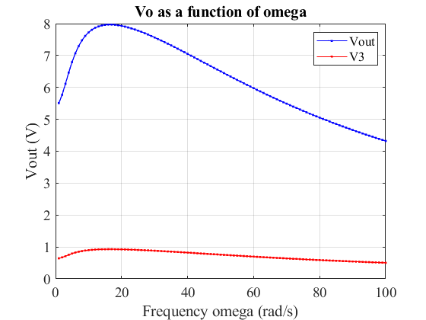
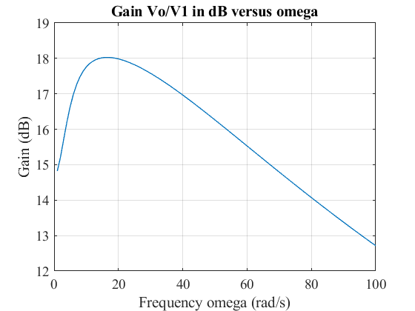

Q3 b) iii.
For the AC case, plot the gain as function of random perturbations on C using a normal distribution with std=.05 at omega = pi. Do a histogram of the gain.
simSteps = 1000; % Simulation steps
omega = pi;
std = 0.05; % Standard deviation of the normal distribution
randomC = std .* randn(simSteps, 1)+C; % vector store the random C
Vo = zeros(simSteps, 1); % vector store the output voltages
Vin = 10; % Value for input voltage
vectorF(1) = Vin; % Setup the input voltage
% Plot the normal distribution of C
nbins = 10; % Number of bins for the histogram
figure(5)
histogram(randomC, nbins);
title("Distribution of C")
xlabel("C (F)")
ylabel("Number")
grid on
snapnow
% Loop through the random C
for iSim=1:simSteps
C = randomC(iSim); % Retrieve the C value
% Reconstruct the C matrix
matrixC = [0, 0, 0, 0, 0, 0, 0, 0, 0;
C, -C, 0, 0, 0, 0, 0, 0, 0;
-C, C, 0, 0, 0, 0, 0, 0, 0;
0, 0, 0, 0, 0, 0, -L, 0, 0;
0, 0, 0, 0, 0, 0, 0, 0, 0;
0, 0, 0, 0, 0, 0, 0, 0, 0;
0, 0, 0, 0, 0, 0, 0, 0, 0;
0, 0, 0, 0, 0, 0, 0, 0, 0;
0, 0, 0, 0, 0, 0, 0, 0, 0];
% Construct the G+jwC matrix
matrixGC = matrixG + 1j*omega*matrixC;
% Find the solution
vectorV = matrixGC\vectorF;
% Save answers
Vo(iSim) = abs(vectorV(5)); % Save Vout
end
% Plot the distribution of gain
figure(6)
gain = Vo ./ Vin; % Calculate the gain
histogram(gain, nbins);
title("Distribution of Gain")
xlabel("Vo/Vi (V/V)")
ylabel("Number")
grid on
snapnow
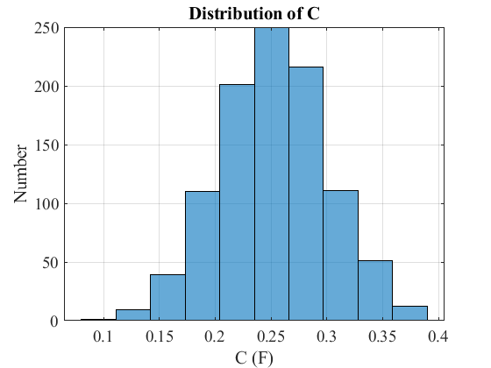
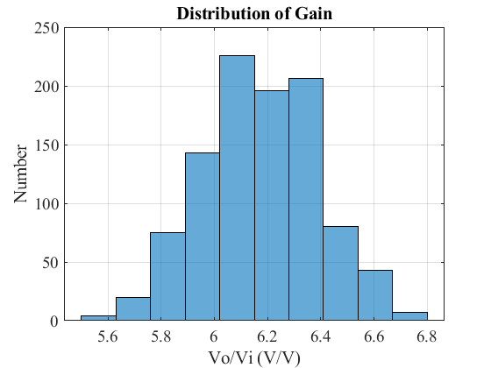

Q4 Transient Circuit Simulation
The circuit can be represented in the time domain as: C*dV/dt + G*V = F

Q4 a)
By inspection what type of circuit is this?
By inspection, the circuit is an LRC circuit, and the circuit models an amplifier. The circuit is linear since it does not contain any nonlinear components yet.

Q4 b)
What sort of frequency response would you expect?
When the frequency is high, the impedance for L will be large, and the output voltage will be low. This suggest that the circuit has an overall low pass response. However, the simulation waveform of Gain versus omega shows that the gain is also relatively low at the near DC frequency. Therefore, strictly speaking, the frequency response of the circuit is bandpass response.

Q4 c)
The derivation for the formulation in time domain is shown as follow: TODO: replace in word.
Derived equation: V(j) = A^-1 * [C*V(j-1)/deltaT + F(tj)] Where A = C/deltaT + G

Q4 d)
Write a Matlab program that can simulate the circuit. Simulate for 1s and use 1000 steps.
simTime = 1; % Simulate for 1 second
simSteps = 1000; % Use 1000 steps
% Calculate the deltaT
deltaT = simTime/simSteps; % second/step
% Declare the time vector
vecTime = linspace(0,1,simSteps);

Q4 d) Input signal A:
A step that transitions from 0 to 1 at 0.03s. iii. Plot the input Vin and output V as the simulation progresses. iv. After the simulation is completed, use the fft() and fftshift() functions to plot the frequency of the input and output signals.
% Declare the input for a step from 0 to 1 at 0.03s
vecInputV = zeros(1, simSteps);
vecInputV(0.03*simSteps:simSteps) = 1;
% Hold the output vector
vecOutputV = zeros(1, simSteps);
% Initialize the V and F vector
vectorV = zeros(9, 1); % solution vector: [N1, N2, N3, N4, N5, I1, IL, I3, I4]
vectorF = zeros(9, 1); % F vector: F(1) = VIN
% Construct the A matrix
matrixA = matrixC/deltaT + matrixG;
% Loop through the simulation
for iSim = 1:simSteps
% Update the F vector
vectorF(1) = vecInputV(iSim);
% Update the V vector
vectorV = matrixA^-1 * (matrixC * vectorV / deltaT + vectorF);
% Save the output voltage
vecOutputV(iSim) = vectorV(5);
% % Plot the input Vin and output V as the simulation progresses
% figure(7)
% plot(vecTime(1:iSim), vecInputV(1:iSim), "-r.") % Vin versus time
% hold on
% plot(vecTime(1:iSim), vecOutputV(1:iSim), "-b.") % Vo versus time
% hold off
% title("Transient simulation for a step input")
% xlabel("Time (s)")
% ylabel("Voltage (V)")
% legend("Vin versus time", "Vo versus time", "Location", "southeast")
% grid on
% % Pause for a while
% pause(0.002)
end
% Plot of completed transient simulation for step input
figure(7)
% Time domain plot
subplot(1,2,1)
plot(vecTime, vecInputV, "-b.") % Vin versus time
hold on
plot(vecTime, vecOutputV, "-r.") % Vo versus time
hold off
title("Transient simulation for a step input")
xlabel("Time (s)")
ylabel("Voltage (V)")
legend("Vin versus time", "Vo versus time")
grid on
% Frequency domain plot (fft)
subplot(1,2,2)
% Calculate sampling frequency
Fs = 1/deltaT;
df = Fs/length(vecInputV);
vecFreqPlot = -Fs/2:df:Fs/2-df; % Create the frequency vector for plot
vecOmega = 2*pi*vecFreqPlot; % Calculate the omega vector
fftVin = 20*log10(abs(fftshift(fft(vecInputV)))/simSteps); % Input fft in dB
plot(vecOmega, fftVin, "-b.") % Plot the input fft
hold on
fftVo = 20*log10(abs(fftshift(fft(vecOutputV)))/simSteps); % Output fft in dB
plot(vecOmega, fftVo, "-r.") % Plot the output fft
hold off
title("FFT of the step input")
xlabel("Omega (rad/s)")
ylabel("V (dB)")
legend("Vin versus time", "Vo versus time")
grid on
snapnow
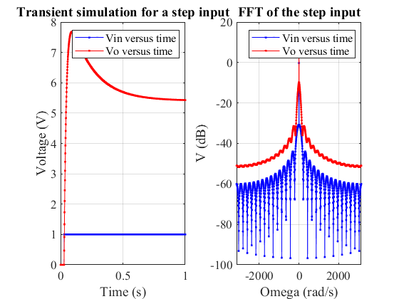

Q4 d) Input signal B:
A sin(2*pi*f*t) function with f=1/0.03 Hz. Try few other frequencies. iii. Plot the input Vin and output V as the simulation progresses. iv. After the simulation is completed, use the fft() and fftshift() functions to plot the frequency of the input and output signals.
% Declare the input for a sin(2*pi*f*t) with freq=1/0.03 Hz
freq = 1/0.03; % Hz
vecInputV = sin(2*pi*freq*vecTime);
% Hold the output vector
vecOutputV = zeros(1, simSteps);
% Initialize the V and F vector
vectorV = zeros(9, 1); % solution vector: [N1, N2, N3, N4, N5, I1, IL, I3, I4]
vectorF = zeros(9, 1); % F vector: F(1) = VIN
% Construct the A matrix
matrixA = matrixC/deltaT + matrixG;
% Loop through the simulation
for iSim = 1:simSteps
% Update the F vector
vectorF(1) = vecInputV(iSim);
% Update the V vector
vectorV = matrixA^-1 * (matrixC * vectorV / deltaT + vectorF);
% Save the output voltage
vecOutputV(iSim) = vectorV(5);
end
% Plot of completed transient simulation for sinusoidal input with f = 1/0.03 Hz
figure(8)
subplot(1,2,1)
plot(vecTime, vecInputV, "-b.") % Vin versus time
hold on
plot(vecTime, vecOutputV, "-r.") % Vo versus time
hold off
title("Transient simulation for sinusoidal input with f = 1/0.03 Hz")
xlabel("Time (s)")
ylabel("Voltage (V)")
legend("Vin versus time", "Vo versus time")
grid on
% Frequency domain plot (fft)
subplot(1,2,2)
% Calculate sampling frequency
Fs = 1/deltaT;
df = Fs/length(vecInputV);
vecFreqPlot = -Fs/2:df:Fs/2-df; % Create the frequency vector for plot
vecOmega = 2*pi*vecFreqPlot; % Calculate the omega vector
fftVin = 20*log10(abs(fftshift(fft(vecInputV)))/simSteps); % Input fft in dB
plot(vecOmega, fftVin, "-b.") % Plot the input fft
hold on
fftVo = 20*log10(abs(fftshift(fft(vecOutputV)))/simSteps); % Output fft in dB
plot(vecOmega, fftVo, "-r.") % Plot the output fft
hold off
title("FFT of the sinusoidal input with f = 1/0.03 Hz")
xlabel("Omega (rad/s)")
ylabel("V (dB)")
legend("Vin versus time", "Vo versus time")
grid on
snapnow
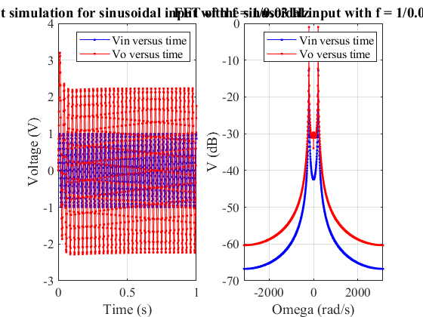

Q4 d) Input signal B (few other frequencies):
iii. Plot the input Vin and output V as the simulation progresses. iv. After the simulation is completed, use the fft() and fftshift() functions to plot the frequency of the input and output signals.
% Declare the frequencies
vecFreq = [1, 10, 35]; % Hz
% Loop through the frequencies
for iFreq = 1:length(vecFreq)
% Declare the input for a sin(2*pi*f*t)
freq = vecFreq(iFreq); % Hz
vecInputV = sin(2*pi*freq*vecTime);
% Hold the output vector
vecOutputV = zeros(1, simSteps);
% Initialize the V and F vector
vectorV = zeros(9, 1); % solution vector: [N1, N2, N3, N4, N5, I1, IL, I3, I4]
vectorF = zeros(9, 1); % F vector: F(1) = VIN
% Construct the A matrix
matrixA = matrixC/deltaT + matrixG;
% Loop through the simulation
for iSim = 1:simSteps
% Update the F vector
vectorF(1) = vecInputV(iSim);
% Update the V vector
vectorV = matrixA^-1 * (matrixC * vectorV / deltaT + vectorF);
% Save the output voltage
vecOutputV(iSim) = vectorV(5);
end
% Plot of completed transient simulation for sinusoidal input with f
figure(8+iFreq)
subplot(1,2,1)
plot(vecTime, vecInputV, "-b.") % Vin versus time
hold on
plot(vecTime, vecOutputV, "-r.") % Vo versus time
hold off
title("Transient simulation for sinusoidal input with f = "+freq+" Hz")
xlabel("Time (s)")
ylabel("Voltage (V)")
legend("Vin versus time", "Vo versus time")
grid on
% Frequency domain plot (fft)
subplot(1,2,2)
% Calculate sampling frequency
Fs = 1/deltaT;
df = Fs/length(vecInputV);
vecFreqPlot = -Fs/2:df:Fs/2-df; % Create the frequency vector for plot
vecOmega = 2*pi*vecFreqPlot; % Calculate the omega vector
fftVin = 20*log10(abs(fftshift(fft(vecInputV)))/simSteps); % Input fft in dB
plot(vecOmega, fftVin, "-b.") % Plot the input fft
hold on
fftVo = 20*log10(abs(fftshift(fft(vecOutputV)))/simSteps); % Output fft in dB
plot(vecOmega, fftVo, "-r.") % Plot the output fft
hold off
title("FFT of the sinusoidal input with f = "+freq+" Hz")
xlabel("Omega (rad/s)")
ylabel("V (dB)")
legend("Vin versus time", "Vo versus time")
grid on
snapnow
end
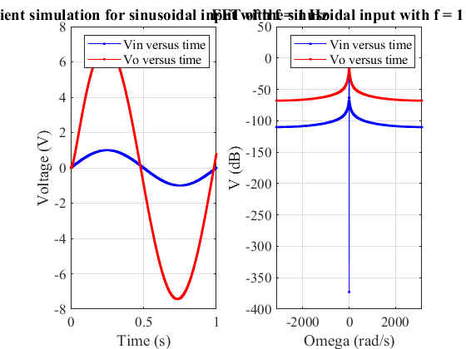
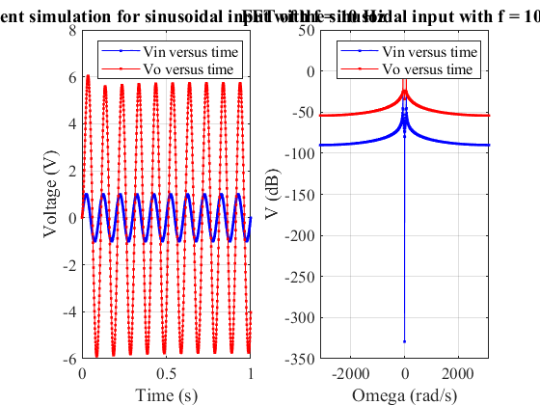
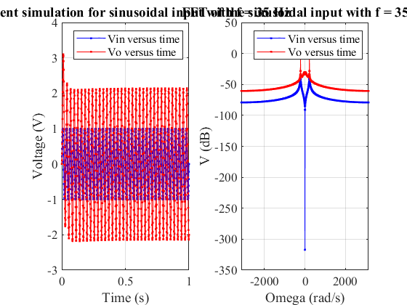

Q4 d) Input signal C
A gaussian pulse with a magnitude of 1, std dev. of 0.03s and a delay of 0.06s iii. Plot the input Vin and output V as the simulation progresses. iv. After the simulation is completed, use the fft() and fftshift() functions to plot the frequency of the input and output signals.
% Declare the input for a guassian pulse
stddev = 0.03; % std dev. of 0.03s
pulseDelay = 0.06; % delay pf 0.06s
vecInputV = exp(-((vecTime-pulseDelay)/stddev).^2/2);
% Hold the output vector
vecOutputV = zeros(1, simSteps);
% Initialize the V and F vector
vectorV = zeros(9, 1); % solution vector: [N1, N2, N3, N4, N5, I1, IL, I3, I4]
vectorF = zeros(9, 1); % F vector: F(1) = VIN
% Construct the A matrix
matrixA = matrixC/deltaT + matrixG;
% Loop through the simulation
for iSim = 1:simSteps
% Update the F vector
vectorF(1) = vecInputV(iSim);
% Update the V vector
vectorV = matrixA^-1 * (matrixC * vectorV / deltaT + vectorF);
% Save the output voltage
vecOutputV(iSim) = vectorV(5);
end
% Plot of completed transient simulation for a gaussian pulse
figure(12)
subplot(1,2,1)
plot(vecTime, vecInputV, "-b.") % Vin versus time
hold on
plot(vecTime, vecOutputV, "-r.") % Vo versus time
hold off
title("Transient simulation for Gaussian pulse input")
xlabel("Time (s)")
ylabel("Voltage (V)")
legend("Vin versus time", "Vo versus time")
grid on
% Frequency domain plot (fft)
subplot(1,2,2)
% Calculate sampling frequency
Fs = 1/deltaT;
df = Fs/length(vecInputV);
vecFreqPlot = -Fs/2:df:Fs/2-df; % Create the frequency vector for plot
vecOmega = 2*pi*vecFreqPlot; % Calculate the omega vector
fftVin = 20*log10(abs(fftshift(fft(vecInputV)))/simSteps); % Input fft in dB
plot(vecOmega,fftVin, "-b.") % Plot the input fft
hold on
fftVo = 20*log10(abs(fftshift(fft(vecOutputV)))/simSteps); % Output fft in dB
plot(vecOmega,fftVo, "-r.") % Plot the output fft
hold off
title("FFT of Gaussian pulse input")
xlabel("Omega (rad/s)")
ylabel("V (dB)")
legend("Vin versus time", "Vo versus time")
grid on
snapnow
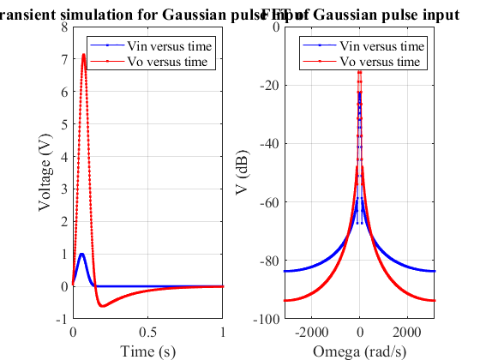

Q4 d) v
Increase the time step and see what happens. Comment.
simTime = 1; % Simulate for 1 second
simSteps = 100; % Decrease the simulation steps to 100 steps
% Calculate the deltaT
deltaT = simTime/simSteps; % second/step
% Declare the time vector
vecTime = linspace(0,1,simSteps);
% Declare the input for a guassian pulse
stddev = 0.03; % std dev. of 0.03s
pulseDelay = 0.06; % delay pf 0.06s
vecInputV = exp(-((vecTime-pulseDelay)/stddev).^2/2);
% Hold the output vector
vecOutputV = zeros(1, simSteps);
% Initialize the V and F vector
vectorV = zeros(9, 1); % solution vector: [N1, N2, N3, N4, N5, I1, IL, I3, I4]
vectorF = zeros(9, 1); % F vector: F(1) = VIN
% Construct the A matrix
matrixA = matrixC/deltaT + matrixG;
% Loop through the simulation
for iSim = 1:simSteps
% Update the F vector
vectorF(1) = vecInputV(iSim);
% Update the V vector
vectorV = matrixA^-1 * (matrixC * vectorV / deltaT + vectorF);
% Save the output voltage
vecOutputV(iSim) = vectorV(5);
end
% Plot of completed transient simulation for step input
figure(13)
% Time domain plot
subplot(1,2,1)
plot(vecTime, vecInputV, "-b.") % Vin versus time
hold on
plot(vecTime, vecOutputV, "-r.") % Vo versus time
hold off
title("Transient simulation for a Guassian input for "+ simSteps + " steps")
xlabel("Time (s)")
ylabel("Voltage (V)")
legend("Vin versus time", "Vo versus time")
grid on
% Frequency domain plot (fft)
subplot(1,2,2)
% Calculate sampling frequency
Fs = 1/deltaT;
df = Fs/length(vecInputV);
vecFreqPlot = -Fs/2:df:Fs/2-df; % Create the frequency vector for plot
vecOmega = 2*pi*vecFreqPlot; % Calculate the omega vector
fftVin = 20*log10(abs(fftshift(fft(vecInputV)))/simSteps); % Input fft in dB
plot(vecOmega,fftVin, "-b.") % Plot the input fft
hold on
fftVo = 20*log10(abs(fftshift(fft(vecOutputV)))/simSteps); % Output fft in dB
plot(vecOmega,fftVo, "-r.") % Plot the output fft
hold off
title("FFT of the Guassian input for "+simSteps+" steps")
xlabel("Omega (rad/s)")
ylabel("V (dB)")
legend("Vin versus time", "Vo versus time")
grid on
snapnow
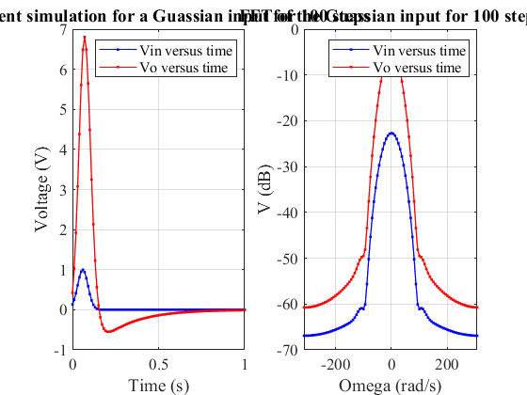

Q4 d) v Comment
After increasing the time steps (decreases simulation steps), the time domain waveform contains less points, and the the frequency domain plot contains less detail. This is because the sampling rate is lower.

Q5 Circuit with Noise
In Q5, a current souce In in parallel with R3 is added to model the thermal noise generated in the resistor R3. A capacitor Cn in parallel with the resistor is also added to bandwidth limit the noise.
Please see Appendix B for the derivation of the formulation of the matrices and equations.
simTime = 1; % Simulate for 1 second
simSteps = 1000; % Use 1000 steps
% Calculate the deltaT
deltaT = simTime/simSteps; % second/step
% Declare the time vector
vecTime = linspace(0,1,simSteps);
% Declare the capacitor Cn
Cn = 0.00001;
magIn = 0.001; % Magnitude for In
% Declare the input for a guassian pulse
stddev = 0.03; % std dev. of 0.03s
pulseDelay = 0.06; % delay pf 0.06s
vecInputV = exp(-((vecTime-pulseDelay)/stddev).^2/2);
% Hold the output vector
vecOutputV = zeros(1, simSteps);
% Generate the vector for noise current
vecIn = magIn*randn(1, simSteps);
% Declare the vectors
vectorV = zeros(10, 1); % solution vector: [N1, N2, N3, N4, N5, I1, IL, I3, I4, In]
vectorF = zeros(10, 1); % F vector: F(1) = VIN, F(10) = In
% Declare the C matrix
matrixC = [0, 0, 0, 0, 0, 0, 0, 0, 0, 0;
C, -C, 0, 0, 0, 0, 0, 0, 0, 0;
-C, C, 0, 0, 0, 0, 0, 0, 0, 0;
0, 0, 0, 0, 0, 0, -L, 0, 0, 0;
0, 0, Cn, 0, 0, 0, 0, 0, 0, 0;
0, 0, 0, 0, 0, 0, 0, 0, 0, 0;
0, 0, 0, 0, 0, 0, 0, 0, 0, 0;
0, 0, 0, 0, 0, 0, 0, 0, 0, 0;
0, 0, 0, 0, 0, 0, 0, 0, 0, 0;
0, 0, 0, 0, 0, 0, 0, 0, 0, 0];
% Declare the G matrix
matrixG = [1, 0, 0, 0, 0, 0, 0, 0, 0, 0;
1/R1, -1/R1, 0, 0, 0, 1, 0, 0, 0, 0;
-1/R1, 1/R1+1/R2, 0, 0, 0, 0, 1, 0, 0, 0;
0, 1, -1, 0, 0, 0, 0, 0, 0, 0;
0, 0, 0, 0, 0, 0, -1, 1, 0, 1;
0, 0, -1/R3, 0, 0, 0, 0, 1, 0, 0;
0, 0, 0, 1/R4, -1/R4, 0, 0, 0, 1, 0;
0, 0, 0, 1, 0, 0, 0, -alpha, 0, 0;
0, 0, 0, -1/R4, 1/R4+1/RO, 0, 0, 0, 0, 0;
0, 0, 0, 0, 0, 0, 0, 0, 0, 1];
% Construct the A matrix
matrixA = matrixC/deltaT + matrixG;
% Loop through the simulation
for iSim = 1:simSteps
% Update the F vector for Vin and In
vectorF(1) = vecInputV(iSim);
vectorF(10) = vecIn(iSim);
% Update the V vector
vectorV = matrixA^-1 * (matrixC * vectorV / deltaT + vectorF);
% Save the output voltage
vecOutputV(iSim) = vectorV(5);
end
% Plot of completed transient simulation for a Gaussian input
figure(14)
% Time domain plot
subplot(1,2,1)
plot(vecTime, vecInputV, "-b.") % Vin versus time
hold on
plot(vecTime, vecOutputV, "-r.") % Vo versus time
hold off
title("Transient simulation for a Gaussian input with noise")
xlabel("Time (s)")
ylabel("Voltage (V)")
legend("Vin versus time", "Vo versus time")
grid on
% Frequency domain plot (fft)
subplot(1,2,2)
% Calculate sampling frequency
Fs = 1/deltaT;
df = Fs/length(vecInputV);
vecFreqPlot = -Fs/2:df:Fs/2-df; % Create the frequency vector for plot
vecOmega = 2*pi*vecFreqPlot; % Calculate the omega vector
fftVin = 20*log10(abs(fftshift(fft(vecInputV)))/simSteps); % Input fft in dB
plot(vecOmega, fftVin, "-b.") % Plot the input fft
hold on
fftVo = 20*log10(abs(fftshift(fft(vecOutputV)))/simSteps); % Output fft in dB
plot(vecOmega, fftVo, "-r.") % Plot the output fft
hold off
title("FFT of the Gaussian input with noise")
xlabel("Omega (rad/s)")
ylabel("V (dB)")
legend("Vin versus time", "Vo versus time")
grid on
snapnow
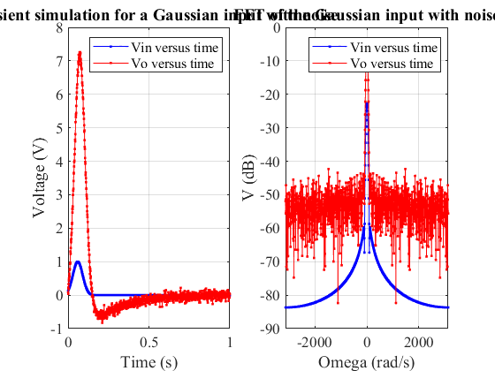

Q5 vi
Vary Cn to see how the bandwodth changes. Comment on your results
% Create an array for three different Cn
arrCn = [0.000002, 0.0002, 0.02];
% Simulation loop for different Cn
for iCn = 1:length(arrCn)
% Retrieve the corresponding Cn
Cn = arrCn(iCn);
magIn = 0.001; % Magnitude for In
% Declare the input for a guassian pulse
stddev = 0.03; % std dev. of 0.03s
pulseDelay = 0.06; % delay pf 0.06s
vecInputV = exp(-((vecTime-pulseDelay)/stddev).^2/2);
% Generate the vector for noise current
vecIn = magIn*randn(1, simSteps);
% Hold the output vector
vecOutputV = zeros(1, simSteps);
% Declare the vectors
vectorV = zeros(10, 1); % solution vector: [N1, N2, N3, N4, N5, I1, IL, I3, I4, In]
vectorF = zeros(10, 1); % F vector: F(1) = VIN, F(10) = In
% Declare the C matrix
matrixC = [0, 0, 0, 0, 0, 0, 0, 0, 0, 0;
C, -C, 0, 0, 0, 0, 0, 0, 0, 0;
-C, C, 0, 0, 0, 0, 0, 0, 0, 0;
0, 0, 0, 0, 0, 0, -L, 0, 0, 0;
0, 0, Cn, 0, 0, 0, 0, 0, 0, 0;
0, 0, 0, 0, 0, 0, 0, 0, 0, 0;
0, 0, 0, 0, 0, 0, 0, 0, 0, 0;
0, 0, 0, 0, 0, 0, 0, 0, 0, 0;
0, 0, 0, 0, 0, 0, 0, 0, 0, 0;
0, 0, 0, 0, 0, 0, 0, 0, 0, 0];
% Declare the G matrix
matrixG = [1, 0, 0, 0, 0, 0, 0, 0, 0, 0;
1/R1, -1/R1, 0, 0, 0, 1, 0, 0, 0, 0;
-1/R1, 1/R1+1/R2, 0, 0, 0, 0, 1, 0, 0, 0;
0, 1, -1, 0, 0, 0, 0, 0, 0, 0;
0, 0, 0, 0, 0, 0, -1, 1, 0, 1;
0, 0, -1/R3, 0, 0, 0, 0, 1, 0, 0;
0, 0, 0, 1/R4, -1/R4, 0, 0, 0, 1, 0;
0, 0, 0, 1, 0, 0, 0, -alpha, 0, 0;
0, 0, 0, -1/R4, 1/R4+1/RO, 0, 0, 0, 0, 0;
0, 0, 0, 0, 0, 0, 0, 0, 0, 1];
% Construct the A matrix
matrixA = matrixC/deltaT + matrixG;
% Loop through the simulation
for iSim = 1:simSteps
% Update the F vector for Vin and In
vectorF(1) = vecInputV(iSim);
vectorF(10) = vecIn(iSim);
% Update the V vector
vectorV = matrixA^-1 * (matrixC * vectorV / deltaT + vectorF);
% Save the output voltage
vecOutputV(iSim) = vectorV(5);
end
% Plot of completed transient simulation for step input
figure(14+iCn)
% Time domain plot
subplot(1,2,1)
plot(vecTime, vecInputV, "-b.") % Vin versus time
hold on
plot(vecTime, vecOutputV, "-r.") % Vo versus time
hold off
title("Transient simulation for a Gaussian input with noise for Cn = "+Cn+" F")
xlabel("Time (s)")
ylabel("Voltage (V)")
legend("Vin versus time", "Vo versus time")
grid on
% Frequency domain plot (fft)
subplot(1,2,2)
% Calculate sampling frequency
Fs = 1/deltaT;
df = Fs/length(vecInputV);
vecFreqPlot = -Fs/2:df:Fs/2-df; % Create the frequency vector for plot
vecOmega = 2*pi*vecFreqPlot; % Calculate the omega vector
fftVin = 20*log10(abs(fftshift(fft(vecInputV)))/simSteps); % Input fft in dB
plot(vecOmega, fftVin, "-b.") % Plot the input fft
hold on
fftVo = 20*log10(abs(fftshift(fft(vecOutputV)))/simSteps); % Output fft in dB
plot(vecOmega, fftVo, "-r.") % Plot the output fft
hold off
title("FFT of the Gaussian input with noise for Cn = "+Cn+" F")
xlabel("Omega (rad/s)")
ylabel("V (dB)")
legend("Vin versus time", "Vo versus time")
grid on
snapnow
end
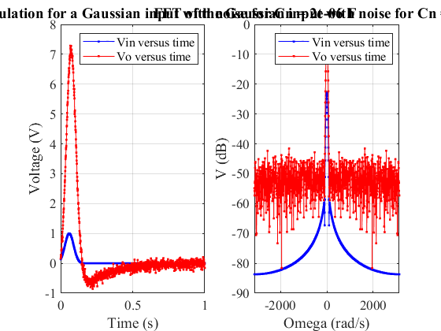
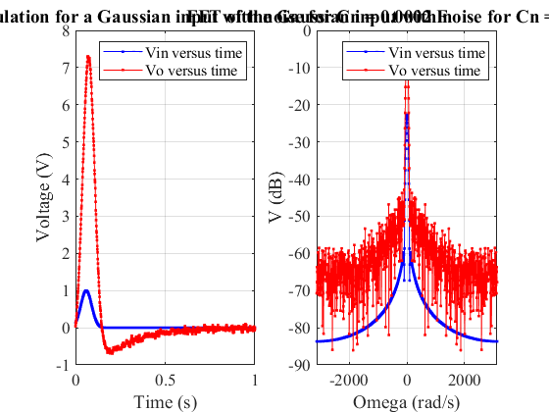
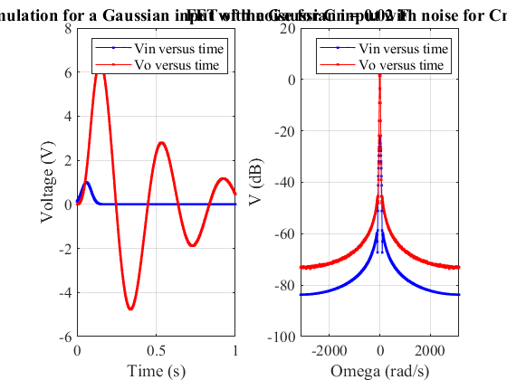

Q5 vi. Comment
The bandwidth decreases as Cn increases. As Cn increases, and the output waveforms become smoother, which suggest that the effect of the noise is reduced. However, the transient output waveform for a large Cn value will also contain oscillation.

Q5 vii
Vary the time step and see how that changes the simulation. In the following code, the simulation steps is varied, which effectively varied the time step since deltaT = simTime/simSteps, and simTime is 1 second.
simTime = 1; % Simulate for 1 second
% Create an array of simulation steps.
arrSimSteps = [100, 10000];
% Declare the capacitor Cn
Cn = 0.00001;
magIn = 0.001; % Magnitude for In
% Simulation loops for different simulation steps
for iSimSteps = 1:length(arrSimSteps)
% Retrieve the simulation step
simSteps = arrSimSteps(iSimSteps);
% Calculate the deltaT
deltaT = simTime/simSteps; % second/step
% Declare the time vector
vecTime = linspace(0,1,simSteps);
% Declare the input for a guassian pulse
stddev = 0.03; % std dev. of 0.03s
pulseDelay = 0.06; % delay pf 0.06s
vecInputV = exp(-((vecTime-pulseDelay)/stddev).^2/2);
% Generate the vector for noise current
vecIn = magIn*randn(1, simSteps);
% Hold the output vector
vecOutputV = zeros(1, simSteps);
% Declare the vectors
vectorV = zeros(10, 1); % solution vector: [N1, N2, N3, N4, N5, I1, IL, I3, I4, In]
vectorF = zeros(10, 1); % F vector: F(1) = VIN, F(10) = In
% Declare the C matrix
matrixC = [0, 0, 0, 0, 0, 0, 0, 0, 0, 0;
C, -C, 0, 0, 0, 0, 0, 0, 0, 0;
-C, C, 0, 0, 0, 0, 0, 0, 0, 0;
0, 0, 0, 0, 0, 0, -L, 0, 0, 0;
0, 0, Cn, 0, 0, 0, 0, 0, 0, 0;
0, 0, 0, 0, 0, 0, 0, 0, 0, 0;
0, 0, 0, 0, 0, 0, 0, 0, 0, 0;
0, 0, 0, 0, 0, 0, 0, 0, 0, 0;
0, 0, 0, 0, 0, 0, 0, 0, 0, 0;
0, 0, 0, 0, 0, 0, 0, 0, 0, 0];
% Declare the G matrix
matrixG = [1, 0, 0, 0, 0, 0, 0, 0, 0, 0;
1/R1, -1/R1, 0, 0, 0, 1, 0, 0, 0, 0;
-1/R1, 1/R1+1/R2, 0, 0, 0, 0, 1, 0, 0, 0;
0, 1, -1, 0, 0, 0, 0, 0, 0, 0;
0, 0, 0, 0, 0, 0, -1, 1, 0, 1;
0, 0, -1/R3, 0, 0, 0, 0, 1, 0, 0;
0, 0, 0, 1/R4, -1/R4, 0, 0, 0, 1, 0;
0, 0, 0, 1, 0, 0, 0, -alpha, 0, 0;
0, 0, 0, -1/R4, 1/R4+1/RO, 0, 0, 0, 0, 0;
0, 0, 0, 0, 0, 0, 0, 0, 0, 1];
% Construct the A matrix
matrixA = matrixC/deltaT + matrixG;
% Loop through the simulation
for iSim = 1:simSteps
% Update the F vector for Vin and In
vectorF(1) = vecInputV(iSim);
vectorF(10) = vecIn(iSim);
% Update the V vector
vectorV = matrixA^-1 * (matrixC * vectorV / deltaT + vectorF);
% Save the output voltage
vecOutputV(iSim) = vectorV(5);
end
% Plot of completed transient simulation for step input
figure(18+iSimSteps)
% Time domain plot
subplot(1,2,1)
plot(vecTime, vecInputV, "-b.") % Vin versus time
hold on
plot(vecTime, vecOutputV, "-r.") % Vo versus time
hold off
title("Transient simulation for a step input with noise for simulation steps = "+simSteps)
xlabel("Time (s)")
ylabel("Voltage (V)")
legend("Vin versus time", "Vo versus time")
grid on
% Frequency domain plot (fft)
subplot(1,2,2)
% Calculate sampling frequency
Fs = 1/deltaT;
df = Fs/length(vecInputV);
vecFreqPlot = -Fs/2:df:Fs/2-df; % Create the frequency vector for plot
vecOmega = 2*pi*vecFreqPlot; % Calculate the omega vector
fftVin = 20*log10(abs(fftshift(fft(vecInputV)))/simSteps); % Input fft in dB
plot(vecOmega, fftVin, "-b.") % Plot the input fft
hold on
fftVo = 20*log10(abs(fftshift(fft(vecOutputV)))/simSteps); % Output fft in dB
plot(vecOmega, fftVo, "-r.") % Plot the output fft
hold off
title("FFT of the step input with noise for simulation steps = "+simSteps)
xlabel("Omega (rad/s)")
ylabel("V (dB)")
legend("Vin versus time", "Vo versus time")
grid on
snapnow
end
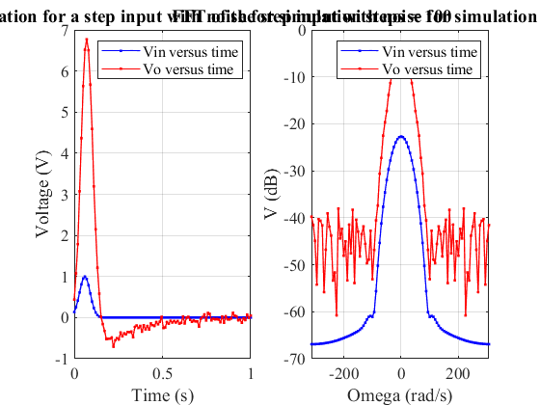
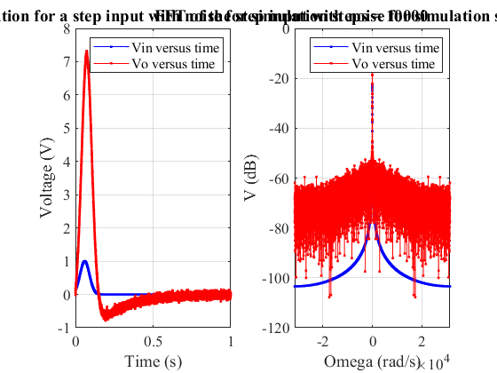

Q5 vii Comment
The waveform for low simulation steps has less detail because the sampling rate is low, and the waveform for higher simulation steps has more detail because the sampling rate is high.

Q6 Non-linearity
If the voltage souce on the output stage described by the transconductance equation V = alpha*I3 was instead modeled by V = alpha*I3 + beta*I3^2 + gamma*I3^3, what whould need to change in your simulator?
TODO: replace the following from the word To model the non-linearity, we need to add B(V) in our matrix equation. The B(V) models the non-linearity of the circuit: beta*I3^2 and gamma*I3^3. The implementation can be as follow: a) Add B(V) vector to model the non-linearity of the circuit b) Compute the Jacobian matrix J = dB/dV c) Compute f(Vn) = (C/deltaT+G)

Q6 Implementation
The following code shows the implementation of the non-linearity. The non-linearity of the circuit are shown in the output waveforms.
simTime = 1; % Simulate for 1 second
simSteps = 1000; % Use 1000 steps
% Calculate the deltaT
deltaT = simTime/simSteps; % second/step
% Declare the time vector
vecTime = linspace(0,1,simSteps);
% Tolerance
tol = 0.01;
% Transconductance parameters
alpha = 100;
beta = 500;
gamma = 1000;
% Declare the capacitor Cn
Cn = 0.00001;
magIn = 0.001; % Magnitude for In
% Declare the input for a sin(2*pi*f*t)
freq = 1/0.03; % Hz
vecInputV = sin(2*pi*freq*vecTime);
% Generate the vector for noise current
vecIn = magIn*randn(1, simSteps);
% Hold the output vector
vecOutputV = zeros(1, simSteps);
% Declare the vectors
vectorV = zeros(10, 1); % solution vector: [N1, N2, N3, N4, N5, I1, IL, I3, I4, In]
vectorF = zeros(10, 1); % F vector: F(1) = VIN, F(10) = In
% Declare the C matrix
matrixC = [0, 0, 0, 0, 0, 0, 0, 0, 0, 0;
C, -C, 0, 0, 0, 0, 0, 0, 0, 0;
-C, C, 0, 0, 0, 0, 0, 0, 0, 0;
0, 0, 0, 0, 0, 0, -L, 0, 0, 0;
0, 0, Cn, 0, 0, 0, 0, 0, 0, 0;
0, 0, 0, 0, 0, 0, 0, 0, 0, 0;
0, 0, 0, 0, 0, 0, 0, 0, 0, 0;
0, 0, 0, 0, 0, 0, 0, 0, 0, 0;
0, 0, 0, 0, 0, 0, 0, 0, 0, 0;
0, 0, 0, 0, 0, 0, 0, 0, 0, 0];
% Declare the G matrix
matrixG = [1, 0, 0, 0, 0, 0, 0, 0, 0, 0;
1/R1, -1/R1, 0, 0, 0, 1, 0, 0, 0, 0;
-1/R1, 1/R1+1/R2, 0, 0, 0, 0, 1, 0, 0, 0;
0, 1, -1, 0, 0, 0, 0, 0, 0, 0;
0, 0, 0, 0, 0, 0, -1, 1, 0, 1;
0, 0, -1/R3, 0, 0, 0, 0, 1, 0, 0;
0, 0, 0, 1/R4, -1/R4, 0, 0, 0, 1, 0;
0, 0, 0, 1, 0, 0, 0, -alpha, 0, 0;
0, 0, 0, -1/R4, 1/R4+1/RO, 0, 0, 0, 0, 0;
0, 0, 0, 0, 0, 0, 0, 0, 0, 1];
% Loop through the simulation
for iSim = 1:simSteps
% Update the F vector for Vin and In
vectorF(1) = vecInputV(iSim);
vectorF(10) = vecIn(iSim);
% Hold the old vectorV
oldVectorV = vectorV;
% Boolean indicating whether the tolerance is meet to end while loop
bTolMeet = false;
% Loop to find V vector
while ~bTolMeet
% Construct the B vector
vectorB = zeros(10,1);
vectorB(8) = -beta*vectorV(8)^2 - gamma*vectorV(8)^3;
% Update the f(Vn) vector
fVn = (matrixC/deltaT + matrixG)*vectorV - matrixC/deltaT*oldVectorV + vectorB - vectorF;
% Construct the J matrix
matrixJ = zeros(10,10);
matrixJ(8, 8) = -2*beta*vectorV(8) - 3*gamma*vectorV(8)^2;
% Calculate the H matrix
matrixH = matrixC/deltaT + matrixG + matrixJ;
% Calculate the deltaV vector
vecDeltaV = - matrixH^-1 * fVn;
% Update the V vector
vectorV = vectorV + vecDeltaV;
% Check whether the tolerance is met or not
bTolMeet = abs(vecDeltaV) <= tol;
end
% Save the output voltage
vecOutputV(iSim) = vectorV(5);
end
% Plot of completed transient simulation for step input
figure(21)
% Time domain plot
subplot(1,2,1)
plot(vecTime, vecInputV, "-b.") % Vin versus time
hold on
plot(vecTime, vecOutputV, "-r.") % Vo versus time
hold off
title("Transient simulation for a sinusoidal input with noise and non-linearity")
xlabel("Time (s)")
ylabel("Voltage (V)")
legend("Vin versus time", "Vo versus time")
grid on
% Frequency domain plot (fft)
subplot(1,2,2)
% Calculate sampling frequency
Fs = 1/deltaT;
df = Fs/length(vecInputV);
vecFreqPlot = -Fs/2:df:Fs/2-df; % Create the frequency vector for plot
vecOmega = 2*pi*vecFreqPlot; % Calculate the omega vector
fftVin = 20*log10(abs(fftshift(fft(vecInputV)))/simSteps); % Input fft in dB
plot(vecOmega,fftVin, "-b.") % Plot the input fft
hold on
fftVo = 20*log10(abs(fftshift(fft(vecOutputV)))/simSteps); % Output fft in dB
plot(vecOmega,fftVo, "-r.") % Plot the output fft
hold off
title("FFT of a sinusoidal input with noise and non-linearity")
xlabel("Omega (rad/s)")
ylabel("V (dB)")
legend("Vin versus time", "Vo versus time")
grid on
snapnow
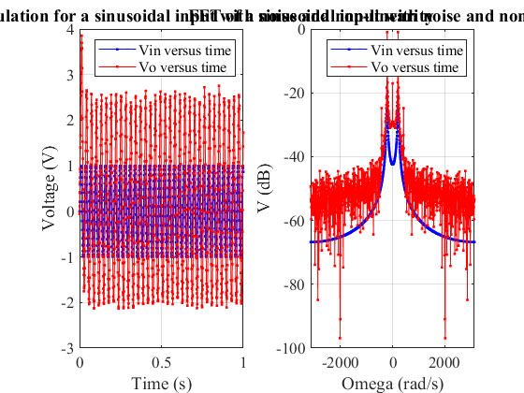

Helper functions
The following functions are helper functions used in the main code
% Helper function for mapping index
% @param iRow = i index for the row
% jRow = j index for the column
% ny = size of the y
function [n] = mappingEq(iRow, jCol, ny)
n = jCol + (iRow - 1) * ny;
end % End mappingEq
% Helper function to add the obstacles
% @ param boxLF = length of the box in fraction of region.x
% boxWF = width of the box in fraction of region.y
% region = region.x and region.y
function [numBox] = AddObstacles(boxLF, boxWF, region)
global boxes % Matrix for holding the boxes
% Find the x, y, w, h for the bottom box
xbb = region.x/2 - region.x*boxLF/2;
ybb = 0;
wbb = region.x*boxLF;
hbb = region.y * boxWF;
% Find the x, y, w, h for the upper box
xub = region.x/2 - region.x * boxLF/2;
yub = region.y * (1-boxWF);
wub = region.x * boxLF;
hub = region.y * boxWF;
% Create the boxes
boxes = [xbb ybb wbb hbb;
xub yub wub hub];
% Return number of boxes
numBox = height(boxes);
end % End AddObstacles
% This function add a bunch of electrons in a given region randomly for Q3
% @param numE = number of electrons
% region = region for the electrons
% T = temperature in Kelvin
% numBox = number of boxes
function AddElectrons_WithBox(numE, region, T, numBox)
global Const % Constants
global x y % arrays for current electron positions
global xp yp % arrays for previous electron positions
global vx vy % arrays for current electron velocities
global boxes % Matrix for the boxes position
% Create the arrays for electrons locations
x = rand(1, numE) * region.x;
y = rand(1, numE) * region.y;
% Loop through the electrons to make sure that no electrons inside obstacles
for iE = 1:numE
% Flag to indicate whether inside box
insideBox = true;
while (insideBox)
insideBox = false;
% Loop through the boxes
for iBox = 1:numBox
% Check for invalid electrons position
if (x(iE)>boxes(iBox, 1) && x(iE)<(boxes(iBox, 1)+boxes(iBox, 3)) ...
&& y(iE)>boxes(iBox, 2) && y(iE) < (boxes(iBox, 2)+boxes(iBox, 4)))
insideBox = true;
break;
end
end
if (insideBox)
% Regenerate position
x(iE) = rand() * region.x;
y(iE) = rand() * region.y;
end
end
end
% Create the arrays for previous electron positions
xp = x;
yp = y;
% Create helper arrays for velocity distrubution
vx = sqrt(Const.kb*T/Const.mn).*randn(1, numE);
vy = sqrt(Const.kb*T/Const.mn).*randn(1, numE);
end % End AddElectrons_WithBox
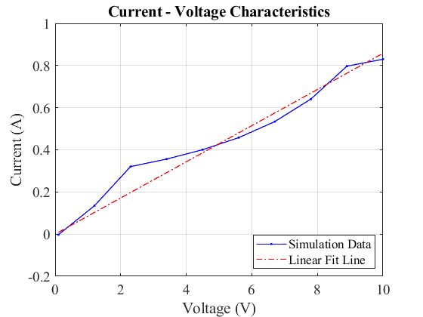
Published with MATLAB® R2021b

