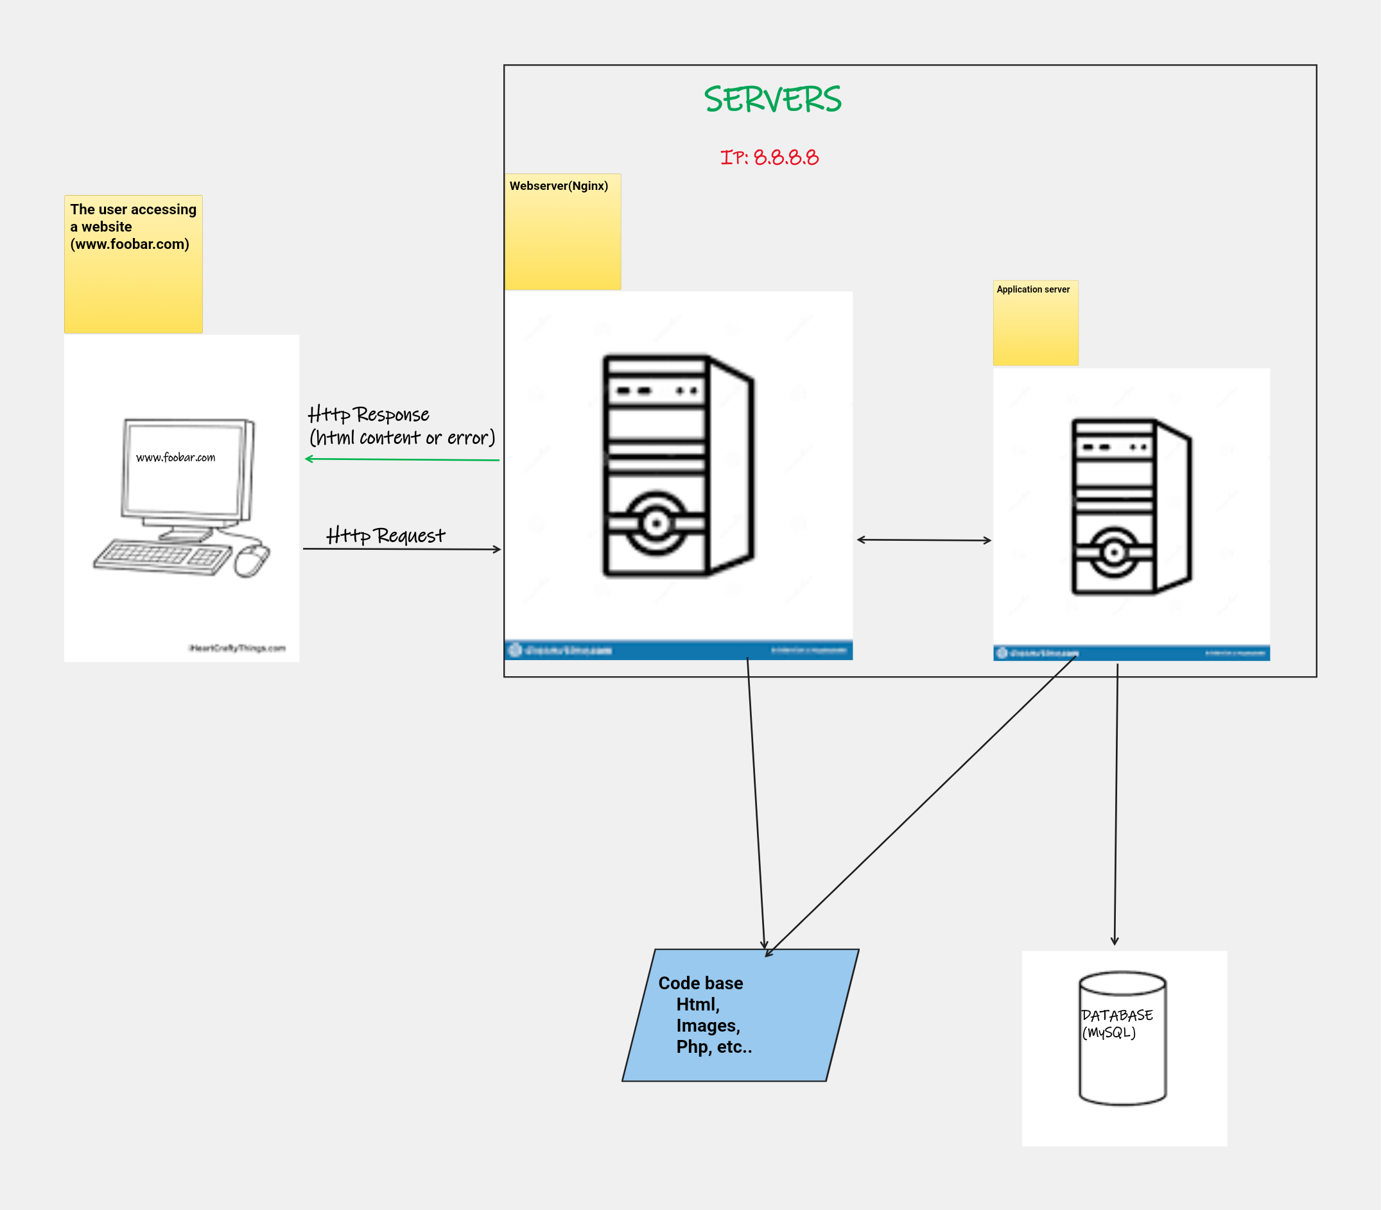

A Server is a computer program that manages access to a resource or

service in a network. We have many types of servers, the most commonly

used server are web and application server.

A web server is a computer that stores web server software and websites

components files e.g html, css, images e.t.c.

An application server is a server that host applications or softwares through

a communication protocol.

In the foobar.com domain are resolved by the authoritative DNS. The application

server role is to act as host for the user and enhance performance for applications.

While the web server is to accept a request for data and send the relevant documents.

The role of a database is to allow different data sets to relate to one another. The server

uses HTTP to communicate with the computer of the user.

**Issues of the above diagram are:**

**1: SCOP (Single point of failure):** itrefers to one malfunction can allow the whole system

to stop operating.

2: **Downtime when maintenance needed (like deploying new code web server needs to be restarted)**

**3: Cannot scale if too much incoming traffic**