Sparteca Exports to New Zealand

Report Prepared by ECO, 28 September 2021

# Summary

* There was $242 million trade of exports from pacific countries into New Zealand, of which the majority of exports was claimed either through MFN ($175 m) and Sparteca ($55 m)
* Fiji is the largest driver of exports into New Zealand and makes up 46% of total exports into New Zealand, of which 90% of total Sparteca exports are claimed
* however, as a percentage of total country exports claimed using Sparteca, Niue claims over 60%, followed by Fiji (of 46%)
* There is slightly more claimed under Non-Agricultural than Agricultural goods, however, there is little difference in amount claimed under Sparteca,
* The largest sector exports are within Agr, Fruits and nuts ($X), followed by Wood ($X) then other food products ($X)
* However, as a proportion of Sector trade, X, Y and Z have the highest utilisation of Sparteca,

## Report

In-coming trade from the Pacific is approximately $242 million, of which about $175 million (75%) comes under MFN, and about $55 million comes under Sparteca. Fiji is the largest contributor to trade for the Pacific Island Countries (PICs), making up $111 million (46%) of total incoming trade. Following Fiji, is PNG (of $52 million), Solomon Islands ($27) million, and Samoa($24 million).

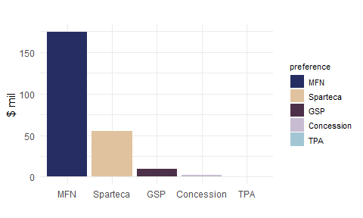

Figure 1: Total PIC Exports by Preference

Table 1: Exports by Country

|  |  |  |
| --- | --- | --- |
| Country | Exports, $ mil | % Total |
| Fiji | 110.8 | 45.6 |
| PNG | 52.4 | 21.6 |
| Solomon Islands | 26.6 | 10.9 |
| Samoa | 23.8 | 9.8 |
| Tonga | 14.7 | 6.1 |
| Cook Islands | 12.7 | 5.2 |
| Niue | 1.4 | 0.6 |
| Kitibati | 0.4 | 0.2 |
| Nauru | 0.0 | 0.0 |
| Tuvalu | 0.0 | 0.0 |

Sparteca uptake across countries is varied but in general remains low. As a percentage of countries own total trade (RHS graph), Niue has the highest Sparteca uptake, however exports were about $1 million, Fiji is the next country who has the highest proportion of total trade claimed under Sparteca (about 44%). However, Fiji accounts for almost 90% of total incoming trade under Sparteca compared to other PICs.

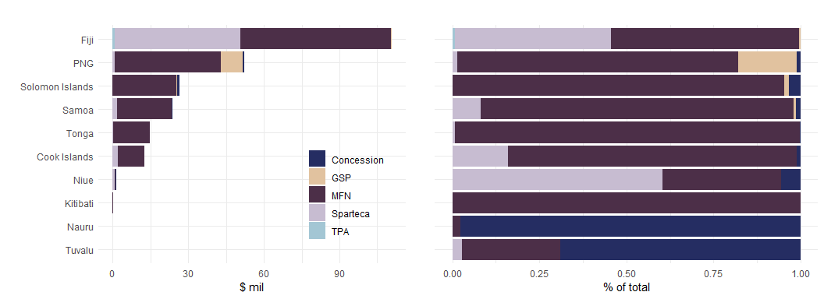

Figure 2: Exports by Country and by Preference

Table 2: Exports by Country and Preferece, $ mil’s

|  |  |  |  |  |
| --- | --- | --- | --- | --- |
| Country | MFN | Sparteca | GSP | Concession |
| Fiji | 59.9 | 49.8 | 0.4 | 0.0 |
| PNG | 42.2 | 0.8 | 8.7 | 0.6 |
| Solomon Islands | 25.3 | 0.0 | 0.3 | 0.9 |
| Samoa | 21.4 | 1.9 | 0.2 | 0.3 |
| Tonga | 14.6 | 0.1 | 0.0 | 0.0 |
| Cook Islands | 10.5 | 2.0 | 0.0 | 0.1 |
| Niue | 0.5 | 0.8 | 0.0 | 0.1 |
| Kitibati | 0.4 | 0.0 | 0.0 | 0.0 |
| Nauru | 0.0 | 0.0 | 0.0 | 0.0 |
| Tuvalu | 0.0 | 0.0 | 0.0 | 0.0 |

There is little difference between Agricultural and Non-Agricultural trade exports to New Zealand from PICS [1], both in terms of value and claims under preference. There was $115 million worth of Agricultural products, and $128 million worth of Non-Agricultural products , of which $27.4 and $28.1 were claimed under Sparteca respectively. In each case, the majority being claimed under MFN and Fiji being main country to utilise exports under Sparteca.

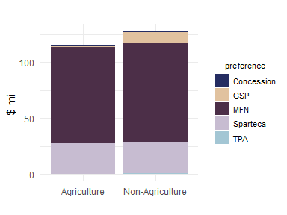

Figure 3: Exportts by Agricultural Products

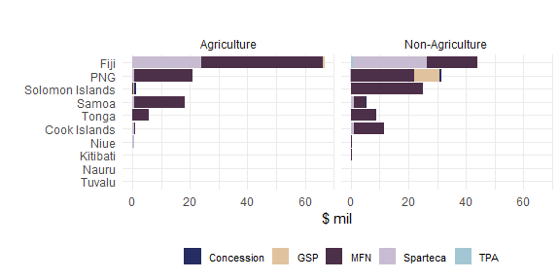

Figure 4: Exports by Country and Agricultural Products

Some of the highest sector exports are have very low rates of trade being claimed under Sparteca. For example, The fruit, nuts, vegetables and plant sector exported $48.4 million, however 5% ($2.22 million) was claimed under Sparteca., with the majority being MFN (95%). This is similar for wood, pulp and paper (worth $46.9 million), with less than 1% of trade being claimed under. Some sectors such as:

* Other foods products, worth $X and X% claimed under Sparteca,
* Clothing and footwear, worth $X and X% claimed under Sparteca, and
* Chemicals and chemical products, worth $X and X% being claimed under Sparteca.

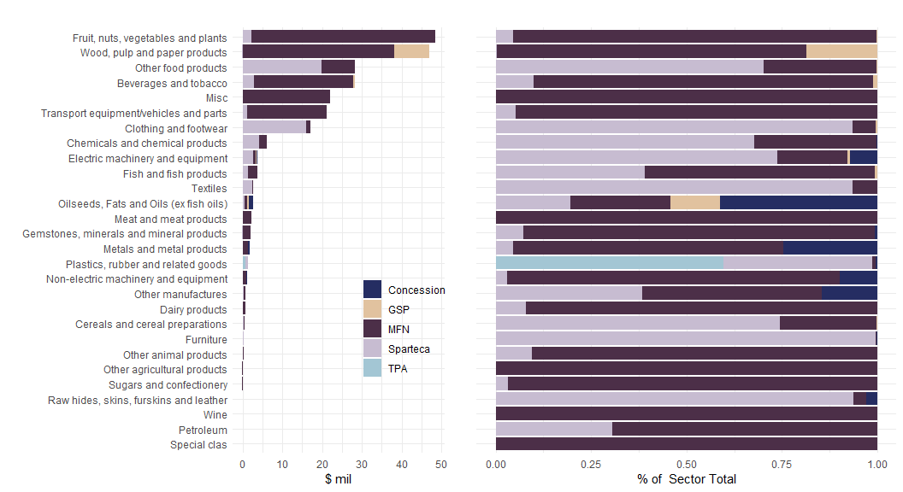

Figure 5: Exports by Sector

Table 3: Exports by Sector and Preferece, $ mil’s

|  |  |  |  |  |
| --- | --- | --- | --- | --- |
| Sector | MFN | Sparteca | Concession | GSP |
| Fruit, nuts, vegetables and plants | 46.1 | 2.2 | 0.0 | 0.1 |
| Wood, pulp and paper products | 38.1 | 0.1 | 0.0 | 8.8 |
| Beverages and tobacco | 25.0 | 2.8 | 0.0 | 0.3 |
| Misc | 22.0 | 0.0 | 0.0 | 0.0 |
| Transport equipment/vehicles and parts | 20.1 | 1.1 | 0.0 | 0.0 |
| Other food products | 8.4 | 19.9 | 0.0 | 0.0 |
| Fish and fish products | 2.2 | 1.4 | 0.0 | 0.0 |
| Meat and meat products | 2.2 | 0.0 | 0.0 | 0.0 |
| Chemicals and chemical products | 2.0 | 4.2 | 0.0 | 0.0 |
| Gemstones, minerals and mineral products | 1.9 | 0.2 | 0.0 | 0.0 |
| Metals and metal products | 1.3 | 0.1 | 0.4 | 0.0 |
| Clothing and footwear | 1.0 | 16.0 | 0.0 | 0.1 |
| Non-electric machinery and equipment | 1.0 | 0.0 | 0.1 | 0.0 |
| Dairy products | 0.7 | 0.1 | 0.0 | 0.0 |
| Oilseeds, Fats and Oils (ex fish oils) | 0.7 | 0.5 | 1.1 | 0.3 |
| Electric machinery and equipment | 0.7 | 2.7 | 0.3 | 0.0 |
| Other manufactures | 0.4 | 0.3 | 0.1 | 0.0 |
| Other animal products | 0.3 | 0.0 | 0.0 | 0.0 |
| Textiles | 0.2 | 2.6 | 0.0 | 0.0 |
| Other agricultural products | 0.2 | 0.0 | 0.0 | 0.0 |
| Cereals and cereal preparations | 0.1 | 0.4 | 0.0 | 0.0 |
| Sugars and confectionery | 0.1 | 0.0 | 0.0 | 0.0 |
| Plastics, rubber and related goods | 0.0 | 0.5 | 0.0 | 0.0 |
| Wine | 0.0 | 0.0 | 0.0 | 0.0 |
| Furniture | 0.0 | 0.3 | 0.0 | 0.0 |
| Raw hides, skins, furskins and leather | 0.0 | 0.0 | 0.0 | 0.0 |
| Petroleum | 0.0 | 0.0 | 0.0 | 0.0 |
| Special clas | 0.0 | 0.0 | 0.0 | 0.0 |

1. Note: Agricultural goods is defined by HS01 to HS24 codes