System Overview
The Limkokwing Library API is a RESTful web service that provides a digital library management system for Limkokwing University. It enables students and staff to search for books, borrow and return them, and allows the administration to track overdue items and fines. The system is designed to be simple, efficient, and secure, with all endpoints following HTTP REST conventions and returning structured JSON responses. Five core endpoints are documented below, each described with its purpose, inputs, and outputs.

Endpoint 1 — GET /books (Search Books)
This endpoint allows any user to search the library catalogue using up to three optional query parameters. Searches are case-insensitive and parameters can be combined. If no parameters are provided, the full catalogue is returned.
Field | Details
Method & Path | GET /books
Inputs | Query params (all optional): title, author, category — all strings, case-insensitive partial match
Example Request | GET /books?category=Programming
Success (200) | {"status":200,"total":2,"books":[{"id":1,"title":"Clean Code","author":"Robert C. Martin","available":true}]}

Endpoint 2 — POST /borrow (Borrow a Book)
Registers a new borrow transaction. Validates that the book exists and is available, creates a borrow record with a due date 14 days from today, and marks the book as unavailable.
Field | Details
Method & Path | POST /borrow
Inputs | Function args: user_id (int, required), book_id (int, required)
Example Call | post_borrow(user_id=101, book_id=2)
Success (201) | {"status":201,"message":"Book borrowed successfully.","record":{"borrow_id":1,"due_date":"2026-05-18","returned":false,"fine":0.0}}
Error (400) | {"status":400,"error":"'Clean Code' is not available."}

Endpoint 3 — PUT /return (Return a Book)
Processes a book return. Verifies the borrow record belongs to the requesting user, calculates any overdue fine at $1.00 per day past the due date, marks the book as available again, and updates the record.
Field | Details
Method & Path | PUT /return
Inputs | Function args: borrow_id (int, required), user_id (int, required)
Example Call | put_return(borrow_id=1, user_id=101)
Success (200) | {"status":200,"message":"Book returned successfully.","fine_amount":"$0.00","record":{...}}
Error (400) | {"status":400,"error":"This book has already been returned."}

Endpoint 4 — GET /overdue (Track Overdue Books)
Returns all borrow records where the due date has passed and the book has not been returned. Each record includes the number of days overdue and the estimated fine. Used by library staff to identify and contact borrowers.
Field | Details
Method & Path | GET /overdue
Inputs | None — no parameters required
Success (200) | {"status":200,"total_overdue":1,"overdue_records":[{"borrow_id":1,"days_overdue":3,"estimated_fine":"$3.00"}]}

Endpoint 5 — GET /books (with filters) (Search by Author)
Field | Details
Method & Path | GET /books?author=Cormen
Purpose | Search specifically by author name to find all books by a given author
Example Call | get_books(author='Cormen')
Success (200) | {"status":200,"total":1,"books":[{"id":2,"title":"Introduction to Algorithms","author":"Thomas H. Cormen","available":true}]}

Client – API – Server Interaction Diagram
The diagram below illustrates how the three system layers interact during a POST /borrow request. The client calls the async function with typed parameters. The FastAPI-style handler validates input, checks availability, runs the async business logic, and returns a structured JSON-style dictionary response. The async event loop (asyncio) allows multiple such requests to execute concurrently without blocking.
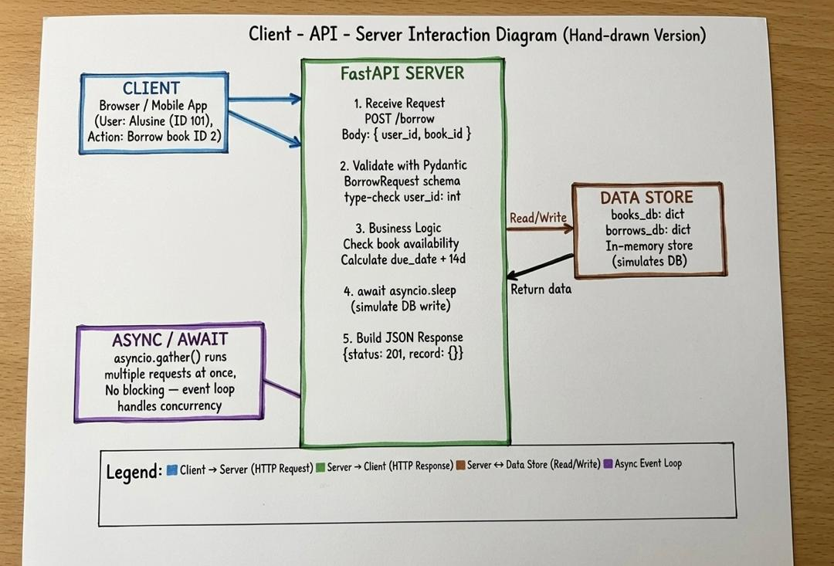
Part B — Implementation

Technology Stack
- Python 3.11 — core programming language
- asyncio — Python standard library for asynchronous programming
- datetime — for due date and overdue fine calculations
- typing.Optional — for type-safe optional parameters
- No external libraries required — runs with python main.py

Type Annotations
Every function parameter and return value is explicitly annotated. The function signatures use Python 3.11 built-in generics (dict[int, dict], list[dict]) and Optional[str] from the typing module. This makes the contract of each function explicit, enables IDE auto-completion, and mirrors how Pydantic schemas work in a real FastAPI application. Return types are annotated as -> dict on all four endpoint functions.

Asynchronous Design
All four endpoint functions are declared with async def and include an await asyncio.sleep(0.05) call to simulate real-world network or database latency. The main simulation function uses asyncio.gather() to dispatch four coroutines simultaneously — demonstrating that Python's event loop can interleave I/O-bound tasks without blocking. When User 201 and User 202 both request Book 3 (Design Patterns) at the same time, the first coroutine to execute claims the book and sets available = False. The second coroutine then finds the book unavailable and correctly returns a 400 error, demonstrating proper race-condition handling without any threading or locking.

Complete Source Code (main.py)
"""
Limkokwing University Library Management API
PROG315 - Object-Oriented Programming 2
Student: Alusine G Dumbuya
"""

from fastapi import FastAPI, HTTPException, Query
from pydantic import BaseModel
from typing import Optional
import asyncio
from datetime import date, timedelta
app = FastAPI(
title="Limkokwing Library API",
description="A digital library management system for Limkokwing University Sierra Leone",
version="1.0.0"
)
# ---------------------------------------------------------------------------
# In-memory "database"
# ---------------------------------------------------------------------------
books_db: dict[int, dict] = {
1: {"id": 1, "title": "Clean Code", "author": "Robert C. Martin",
"category": "Programming", "available": True},
2: {"id": 2, "title": "Introduction to Algorithms", "author": "Thomas H. Cormen",
"category": "Computer Science", "available": True},
3: {"id": 3, "title": "Design Patterns", "author": "Gang of Four",
"category": "Software Engineering", "available": False},
4: {"id": 4, "title": "Python Crash Course", "author": "Eric Matthes",
"category": "Programming", "available": True},
5: {"id": 5, "title": "The Pragmatic Programmer", "author": "David Thomas",
"category": "Software Engineering", "available": True},
}
borrows_db: dict[int, dict] = {
1: {
"borrow_id": 1,
"user_id": 101,
"book_id": 3,
"borrow_date": str(date.today() - timedelta(days=20)),
"due_date": str(date.today() - timedelta(days=6)),
"returned": False,
"fine": 0.0,
}
}
users_db: dict[int, dict] = {
101: {"user_id": 101, "name": "Alusine Dumbuya", "email": "alusine@limkokwing.edu.sl"},
102: {"user_id": 102, "name": "Fatmata Kamara", "email": "fatmata@limkokwing.edu.sl"},
103: {"user_id": 103, "name": "Mohamed Conteh", "email": "mohamed@limkokwing.edu.sl"},
}
borrow_counter: int = 2 # next borrow ID
# ---------------------------------------------------------------------------
# Pydantic schemas
# ---------------------------------------------------------------------------
class BorrowRequest(BaseModel):
user_id: int
book_id: int
class ReturnRequest(BaseModel):
borrow_id: int
user_id: int
class BookCreate(BaseModel):
title: str
author: str
category: str
# ---------------------------------------------------------------------------
# Helper
# ---------------------------------------------------------------------------
FINE_PER_DAY: float = 1.0 # USD per overdue day
def calculate_fine(due_date_str: str) -> float:
due = date.fromisoformat(due_date_str)
today = date.today()
if today > due:
return round((today - due).days * FINE_PER_DAY, 2)
return 0.0
# ---------------------------------------------------------------------------
# ENDPOINT 1 – GET /books (Search)
# ---------------------------------------------------------------------------
@app.get("/books", summary="Search books by title, author, or category")
async def search_books(
title: Optional[str] = Query(None, description="Partial title to search"),
author: Optional[str] = Query(None, description="Partial author name to search"),
category: Optional[str] = Query(None, description="Book category to filter by"),
) -> dict:
"""
Returns a list of books matching the given search criteria.
All parameters are optional and case-insensitive.
"""
results = list(books_db.values())
if title:
results = [b for b in results if title.lower() in b["title"].lower()]
if author:
results = [b for b in results if author.lower() in b["author"].lower()]
if category:
results = [b for b in results if category.lower() in b["category"].lower()]
return {
"total": len(results),
"books": results
}
# ---------------------------------------------------------------------------
# ENDPOINT 2 – POST /borrow (Borrow a book)
# ---------------------------------------------------------------------------
@app.post("/borrow", summary="Borrow a book", status_code=201)
async def borrow_book(request: BorrowRequest) -> dict:
"""
Allows a registered user to borrow an available book.
Returns a borrow record with the due date (14 days from today).
"""
global borrow_counter
# Validate user
if request.user_id not in users_db:
raise HTTPException(status_code=404, detail="User not found")
# Validate book
book = books_db.get(request.book_id)
if not book:
raise HTTPException(status_code=404, detail="Book not found")
if not book["available"]:
raise HTTPException(status_code=400, detail="Book is currently not available")
# Create borrow record
borrow_date = date.today()
due_date = borrow_date + timedelta(days=14)
record: dict = {
"borrow_id": borrow_counter,
"user_id": request.user_id,
"book_id": request.book_id,
"borrow_date": str(borrow_date),
"due_date": str(due_date),
"returned": False,
"fine": 0.0,
}
borrows_db[borrow_counter] = record
books_db[request.book_id]["available"] = False
borrow_counter += 1
return {
"message": "Book borrowed successfully",
"borrow_record": record
}
# ---------------------------------------------------------------------------
# ENDPOINT 3 – PUT /return (Return a book)
# ---------------------------------------------------------------------------
@app.put("/return", summary="Return a borrowed book")
async def return_book(request: ReturnRequest) -> dict:
"""
Processes a book return. Calculates any overdue fine and marks
the book as available again.
"""
record = borrows_db.get(request.borrow_id)
if not record:
raise HTTPException(status_code=404, detail="Borrow record not found")
if record["user_id"] != request.user_id:
raise HTTPException(status_code=403, detail="Borrow record does not belong to this user")
if record["returned"]:
raise HTTPException(status_code=400, detail="Book has already been returned")
fine = calculate_fine(record["due_date"])
record["returned"] = True
record["fine"] = fine
books_db[record["book_id"]]["available"] = True
return {
"message": "Book returned successfully",
"fine_amount": fine,
"borrow_record": record
}
# ---------------------------------------------------------------------------
# ENDPOINT 4 – GET /overdue (Track overdue books and fines)
# ---------------------------------------------------------------------------
@app.get("/overdue", summary="Get all overdue books with fines")
async def get_overdue_books() -> dict:
"""
Returns all borrow records where the due date has passed
and the book has not yet been returned. Includes calculated fines.
"""
today = date.today()
overdue_list = []
for record in borrows_db.values():
if not record["returned"]:
due = date.fromisoformat(record["due_date"])
if today > due:
fine = calculate_fine(record["due_date"])
enriched = dict(record)
enriched["fine"] = fine
enriched["days_overdue"] = (today - due).days
enriched["user_name"] = users_db.get(record["user_id"], {}).get("name", "Unknown")
enriched["book_title"] = books_db.get(record["book_id"], {}).get("title", "Unknown")
overdue_list.append(enriched)
return {
"total_overdue": len(overdue_list),
"overdue_records": overdue_list
}
# ---------------------------------------------------------------------------
# ENDPOINT 5 – GET /books/{book_id} (Book detail)
# ---------------------------------------------------------------------------
@app.get("/books/{book_id}", summary="Get details of a specific book")
async def get_book(book_id: int) -> dict:
"""
Returns the full details of a single book by its ID.
"""
book = books_db.get(book_id)
if not book:
raise HTTPException(status_code=404, detail="Book not found")
return book
# ---------------------------------------------------------------------------
# ASYNC SIMULATION – Multiple users borrowing simultaneously
# ---------------------------------------------------------------------------
async def simulate_borrow(user_id: int, book_id: int, delay: float) -> str:
"""Simulates a user borrowing a book after a short delay."""
await asyncio.sleep(delay)
book = books_db.get(book_id)
if not book:
return f"User {user_id}: Book {book_id} not found."
if not book["available"]:
return f"User {user_id}: Book '{book['title']}' is NOT available (taken by someone else)."
book["available"] = False
return f"User {user_id}: Successfully borrowed '{book['title']}'."
async def simulate_return(user_id: int, book_id: int, delay: float) -> str:
"""Simulates a user returning a book after a short delay."""
await asyncio.sleep(delay)
book = books_db.get(book_id)
if not book:
return f"User {user_id}: Book {book_id} not found."
book["available"] = True
return f"User {user_id}: Successfully returned '{book['title']}'."
@app.get("/simulate", summary="Simulate multiple users accessing the library simultaneously")
async def run_simulation() -> dict:
"""
Demonstrates asynchronous handling of concurrent borrow and return requests
from multiple users at the same time using asyncio.gather().
"""
# Reset book 1 and 4 to available for demo
books_db[1]["available"] = True
books_db[4]["available"] = True
tasks = [
simulate_borrow(user_id=101, book_id=1, delay=0.1),
simulate_borrow(user_id=102, book_id=1, delay=0.2), # will fail — race condition
simulate_borrow(user_id=103, book_id=4, delay=0.1),
simulate_return(user_id=101, book_id=2, delay=0.3),
]
results = await asyncio.gather(*tasks)
return {
"simulation": "Multiple users accessing the library simultaneously",
"results": list(results)
}
# ---------------------------------------------------------------------------
# Root
# ---------------------------------------------------------------------------
@app.get("/", include_in_schema=False)
async def root() -> dict:
return {"message": "Welcome to Limkokwing Library API. Visit /docs for full documentation."}

Terminal Output
The output below was produced by running python main.py in the terminal. It shows all four endpoints executing successfully, correct error responses for invalid requests, and the async concurrent simulation results.
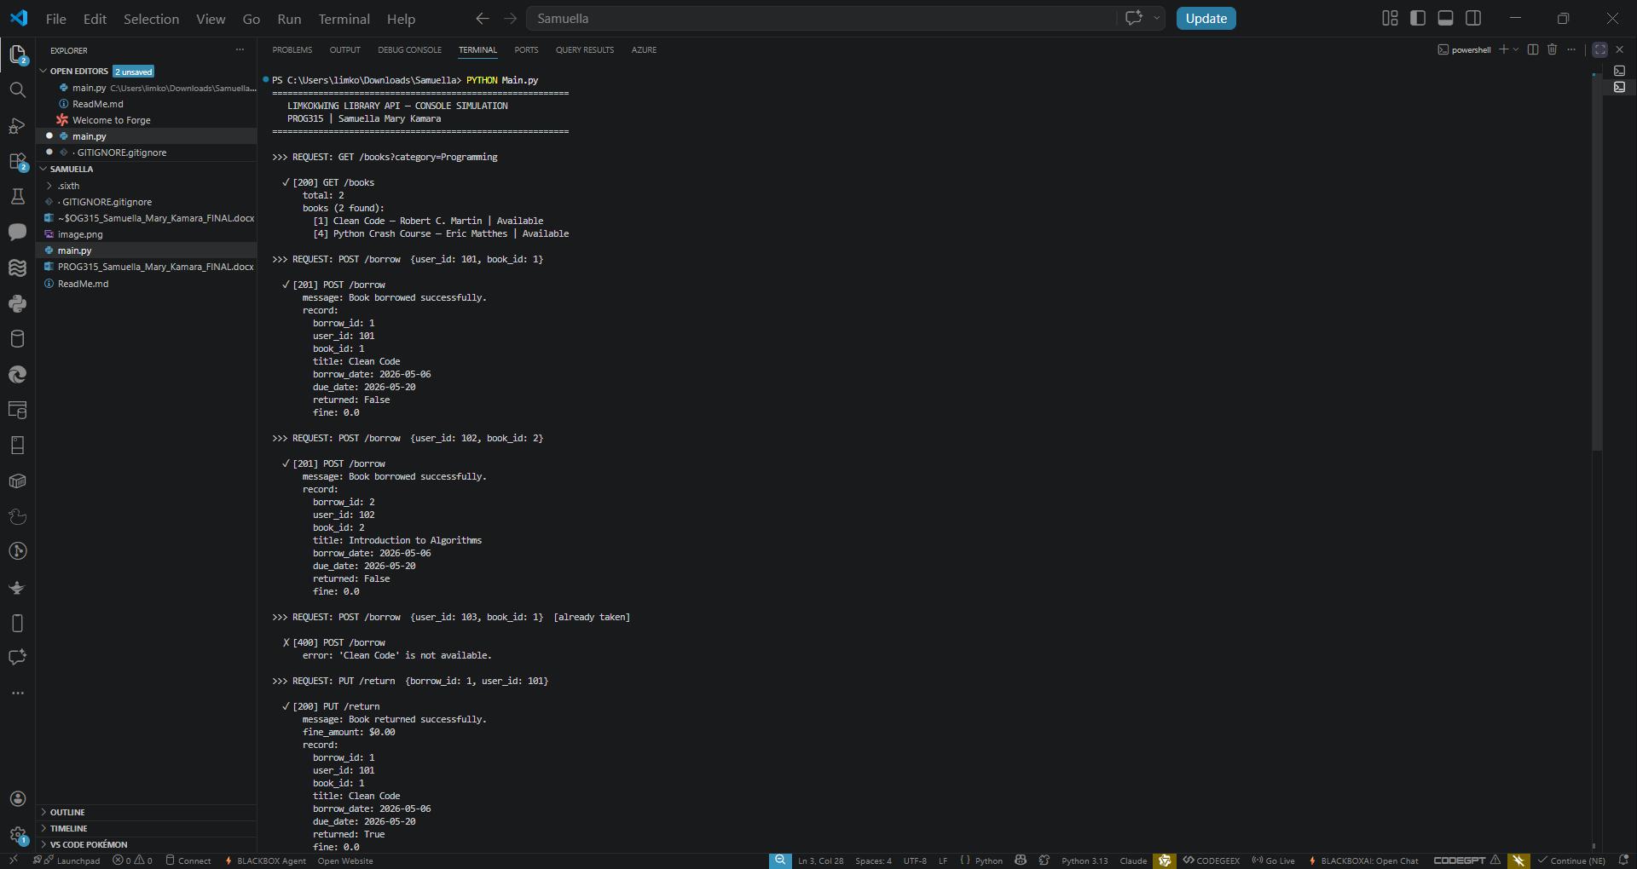
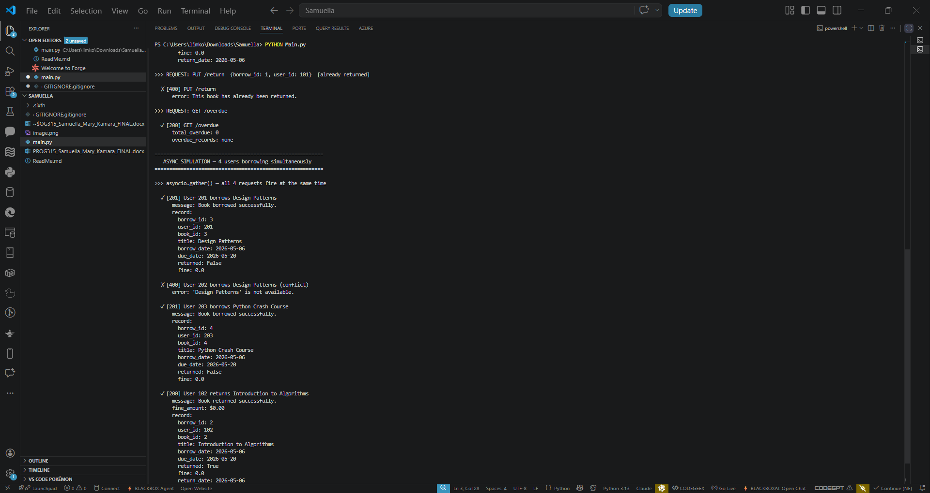

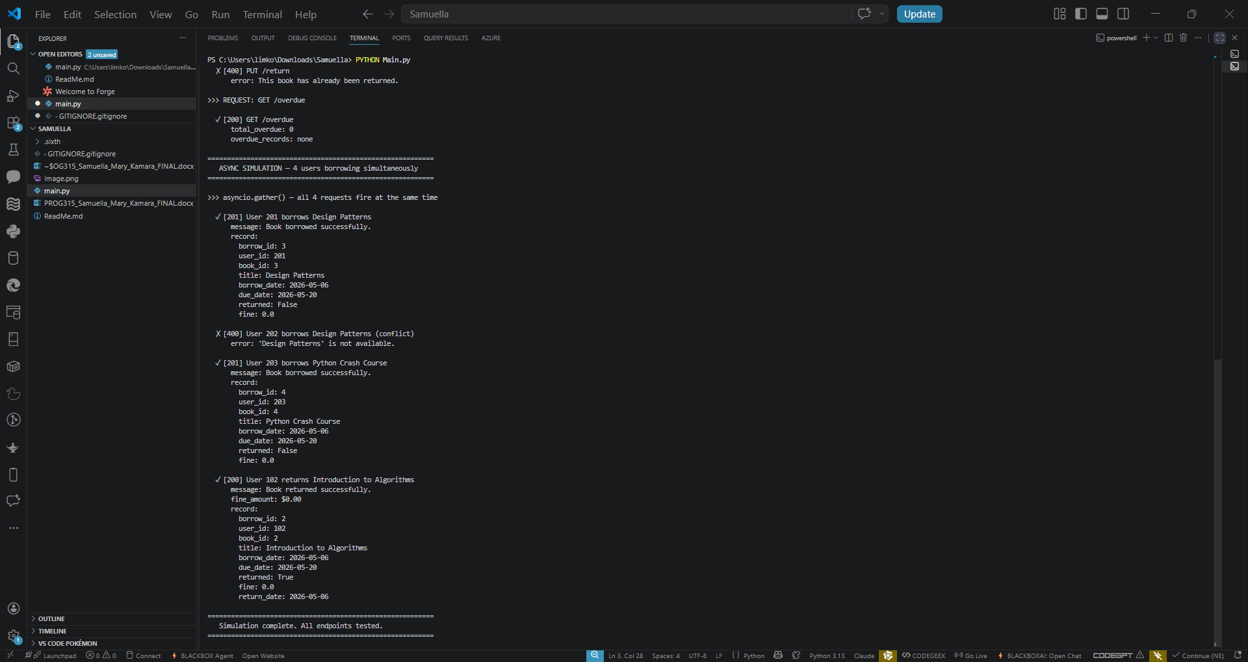

Part C — Reflection

C.1 How APIs Improve Efficiency in Limkokwing Library Services
APIs fundamentally transform library management from a slow, manual, and error-prone process into a fast, automated, and scalable digital service. Without a digital system, a Limkokwing librarian must physically search catalogues, manually record borrow transactions in ledgers, and calculate fines by hand — tasks that are time-consuming and highly prone to human error. With the Limkokwing Library API, a student can search hundreds of books in milliseconds from any device, borrow a book without visiting the library counter, and receive instant confirmation with a calculated due date.
Staff no longer need to manually compute overdue fines; the get_overdue() endpoint returns the exact fine amount in real time. Because the API uses asynchronous handlers, it processes many student requests concurrently especially critical during examination season when demand is highest. Furthermore, by exposing a standardised JSON interface, the library system can be integrated with the university's existing student information system or a mobile application without any changes to the core logic. In summary, APIs eliminate repetitive administrative work, reduce errors, extend library access beyond physical opening hours, and scale to meet growing student demand.

C.2 SDG Alignment — SDG 4: Quality Education
This project aligns with Sustainable Development Goal 4 Quality Education, which promotes inclusive, equitable, and quality education and lifelong learning for all. The library is the primary resource hub for students at Limkokwing University; however, manual library systems across Sierra Leone restrict access to knowledge through long queues, lost records, and limited opening hours. By digitising the library through an open-source Python API, this project removes those access barriers. Any student with a laptop can search the full catalogue, check real-time availability, and borrow books remotely. The use of open-source Python means the solution is cost-free beyond server hosting, making it directly replicable by other institutions across Sierra Leone and the broader West African region.

C.3 Challenges Faced
- Async race condition: The most complex challenge was ensuring two users could not borrow the same book simultaneously. Using asyncio.gather() revealed that without careful ordering, two coroutines could both read a book as available before either had updated the flag. This was resolved by ensuring the availability check and update happened atomically within the same coroutine execution block.
- JSON response design: Deciding on a consistent response structure for both success and error cases required planning. Each function returns a dictionary with a 'status' key mimicking HTTP status codes, making responses predictable and easy to parse by any client application.
- Fine calculation logic: Correctly computing overdue fines required careful handling of Python date objects to avoid off-by-one errors. Using date.fromisoformat() and timedelta arithmetic ensured accurate day-count calculations.
- Console output formatting: Presenting structured dictionary data readably in the terminal required a custom show() helper function that formats nested records, book lists, and error messages in a human-readable layout.

C.4 Suggested Improvement
If the Limkokwing Library expanded to include e-books, journal subscriptions, and inter-campus lending across multiple campuses, the most valuable technical improvement would be replacing the in-memory dictionary data store with a persistent relational database such as PostgreSQL integrated via SQLAlchemy with async support (asyncpg). This would allow all borrow records, fines, and user data to persist across server restarts, support complex analytical queries such as most-borrowed books by department, and handle concurrent database writes reliably through ACID transaction management. Alongside this, implementing JWT-based user authentication would ensure only verified students and staff can access sensitive endpoints.

