Samuel Rincon

**Project One**

* This project is part of the full-stack development for Grazioso Salvare, an international rescue-animal training company.
* The project includes a MongoDB database that stores data on animals in shelters, and a Python module that performs CRUD (Create, Read, Update, Delete) operations on this database.

**Purpose of the CRUD Python Module**

* The CRUD module interacts with a MongoDB database to allow users to add, retrieve, update, and delete records of animals in the shelter system.
* This functionality supports Grazioso Salvare in identifying animals for search-and-rescue training.

**How to Use the CRUD Module**

Prerequisites:

- Ensure MongoDB is installed and running on your machine.

- Install the required Python packages using:

pip install pymongo

**Running the Module:**

* The `animal_shelter.py` file contains a class `AnimalShelter` that provides methods for CRUD operations.
* You can use the following methods in a Python script or Jupyter Notebook to interact with the MongoDB database:

- create()

- read()

- update()

- delete()

**CRUD Operations**

1. Create

* This method inserts a new document into the MongoDB collection.

new_animal = {

"animal_id": "A67890",

"name": "Buddy",

"breed": "Golden Retriever",

"age": 3,

"outcome": "Adopted"

}

shelter.create(new_animal)

2. Read

* This method retrieves documents from the MongoDB collection based on a query.

query = {"outcome": "Adopted"}

result = shelter.read(query)

if result:

print("Matching documents found:")

for doc in result:

print(doc)

else:

print("No matching documents found.")

3. Update

* This method updates a document in the MongoDB collection.

update_query = {"animal_id": "A67890"}

new_values = {"age": 4}

shelter.update(update_query, new_values)

4. Delete

* This method deletes a document from the MongoDB collection.

delete_query = {"animal_id": "A67890"}

shelter.delete(delete_query)

**Demonstration of CRUD Operations**

* Below is the screenshot demonstrating the successful execution of the CRUD operations in a Jupyter Notebook:

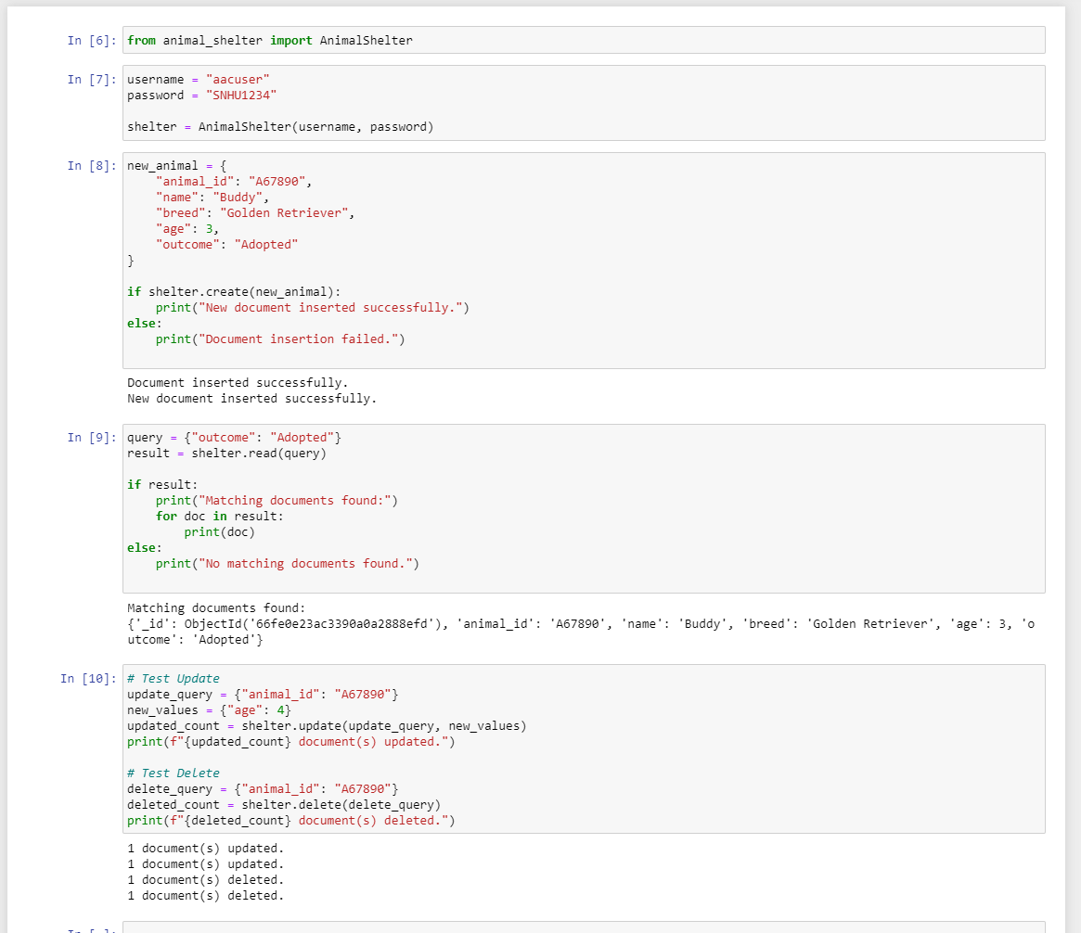

**Conclusion**

* This project provides the Grazioso Salvare organization with a full CRUD application using MongoDB.
* The Python module developed here enables efficient management of animal records, ensuring that the system can support search-and-rescue dog identification in a scalable and maintainable way.