# CS 499 Module One Assignment Template

Complete this template by replacing the bracketed text with the relevant information.

1. **Self-Introduction:** Address all of the following questions to introduce yourself.
   1. How long have you been in the Computer Science program?

I have spent three years completing an associate degree and two years pursuing my bachelor's degree in Computer Science, making it a total of five years in the field.

* 1. What have you learned while in the program? List three of the most important concepts or skills you have learned.

The three most important skills I have learned are problem-solving, responsibility, and perseverance. These skills have shaped my approach to tackling challenges in computer science and beyond.

* 1. Discuss the specific skills you aim to demonstrate through your enhancements to reach each of the course outcomes.

Through my enhancements, I aim to demonstrate better communication and writing skills. This includes structuring technical documents clearly, effectively presenting code and ideas, and ensuring that my work meets professional standards.

* 1. How do the specific skills you will demonstrate align with your career plans related to your degree?

These skills align with my career plans because I aspire to be self-sufficient and take on leadership roles in the future. Improved communication and technical proficiency will enable me to take charge of projects and work effectively with teams.

* 1. How does this contribute to the specialization you are targeting for your career?

I am particularly interested in automation, and these enhancements will help me become more proficient in designing efficient solutions, which is essential for working in this specialization.

1. **ePortfolio Set Up:**
   1. Submit a **screen capture** of your ePortfolio GitHub Pages home page that clearly shows your URL.
      1. You already have a repository in GitHub where you uploaded projects in previous courses. Your ePortfolio will reside in GitHub but can link to work at other sites, such as Bitbucket.
   2. Use the GitHub Pages link in the Resource section for directions on:
      1. How to create your GitHub website and publish code to GitHub Pages
      2. Issues, such as adding links to other sites
   3. Paste a screenshot of your GitHub Pages home page with your URL clearly showing in the space below.

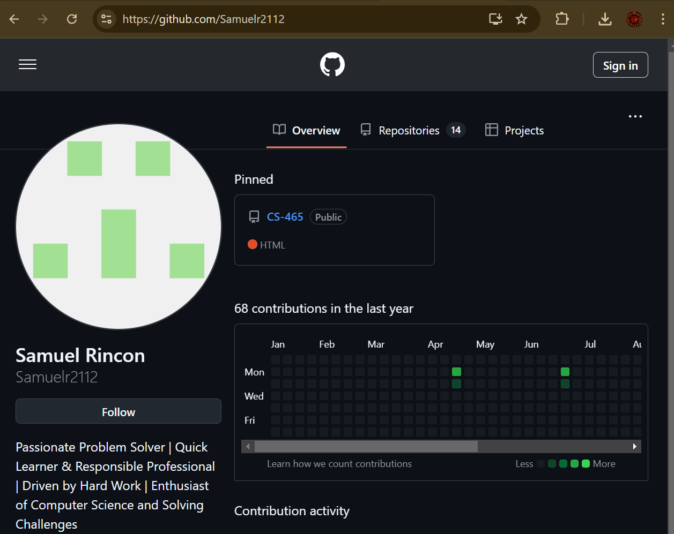

1. **Enhancement Plan:** 
   1. **Category One:** Software Engineering and Design
      1. **Select an** **artifact** that is **aligned with** **the** software engineering and design **category** and explain its origin. Submit a file containing the code for the artifact you choose with your enhancement plan.

Software Engineering and Design i. Select an artifact that is aligned with the software engineering and design category and explain its origin. Submit a file containing the code for the artifact you choose with your enhancement plan. For this category, I will use an artifact from my CS 320: Software Testing, Automation, and Quality Assurance course. This project involved developing unit tests for a mobile application that included Contact, Task, and Appointment services. The tests ensured compliance with requirements and robust error handling for various edge cases.

Note: Your artifact may be work from the following courses:

* IT 145: Foundation in Application Development
* CS 250: Software Development Lifecycle
* CS 260: Data Structures and Algorithms
* IT 315: Object Oriented Analysis and Design
* CS 320: Software Testing, Automation, and Quality Assurance
* CS 330: Computational Graphics and Visualization
* CS 340: Advanced Programming Concepts
* CS 350: Emerging Systems Architectures and Technologies
* CS 360: Mobile Architecture and Programming
* IT 365: Operating Environments
* IT 380: Cybersecurity and Information Assurance
* CS 405: Secure Coding
* CS 410: Reverse Software engineering
* IT 340: Network and Telecommunication Management
* IT 380: Cybersecurity and Information Assurance
  + 1. **Describe** a practical, well-illustrated **plan** for enhancement in alignment with the category, including a pseudocode or flowchart that illustrates the planned enhancement.

The enhancement involves expanding the test coverage to include integration testing for interactions between the services. Additionally, I will implement stress testing to assess the application's behavior under high workloads.

Pseudocode Example:

function stressTestContacts(service):

for i in range(1, 10000):

contact = createContact(i)

service.add(contact)

assert service.get(contact.id) == contact

function integrationTestServices():

contact = createContact()

task = createTask(contact.id)

service.addTask(task)

assert service.getTasks(contact.id).contains(task)

For this category of enhancement, consider improving a piece of software, transferring a project into a different language, reverse engineering a piece of software for a different operating system, or expanding a project’s complexity. These are just recommendations. Consider being creative and proposing an alternative enhancement to your instructor.

Think about what additions to include to complete the enhancement criteria in this category. Since one example option is to port to a new language, that is the kind of scale that is expected. This does not mean you need to port to a new language but instead have an equivalent scale of enhancement. Underlying expectations of any enhancement include fixing errors, debugging, and cleaning up comments, but these are not enhancements themselves.

* + 1. Explain how the planned enhancement will **demonstrate** specific **skills** and align with course outcomes.
       1. Identify and describe the specific skills you will demonstrate that align with the course outcome.
* Advanced testing techniques, including integration and stress testing.
* Ensuring system reliability and robustness.
  + - 1. Select one or more of the course outcomes below that your enhancement will align with.
* Design and evaluate computing solutions (CO3).
* Demonstrate innovative techniques in computing practices (CO4).

Course Outcomes:

1. Employ strategies for building collaborative environments that enable diverse audiences to support organizational decision-making in the field of computer science.
2. Design, develop, and deliver professional-quality oral, written, and visual communications that are coherent, technically sound, and appropriately adapted to specific audiences and contexts.
3. Design and evaluate computing solutions that solve a given problem using algorithmic principles and computer science practices and standards appropriate to its solution while managing the trade-offs involved in design choices.
4. Demonstrate an ability to use well-founded and innovative techniques, skills, and tools in computing practices for the purpose of implementing computer solutions that deliver value and accomplish industry-specific goals.
5. Develop a security mindset that anticipates adversarial exploits in software architecture and designs to expose potential vulnerabilities, mitigate design flaws, and ensure privacy and enhanced security of data and resources.
   1. **Category Two:** Algorithms and Data Structures
6. **Select an artifact** that is **aligned with the** algorithms and data structures **category** and explain its origin. Submit a file containing the code for the artifact you choose with your enhancement plan. You may choose work from the courses listed under Category One.

I will use an artifact from my CS 340: Advanced Programming Concepts course. This project involved implementing a graph traversal algorithm to find the shortest path between nodes in a network. The artifact includes the use of data structures such as adjacency lists and algorithms like Dijkstra's to optimize performance.

1. **Describe** a practical, well-illustrated **plan** for enhancement in alignment with the category, including a pseudocode or flowchart that illustrates the planned enhancement.

**I plan to enhance the artifact by adding support for weighted edges and incorporating a feature to dynamically update the graph as nodes or edges are added or removed. This will improve the artifact's real-world applicability, such as for route planning in logistics systems.**

Pseudocode Example:

function updateGraph(graph, edge, operation):

if operation == 'add':

graph.addEdge(edge)

elif operation == 'remove':

graph.removeEdge(edge)

recalculatePaths(graph)

function findShortestPath(graph, start, end):

initialize distances to infinity

set distance[start] = 0

while unvisited nodes exist:

current = node with smallest distance

for neighbor in current.neighbors:

calculate tentative distance

if tentative distance < known distance:

update distance

return distance[end]

For this category of enhancement, consider improving the efficiency of a project or expanding the complexity of the use of data structures and algorithms for your artifact. These are just recommendations. Consider being creative and proposing an alternative enhancement to your instructor. Note: You only need to choose one type of enhancement per category.

Think about what additions to include to complete the enhancement criteria in this category. Since one example option is to port to a new language, that is the kind of scale that is expected. Perhaps you might increase the efficiency and time complexity of an algorithm in an application and detail the logic of the increased time complexity. Remember, you do not need to port to a new language but instead have an equivalent scale of enhancement. Underlying expectations of any enhancement include fixing errors, debugging, and cleaning up comments, but these are not enhancements themselves.

1. Explain how the planned enhancement will **demonstrate** specific **skills** and align with course outcomes.
   1. Identify and describe the specific skills you will demonstrate to align with the course outcome.

* **Advanced problem-solving with algorithms.**
* **Designing efficient and scalable solutions.**
  1. Select one or more of the course outcomes listed under Category One that your enhancement will align with.
* Design and evaluate computing solutions (CO3).
* Demonstrate innovative techniques in computing practices (CO4).
  1. **Category Three: Databases**
     1. **Select an artifact** that is **aligned with the** databases **category** and explain its origin. Submit a file containing the code for the artifact you choose with your enhancement plan. You may choose work from the courses listed under Category One.

I will use an artifact from my CS 270: Database Systems course. This project involved designing and implementing a relational MySQL database to manage student records. It included creating tables, relationships, and queries to perform CRUD operations effectively.

* + 1. **Describe** a practical, well-illustrated **plan** for enhancement in alignment with the category, including a pseudocode or flowchart that illustrates the planned enhancement.

The enhancement involves optimizing query performance by adding indexes to frequently queried fields and introducing stored procedures to automate complex operations such as calculating aggregate data or validating inputs.

Pseudocode Example:

function addIndex(database, table, field):

query = "CREATE INDEX idx_" + field + " ON " + table + "(" + field + ")"

database.execute(query)

function createStoredProcedure(database):

procedure = "CREATE PROCEDURE CalculateGPA(student_id INT) BEGIN\n" +

"SELECT AVG(grade) AS GPA FROM grades WHERE student_id = student_id;\n" +

"END;"

database.execute(procedure)

For this category of enhancement, consider adding more advanced concepts of MySQL, incorporating data mining, creating a MongoDB interface with HTML/JavaScript, or building a full stack with a different programming language for your artifact. These are just recommendations; consider being creative and proposing an alternative enhancement to your instructor. Note: You only need to choose one type of enhancement per category.

Think about what additions to include to complete the enhancement criteria in this category. Since one example option is to port to a new language, that is the kind of scale that is expected. Perhaps you might increase the efficiency and time complexity of an algorithm in an application and detail the logic of the increased time complexity. Remember, you do not need to port to a new language but instead have an equivalent scale of enhancement. Underlying expectations of any enhancement include fixing errors, debugging, and cleaning up comments, but these are not enhancements themselves.

* + 1. Explain how the planned enhancement will **demonstrate** specific **skills** and align with course outcomes.
       1. Identify and describe the specific skills you will demonstrate that align with the course outcome.
* Optimizing relational database performance.
* Automating database processes using stored procedures.
  + - 1. Select one or more of the course outcomes listed under Category One that your enhancement will align with.
* Design and evaluate computing solutions (CO3).
* Develop a security mindset to ensure privacy and enhanced security of data (CO5).

1. **ePortfolio Overall Skill Set**
   1. Accurately describe the **skill set** to be illustrated by the **ePortfolio** **overall**.
      1. Skills and outcomes planned to be illustrated in the code review

The code review will illustrate problem-solving, attention to detail, and adherence to best coding practices.

* + 1. Skills and outcomes planned to be illustrated in the narratives

The narratives will highlight communication skills and the ability to explain technical concepts clearly and concisely.

* + 1. Skills and outcomes planned to be illustrated in the professional self-assessment

The self-assessment will showcase my ability to reflect on my growth, identify areas for improvement,

and align my skills with industry needs.