Enterprise Risk Assessment of Apple Inc.’s Proposed Acquisition of Netflix

A Competitive Intelligence and Quantitative Risk Analytics Approach

Samuel Tweneboah-Kodua Nyamekye, Adebukola Fadina, and Sandeep Kaur

College of Professional Studies, Northeastern University
ALY 6130: Enterprise Risk Management

Spring 2026

1. Background
Apple Inc. is evaluating the acquisition of Netflix to accelerate its Services strategy and gain immediate scale in subscription streaming. Apple carries about 153 billion dollars in cash and marketable securities as of fiscal year 2024, reaches roughly 2.2 billion active devices, and runs the Apple One bundle, but Apple TV+ remains a small player (Apple Inc., 2024). Netflix brings about 301 million paid memberships as of the fourth quarter of 2024, a global content engine, and a market value in the range of 380 to 420 billion dollars in early 2025 (Netflix, Inc., 2025). The strategic logic is straightforward. Apple buys instant streaming scale, a way to lift Services revenue per user through bundling, and a path to vertical integration of content and devices.
That logic also moves Apple into a competitive environment it has not operated in at this scale. Owning a production slate and a 300 million subscriber service puts Apple in direct contest with Disney, Amazon Prime Video, and Warner Bros Discovery, and it pulls Apple deeper into content cost economics. A deal this large would be among the biggest in technology history, which draws heavy regulatory attention. This report aggregates the term’s enterprise risk management work into a single assessment for decision makers. It applies a competitive intelligence lens drawn from Fleisher and Bensoussan (2015) and moves beyond qualitative description into quantitative modeling of the risks that matter most.

2. Identification of Risks
Risks were surfaced with three structured techniques. PESTEL framed the external forces, Porter’s Five Forces framed the industry, and a Risk Breakdown Structure organized the internal exposures. The results were arranged in the SWOT matrix below, with an enterprise risk focus, and then narrowed to three competitive risks that define this acquisition. The full set of identified risks is tracked in the Risk Treatment and Response Plan in Appendix 1. This report develops the three competitive risks in depth.
Strengths  Financial firepower. about 153 billion dollars in cash funds the deal and the integration  Distribution reach. about 2.2 billion active devices give an instant channel to bundle and cross sell  Brand and privacy trust. a security and privacy reputation eases the subscriber transition | Weaknesses  Thin content experience. running a library and slate at Netflix scale is new to Apple  Integration and culture. merging a device culture with a creative culture is hard  Price and goodwill. a large premium creates exposure if synergies lag
Opportunities  Instant scale. about 301 million memberships move Apple to global leader at once  Bundling and ARPU. folding Netflix into Apple One can lower churn and lift Services revenue  New monetization. the ad supported tier and global content open advertising upside | Threats (new competitive environment)  Antitrust action. a deal this size invites deep scrutiny in the United States and Europe  Content arms race. direct rivalry with Disney, Amazon, and Warner drives cost inflation  Subscriber and data exposure. a larger base and merged data raise breach and churn risk
Figure 1. SWOT matrix for the proposed acquisition, framed for enterprise risk management.
Three competitive risks were carried forward. R1, regulatory and antitrust risk, is the chance that the combination of Apple’s platform power and Netflix’s streaming scale triggers a deep antitrust review and a remedy, a long delay, or a block. Its cause is market concentration concern, the existing scrutiny of Apple as a gatekeeper, and political attention to large technology mergers. R2, subscriber churn and competitive response risk, is the chance that rivals respond, content costs climb, and bundling or a price change drives subscribers away, eroding the revenue the deal was meant to secure. Its cause is a saturated and rivalrous market, price sensitivity, and integration missteps. R3, cybersecurity and data integration risk, is the chance that merging Netflix data into Apple’s ecosystem enlarges the attack surface and raises breach and privacy risk during a complex integration. Its cause is integration complexity, a larger high value data store, and a heightened threat environment.
Each risk was scored on the course 1 to 9 scale. Likelihood is drawn from 1, 3, 5, 7, and 9, impact from 1, 2, 4, 6, 8, and 9, and the score is likelihood times impact. The bands are Low from 1 to 20, Medium from 21 to 54, and High from 55 to 81. The register and the heatmap below place the three risks on that scale.
ID | Risk | Category | Contributing factor | Likelihood | Impact | Score | Band
R1 | Regulatory and antitrust | External, regulatory | Market concentration, gatekeeper scrutiny, political attention | 7 | 9 | 63 | High
R2 | Subscriber churn and competitive response | Business, financial | Rivalrous market, price sensitivity, integration missteps | 7 | 8 | 56 | High
R3 | Cybersecurity and data integration | Technological, infosec | Integration complexity, larger data target, threat environment | 5 | 8 | 40 | Medium
Table 1. Risk register for the three competitive risks, scored on the 1 to 9 scale.
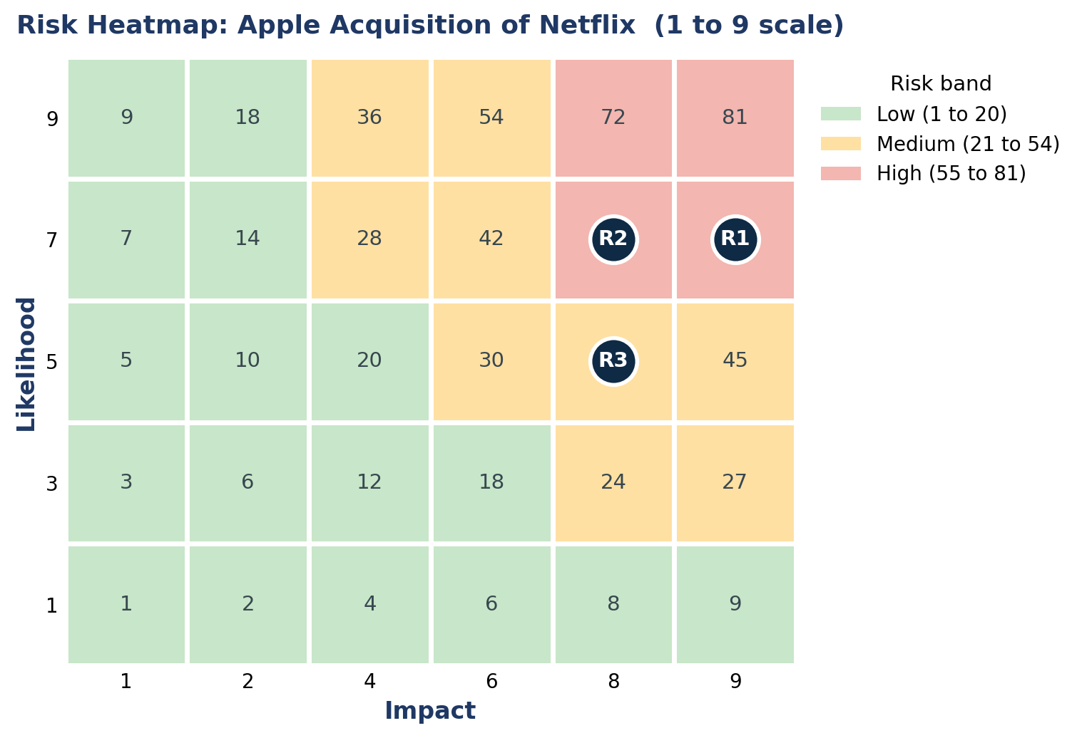
Figure 2. Risk heatmap. R1 and R2 fall in the High band, R3 in the Medium band.

3. Qualitative Risk Assessment
Two analytic methods from the course carried the qualitative work. Scenario Analytics, from Chapter 22 of Fleisher and Bensoussan (2015), built three plausible futures for the acquisition and traced how each risk behaves across them. A clean approval lets integration run on plan. An approval with remedies forces divestitures or behavioral commitments and slows the timeline. A blocked deal removes the strategic prize and triggers break costs. Walking the three risks through these scenarios is what set their likelihood and impact, rather than a single point guess.
Industry Fusion Analytics, from Chapter 17, fused signals across the streaming landscape so each risk rested on more than one source. Competitor pricing and content spend, regulator posture and merger history, subscriber and churn trends, and security incident data were combined to triangulate each risk. That is notable because it guards against a read driven by one headline. For R1, the fusion of regulator history and Apple’s gatekeeper scrutiny pointed to high likelihood and severe impact. For R2, competitor moves and churn data showed a market primed to react. For R3, breach cost and integration complexity signals showed a real but controllable exposure.
All three risks clear the bar for quantitative analysis, and each suits a different technique. R1 fits scenario based numerical modeling and a Monte Carlo simulation of the approval timeline and deal cost. R2 fits a predictive model of subscriber churn tied to its indicators, plus a Monte Carlo on revenue impact. R3 fits a loss distribution in the style of the FAIR model, pairing breach frequency with loss severity. Section 4 develops these models.

4. Quantitative Risk Assessment
This section moves the assessment from description to numbers. It has the four parts the assignment calls for, probability distributions with expected loss and exposure, a machine learning prediction tied to the Key Risk Indicators, a Monte Carlo simulation, and an integrated situation assessment. The earlier Indicators and Warning analysis from Chapter 16, which gave a first quantitative read on the regulatory risk, set the indicators that this section now models in full. Because no real dataset exists for a hypothetical acquisition, the models use synthetic data that simulates the combined business, with the parameters and assumptions stated in the analysis notebooks and summarized below. Every figure comes from a fixed seed, so the numbers reproduce exactly.

4.1 Standardized quantitative risk modeling
Each risk was given a loss model grounded in the qualitative findings. R1 regulatory uses a scenario model with three outcomes, a clean approval at 0.30, an approval with remedies at 0.45, and a block at 0.25, with the loss under each outcome drawn from a triangular distribution. R3 cybersecurity uses a FAIR structure (Freund & Jones, 2014; Hubbard & Seiersen, 2016), where the loss event frequency is Poisson and the loss per event is the number of records breached, drawn from a lognormal, times the cost per record, plus a response cost. R2 churn is measured as the revenue at risk when monthly churn rises above a 2.5 percent baseline. The expected loss, the variance, and the tail are then read from the simulated distributions in Section 4.3.
Figure 3 sets the three risks side by side. R1 carries an expected loss near 12.8 billion dollars, far above the others, with a P95 tail near 40.9 billion. R2 carries an expected first year revenue loss near 1.9 billion, with a P95 near 4.4 billion. R3 carries an expected annual loss near 0.20 billion, smaller in the middle but with a heavy tail that reaches 1.41 billion at the 99th percentile. That is notable because it sets the order of attention. The expected loss sets the priority, and the tail sizes the reserve.
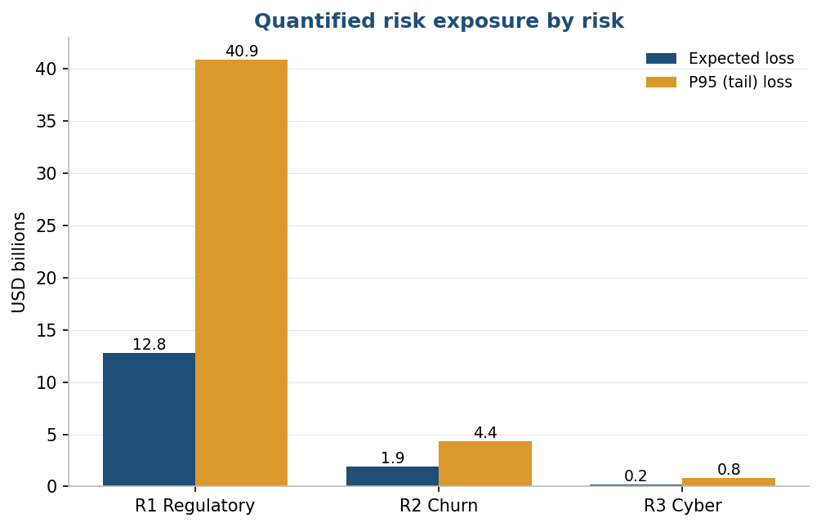
Figure 3. Quantified risk exposure by risk, expected loss against the P95 tail.

4.2 Machine learning based risk prediction
R2 was modeled with a supervised classifier that predicts whether a subscriber churns. The features were chosen to match the R2 Key Risk Indicators, the content cost ratio, competitor moves, and price increases, alongside subscriber attributes such as tenure, engagement, plan, and region. The data is a synthetic panel of 6,000 subscriber months. Churn was generated from a known logistic relationship, so the signal is real and learnable, with a base churn rate near 22 percent. Two models were trained on 70 percent of the data and tested on the held-out 30 percent, both with balanced class weights to handle the imbalance.
The logistic regression reached an area under the ROC curve of 0.71 and the random forest 0.69. At the chosen threshold the model catches about half of the churners, which suits an early warning signal rather than a precise forecast. What matters most for risk management is which drivers the model leans on. Figure 4 shows the feature importance. The content cost ratio, price increases, tenure, and engagement lead, and three of those are exactly the quantities tracked as R2 indicators. What that means is the model validates the indicator choice, the things we watch are the things that move churn.
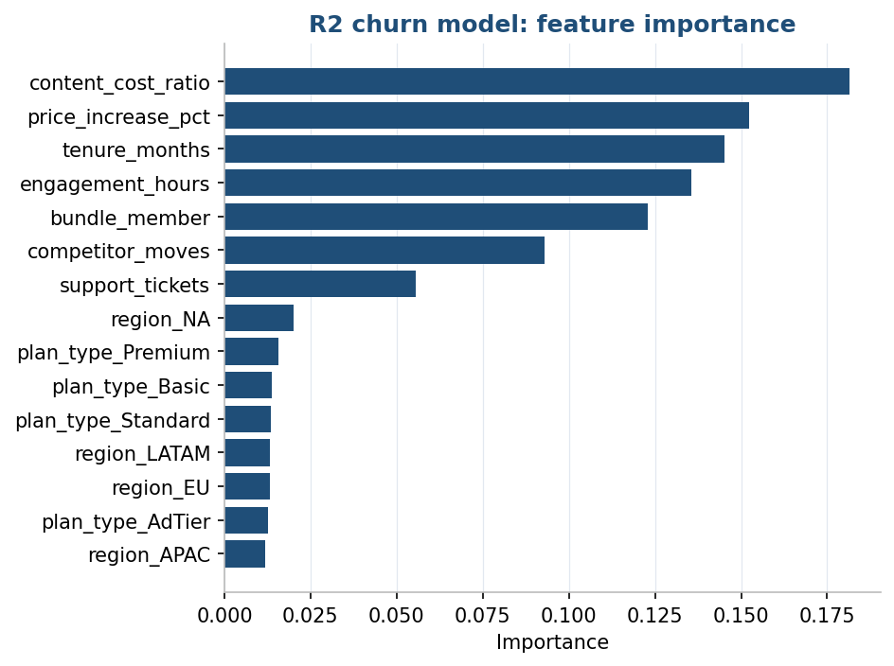
Figure 4. Churn model feature importance. The leading drivers match the R2 Key Risk Indicators.

4.3 Monte Carlo simulation
Each risk was simulated 50,000 times. R1 draws an outcome, then a loss from that outcome’s triangular distribution. R2 draws a monthly churn rate from a truncated normal centered above the baseline, converts the excess churn into lost subscribers, and prices the first year revenue loss. R3 draws the number of breach events from the Poisson frequency, then sums the per event losses. Each run returns the full loss distribution, from which the expected loss, the standard deviation, and the percentiles are read.
Figure 5 shows the R1 distribution. The mass near zero is the clean approval, the middle cluster is the remedy outcome, and the long right tail is the block. The expected loss is 12.8 billion dollars, the standard deviation is 13.4 billion, which is large because the three outcomes differ so much, and the P95 is 40.9 billion.
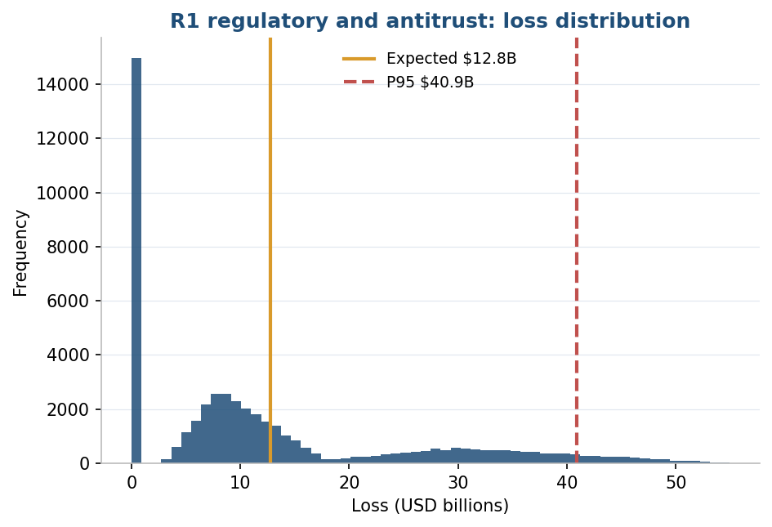
Figure 5. R1 regulatory loss distribution. Expected 12.8 billion, P95 40.9 billion.
Figure 6 shows the R2 revenue at risk, centered near 1.9 billion with a P95 of 4.4 billion and about 27 million subscribers exposed in the stressed case. Figure 7 shows the R3 annualized loss exposure, expected near 0.20 billion but with a heavy tail, 0.81 billion at the 95th percentile and 1.41 billion at the 99th. The shape matters as much as the average, since a rare breach can cost far more than a typical year.

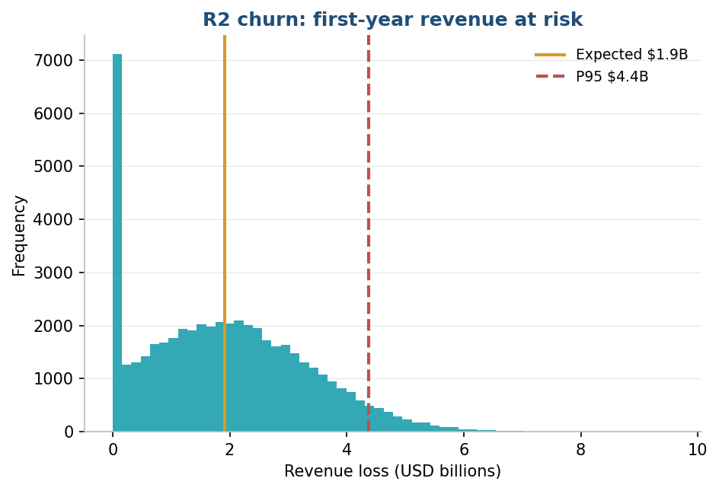
Figure 6. R2 first year revenue at risk. Expected 1.9 billion, P95 4.4 billion.

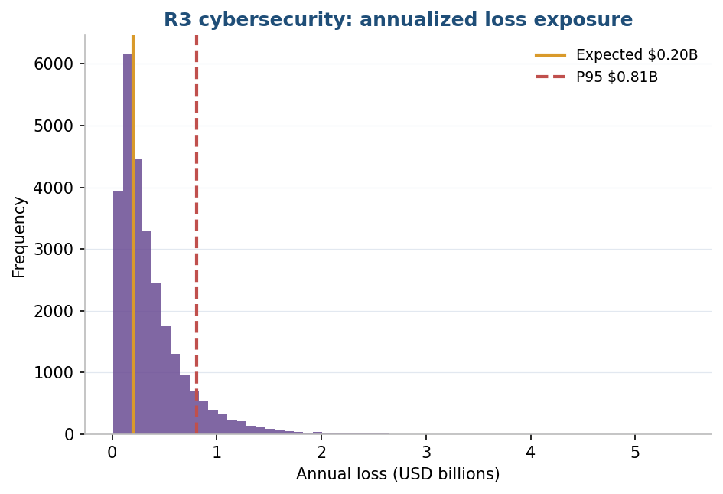
Figure 7. R3 cyber annualized loss exposure. Expected 0.20 billion, P99 1.41 billion.

4.4 Integrated situation assessment
The model inputs are not free choices. They are wired to the business and the non business environment, which is what makes this an enterprise view rather than three separate calculations. On the non business side, the regulatory posture and the history of large technology mergers set the R1 outcome probabilities, the geopolitical and trade setting stretches the review timeline, and the technology threat landscape sets the R3 loss event frequency. On the business side, the intensity of streaming competition drives the R2 competitor moves and churn, the content cost economics drive the R2 content cost ratio, and the broader financial conditions set the discount applied to the deal. When any of those conditions worsens, the matching distribution shifts and the overall exposure rises. The integrated mapping in the quantitative notebook lists each link.

5. Risk Response Strategy
R1, regulatory and antitrust. The strategy is Mitigate plus Accept. Mitigation prepares remedy options early, such as targeted divestitures and behavioral commitments, backs them with heavy legal and policy engagement, and phases the integration so it does not presume approval. The residual is accepted with a contingency reserve and a defined break path. This risk is not transferable, since insurance does not cover an antitrust block, a point the team corrected from earlier work.
R2, subscriber churn and competitive response. The strategy is Mitigate plus a positive Exploit. Mitigation rests on disciplined content spend, careful bundling, and win back programs. The Exploit captures the upside, cross selling Netflix into the large Apple base, so the combined reach is treated as an opportunity and not only a threat.
R3, cybersecurity and data integration. The strategy is Mitigate plus Transfer plus Accept. Mitigation uses mandatory multifactor authentication, strict patch service levels, continuous monitoring, and zero trust controls on the merged data. Part of the residual is transferred through cyber insurance. The small remaining residual is accepted and monitored.

6. Key Risk Indicators and Trigger Points
Each Key Risk Indicator is tied to a risk and to a phase of CRISP-DM (Chapman et al., 2000), so monitoring rests on real data and models rather than intuition. The data understanding and modeling phases feed the leading indicators, which warn before a risk materializes, while the deployment and monitoring phases feed the lagging indicators, which confirm what has already happened. The Green, Amber, and Red columns set the trigger points. A move into Red invokes the response strategy for that risk.

R1. Regulatory and antitrust
KRI | Type | Green | Amber | Red
Regulatory milestone slippage versus plan | Leading | On schedule | 30 to 90 days late | Over 90 days late
Adverse regulator or political statements per quarter | Leading | 0 to 1 | 2 to 4 | 5 or more
Analyst implied probability of approval | Leading | Above 70% | 50 to 70% | Below 50%
Second request or phase 2 investigation opened | Lagging | No | Pending | Yes

R2. Subscriber churn and competitive response
KRI | Type | Green | Amber | Red
Monthly subscriber churn rate | Lagging | Below 2.5% | 2.5 to 4% | Above 4%
Net subscriber adds versus forecast | Lagging | At or above plan | 0 to 10% below | Over 10% below
Content cost as percent of streaming revenue | Leading | Below 50% | 50 to 60% | Above 60%
Competitor price or bundle moves per quarter | Leading | 0 to 1 | 2 to 3 | 4 or more

R3. Cybersecurity and data integration
KRI | Type | Green | Amber | Red
Mandatory MFA adoption rate | Leading | Above 98% | 95 to 98% | Below 95%
Critical unpatched vulnerability count | Leading | 0 beyond 30 days | 1 to 3 | Above 3
Mean time to detect | Lagging | Below 24 hours | 24 to 72 hours | Above 72 hours
Data breach cost per record | Lagging | Below $150 | $150 to $200 | Above $200

These KRIs feed directly into the quantitative work. The leading indicators for R2 and R3 become features in the machine learning model in Section 4, and their thresholds anchor the scenario inputs for the Monte Carlo runs. That keeps monitoring, modeling, and response on one consistent thread.

7. Conclusion
This assessment set out to judge the risk in Apple acquiring Netflix and to put numbers on it. Three competitive risks define the deal. Regulatory and antitrust risk and subscriber churn risk both score in the High band, and cybersecurity and data integration risk scores Medium. The qualitative work with Scenario Analytics and Industry Fusion Analytics ranked them, and the quantitative work confirmed the ranking with hard figures. Regulatory risk is the largest exposure by far, an expected loss near 12.8 billion dollars and a tail above 40 billion. Churn risk puts a few billion of first year revenue at stake. Cyber risk is smaller on average but carries a heavy tail.
The response follows the numbers. Regulatory risk is mitigated and accepted, since it cannot be insured, which means preparing remedies and holding a reserve sized to the tail. Churn risk is mitigated and its upside exploited through the Apple base. Cyber risk is mitigated, transferred through insurance, and the small residual accepted. Each risk is watched through Key Risk Indicators with clear red triggers that invoke the response. The conclusion for decision makers is that the acquisition is viable, but the regulatory path governs the timeline and the downside, so the deal should proceed only with antitrust remedies prepared and a contingency reserve in
place.

Use of Generative AI
Generative AI tools were used to support the structuring and parts of the quantitative modeling for this assessment. The team reviewed and verified every output, corrected factual and methodological errors, and synthesized the material into the analysis presented here. The risk selection, the assessment, the figures, and the conclusions reflect the team’s own judgment.

References
Apple Inc. (2024). Form 10-K for fiscal year 2024. U.S. Securities and Exchange Commission.
Chapman, P., Clinton, J., Kerber, R., Khabaza, T., Reinartz, T., Shearer, C., & Wirth, R. (2000). CRISP-DM 1.0: Step-by-step data mining guide. SPSS Inc.
Fleisher, C. S., & Bensoussan, B. E. (2015). Business and competitive analysis: Effective application of new and classic methods (2nd ed.). Pearson FT Press.
Freund, J., & Jones, J. (2014). Measuring and managing information risk: A FAIR approach. Butterworth-Heinemann.
Hubbard, D. W., & Seiersen, R. (2016). How to measure anything in cybersecurity risk. Wiley.
Netflix, Inc. (2025). Q4 2024 shareholder letter.

Appendix 1: Complete Risk Treatment and Response Plan
The plan records each risk in full, the scoring, the quantified exposure, the owner, the response strategy, the treatment actions, the indicators and their red triggers, and the residual rating after treatment. It was updated through the term as the analysis developed.

R1. Regulatory and antitrust
Risk and cause | Regulatory or antitrust action blocks, delays, or forces remedies on the deal. Cause: market concentration, Apple gatekeeper scrutiny, and political attention to large technology mergers.
Category | Non business, regulatory and legal
Likelihood / Impact | 7 / 9
Score and band | 63, High
Quantified exposure | Expected loss 12.8 billion, P95 40.9 billion (Monte Carlo)
Risk owner | General Counsel with Corporate Development
Response strategy | Mitigate and Accept
Treatment actions | Prepare divestiture and behavioral remedy options early. Engage antitrust counsel and policy teams. Phase integration so it does not presume approval. Hold a contingency reserve and define a break path.
Indicators and red triggers | Probability of approval, red below 50 percent. Milestone slippage, red over 90 days. Adverse statements, red at 5 or more per quarter. Second request opened.
Residual rating | Medium. Not transferable, since insurance does not cover an antitrust block.
Status | Open, monitored weekly

R2. Subscriber churn and competitive response
Risk and cause | Churn and competitive response erode the revenue the deal was meant to secure. Cause: a saturated and rivalrous market, price sensitivity, and integration missteps.
Category | Business, market and financial
Likelihood / Impact | 7 / 8
Score and band | 56, High
Quantified exposure | Expected first year revenue at risk 1.9 billion, P95 4.4 billion. Churn model AUC 0.71.
Risk owner | Chief Revenue Officer with the Services lead
Response strategy | Mitigate and Exploit
Treatment actions | Disciplined content spend. Careful bundling into Apple One. Win back and retention programs. Cross sell to the Apple device base to turn reach into an advantage.
Indicators and red triggers | Monthly churn, red above 4 percent. Content cost ratio, red above 60 percent. Net adds, red over 10 percent below plan. Competitor moves, red at 4 or more.
Residual rating | Medium, after retention and disciplined spend
Status | Open, monitored monthly

R3. Cybersecurity and data integration
Risk and cause | A breach or a failed data integration during the merge of Netflix and Apple data. Cause: integration complexity, a larger high value data store, and a heightened threat environment.
Category | Technological, information security
Likelihood / Impact | 5 / 8
Score and band | 40, Medium
Quantified exposure | Expected annual loss 0.20 billion, P95 0.81 billion, P99 1.41 billion (FAIR Monte Carlo)
Risk owner | Chief Information Security Officer
Response strategy | Mitigate, Transfer, and Accept
Treatment actions | Mandatory multifactor authentication. Strict patch service levels. Continuous monitoring and zero trust on the merged data. Transfer the tail through cyber insurance.
Indicators and red triggers | MFA adoption, red below 95 percent. Critical unpatched vulnerabilities, red above 3. Mean time to detect, red over 72 hours. Breach cost per record, red above 200 dollars.
Residual rating | Low to Medium, after controls and insurance
Status | Open, monitored continuously

