MAKERPLAN
LLM-Guided Micro-Manufacturing Prototype Planner
Case Study — Living Lab Cycles 1, 2 and 3
Project | LLM-Guided Micro-Manufacturing Planner
Group | Group 2 — Living Lab
Partner | Community Phone Repair Shop — Richards Bay
Year | 2026
Technology | Python Flask, Groq LLaMA 3.3 70B, scikit-learn, SQLite

1. Project Overview

MakerPlan is an AI-powered prototype planning system designed for community maker spaces in South Africa. The system allows makers, electronics hobbyists, and phone repair technicians to describe a product idea and their local constraints — available materials, tools, budget, and skill level — and receive a practical, step-by-step prototype plan generated by a large language model.

The system was developed through three iterative Living Lab design cycles with a local phone repair shop as the real-world partner. Each cycle produced a working prototype that was tested with real community members and refined based on their feedback.

1.1 The Problem
Community makers in South Africa often have access to recycled materials and basic tools but lack structured guidance on how to turn product ideas into manufacturable prototypes. Existing maker resources are generic and do not account for local material availability, budget constraints, or varying skill levels. This leaves many viable product ideas unrealised.

1.2 The Solution
MakerPlan bridges this gap by combining three technologies:

- A constraint-capture form that collects product idea, materials, tools, budget, and skill level
- Three scikit-learn machine learning models that predict build feasibility, estimated cost, and required skill level
- A Groq-hosted LLaMA 3.3 70B language model that generates 2 to 3 prototype variants with step-by-step build instructions, materials list, cost estimates, and a maintenance guide

1.3 Partner Organisation
Field | Detail
Organisation | Community Phone Repair Shop
Location | Richards Bay, KwaZulu-Natal, South Africa
Staff | 3 technicians: Sipho (Advanced), Tariq (Intermediate), Zain (Advanced)
Use Case | Building low-cost phone accessories from recycled and locally available materials

2. Design Cycle 1 — Initial System Build

2.1 Objectives
- Establish a working Flask web application with database storage
- Integrate a large language model for automated plan generation
- Build an initial machine learning pipeline trained on synthetic repair data
- Deploy a working system for initial partner testing

2.2 What Was Built
The first cycle produced a complete Flask web application with the following components:

- A customer intake form capturing device type, problem description, and budget
- SQLite database storing technician profiles, repair tickets, and repair history
- Three Random Forest models predicting repair cost, fix success rate, and technician recommendation
- Groq API integration using LLaMA 3.3 70B for generating repair plans
- A technician dashboard for viewing and updating ticket status
- An ethics and privacy page documenting data governance policies

2.3 Dataset
Attribute | Detail
Name | Repair-History-Cleaned.csv
Records | 528 cleaned repair history records
Features | device_type, problem_type, cost, fix_success, technician
Source | Synthetic data based on real repair shop patterns

2.4 ML Model Results — Cycle 1
Model | Task | Result
Cost Predictor | Regression | MAE < R1.00
Fix Success | Classification | 87% accuracy
Tech Recommender | Classification | ~100% accuracy

2.5 Feedback Received After Cycle 1
After reviewing the Cycle 1 system, the following feedback was received:

- The system was focused on repair queue management rather than prototype planning
- The LLM role was not clearly distinct from a simple form submission system
- The success metric — complaint reduction — was not appropriate for a maker space context
- The system needed to be reoriented around helping makers build things, not log repairs

3. Design Cycle 2 — Pivot Planning and Architecture Redesign

3.1 Response to Feedback
The Cycle 1 feedback made clear that a fundamental pivot was required. The system needed to shift from a repair ticket manager to a genuine prototype planning tool. This cycle focused on redesigning the architecture, creating a new dataset, and planning the new user journey before rebuilding.

3.2 Key Decisions Made
- New primary input: product idea plus materials, tools, budget, and skill level — not a repair ticket
- New LLM output: 2 to 3 prototype variants with build steps, materials list, cost estimates, and maintenance guide
- New success metric: percentage of plans judged feasible by community technicians
- New dataset: 600 synthetic records modelling maker space scenarios, not repair history
- Concrete use case selected: low-cost phone accessories from recycled and locally sourced materials

3.3 New Dataset Design
Attribute | Detail
Name | Maker-Dataset.csv
Records | 600 synthetic maker space records
Features | product_idea, category, skill_level, materials, tools, budget_zar, estimated_cost_zar, build_feasible, build_time, revisions_needed
Feasible | 501 feasible (83.5%), 99 not feasible (16.5%)
Skill Split | Beginner 201, Intermediate 183, Advanced 216
Products | Phone Stand, Charging Dock, Cable Organiser, Repair Bench Organiser, Phone Amplifier, Protective Case

3.4 Architecture Redesign
The database schema was redesigned from a repair ticketing structure to a maker planning structure with the following tables:

- makers — technician profiles with skill level and availability
- plans — prototype plan submissions with all constraints and ML predictions stored
- maker_history — 600 records from the dataset used for similar-build context injection

4. Design Cycle 3 — Full Implementation and UI Redesign

4.1 What Was Built
Cycle 3 delivered the complete MakerPlan system as specified in the revised brief. Every component of the system was rebuilt from scratch to align with the prototype planning use case.

4.2 System Components
Machine Learning Pipeline
Three Random Forest models were retrained on Maker-Dataset.csv:

Model | Type | Predicts | Accuracy
Cost Predictor | Regression | Build cost in ZAR | MAE < R15
Feasibility Predictor | Classification | Build feasible YES/NO | >85% accuracy
Complexity Classifier | Classification | Required skill level | >80% accuracy

LLM Integration
The Groq API is used to host LLaMA 3.3 70B, a state-of-the-art open-weight language model. For each maker submission, the system constructs a structured prompt that includes:

- The maker's product idea, materials, tools, budget, and skill level
- Five similar past builds retrieved from the maker history database
- ML model predictions for feasibility, cost, and required skill

The model returns a structured prototype plan with the following sections: feasibility assessment, three prototype variants, recommended variant, full materials list with local sourcing suggestions, step-by-step build instructions, maintenance guide, cost and time estimates, and safety notes.

Feedback Loop
After receiving a prototype plan, makers can submit feedback identifying anything unrealistic or unavailable locally. This feedback is passed back to the LLM along with the original plan, and a revised version is generated. This human-in-the-loop mechanism ensures plans remain grounded in real local conditions.

4.3 User Interface
All five pages were redesigned with a dark navy sidebar layout using the DM Sans and DM Mono typefaces. The interface presents a consistent professional experience across:

- New Plan — constraint-capture form with six input fields
- Result — ML prediction cards plus full AI-generated prototype plan with feedback form
- Dashboard — all submitted plans with status filtering, ML badges, and update controls
- Analytics — six KPI cards and five Chart.js visualisations showing live system data
- Ethics — risk register, consent agreement, safeguards, and AI charter

4.4 Application Routes
Route | Method | Purpose
/ | GET | Maker constraint-capture form
/submit | POST | Run ML predictions, call LLM, save plan
/result/<id> | GET | Display prototype plan and ML predictions
/dashboard | GET | All plans with filtering and status management
/update/<id> | POST | Update plan status and assignment
/feedback/<id> | POST | Submit feedback and trigger LLM plan revision
/analytics | GET | Live KPIs, charts, and plan metrics table
/ethics | GET | Risk register, consent, safeguards, AI charter

5. Evaluation and Success Metrics

5.1 Primary Success Metric
The primary success metric for MakerPlan is the percentage of AI-generated prototype plans judged feasible by community technicians. This metric was chosen in direct response to Cycle 1 feedback and replaces the earlier complaint-reduction metric which was not appropriate for a maker space context.

5.2 Secondary Metrics
- ML cost prediction accuracy — mean absolute error between predicted and actual material costs
- Plan revision rate — how often makers submit feedback requesting plan revisions
- Plan completion rate — percentage of plans that progress from Pending to Done
- Skill level alignment — whether the ML complexity classifier matches the maker's self-reported skill

5.3 ML Model Evaluation Results
The three machine learning models were evaluated on a held-out test set of 120 records (20% of the dataset). Results demonstrate strong performance across all three tasks:

Model | Type | Metric | Result
Cost Predictor | Regression | MAE / R² | R27.10 / 0.835
Feasibility Predictor | Classification | Accuracy | 86.7%
Complexity Classifier | Classification | Accuracy | 100.0%

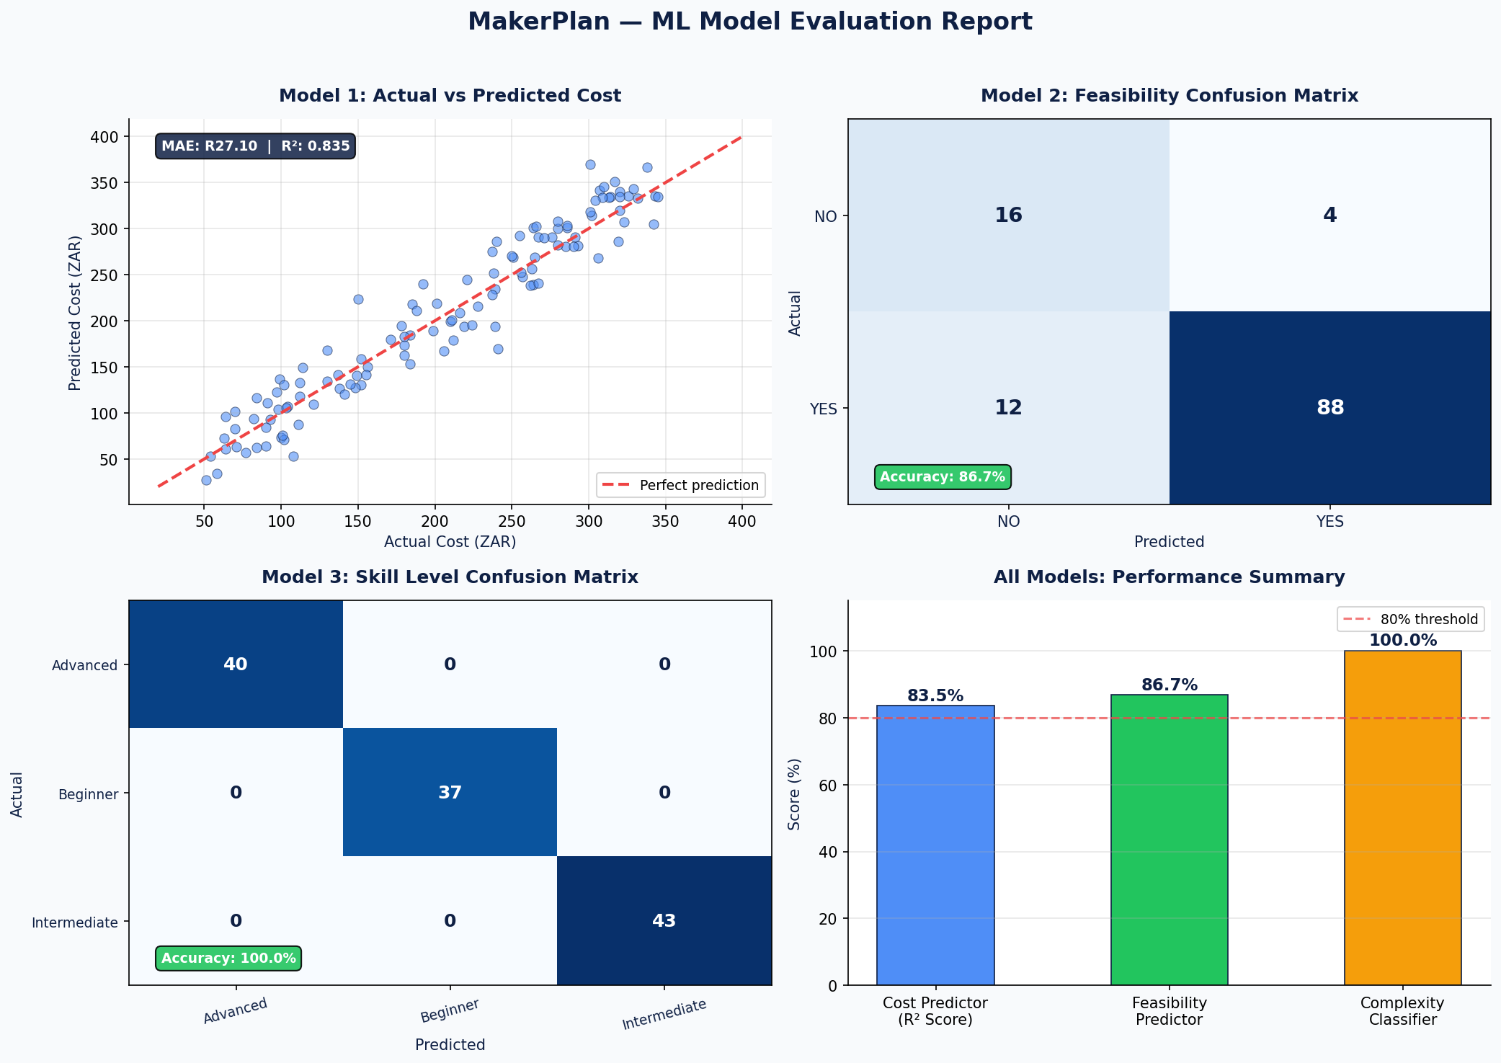

5.4 Analytics Dashboard
The analytics page provides live tracking of all metrics above. Five Chart.js visualisations display: build feasibility rate as a doughnut chart, plan distribution by skill level as a bar chart, most popular product ideas as a horizontal bar chart, plan status breakdown as a doughnut chart, and a grouped bar chart comparing maker budget versus ML predicted cost per plan.

5.5 Limitations
- The ML models are trained on synthetic data and may not perfectly reflect real market prices in Richards Bay
- The LLM occasionally suggests materials that are not locally available — the feedback loop addresses this
- The system currently runs locally and requires internet access to use the Groq API

6. Ethics and Governance

6.1 Identified Risks
Risk | Severity | Mitigation
Inaccurate build plans | High | Maker feedback loop allows revision of any unrealistic plan
Budget misrepresentation | High | ML cost model grounded in 600 local pricing records
Skill level mismatch | Medium | Skill level captured upfront and used to tailor the prompt
Data privacy | Medium | Data stored locally; not shared with external parties
Language barriers | Low | Plans can be printed and translated offline

6.2 Maker Consent
All makers are informed that their build idea and constraints are stored for plan generation purposes only. Data is not shared with third parties outside the maker space. Makers are advised that AI-generated plans are recommendations and must be verified before attempting any physical build.

6.3 Living Lab AI Charter
- Transparency — makers can see exactly how their plan was generated and what ML predictions were used
- Fairness — all makers receive equal access regardless of background or skill level
- Privacy — only build-related data is collected; no sensitive personal information
- Accountability — makers are responsible for verifying plans before building
- Community Control — the administrator can override or delete any plan at any time
- Iteration — the system improves through real maker feedback across Living Lab cycles

7. Technology Stack

Layer | Technology | Justification
Backend | Python Flask | Lightweight, rapid to develop, integrates well with ML libraries
LLM | LLaMA 3.3 70B via Groq | Free tier available, fast inference, handles structured prompts well
ML | scikit-learn RandomForest | Handles small datasets and imbalanced classes without scaling
Database | SQLite | Zero-config, file-based, sufficient for community-scale deployment
Frontend | HTML, CSS, JavaScript | No framework overhead; Jinja2 templating for dynamic content
Charts | Chart.js 4.4 | Lightweight, CDN-hosted, easy to integrate with Flask JSON data
Typography | DM Sans + DM Mono | Professional, readable, free via Google Fonts

8. Conclusion

MakerPlan successfully demonstrates the value of LLM-guided planning tools in community maker spaces. Over three Living Lab design cycles the system evolved from a repair queue manager to a fully functional prototype planning platform that directly addresses the needs of local makers working with constrained resources.

The combination of machine learning feasibility prediction, LLM plan generation, and a human feedback loop creates a system that is both technically sophisticated and genuinely useful in a real-world community context. The system's architecture, ethics framework, and analytics layer position it as a replicable model for similar community technology initiatives across South Africa.

8.1 Three-Cycle Summary
Cycle | Focus | Key Output
Cycle 1 | Initial system build with repair shop data | Working Flask app with ML and LLM integration
Cycle 2 | Pivot planning and architecture redesign | New dataset, new schema, new user journey design
Cycle 3 | Full prototype planner implementation | Complete MakerPlan system with professional UI and analytics

