CROP YIELD PREDICTION AND CROP DISEASE PREDICTION USING DENSENET-121

**SAMUNDAR SINGH Guide: DR. R. GEETHA RAMANI**

Reg.no: 2019272033

MCA -SS (3yrs)

**Abstract**

India is an Agriculture based economy whose most of the GDP comes from farming. The motivation of this project comes from the increasing suicide rates in farmers which may be due to low harvest in crops. Predicting the crop yield in advance of its harvest would help the policy makers and farmers for taking appropriate measures for marketing and storage. This project will help the farmers to know the yield of their crop before cultivating onto the agricultural field and thus help them to make the appropriate decisions. In India Majority of farmers have basic level of education and less involvement in Technology so a better visualization is needed to make them understand the data which help them in better production of crops.

**Problem Statement**

During the analysis of the retrieved publications, one of the exclusion criteria is that the publication or traditional review paper. Crop yield are predicted on basis of weak dataset and also it can’t suggest the amount of fertilizer and irrigation that is to be used for maximum yield. The plant disease prediction system is also not as accurate since it takes the background noise to train the data.

**Objective**

The purposed system will predict the yield and shows the irrigation, fertilizer, Rainfall, livestock (Egg and Meat) by means of Visualization. The app will also suggest best suitable crop, amount of fertilizer and irrigation by means of Machine Learning models. The goal in this project to achieve a high level of accuracy in prediction and make the user interface less complex so that a farmer with very low technical knowledge can easily interact with it. Predicting the crop yield in advance of its harvest would help the policy makers and farmers for taking appropriate measures for marketing and storage. This project will help the farmers to know the yield of their crop before cultivating onto the agricultural field and thus help them to make the appropriate decisions. In India Majority of farmers have basic level of education and less involvement in Technology so a better visualization is needed to make them understand the data which help them in better production of crops. I am going to use DENSENET-121 in which I remove the background noise of the image so that the accuracy to predict the disease increases.

**Architecture Diagram**

**Module 1 & 2:**

User input

District ,Area ,Crop

District, Crop name

Fertilizers amount prediction using multiple Regression Module

Mapping the fertilizer and yield per year on basis of district

Predict the types of fertilizer to be used

Predict the amount of fertilizer to be used

Fertilizer output

Model Banks

Yield prediction by Lassos regression model

Prediction on basis of district

prediction on basis of state

Prediction on basis commercial crop

Predicted yield output of various commercial crops

Input feed to model

Model predict the Accurate yield

Fertilizers amount prediction using multiple Regression Module

Mapping the fertilizer and yield per year on basis of district

Predict the types of fertilizer to be used

Predict the amount of fertilizer to be used

Fertilizer output

This yield act as input.

odel Banks

Irrigation area prediction using lassos Regression

Predict the amount of irrigation per area

Irrigation area output

Mapping the irrigation and yield per year on basis of district

**Module 3:**

Rain fall historical data graph

Temperature historical data graph

Forecasting rain

Forecasting temperature

Forecasting Wind speed

User input

State and District

**Module 4:**

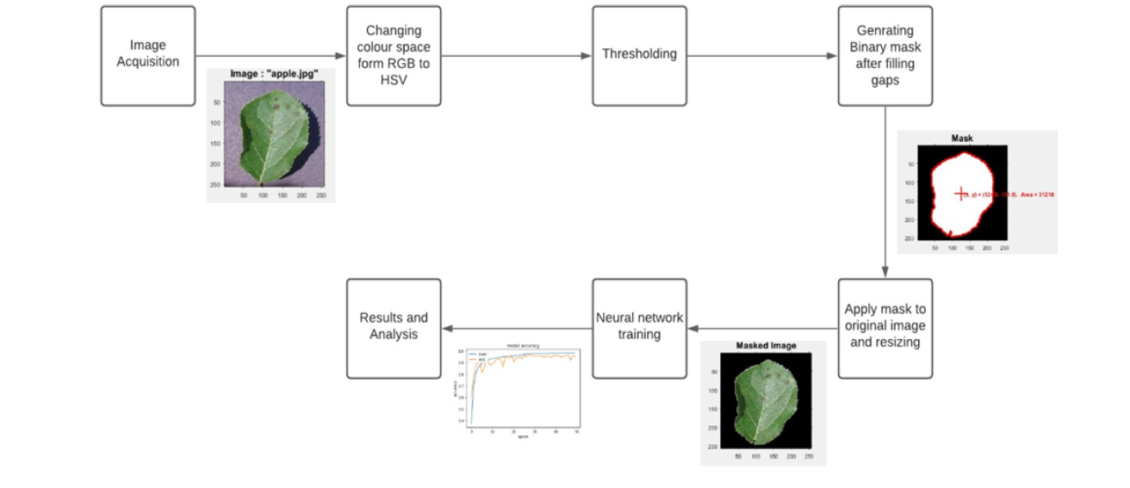

**List of Modules:**

**Module 1:** Crop Yield Prediction.

**Module 2:** Fertilizer and Irrigation suggestion on basis of yields.

**Module 3:** Weather Analysis and forecasting on basis of historical data.

**Module 4:** Plant Disease prediction system.

**Description of Modules:**

**Module 1:** Crop Yield Prediction.

In this module the various Agricultural Crop area, production and yield data is taken according to the historical data the yield is going to be predicted. For better accuracy I used the lassos regression model. The user have to input the state, district and type of crop on behalf of that the yield is predicted The predicted yield is feed as input to the other module-2 as input.

**Module 2:** Fertilizer and Irrigation suggestion on basis of yields.

In this module the fertilizer and irrigation are predicted on behalf of the yields. If a farmer wants to increase its yield then this module will suggest at what extent the fertilizer amount and irrigation supply is need to be increased. I am using Multiple regression Module that help in the prediction (type of regression is under observation.)

**Module 3:** Weather Analysis and forecasting on basis of historical data

In this module a statistical representation is shown which will show the climate information regarding Agriculture on basis of Historical data. This module is also capable of forecasting the Rain, temperature and wind. The user has to insert the state and District in order to retrieve data.

**Module 4:** Plant Disease prediction system.

This module is based on research paper named “**MULTIPLE PLANT LEAF DISEASE CLASSIFICATION USING DENSENET-121 ARCHITECTURE”**  Issue 5, May 2021 .In this module background information which is unnecessary for disease detection in leaves of crops is omitted .This is overcome by RGB color form image to HSV form, segmenting required portion of image by histogram based thresholding and hole-filling ending into a binary mask image and then masked by dot multiplication on the binary mask, finally resizing it for neural network training.

References:

<https://iaeme.com/MasterAdmin/Journal_uploads/IJEET/VOLUME_12_ISSUE_5/IJEET_12_05_005.pdf>

<https://ieeexplore.ieee.org/document/9243422>

<https://ieeexplore.ieee.org/abstract/document/9155815>

<https://www.sciencedirect.com/science/article/pii/S0168169920302301>