School:Named after
Khamza Umarov
Men haqimda:
Men
About me:
I was born in 2006s.
My dad is Kasimov Farhod
My mum is Kasimova Shakhnoza
My sister is Murzayeva Sevinch

Contact
Phone number:
+998 88 284 00 29
Email:
javokhirmurzayev0029@gmail.com
Hobby:
#1 Write code
#2 Build web site
Murzayev Javokhir
Web developer & Social manager &
Computer manager.
Place of study:
27 – school
[2013 – 2018]
Problems
Place of work:

Web developer
[2020 – Now]
Company: School Web site, Javokhir Group
HTML & CSS & JavaScript
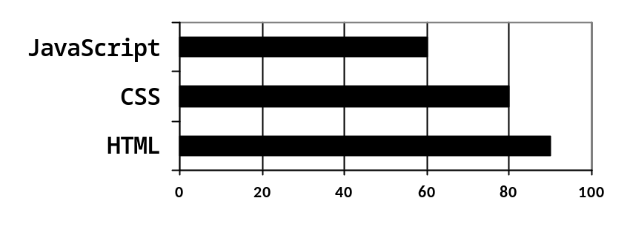
22 – school
[2018 – Now]
I am an exemplary student.

