Write-Up Bashed

By: Samuraii Code

## Settings up

Como configuración inicial debemos conectarnos a la VPN de Hack The Box. Descargaremos el archivo .ovpn de la web oficial y ejecutaremos el siguiente comando:

- sudo openvpn lab_SamuraiCode.ovpn

Luego activaremos la maquina Bashed para empezar a trabajar.

## Nmap

Iniciaremos comprobando que la maquina este encendida haciendo un ping y esperando una respuesta:

- ping -c 1 10.10.10.68

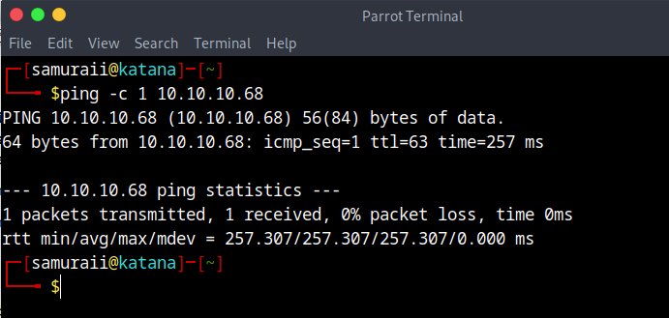

Una vez que se verifique que la maquina esta online procederemos a hacer un escaneo para la identificacion de puertos abiertos, tecnologias empleadas, etc.

- nmap -p- --open --min-rate 5000 -sS -vvv -n -Pn 10.10.10.68 -oG allPorts

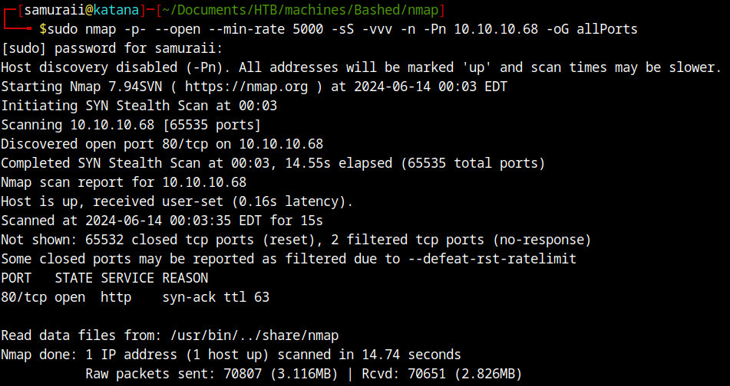

Podemos identificar por consola un puerto que se encuentra abierto que es el puerto 80/tcp, usaremos un conjunto de scripts basicos de reconocimiento para conocer mas sobre nuestra maquina victima.

Extraemos los puetos abiertos de la captura allPorts usando la funcion extractPorts

- extractPorts allPorts

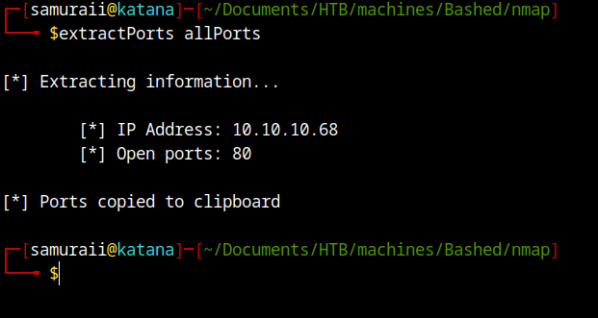

Entonces ya prodremos usar estos puertos para lanzar el escaneo de servicios.

- sudo nmap -sC -sV -p80 10.10.10.68 -oN targeted

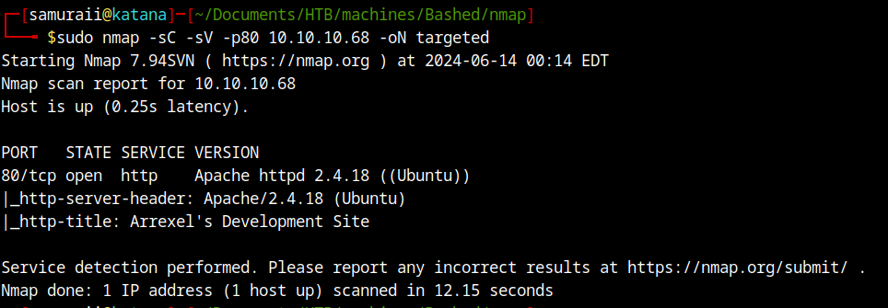

Ahora sabemos que por el pueto 80 esta corriendo un servicio http con version Apache/2.4.18 (Ubuntu). Sabemos que esta corriendo un servicio tipo sitio web por lo tanto podemos ver un poco mas de información de este sitio usando whatweb.

- whatweb http:// 10.10.10.68



Podemos dar un paso mas alla y ver el sitio web.

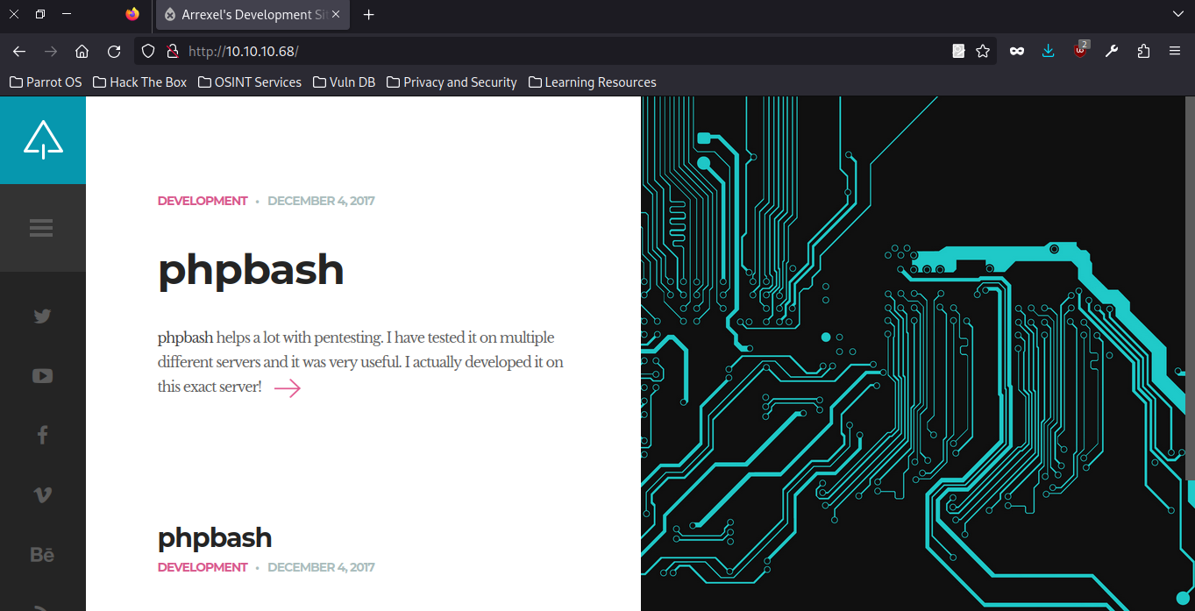

Haciendo uso de la extension wappalyzer podremos tener un poco mas de informacion.

Si hacemos un directory listing podremos encontrar algunas cosas interesantes usaremos una herramienta de fuzzing. Me gusta usar gobuster pero wfuzz es igual de buena (Nota: programas de escaneo de vulnerabilidades como nikto o owasp zap que tambien funciona como proxie hacen este directory listing).

- gobuster dir -u http://10.10.10.68/ -w /home/samuraii/Documents/SecLists/Discovery/Web-Content/directory-list-2.3-medium.txt -t 200

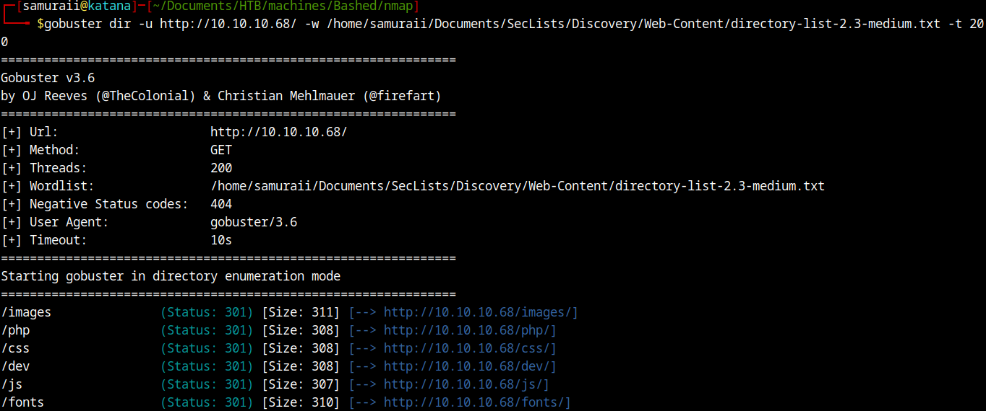

## Exploitation

Lorem Ipsum is simply dummy text of the printing and typesetting industry. Lorem Ipsum has been the industry's standard dummy text ever since the 1500s, when an unknown printer took a galley of type and scrambled it to make a type specimen book. It has survived not only five centuries, but also the leap into electronic typesetting, remaining essentially unchanged. It was popularised in the 1960s with the release of Letraset sheets containing Lorem Ipsum passages, and more recently with desktop publishing software like Aldus PageMaker including versions of Lorem Ipsum.

Lorem Ipsum is simply dummy text of the printing and typesetting industry. Lorem Ipsum has been the industry's standard dummy text ever since the 1500s, when an unknown printer took a galley of type and scrambled it to make a type specimen book. It has survived not only five centuries, but also the leap into electronic typesetting, remaining essentially unchanged. It was popularised in the 1960s with the release of Letraset sheets containing Lorem Ipsum passages, and more recently with desktop publishing software like Aldus PageMaker including versions of Lorem Ipsum.

Lorem Ipsum is simply dummy text of the printing and typesetting industry. Lorem Ipsum has been the industry's standard dummy text ever since the 1500s, when an unknown printer took a galley of type and scrambled it to make a type specimen book. It has survived not only five centuries, but also the leap into electronic typesetting, remaining essentially unchanged. It was popularised in the 1960s with the release of Letraset sheets containing Lorem Ipsum passages, and more recently with desktop publishing software like Aldus PageMaker including versions of Lorem Ipsum.

Lorem Ipsum is simply dummy text of the printing and typesetting industry. Lorem Ipsum has been the industry's standard dummy text ever since the 1500s, when an unknown printer took a galley of type and scrambled it to make a type specimen book. It has survived not only five centuries, but also the leap into electronic typesetting, remaining essentially unchanged. It was popularised in the 1960s with the release of Letraset sheets containing Lorem Ipsum passages, and more recently with desktop publishing software like Aldus PageMaker including versions of Lorem Ipsum.

## Type attack

Lorem Ipsum is simply dummy text of the printing and typesetting industry. Lorem Ipsum has been the industry's standard dummy text ever since the 1500s, when an unknown printer took a galley of type and scrambled it to make a type specimen book. It has survived not only five centuries, but also the leap into electronic typesetting, remaining essentially unchanged. It was popularised in the 1960s with the release of Letraset sheets containing Lorem Ipsum passages, and more recently with desktop publishing software like Aldus PageMaker including versions of Lorem Ipsum.

Lorem Ipsum is simply dummy text of the printing and typesetting industry. Lorem Ipsum has been the industry's standard dummy text ever since the 1500s, when an unknown printer took a galley of type and scrambled it to make a type specimen book. It has survived not only five centuries, but also the leap into electronic typesetting, remaining essentially unchanged. It was popularised in the 1960s with the release of Letraset sheets containing Lorem Ipsum passages, and more recently with desktop publishing software like Aldus PageMaker including versions of Lorem Ipsum.

Lorem Ipsum is simply dummy text of the printing and typesetting industry. Lorem Ipsum has been the industry's standard dummy text ever since the 1500s, when an unknown printer took a galley of type and scrambled it to make a type specimen book. It has survived not only five centuries, but also the leap into electronic typesetting, remaining essentially unchanged. It was popularised in the 1960s with the release of Letraset sheets containing Lorem Ipsum passages, and more recently with desktop publishing software like Aldus PageMaker including versions of Lorem Ipsum.

Lorem Ipsum is simply dummy text of the printing and typesetting industry. Lorem Ipsum has been the industry's standard dummy text ever since the 1500s, when an unknown printer took a galley of type and scrambled it to make a type specimen book. It has survived not only five centuries, but also the leap into electronic typesetting, remaining essentially unchanged. It was popularised in the 1960s with the release of Letraset sheets containing Lorem Ipsum passages, and more recently with desktop publishing software like Aldus PageMaker including versions of Lorem Ipsum.

## vulnerabilities

Lorem Ipsum is simply dummy text of the printing and typesetting industry. Lorem Ipsum has been the industry's standard dummy text ever since the 1500s, when an unknown printer took a galley of type and scrambled it to make a type specimen book. It has survived not only five centuries, but also the leap into electronic typesetting, remaining essentially unchanged. It was popularised in the 1960s with the release of Letraset sheets containing Lorem Ipsum passages, and more recently with desktop publishing software like Aldus PageMaker including versions of Lorem Ipsum.

Lorem Ipsum is simply dummy text of the printing and typesetting industry. Lorem Ipsum has been the industry's standard dummy text ever since the 1500s, when an unknown printer took a galley of type and scrambled it to make a type specimen book. It has survived not only five centuries, but also the leap into electronic typesetting, remaining essentially unchanged. It was popularised in the 1960s with the release of Letraset sheets containing Lorem Ipsum passages, and more recently with desktop publishing software like Aldus PageMaker including versions of Lorem Ipsum.

Lorem Ipsum is simply dummy text of the printing and typesetting industry. Lorem Ipsum has been the industry's standard dummy text ever since the 1500s, when an unknown printer took a galley of type and scrambled it to make a type specimen book. It has survived not only five centuries, but also the leap into electronic typesetting, remaining essentially unchanged. It was popularised in the 1960s with the release of Letraset sheets containing Lorem Ipsum passages, and more recently with desktop publishing software like Aldus PageMaker including versions of Lorem Ipsum.