Baza Jednostki Wojskowej

Spis treści

1. Wstęp 3

2. Analiza wymagań systemu 3

2.1 Wymagania funkcjonalne 3

2.2 Wymagania niefunkcjonalne 3

2.3 Diagram przypadków użycia 4

3. Wykorzystane technologie 4

4. Projekt aplikacji 5

4.1 Architektura aplikacji 5

4.2 Projekt koncepcyjny bazy danych 5

4.3 Projekt schematu relacyjnego 6

4.4 Mapowanie klas na tabele bazodanowe 6

5. Funkcjonalność aplikacji 6

6. Interfejs użytkownika 7

7. Podsumowanie 7

Dodatek A: Skrypty tworzące obiekty baz danych 8-22

# Wstęp

Przedstawiona baza danych umożliwia proste zarządzanie jednostką wojskową. W bazie zawarte są wszystkie dane każdego żołnierza, sprzętu jaki jest na wyposażeniu jednostki, oraz informacje odnośnie stopni i specjalizacji.

# Analiza wymagań systemu



## Wymagania funkcjonalne

- Wybór, które dane powinny być wyświetlane,

- Wyświetlanie danych w czytelny sposób,

- Dodawanie danych do konkretnych tabel,

- Edycja danych,

- Usuwanie danych,

## Wymagania niefunkcjonalne

- Wydajność,

- Niezawodność,

- Łatwość użycia,

## Diagram przypadków użycia

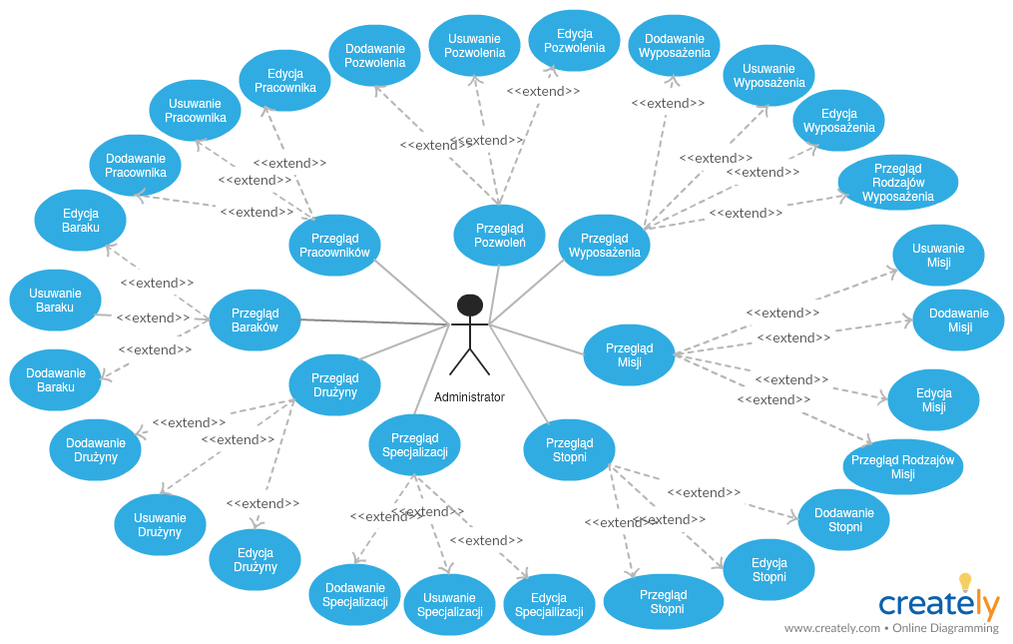

# Wykorzystane technologie

- MicrosoftSQLServer

- Język C#

- WPF

- Entity Framework

- Caliburn Micro

# Projekt aplikacji



## Architektura aplikacji

- Models – przechowuje modele bazy danych,

- Views – przechowuje widoki aplikacji,

- ViewModels – odpowiada za logikę systemu

- Services – do obsługi bazy danych.

## Projekt koncepcyjny bazy danych

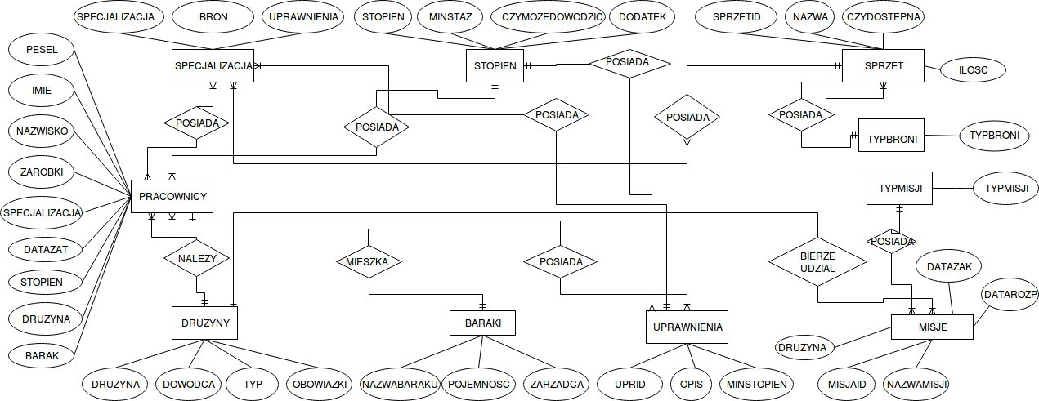

## Projekt schematu relacyjnego

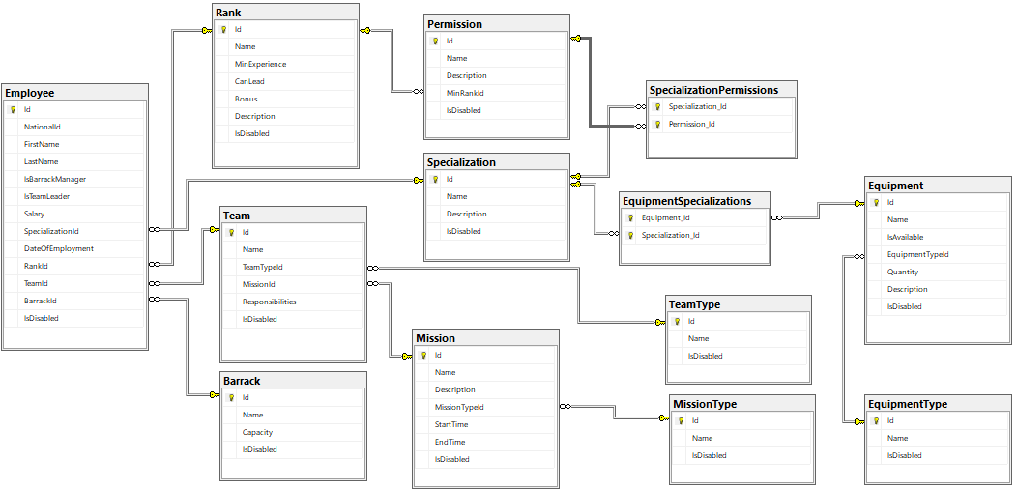

## Mapowanie klas na tabele bazodanowe

Code First poprzez Entity Framework.



# Funkcjonalność aplikacji

- Przegląd, dodawanie, usuwanie i edycja pracowników,

- Przegląd, dodawanie, usuwanie i edycja baraków(koszar),

- Przegląd, dodawanie, usuwanie i edycja wyposażenia oraz jego typu,

- Przegląd, dodawanie, usuwanie i edycja misji oraz ich typów,

- Przegląd, dodawanie, usuwanie i edycja pozwoleń,

- Przegląd, dodawanie, usuwanie i edycja stopni,

- Przegląd, dodawanie, usuwanie i edycja specjalizacji,

- Przegląd, dodawanie, usuwanie i edycja drużyn oraz ich typów,

- Wykrywanie czy istnieje baza danych,

- Możliwość wygenerowania przykładowej bazy danych.

# Interfejs użytkownika

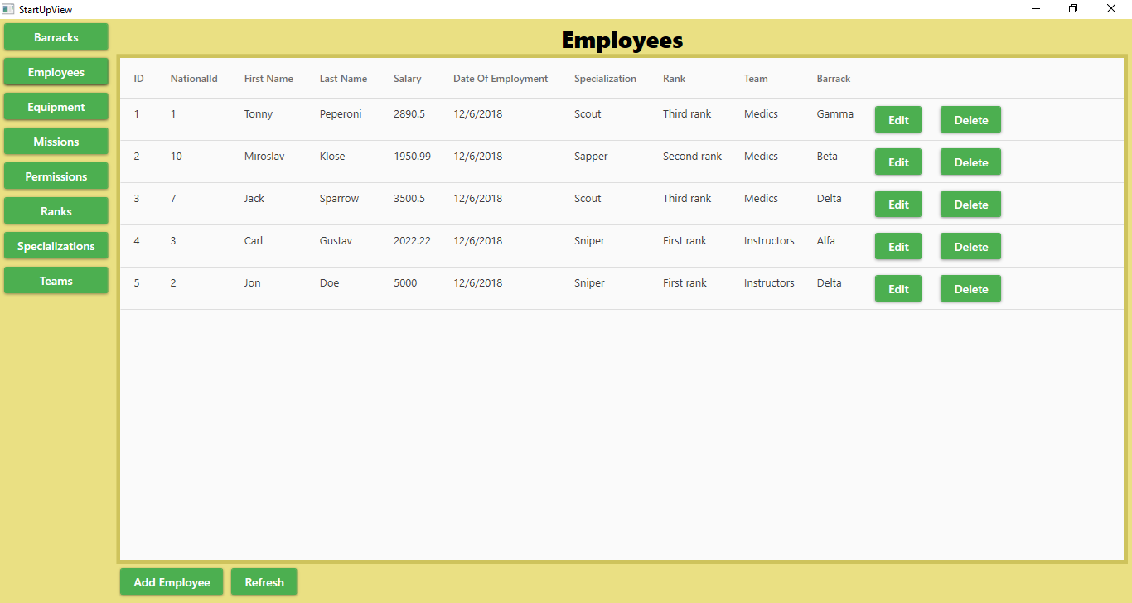

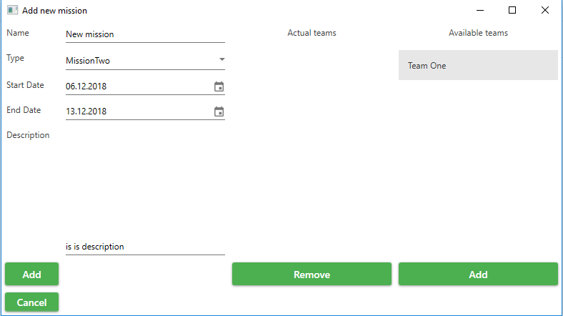



# Podsumowanie

Aplikacja spełnia wszystkie wymagane funkcjonalności. Prosty interfejs sprawia, że obsługa aplikacji jest łatwa. Wszystkie zmiany wprowadzane przez użytkownika w aplikacji są uaktualniane w bazie danych.

# Dodatek A: Skrypty tworzące obiekty baz danych

CREATE DATABASE [ArmyBase]

GO

USE [ArmyBase]

GO

/****** Object: Table [dbo].[__MigrationHistory] Script Date: 07.12.2018 00:31:00 ******/

SET ANSI_NULLS ON

GO

SET QUOTED_IDENTIFIER ON

GO

CREATE TABLE [dbo].[__MigrationHistory](

[MigrationId] [nvarchar](150) NOT NULL,

[ContextKey] [nvarchar](300) NOT NULL,

[Model] [varbinary](max) NOT NULL,

[ProductVersion] [nvarchar](32) NOT NULL,

CONSTRAINT [PK_dbo.__MigrationHistory] PRIMARY KEY CLUSTERED

(

[MigrationId] ASC,

[ContextKey] ASC

)WITH (PAD_INDEX = OFF, STATISTICS_NORECOMPUTE = OFF, IGNORE_DUP_KEY = OFF, ALLOW_ROW_LOCKS = ON, ALLOW_PAGE_LOCKS = ON) ON [PRIMARY]

) ON [PRIMARY] TEXTIMAGE_ON [PRIMARY]

GO

/****** Object: Table [dbo].[Barrack] Script Date: 07.12.2018 00:31:00 ******/

SET ANSI_NULLS ON

GO

SET QUOTED_IDENTIFIER ON

GO

CREATE TABLE [dbo].[Barrack](

[Id] [int] IDENTITY(1,1) NOT NULL,

[Name] [nvarchar](max) NOT NULL,

[Capacity] [int] NOT NULL,

[IsDisabled] [bit] NOT NULL,

CONSTRAINT [PK_dbo.Barrack] PRIMARY KEY CLUSTERED

(

[Id] ASC

)WITH (PAD_INDEX = OFF, STATISTICS_NORECOMPUTE = OFF, IGNORE_DUP_KEY = OFF, ALLOW_ROW_LOCKS = ON, ALLOW_PAGE_LOCKS = ON) ON [PRIMARY]

) ON [PRIMARY] TEXTIMAGE_ON [PRIMARY]

GO

/****** Object: Table [dbo].[Employee] Script Date: 07.12.2018 00:31:00 ******/

SET ANSI_NULLS ON

GO

SET QUOTED_IDENTIFIER ON

GO

CREATE TABLE [dbo].[Employee](

[Id] [int] IDENTITY(1,1) NOT NULL,

[NationalId] [int] NOT NULL,

[FirstName] [nvarchar](max) NOT NULL,

[LastName] [nvarchar](max) NOT NULL,

[IsBarrackManager] [bit] NOT NULL,

[IsTeamLeader] [bit] NOT NULL,

[Salary] [float] NOT NULL,

[SpecializationId] [int] NULL,

[DateOfEmployment] [datetime] NOT NULL,

[RankId] [int] NULL,

[TeamId] [int] NULL,

[BarrackId] [int] NULL,

[IsDisabled] [bit] NOT NULL,

CONSTRAINT [PK_dbo.Employee] PRIMARY KEY CLUSTERED

(

[Id] ASC

)WITH (PAD_INDEX = OFF, STATISTICS_NORECOMPUTE = OFF, IGNORE_DUP_KEY = OFF, ALLOW_ROW_LOCKS = ON, ALLOW_PAGE_LOCKS = ON) ON [PRIMARY]

) ON [PRIMARY] TEXTIMAGE_ON [PRIMARY]

GO

/****** Object: Table [dbo].[Equipment] Script Date: 07.12.2018 00:31:00 ******/

SET ANSI_NULLS ON

GO

SET QUOTED_IDENTIFIER ON

GO

CREATE TABLE [dbo].[Equipment](

[Id] [int] IDENTITY(1,1) NOT NULL,

[Name] [nvarchar](max) NOT NULL,

[IsAvailable] [bit] NOT NULL,

[EquipmentTypeId] [int] NOT NULL,

[Quantity] [int] NOT NULL,

[Description] [nvarchar](max) NULL,

[IsDisabled] [bit] NOT NULL,

CONSTRAINT [PK_dbo.Equipment] PRIMARY KEY CLUSTERED

(

[Id] ASC

)WITH (PAD_INDEX = OFF, STATISTICS_NORECOMPUTE = OFF, IGNORE_DUP_KEY = OFF, ALLOW_ROW_LOCKS = ON, ALLOW_PAGE_LOCKS = ON) ON [PRIMARY]

) ON [PRIMARY] TEXTIMAGE_ON [PRIMARY]

GO

/****** Object: Table [dbo].[EquipmentSpecializations] Script Date: 07.12.2018 00:31:00 ******/

SET ANSI_NULLS ON

GO

SET QUOTED_IDENTIFIER ON

GO

CREATE TABLE [dbo].[EquipmentSpecializations](

[Equipment_Id] [int] NOT NULL,

[Specialization_Id] [int] NOT NULL,

CONSTRAINT [PK_dbo.EquipmentSpecializations] PRIMARY KEY CLUSTERED

(

[Equipment_Id] ASC,

[Specialization_Id] ASC

)WITH (PAD_INDEX = OFF, STATISTICS_NORECOMPUTE = OFF, IGNORE_DUP_KEY = OFF, ALLOW_ROW_LOCKS = ON, ALLOW_PAGE_LOCKS = ON) ON [PRIMARY]

) ON [PRIMARY]

GO

/****** Object: Table [dbo].[EquipmentType] Script Date: 07.12.2018 00:31:00 ******/

SET ANSI_NULLS ON

GO

SET QUOTED_IDENTIFIER ON

GO

CREATE TABLE [dbo].[EquipmentType](

[Id] [int] IDENTITY(1,1) NOT NULL,

[Name] [nvarchar](max) NOT NULL,

[IsDisabled] [bit] NOT NULL,

CONSTRAINT [PK_dbo.EquipmentType] PRIMARY KEY CLUSTERED

(

[Id] ASC

)WITH (PAD_INDEX = OFF, STATISTICS_NORECOMPUTE = OFF, IGNORE_DUP_KEY = OFF, ALLOW_ROW_LOCKS = ON, ALLOW_PAGE_LOCKS = ON) ON [PRIMARY]

) ON [PRIMARY] TEXTIMAGE_ON [PRIMARY]

GO

/****** Object: Table [dbo].[Mission] Script Date: 07.12.2018 00:31:00 ******/

SET ANSI_NULLS ON

GO

SET QUOTED_IDENTIFIER ON

GO

CREATE TABLE [dbo].[Mission](

[Id] [int] IDENTITY(1,1) NOT NULL,

[Name] [nvarchar](max) NOT NULL,

[Description] [nvarchar](max) NULL,

[MissionTypeId] [int] NOT NULL,

[StartTime] [datetime] NOT NULL,

[EndTime] [datetime] NULL,

[IsDisabled] [bit] NOT NULL,

CONSTRAINT [PK_dbo.Mission] PRIMARY KEY CLUSTERED

(

[Id] ASC

)WITH (PAD_INDEX = OFF, STATISTICS_NORECOMPUTE = OFF, IGNORE_DUP_KEY = OFF, ALLOW_ROW_LOCKS = ON, ALLOW_PAGE_LOCKS = ON) ON [PRIMARY]

) ON [PRIMARY] TEXTIMAGE_ON [PRIMARY]

GO

/****** Object: Table [dbo].[MissionType] Script Date: 07.12.2018 00:31:00 ******/

SET ANSI_NULLS ON

GO

SET QUOTED_IDENTIFIER ON

GO

CREATE TABLE [dbo].[MissionType](

[Id] [int] IDENTITY(1,1) NOT NULL,

[Name] [nvarchar](max) NOT NULL,

[IsDisabled] [bit] NOT NULL,

CONSTRAINT [PK_dbo.MissionType] PRIMARY KEY CLUSTERED

(

[Id] ASC

)WITH (PAD_INDEX = OFF, STATISTICS_NORECOMPUTE = OFF, IGNORE_DUP_KEY = OFF, ALLOW_ROW_LOCKS = ON, ALLOW_PAGE_LOCKS = ON) ON [PRIMARY]

) ON [PRIMARY] TEXTIMAGE_ON [PRIMARY]

GO

/****** Object: Table [dbo].[Permission] Script Date: 07.12.2018 00:31:00 ******/

SET ANSI_NULLS ON

GO

SET QUOTED_IDENTIFIER ON

GO

CREATE TABLE [dbo].[Permission](

[Id] [int] IDENTITY(1,1) NOT NULL,

[Name] [nvarchar](max) NOT NULL,

[Description] [nvarchar](max) NULL,

[MinRankId] [int] NOT NULL,

[IsDisabled] [bit] NOT NULL,

CONSTRAINT [PK_dbo.Permission] PRIMARY KEY CLUSTERED

(

[Id] ASC

)WITH (PAD_INDEX = OFF, STATISTICS_NORECOMPUTE = OFF, IGNORE_DUP_KEY = OFF, ALLOW_ROW_LOCKS = ON, ALLOW_PAGE_LOCKS = ON) ON [PRIMARY]

) ON [PRIMARY] TEXTIMAGE_ON [PRIMARY]

GO

/****** Object: Table [dbo].[Rank] Script Date: 07.12.2018 00:31:00 ******/

SET ANSI_NULLS ON

GO

SET QUOTED_IDENTIFIER ON

GO

CREATE TABLE [dbo].[Rank](

[Id] [int] IDENTITY(1,1) NOT NULL,

[Name] [nvarchar](max) NOT NULL,

[MinExperience] [int] NOT NULL,

[CanLead] [bit] NOT NULL,

[Bonus] [int] NULL,

[Description] [nvarchar](max) NULL,

[IsDisabled] [bit] NOT NULL,

CONSTRAINT [PK_dbo.Rank] PRIMARY KEY CLUSTERED

(

[Id] ASC

)WITH (PAD_INDEX = OFF, STATISTICS_NORECOMPUTE = OFF, IGNORE_DUP_KEY = OFF, ALLOW_ROW_LOCKS = ON, ALLOW_PAGE_LOCKS = ON) ON [PRIMARY]

) ON [PRIMARY] TEXTIMAGE_ON [PRIMARY]

GO

/****** Object: Table [dbo].[Specialization] Script Date: 07.12.2018 00:31:00 ******/

SET ANSI_NULLS ON

GO

SET QUOTED_IDENTIFIER ON

GO

CREATE TABLE [dbo].[Specialization](

[Id] [int] IDENTITY(1,1) NOT NULL,

[Name] [nvarchar](max) NOT NULL,

[Description] [nvarchar](max) NULL,

[IsDisabled] [bit] NOT NULL,

CONSTRAINT [PK_dbo.Specialization] PRIMARY KEY CLUSTERED

(

[Id] ASC

)WITH (PAD_INDEX = OFF, STATISTICS_NORECOMPUTE = OFF, IGNORE_DUP_KEY = OFF, ALLOW_ROW_LOCKS = ON, ALLOW_PAGE_LOCKS = ON) ON [PRIMARY]

) ON [PRIMARY] TEXTIMAGE_ON [PRIMARY]

GO

/****** Object: Table [dbo].[SpecializationPermissions] Script Date: 07.12.2018 00:31:00 ******/

SET ANSI_NULLS ON

GO

SET QUOTED_IDENTIFIER ON

GO

CREATE TABLE [dbo].[SpecializationPermissions](

[Specialization_Id] [int] NOT NULL,

[Permission_Id] [int] NOT NULL,

CONSTRAINT [PK_dbo.SpecializationPermissions] PRIMARY KEY CLUSTERED

(

[Specialization_Id] ASC,

[Permission_Id] ASC

)WITH (PAD_INDEX = OFF, STATISTICS_NORECOMPUTE = OFF, IGNORE_DUP_KEY = OFF, ALLOW_ROW_LOCKS = ON, ALLOW_PAGE_LOCKS = ON) ON [PRIMARY]

) ON [PRIMARY]

GO

/****** Object: Table [dbo].[Team] Script Date: 07.12.2018 00:31:01 ******/

SET ANSI_NULLS ON

GO

SET QUOTED_IDENTIFIER ON

GO

CREATE TABLE [dbo].[Team](

[Id] [int] IDENTITY(1,1) NOT NULL,

[Name] [nvarchar](max) NOT NULL,

[TeamTypeId] [int] NOT NULL,

[MissionId] [int] NULL,

[Responsibilities] [nvarchar](max) NULL,

[IsDisabled] [bit] NOT NULL,

CONSTRAINT [PK_dbo.Team] PRIMARY KEY CLUSTERED

(

[Id] ASC

)WITH (PAD_INDEX = OFF, STATISTICS_NORECOMPUTE = OFF, IGNORE_DUP_KEY = OFF, ALLOW_ROW_LOCKS = ON, ALLOW_PAGE_LOCKS = ON) ON [PRIMARY]

) ON [PRIMARY] TEXTIMAGE_ON [PRIMARY]

GO

/****** Object: Table [dbo].[TeamType] Script Date: 07.12.2018 00:31:01 ******/

SET ANSI_NULLS ON

GO

SET QUOTED_IDENTIFIER ON

GO

CREATE TABLE [dbo].[TeamType](

[Id] [int] IDENTITY(1,1) NOT NULL,

[Name] [nvarchar](max) NOT NULL,

[IsDisabled] [bit] NOT NULL,

CONSTRAINT [PK_dbo.TeamType] PRIMARY KEY CLUSTERED

(

[Id] ASC

)WITH (PAD_INDEX = OFF, STATISTICS_NORECOMPUTE = OFF, IGNORE_DUP_KEY = OFF, ALLOW_ROW_LOCKS = ON, ALLOW_PAGE_LOCKS = ON) ON [PRIMARY]

) ON [PRIMARY] TEXTIMAGE_ON [PRIMARY]

GO

ALTER TABLE [dbo].[Barrack] ADD DEFAULT ((0)) FOR [IsDisabled]

GO

ALTER TABLE [dbo].[Employee] ADD DEFAULT ((0)) FOR [IsDisabled]

GO

ALTER TABLE [dbo].[Equipment] ADD DEFAULT ((0)) FOR [IsDisabled]

GO

ALTER TABLE [dbo].[EquipmentType] ADD DEFAULT ((0)) FOR [IsDisabled]

GO

ALTER TABLE [dbo].[Mission] ADD DEFAULT ((0)) FOR [IsDisabled]

GO

ALTER TABLE [dbo].[MissionType] ADD DEFAULT ((0)) FOR [IsDisabled]

GO

ALTER TABLE [dbo].[Permission] ADD DEFAULT ((0)) FOR [IsDisabled]

GO

ALTER TABLE [dbo].[Rank] ADD DEFAULT ((0)) FOR [IsDisabled]

GO

ALTER TABLE [dbo].[Specialization] ADD DEFAULT ((0)) FOR [IsDisabled]

GO

ALTER TABLE [dbo].[Team] ADD DEFAULT ((0)) FOR [IsDisabled]

GO

ALTER TABLE [dbo].[TeamType] ADD DEFAULT ((0)) FOR [IsDisabled]

GO

ALTER TABLE [dbo].[Employee] WITH CHECK ADD CONSTRAINT [FK_dbo.Employee_dbo.Barrack_BarrackId] FOREIGN KEY([BarrackId])

REFERENCES [dbo].[Barrack] ([Id])

GO

ALTER TABLE [dbo].[Employee] CHECK CONSTRAINT [FK_dbo.Employee_dbo.Barrack_BarrackId]

GO

ALTER TABLE [dbo].[Employee] WITH CHECK ADD CONSTRAINT [FK_dbo.Employee_dbo.Rank_RankId] FOREIGN KEY([RankId])

REFERENCES [dbo].[Rank] ([Id])

GO

ALTER TABLE [dbo].[Employee] CHECK CONSTRAINT [FK_dbo.Employee_dbo.Rank_RankId]

GO

ALTER TABLE [dbo].[Employee] WITH CHECK ADD CONSTRAINT [FK_dbo.Employee_dbo.Specialization_SpecializationId] FOREIGN KEY([SpecializationId])

REFERENCES [dbo].[Specialization] ([Id])

GO

ALTER TABLE [dbo].[Employee] CHECK CONSTRAINT [FK_dbo.Employee_dbo.Specialization_SpecializationId]

GO

ALTER TABLE [dbo].[Employee] WITH CHECK ADD CONSTRAINT [FK_dbo.Employee_dbo.Team_TeamId] FOREIGN KEY([TeamId])

REFERENCES [dbo].[Team] ([Id])

GO

ALTER TABLE [dbo].[Employee] CHECK CONSTRAINT [FK_dbo.Employee_dbo.Team_TeamId]

GO

ALTER TABLE [dbo].[Equipment] WITH CHECK ADD CONSTRAINT [FK_dbo.Equipment_dbo.EquipmentType_EquipmentTypeId] FOREIGN KEY([EquipmentTypeId])

REFERENCES [dbo].[EquipmentType] ([Id])

ON DELETE CASCADE

GO

ALTER TABLE [dbo].[Equipment] CHECK CONSTRAINT [FK_dbo.Equipment_dbo.EquipmentType_EquipmentTypeId]

GO

ALTER TABLE [dbo].[EquipmentSpecializations] WITH CHECK ADD CONSTRAINT [FK_dbo.EquipmentSpecializations_dbo.Equipment_Equipment_Id] FOREIGN KEY([Equipment_Id])

REFERENCES [dbo].[Equipment] ([Id])

ON DELETE CASCADE

GO

ALTER TABLE [dbo].[EquipmentSpecializations] CHECK CONSTRAINT [FK_dbo.EquipmentSpecializations_dbo.Equipment_Equipment_Id]

GO

ALTER TABLE [dbo].[EquipmentSpecializations] WITH CHECK ADD CONSTRAINT [FK_dbo.EquipmentSpecializations_dbo.Specialization_Specialization_Id] FOREIGN KEY([Specialization_Id])

REFERENCES [dbo].[Specialization] ([Id])

ON DELETE CASCADE

GO

ALTER TABLE [dbo].[EquipmentSpecializations] CHECK CONSTRAINT [FK_dbo.EquipmentSpecializations_dbo.Specialization_Specialization_Id]

GO

ALTER TABLE [dbo].[Mission] WITH CHECK ADD CONSTRAINT [FK_dbo.Mission_dbo.MissionType_MissionTypeId] FOREIGN KEY([MissionTypeId])

REFERENCES [dbo].[MissionType] ([Id])

ON DELETE CASCADE

GO

ALTER TABLE [dbo].[Mission] CHECK CONSTRAINT [FK_dbo.Mission_dbo.MissionType_MissionTypeId]

GO

ALTER TABLE [dbo].[Permission] WITH CHECK ADD CONSTRAINT [FK_dbo.Permission_dbo.Rank_MinRankId] FOREIGN KEY([MinRankId])

REFERENCES [dbo].[Rank] ([Id])

ON DELETE CASCADE

GO

ALTER TABLE [dbo].[Permission] CHECK CONSTRAINT [FK_dbo.Permission_dbo.Rank_MinRankId]

GO

ALTER TABLE [dbo].[SpecializationPermissions] WITH CHECK ADD CONSTRAINT [FK_dbo.SpecializationPermissions_dbo.Permission_Permission_Id] FOREIGN KEY([Permission_Id])

REFERENCES [dbo].[Permission] ([Id])

ON DELETE CASCADE

GO

ALTER TABLE [dbo].[SpecializationPermissions] CHECK CONSTRAINT [FK_dbo.SpecializationPermissions_dbo.Permission_Permission_Id]

GO

ALTER TABLE [dbo].[SpecializationPermissions] WITH CHECK ADD CONSTRAINT [FK_dbo.SpecializationPermissions_dbo.Specialization_Specialization_Id] FOREIGN KEY([Specialization_Id])

REFERENCES [dbo].[Specialization] ([Id])

ON DELETE CASCADE

GO

ALTER TABLE [dbo].[SpecializationPermissions] CHECK CONSTRAINT [FK_dbo.SpecializationPermissions_dbo.Specialization_Specialization_Id]

GO

ALTER TABLE [dbo].[Team] WITH CHECK ADD CONSTRAINT [FK_dbo.Team_dbo.Mission_MissionId] FOREIGN KEY([MissionId])

REFERENCES [dbo].[Mission] ([Id])

GO

ALTER TABLE [dbo].[Team] CHECK CONSTRAINT [FK_dbo.Team_dbo.Mission_MissionId]

GO

ALTER TABLE [dbo].[Team] WITH CHECK ADD CONSTRAINT [FK_dbo.Team_dbo.TeamType_TeamTypeId] FOREIGN KEY([TeamTypeId])

REFERENCES [dbo].[TeamType] ([Id])

ON DELETE CASCADE

GO

ALTER TABLE [dbo].[Team] CHECK CONSTRAINT [FK_dbo.Team_dbo.TeamType_TeamTypeId]

GO