Delegates most

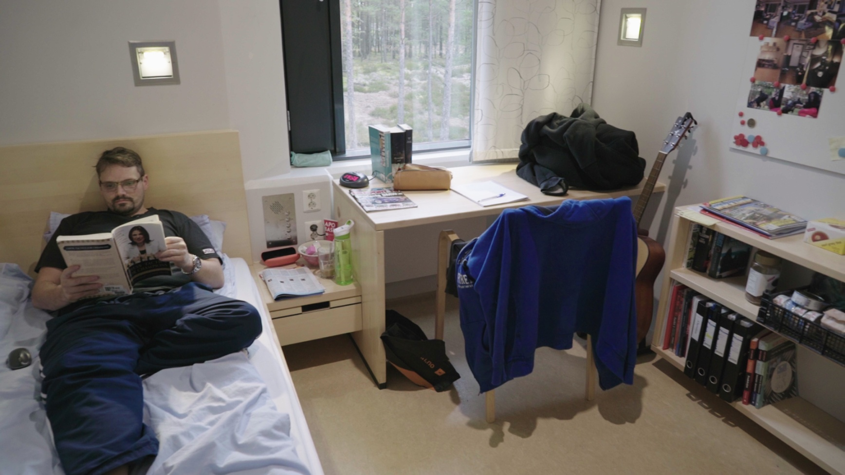

**Norway spent** $129,222 **per prisoner** in 2018 compared with $38,051 **per prisoner** in Michigan. Critics contend the U.S. **spends** more because its **inmates** serve longer sentences and are more likely to return to **prison.**

