Inverse Kin Documentation
Intro
Inverse kinematics is a mathematical method used to calculate the required joint angles of a robotic arm based on a desired position in Cartesian coordinates (X, Y, Z). Rather than controlling each servo motor individually, inverse kinematics allows the user to specify a target position, with the necessary joint angles calculated automatically.
This approach enables more precise and intuitive control of the robotic arm, allowing it to follow defined paths, such as moving in a straight line between two points. By providing greater control over the position and movement of the arm's end effector, inverse kinematics significantly improves the arm's usability, accuracy, and overall functionality.

Machine Properties
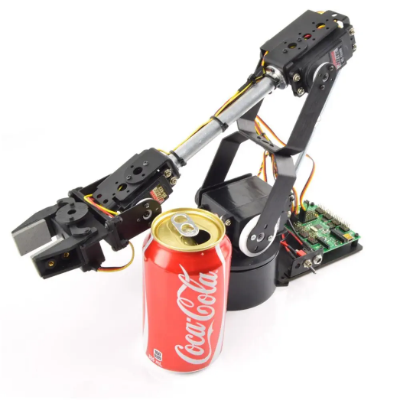
The robot arm is a four-axis, four-servo robotic manipulator based on the Lynxmotion AL5D 4DOF Robotic Arm.
To simplify the inverse kinematics calculations, the wrist assembly will be removed and replaced with a coordinate sphere. This allows the position of the arm's endpoint to be represented more clearly within a three-dimensional Cartesian coordinate system (X, Y, Z), making it easier to visualise and calculate the arm's movements.

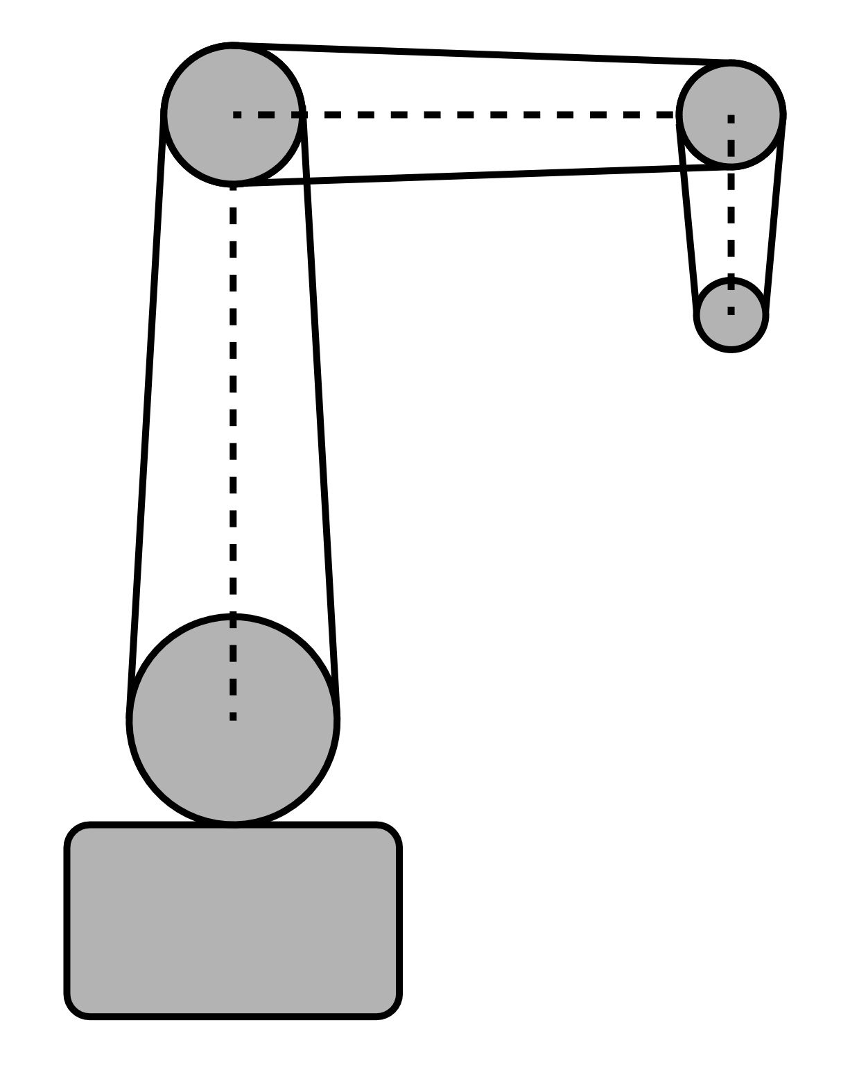
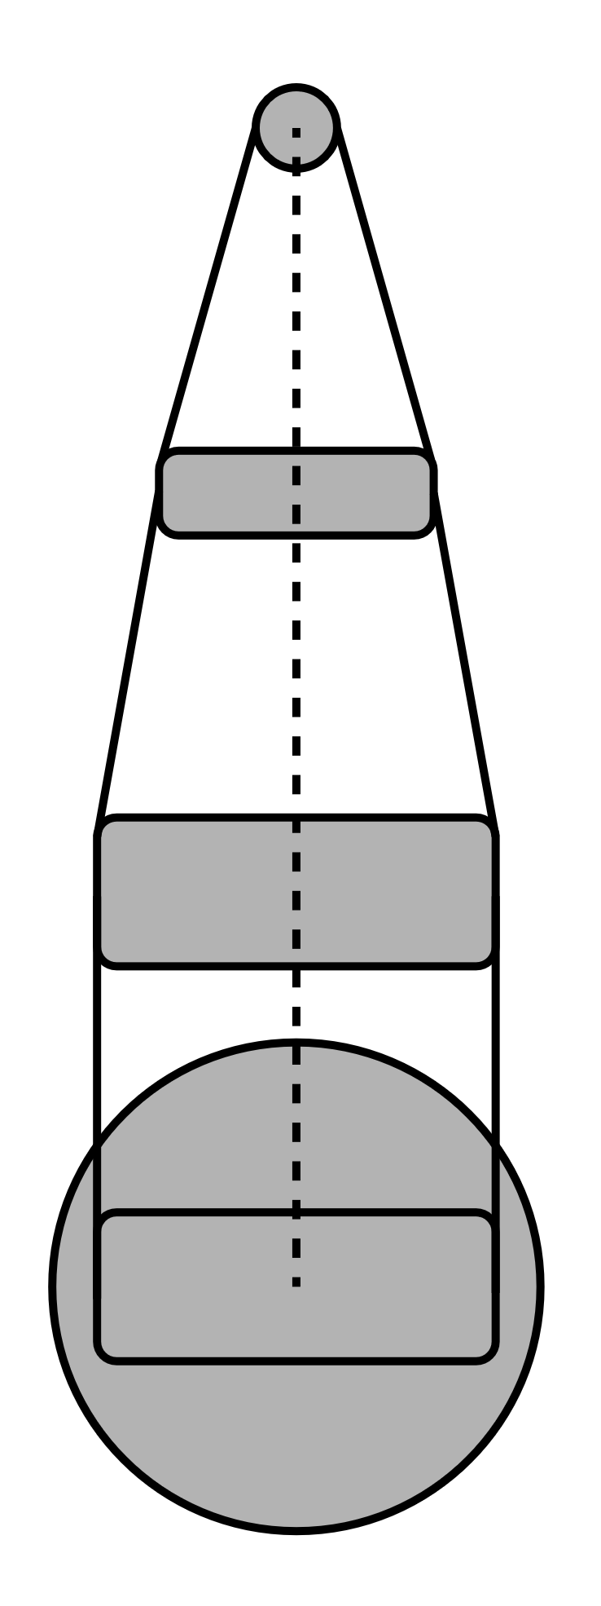
The robot can be represented by:

Link Properties:
The machines physical properties are needed in calculating the inverse kinematic calculations the lengths of the arms are represented as Lx: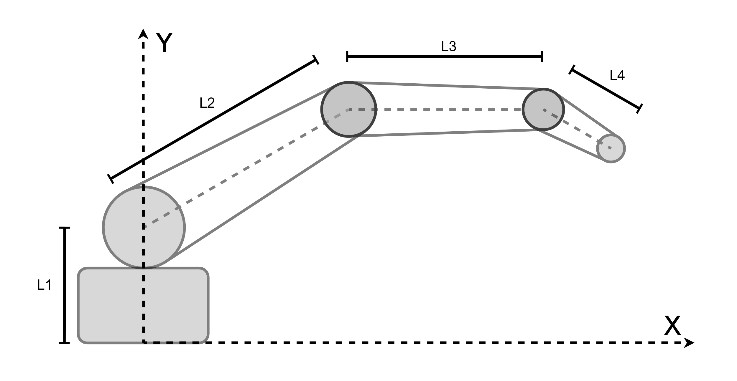
L1 = 74.00 mm, L2 = 145.95 mm, L3 = 183.70 mm, L4 = 63.00 mm

Servo properties:
The second thig needed to define the inverse kinematic properties of the robot are the servos:
Property | S1 – Base | S2 – Shoulder | S3 – Elbow | S4 – Wrist
Servo model | HS-485HB | HS-805BB | HS-755HB | HS-645MG
Servo type | Analogue | Analogue | Analogue | Analogue
Operating voltage | 4.8–6 V | 4.8–6 V | 4.8–6 V | 4.8–6 V
Stall torque at 6 V | 6.0 kg·cm | 24.7 kg·cm | 13.2 kg·cm | 9.6 kg·cm
Speed at 6 V | 0.18 s/60° | 0.14 s/60° | 0.23 s/60° | 0.20 s/60°
Weight | 45 g | 152 g | 110 g | 55.2 g
Gear material | Resin | Resin | Resin | Metal/hybrid
Control method | PWM | PWM | PWM | PWM
Nominal joint range* | 180° | 180° | 180° | 180°

The angles of the servos can then be represented in the arm with this:
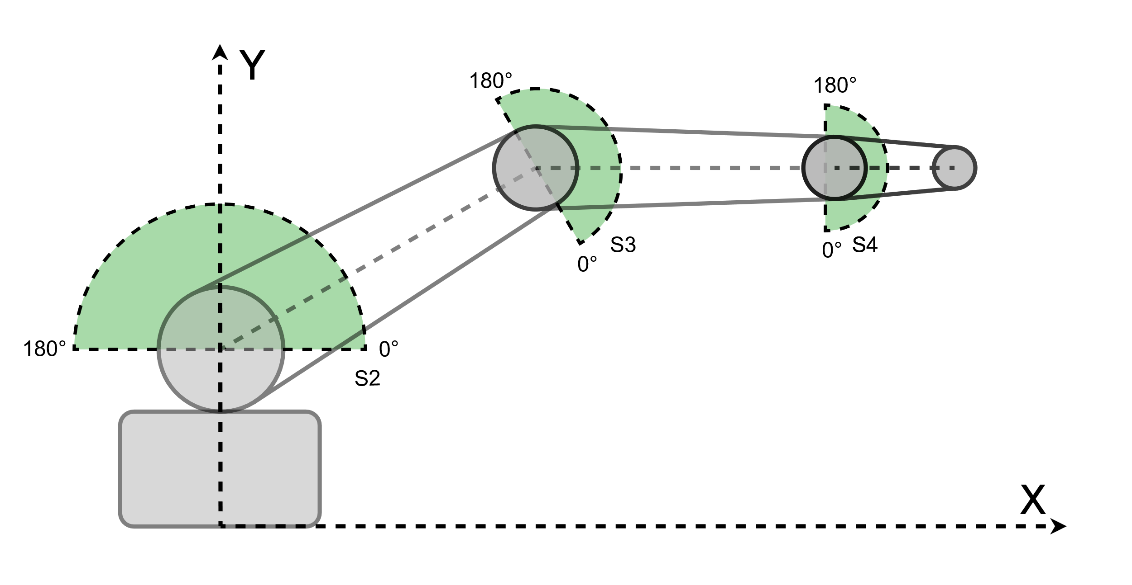
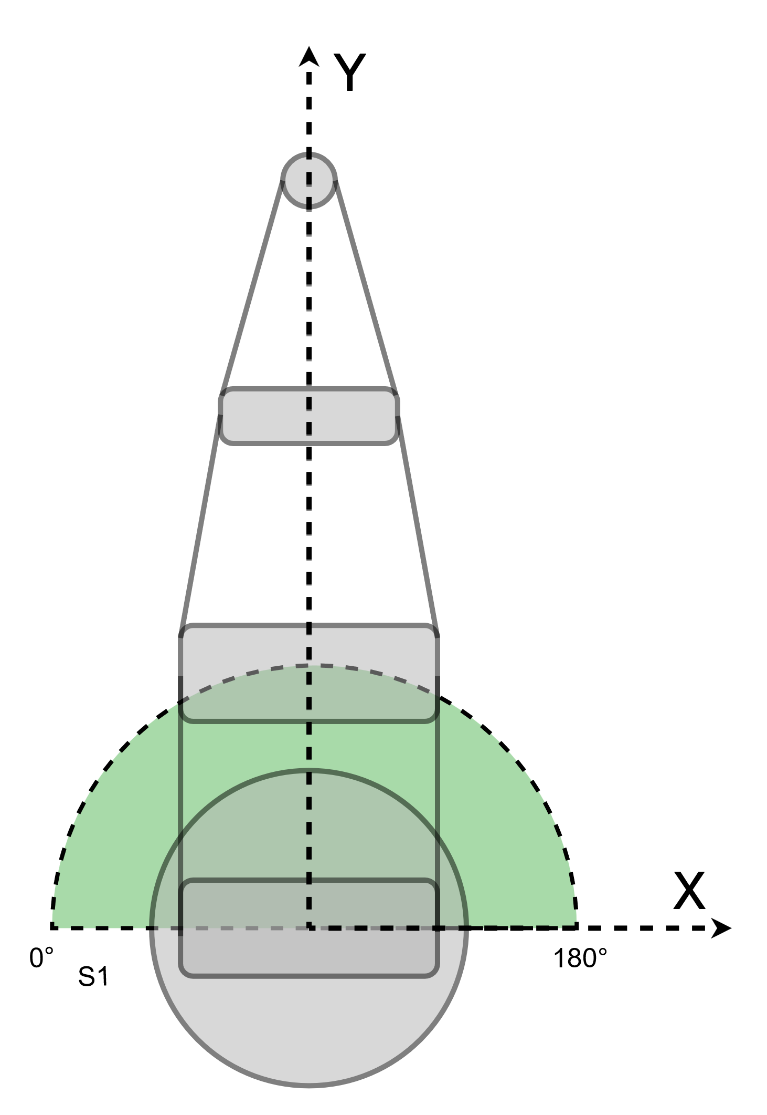

Angle Input
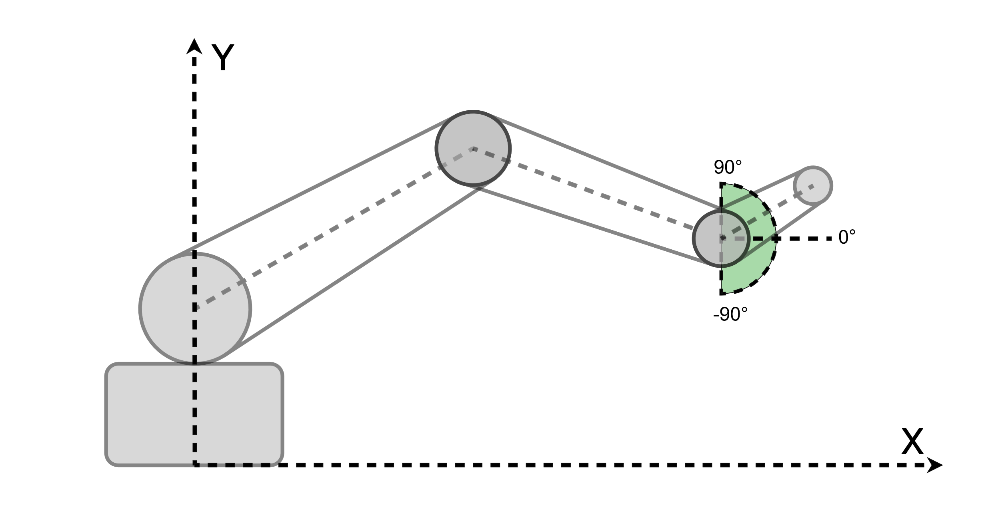
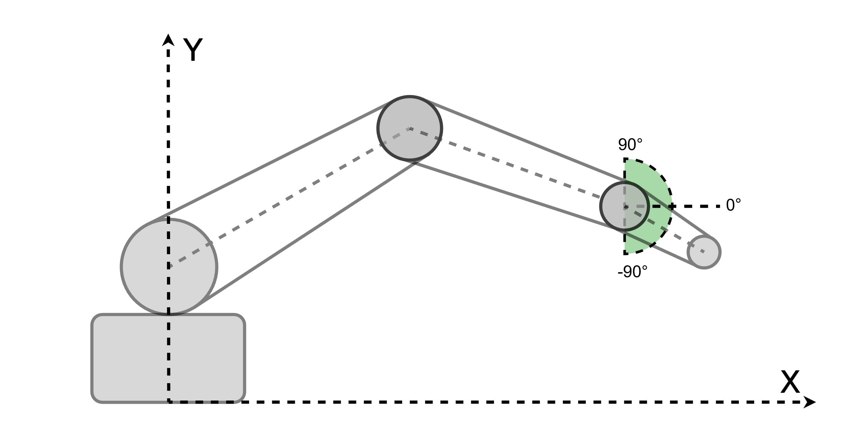
First The Angle Input can be defined by the angle of the arm holding the coordinate ball. From the x axis
Angle = -30°
Angle = 30°

Forward Kin
Forward kinematics is a mathematical method used to calculate the position of a robotic arm's endpoint based on its joint angles (S1, S2, S3 and S4). Unlike inverse kinematics, which calculates the required servo angles from a target position, forward kinematics uses the known servo angles and link lengths to determine the resulting Cartesian coordinates (X, Y, Z).
The calculations are performed sequentially, starting at the base and progressing through each joint until the endpoint is reached. This allows the position of each joint to be determined and provides a method of verifying the accuracy of the inverse kinematics calculations.

1. S1 – Base Rotation
The first servo controls the rotation of the robotic arm around its vertical axis. This determines the direction in which the arm extends across the horizontal X-Y plane.
As the servo angle contains a 90° offset relative to the Cartesian coordinate system, this must first be removed to obtain the actual rotation angle.
$$\boxed{α=S1-\frac{π}{2}}$$
Where $α$ represents the rotation of the arm around the vertical axis.
This angle is used at the end of the calculations to convert the radial reach into X and Y coordinates.

2. S2 – Shoulder Angle
The second servo controls the angle of the upper arm relative to the horizontal plane.
Using the length of the upper arm (L2), trigonometry can be used to calculate the horizontal and vertical displacement from the shoulder to the elbow.
The horizontal position of the elbow is:
$$\boxed{E_{r}=L2\cos\left(S2\right)}$$
The vertical position of the elbow is:
$$\boxed{E_{z}=L1+L2\sin\left(S2\right)}$$
The length L1 is added to the vertical displacement because the shoulder is positioned above the base of the robot.
These calculations provide the elbow coordinates in the arm's two-dimensional radial plane.

3. S3 – Elbow Angle
The third servo controls the angle of the forearm relative to the upper arm.
Unlike the shoulder angle, the elbow servo angle cannot be used directly to calculate the forearm's position, as its orientation is dependent on the shoulder.
To determine the absolute angle of the forearm relative to the horizontal plane, the shoulder angle is added to the elbow angle and the 180° servo offset is removed.
$$\boxed{β=S2+S3-π}$$
Where $β$ represents the absolute angle of the forearm.
The forearm's horizontal displacement can then be added to the elbow position to calculate the wrist's radial position:
$$\boxed{W_{r}=E_{r}+L3\cos\left(β\right)}$$
Similarly, the vertical position is calculated using:
$$\boxed{W_{z}=E_{z}+L3\sin\left(β\right)}$$
This provides the position of the wrist relative to the base of the robot.

4. S4 – Wrist Angle
The fourth servo controls the orientation of the final link, which holds the coordinate sphere.
As the wrist is connected to the forearm, its absolute angle is dependent on the preceding shoulder and elbow angles.
The final link angle relative to the horizontal plane is therefore calculated by adding the three servo angles and subtracting their combined offset of 270°.
$$\boxed{θ=S2+S3+S4-\frac{3π}{2}}$$
Where \(\theta\) represents the angle of the final link relative to the horizontal plane.
The horizontal displacement of the final link is:
$$\boxed{T_{r}=W_{r}+L4\cos\left(θ\right)}$$
The vertical position of the endpoint is:
$$\boxed{Z=W_{z}+L4\sin\left(θ\right)}$$
At this stage, the radial distance from the base and the height of the endpoint have both been determined.

5. Conversion to Cartesian Coordinates
The calculations for S2, S3 and S4 determine the endpoint position within a two-dimensional plane extending outward from the base.
To convert this position into three-dimensional Cartesian coordinates, the base rotation angle calculated from S1 is used.
The X coordinate is:
$$\boxed{X=T_{r}\sin\left(α\right)}$$
The Y coordinate is:
$$\boxed{Y=T_{r}\cos\left(α\right)}$$
The Z coordinate has already been determined from the vertical displacement of each link.
This produces the final endpoint coordinates (X, Y, Z), along with the angle of the final link $θ$.

6. Combined Forward Kinematics Equations
By substituting the intermediate calculations into the final equations, the entire position of the robot can be expressed using the four servo angles and the link lengths.
X coordinate
$$\boxed{\begin{aligned}X=&\left[L2\cos\left(S2\right)\right. \\ &+L3\cos\left(S2+S3-π\right) \\ &\left.+L4\cos\left(S2+S3+S4-\frac{3π}{2}\right)\right] \\ &⋅\sin\left(S1-\frac{π}{2}\right)\end{aligned}}$$
Y coordinate
$$\boxed{\begin{aligned}Y=&\left[L2\cos\left(S2\right)\right. \\ &+L3\cos\left(S2+S3-π\right) \\ &\left.+L4\cos\left(S2+S3+S4-\frac{3π}{2}\right)\right] \\ &⋅\cos\left(S1-\frac{π}{2}\right)\end{aligned}}$$
Z coordinate
$$\boxed{\begin{aligned}Z=&L1+L2\sin\left(S2\right) \\ &+L3\sin\left(S2+S3-π\right) \\ &+L4\sin\left(S2+S3+S4-\frac{3π}{2}\right)\end{aligned}}$$
Final link angle
$$\boxed{θ=S2+S3+S4-\frac{3π}{2}}$$
These equations allow the endpoint coordinates and orientation to be calculated directly from the servo angles without requiring any intermediate positional inputs.

1 | S1 – Base rotation
The base rotates the arm towards the target in the X–Y plane. The script adds π/2 to match the physical S1 angle reference.
$$s1=atan2\left(x,y\right)+π/2$$
To simplify the remaining calculations, the horizontal distance to the tool tip is reduced to a radial coordinate:
$$Reach=√\left(x²+y²\right)$$

2 | Remove the final-link displacement
The desired tool angle θ and length l4 determine the position of the wrist. The arm can then be solved in the radial–vertical plane.
$$Wrist_{r}=Reach-l4cos\left(θ\right)$$
$$Wrist_{z}=z-l4sin\left(θ\right)$$

3 | Shoulder–wrist triangle
The shoulder is at radial position 0 and height l1. The straight-line distance from shoulder to wrist is:
$$Shoulder Wrist Distance=√\left(Wrist_{r}²+\left(Wrist_{z}-l1\right)²\right)$$

The script next finds the distance from the shoulder along the shoulder-to-wrist line to the perpendicular projection of the elbow. This value is named Midpoint Distance in the code, although it need not be the geometric midpoint when l2 and l3 differ.

$$Midpoint Distance=\left(l2²-l3²+Shoulder Wrist Distance²\right)/\left(2×Shoulder_{W}rist_{D}istance\right)$$

The projected point is also calculated in the script, although its coordinates are not needed for the final servo-angle expressions:
$$Midpoint S1 Wrist R=Midpoint Distance×Wrist_{r}/Shoulder Wrist Distance$$

$$Midpoint S1 Wrist Z=l1+Midpoint Distance×\left(Wrist_{z}-l1\right)/Shoulder Wrist Distance$$

The perpendicular distance from this projected point to the elbow is calculated using Pythagoras. The code calls this BisectorLengh:

$$Bisector Lengh=√\left(l2²-MidpointDistance²\right)$$

4 | S2 – Shoulder angle

First calculate the angle from the shoulder to the wrist, measured relative to the horizontal radial axis:

$$Mid Axis Angle=atan2\left(Wrist z-l1,Wrist r\right)$$

Next, add the angular offset associated with the elbow intersection. Elbow Branch selects the side of the shoulder–wrist line on which the elbow lies.

$$S2=MidAxisAngle+atan2\left(ElbowBranch×BisectorLengh, MidpointDistance\right)$$

Elbow Branch = +1 selects the first solution; −1 selects the mirrored solution. Using atan2 rather than a simple arccos preserves the sign/quadrant when Midpoint Distance is negative.

5 | Calculate elbow coordinates
The script uses the calculated s2 and the upper-arm length l2 to locate the elbow:

$$Elbowr=l2cos\left(s2\right)$$

$$Elbowz=l1+l2sin\left(s2\right)$$

6 | S3 – Elbow angle

S3 is not directly calculated from a cosine-rule angle in the supplied Python script. Instead, the script determines the absolute forearm angle from the elbow and wrist coordinates:

$$ForearmAngle=atan2\left(WristZ-ElbowZ,WristR-ElbowR\right)$$

The elbow servo angle is the relative angle between upper arm and forearm, with the script’s 180° offset:

$$S3=π+ForearmAngle-s2$$

This is the exact method implemented in InversekinematicsCalc.py for S3.

7 | S4 – Wrist angle

The tool angle θ is relative to the horizon. After accounting for the shoulder and elbow contributions and the combined servo reference offset, the script computes:

s4 = θ + 3π/2 − s2 − s3

8 | Implementation order (as in Python)
Reach → Wrist_r → Wrist_z → Shoulder_Wrist_Distance → Midpoint_Distance → Midpoint_s1_wrist_r → Midpoint_s1_wrist_z → BisectorLengh → MidAxis_Angle → s1 → s2 → Elbow_r → Elbow_z → Forearm_Angle → s3 → s4.

9 | Geometric checks and verification

The script tests that all lengths are positive and that the shoulder-to-wrist distance lies within the two-link reach limits:

|l2 − l3| ≤ Shoulder_Wrist_Distance ≤ l2 + l3

For the supplied dimensions this is 37.75 mm to 329.65 mm. It separately rejects Shoulder_Wrist_Distance ≈ 0, where the shoulder angle is not uniquely defined. The resulting geometric angles may still exceed physical servo limits.

The script then verifies the inverse-kinematics results by computing forward kinematics, using:

FK_Base_Angle = s1 − π/2

FK_Forearm_Angle = s2 + s3 − π

FK_Tool_Angle = s2 + s3 + s4 − 3π/2

From the forward-calculated tool position, it evaluates the Euclidean distance to the target to check whether the reconstructed endpoint coincides with (x, y, z).

