Inspiration:

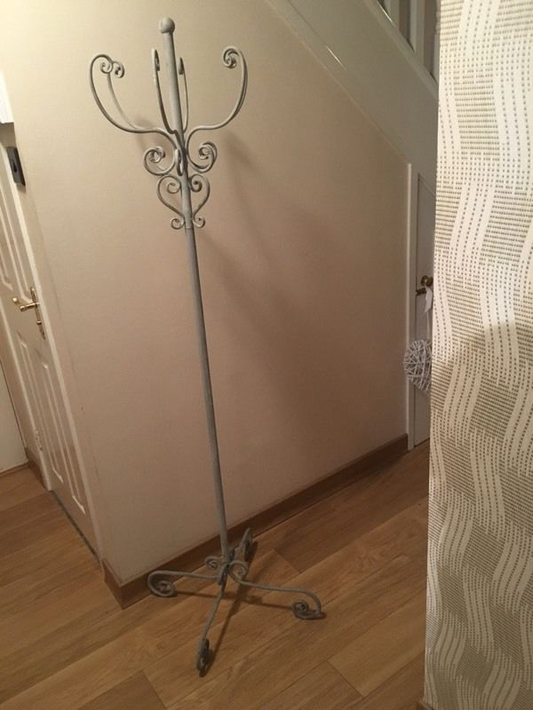

Images from: <https://www.gumtree.com/p/other-miscellaneous-goods/gothic-style-coat-stand/1186960735>

4-15-17

Progress Image 1, added feet to coat stand.

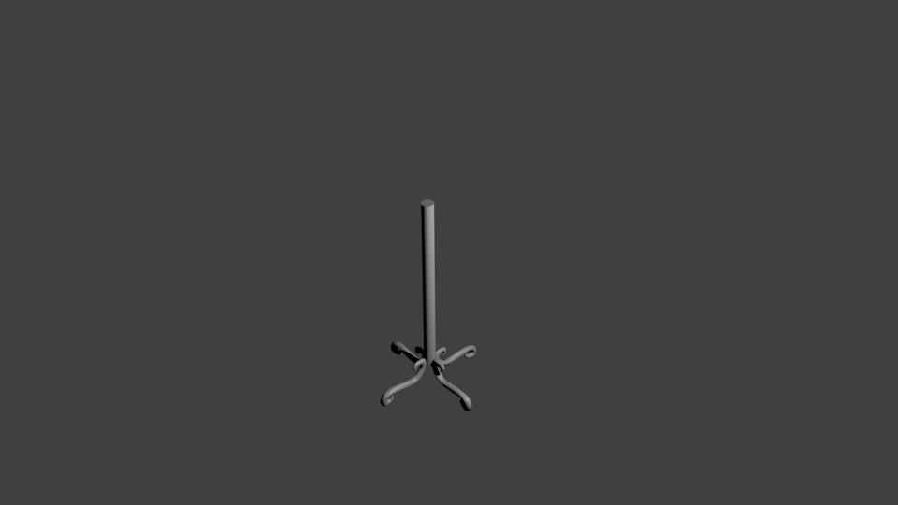

Progress Image 2, added part of upper section to coat stand.

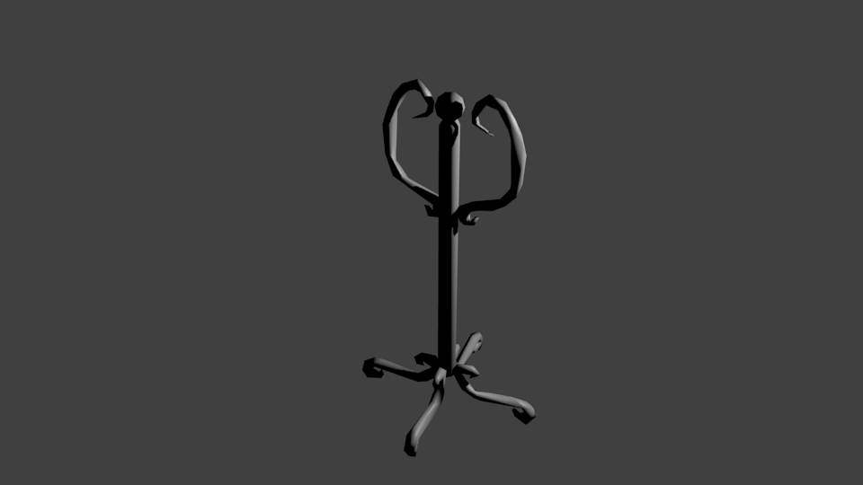

Progress Image 3, finished upper section of coat stand.

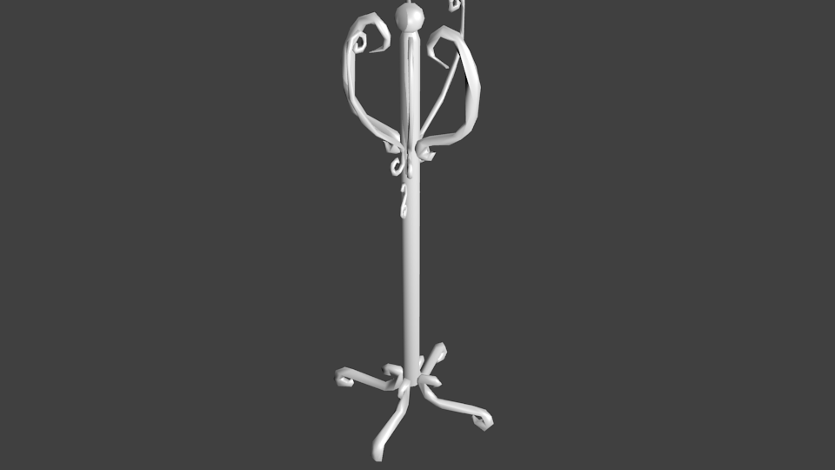

Progress Image 4, textured coat stand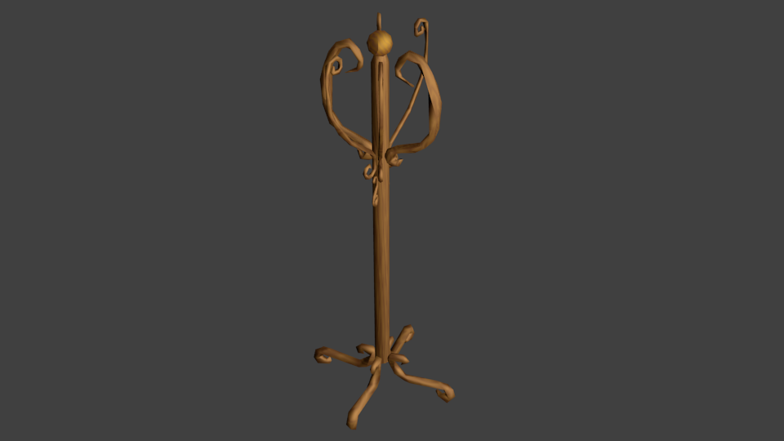

4-17-17

Resized so the coatstand is taller.

