Started work 4-15-17

Inspiration:

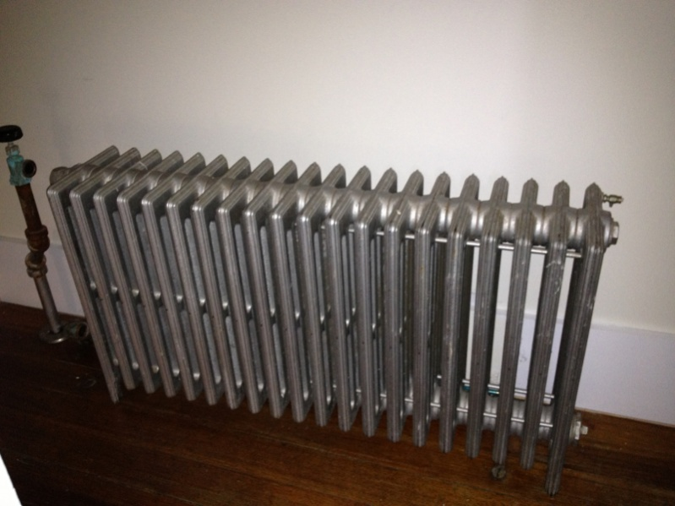

Image from - <http://www.contractortalk.com/f9/how-much-old-radiators-worth-133911/>

4-15-17

First progress image, main pipes created

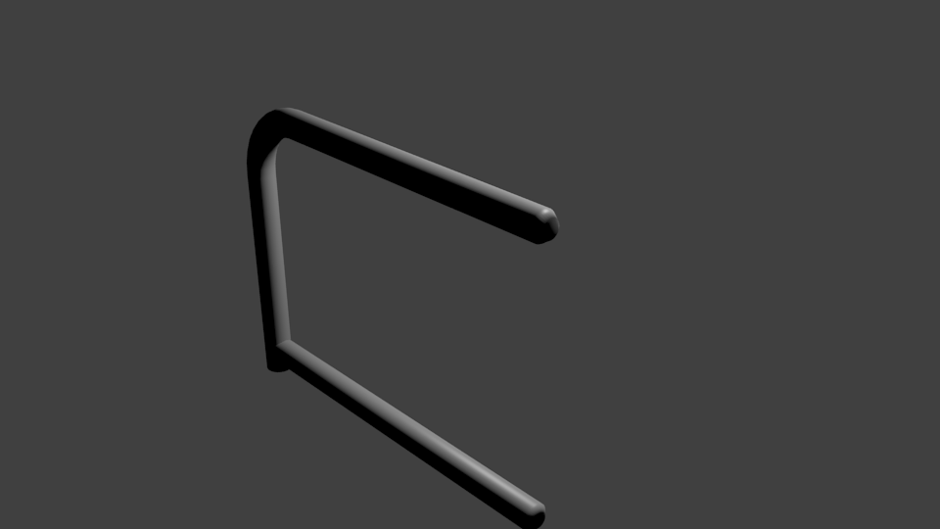

Second progress image, added heat vents

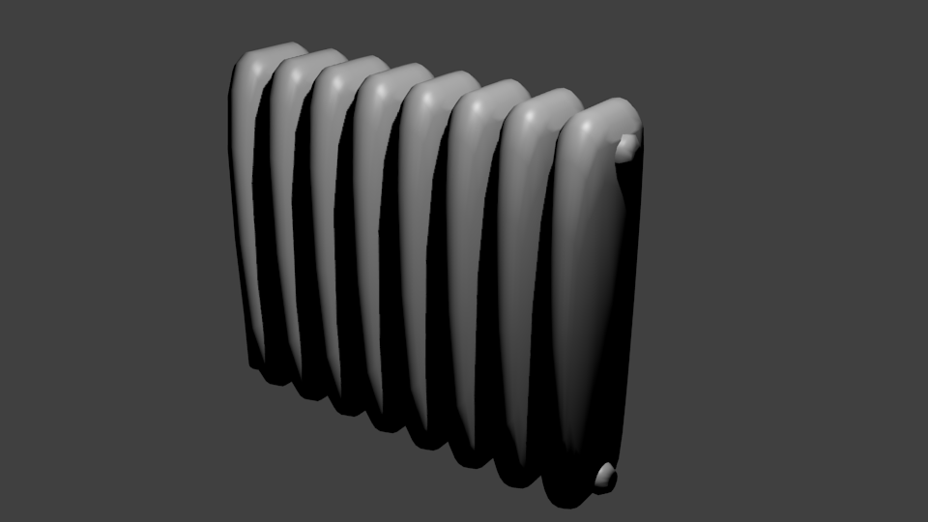

Third progress image, started adding textures and added valve

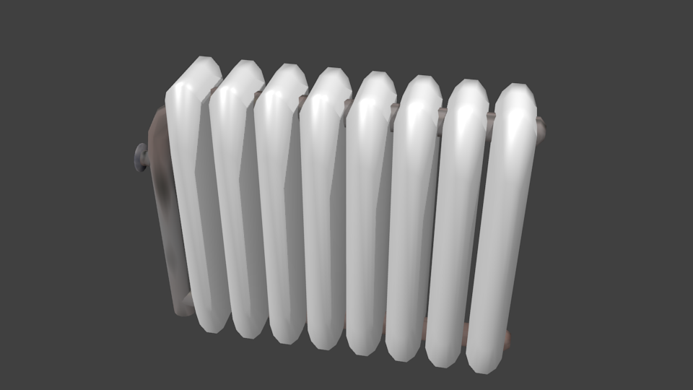

Fourth Progress image, added texture to radiator fans and adjusted lighting

