4-13-17

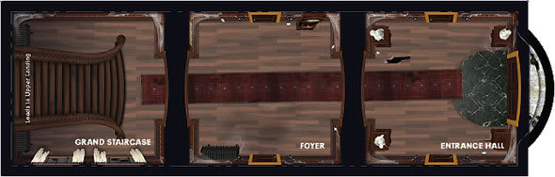

Initial Identification of inspiration, rug from entrance hall in betrayal at house on the hill.

Next step was to make a texture

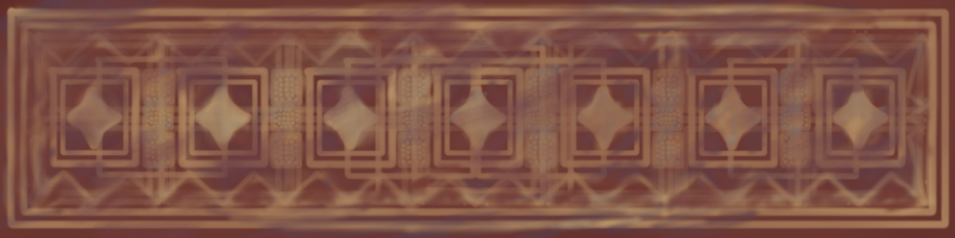

Now I had to make a model.

To do this, I used this tutorial: <http://www.evermotion.org/tutorials/show/10142/creating-a-realistic-carpet-tip-of-the-week> (KAMIL KUKLO, 2016-05-19) with slight modifications along the way.

After following the tutorial, I made this carpet:

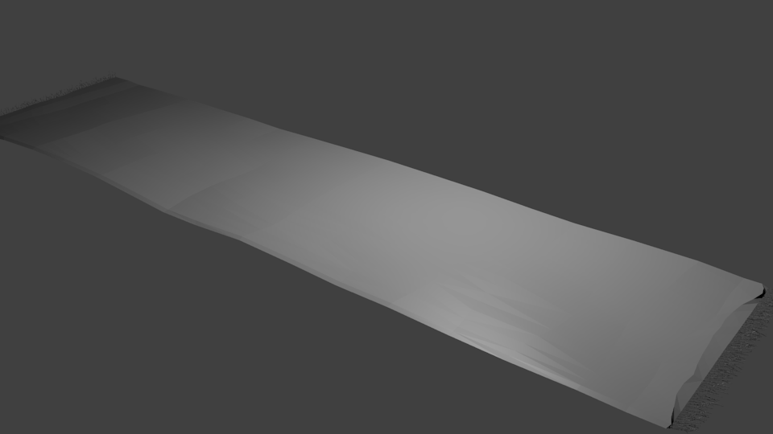

After texturing the carpet and making a few changes, I reached my final result:

