4-22-15 Started work on table

Found image of table:

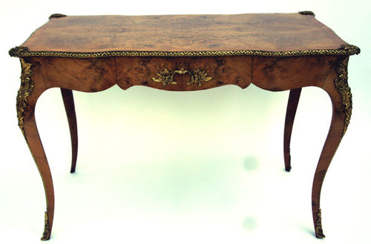

(image from <http://www.antiques-atlas.com/antique/antique_writing_table_french_louis_xv_style/as079a246> )

Made initial sketch of table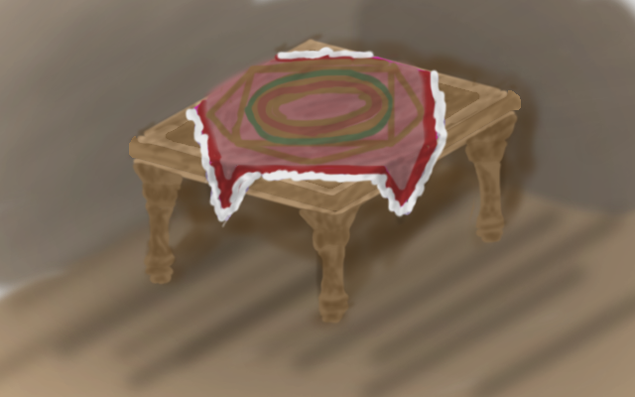

4-22-17

Initial Table modeling

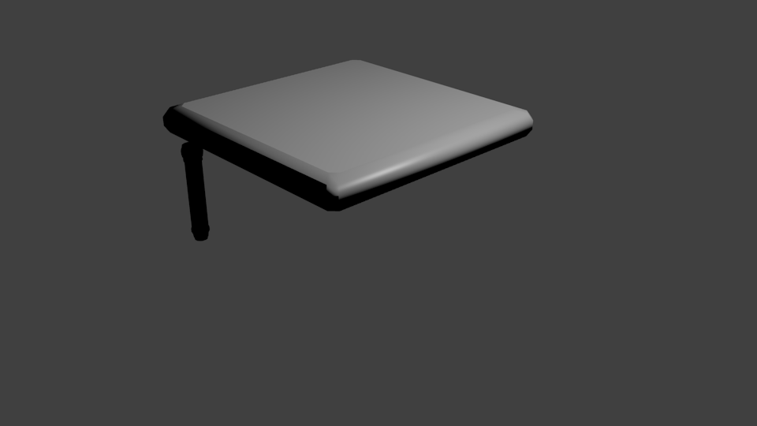

Added Legs

