Artist rendition for sketch of staircase:

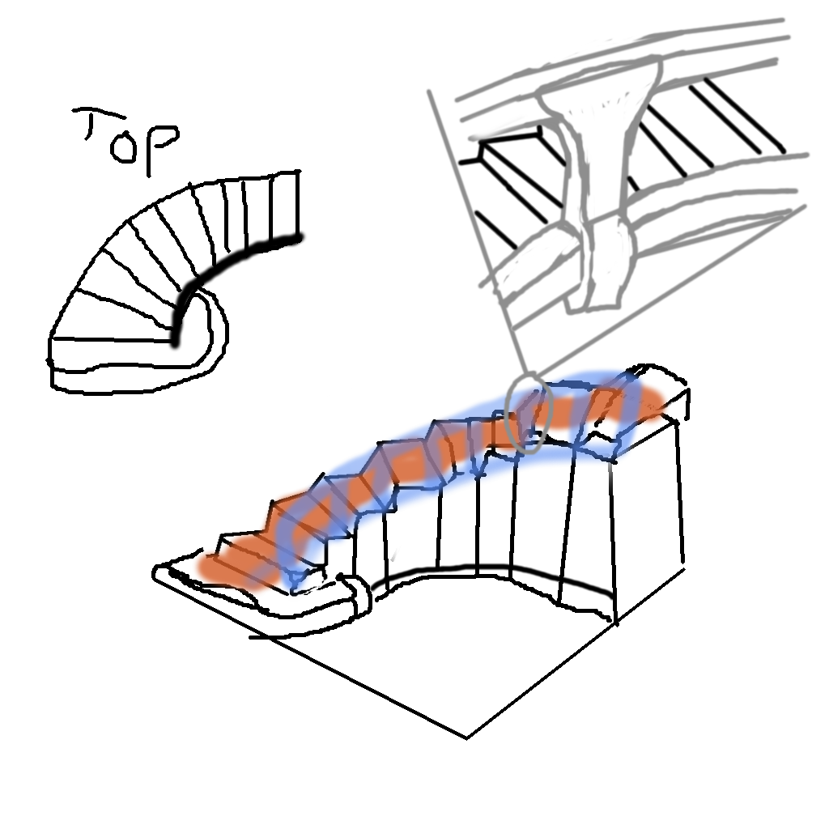

4-6-17

Made initial version of staircase based on sketch and idea.

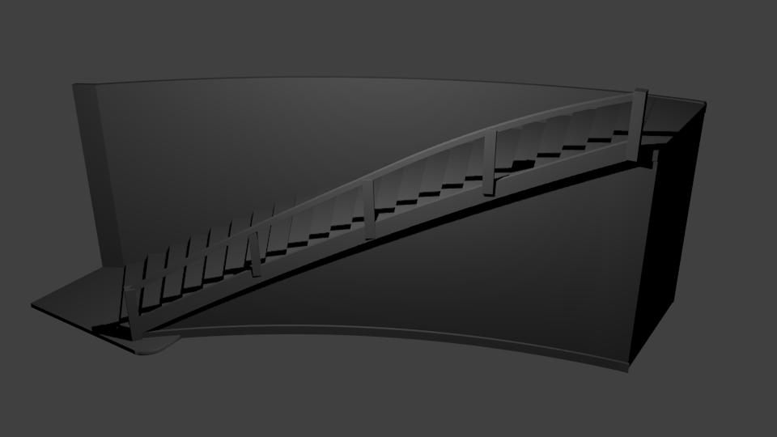

Changed Back Wall to railing – 4/11/17

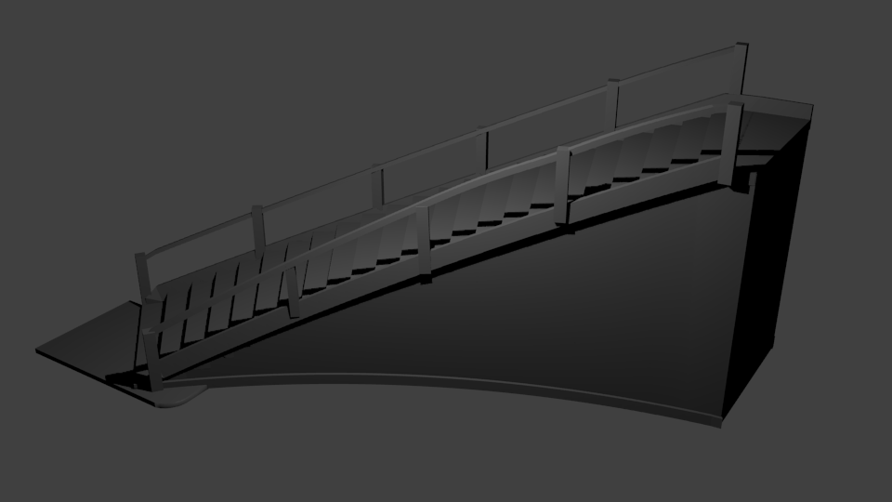

TODO:

Add detail to the steps and railing

Add carpet

Textures and materials…

Better lighting for image

~~Switch back wall to railing~~