



**BTP Report**

**on**

**Virtualization in Cloud: Cloud Based Starbucks Coffee Clone Website**

**Submitted by:**

**Samyak Nitnaware (20CS3055)**

**Submitted to:  
Dr Kalka Dubey**

**Assistant Professor**

**Department of Computer Science and Engineering**

**ABSTRACT**

***Nearly all coffee drinkers – and for that matter non-coffee drinkers – have heard of a little place called Starbucks. Known for their fresh roasted, imported Arabic coffee beans, and friendly Milan-styled coffee bars, Starbucks offers premium coffee in a friendly, unique environment. Many people visit Starbucks for the experience alone, even those who may not normally drink coffee.***

***However, recent market research had suggested that customers were dissatisfied with the level of customer service they were receiving. Starbucks had decided that a solution would need to be in place to win back these customers, and to ensure that no other customers would be dissatisfied or lost to the competition. An idea had been presented to invest $40 million into additional labour hours for Starbucks 4,500 stores – a share of 20 labour hours per week per store. Starbucks will need to make a decision, as to whether or not the investment will work and if so, will the return on the investment net a profit for the company in the years to come.***

***Through this project, users can simulate using the Starbucks website and can order their favourite beverage. Users' preferences will be saved in a database and accessible for uses such as displaying advertisements, selling information to other vendors, and recommending new orders based on saved preferences.***

***By providing all the necessary functionalities along with additional preferences and ordering options, this project replicates the experience of using a real Starbucks Coffee website.***

**Contents**

1. **Chapter 1: Introduction**
   1. **Background of Starbucks Coffee**
   2. **Project Aim**
   3. **Why Cloud Computing**
2. **Chapter 2: Overview & Interface of Project**
   1. **Why Clone?**
   2. **Frontend Interface of Starbucks Coffee Clone Website**
   3. **Google Map of Starbucks Stores available in Washington DC & Zomato**
3. **Chapter 3: Specifications of Project**
4. **Languages/Tools Used**
5. **Chapter 5: Outcome/Results of the Project**

* **Two Major Outcomes & Positives**

1. **Chapter 6: Contribution Made by Me to Project**
2. **Conclusion**

**CHAPTER 1**

**INTRODUCTION**

* 1. **Background of Starbucks Coffee**

**Millions of people all over the world walk into Starbucks every day for their cup of coffee, but it is more than the overpriced coffee that brings people in day after day to the Starbucks stores across the world. Starbucks offers an upbeat environment and friendly and helpful staff to assist customers in any question or problem they might have with the coffee or service. People buy Starbucks for what it represents and the status symbol that comes along with it. Although various business models exist, the principles and structure of Starbucks is a good model to follow, due to its national and global success.**

**1.2 Project Aim**

1. Adding Functionality of creating a profile and saving drink preference in Starbucks Coffee.

2. Creating a virtual ordering experience in Starbucks Coffee, also ordering online on Zomato.

3. Using virtual cloud computing, giving worldwide access to all the resources available on the website.

4. Adding a personalized touch to the website by creating a beautiful and user-friendly interface.

5. Storing the data of user’s preference which will lead to great marketing and money-generating business plan.

6. Locating nearest Starbucks Coffee stores for ease.

**1.3 Why Cloud Computing?**

Cloud computing is an abstraction of compute, storage, and network infrastructure assembled as a platform on which applications and systems can be deployed quickly and scaled on the fly. Crucial to cloud computing is self-service: Users can simply fill in a web form and get up and running.

Most cloud customers consume public cloud computing services over the internet, which are hosted in large, remote data centres maintained by cloud providers.

Cloud computing provide us the following types of services:

**1. Software as a Service (SaaS):** This type of cloud computing delivers applications over the internet, typically with a browser-based user interface. Today, the vast majority of software companies offer their wares via SaaS—if not exclusively, then at least as an Option.

The most popular SaaS applications for business can be found in Google’s G Suite and Microsoft’s Office 365

**2. Platform as a Service (PaaS):** PaaS provides sets of services and workflows that specifically target developers, who can use shared tools, processes, and APIs to accelerate the development, testing, and deployment of applications. Salesforce’s Heroku and Salesforce Platform (formerly Force.com) are popular public cloud PaaS offerings; Cloud Foundry and Red Hat’s OpenShift can be deployed on premises or accessed through the major public clouds. For enterprises, PaaS can ensure that developers have ready access to resources, follow certain processes, and use only a specific array of services, while operators maintain the underlying infrastructure.

**3. Infrastructure as a Service (IaaS):** At a basic level, IaaS cloud providers offer virtualized compute, storage, and networking over the internet on a pay-per-use basis. Think of it as a data centre maintained by someone else, remotely, but with a software layer that virtualizes all those resources and automates customers’ ability to allocate them with little trouble.

But that’s just the basics. The full array of services offered by the major public IaaS providers is staggering: Highly scalable databases, virtual private networks, big data analytics, developer tools, machine learning, application monitoring, and so on.

These service models can be offered to the end user through either of, public cloud, private cloud and hybrid cloud. In this project, SaaS and IaaS service models will be deployed. SaaS accounts for the digital library website application which runs on the server, while IaaS accounts for the physical hardware component – the server hosting the library website application and providing services to users.

**CHAPTER 2**

**OVERVIEW OF PROJECT**

2.1 Why Clone?

Even though there is already an original Starbucks Coffee website, this project's added functionality aims to appeal to a large number of coffee drinkers who can get a Starbucks Coffee website simulation experience by creating a personalised profile and logging in to order their preferred choice drink with a lovely interface. Users from Washington DC can find nearest Starbucks stores for Dine-in and easy Pickups, also users can order the drinks on Zomato with no complications.

Any user can access the Starbucks Coffee clone website from anywhere in the world, and using cloud computing, our services give them very simple access to all the resources which are available on the website. I have used the **Amazon EC2** which is IaaS based Cloud Computing system, makes website database rich and

remotely available to every single user everywhere, where you just need to click on a single link or just have to search for a provided IP Address on the internet and you can access the Starbucks Coffee Clone anytime around the globe.

In this project the technologies which I used are Web Technology and Cloud Computing, with the help of web technology we are eligible to create such environment and user interface in which we and other user for the services has no complication for using the services and then I used the Cloud Computing which helps in hosting the project on cloud resource and makes the website and its resources accessible to everyone with ease.

2.2

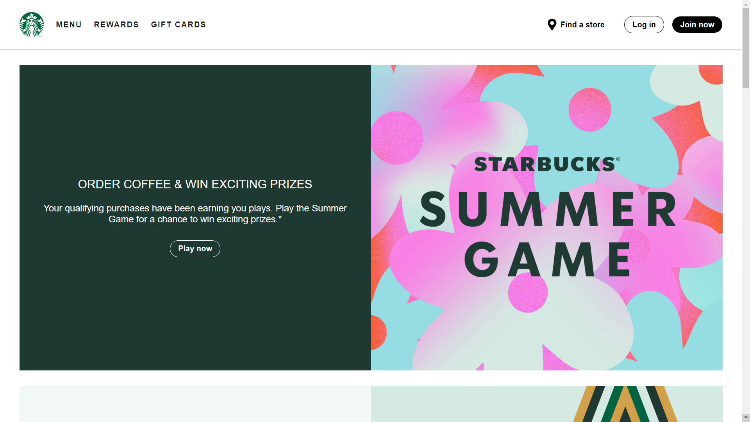

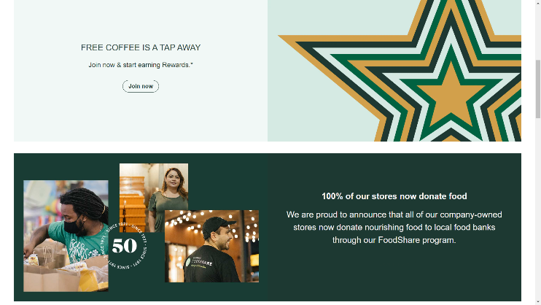

Front Page Interface of Starbucks Coffee Clone

The home/landing page of Starbucks Coffee Clone has a beautiful interface which provides various functionalities for Register, Log-in & Order, Finding Store, Redirecting to Starbucks Coffee social handles, Starbucks Summer Game & much more.

2.3

Google Map of Starbucks Stores available in Washington DC & Starbucks Zomato webpage

**CHAPTER 3**

**SPECIFICATION OF PROJECT**

The main concept of the project is to replicate the major functionalities of Starbucks Coffee website and customize by adding different touches throughout the website which will be pleasant to interact and user-friendly. I created the body of web pages with the use of HTML5 and for the styling of web app I used the CSS 3 and then created web application by connecting Database to PHPMyAdmin to save customer’s credentials and preferences using PHP framework and lastly hosted the website on Amazon EC2 by creating Virtual Instance on the system then hosting the website locally on Virtual Machine by creating a Public IP address, which is accessible worldwide.

**Join Now Window: User needs to register first on Starbucks Coffee Clone website order to save their preference and order on the website further.**

**Once the user has registered on the website, his / her credentials and beverage preference will be available on PHPMyAdmin Database which is linked to the Registration page by the following code -**

**The Password stored on Database is encrypted and nobody other than Admin can access these customers’ credentials.**

**If the user is already registered, the website will show a popup ‘user already exist’.**

**It is mandatory for user to register on Starbucks Coffee Clone before ordering and must select a preference. (‘none’ if the preference is No)**

**Log-in Window: After successful registration, user needs to login for ordering from the provided Starbucks Beverages.**

**Whether a user is registered on the website or not and the user’s registered credentials are available on the database or not is verified by the following code -**

**After Successful login, user can now place an order for single or multiple beverages by selecting from the given drop-down menu.**

**Created an Amazon EC2 Instance for hosting website locally on VM and further hosting on cloud with the help of XAMPP servers by starting MySQL and Apache. The Starbucks Coffee Clone is now deployed on the Amazon Elastic Cloud Compute and can be accessed anywhere by searching the Virtual Instance’s Public IP address. (**[**13.233.77.124**](http://13.233.77.124/dashboard/)**)**

**Why EC2?**

**Amazon EC2 instances eliminate the up-front investment for hardware, and there is no need to maintain any rented hardware. It enables you to build and run applications faster. You can use EC2 in AWS to launch as many virtual servers as you need. Also, you can scale up or down when there is an increase or decrease in website traffic.**

**Now that we know the EC2 overview, let’s now understand Why exactly we need Amazon EC2.**

**Auto-scaling:**

**This is the benefit that makes most businesses opt for AWS EC2. How Netflix uses Amazon EC2 auto-scaling to its advantage and provides a crash-free experience.**

**It is providing resources according to the demand. They either scale up or scale down corresponding to the increase or decrease in demand.**

**Pay-as-you-go:**

**You will be charged by the hour, and you have to pay only for what you have used. A company, XYZ might be using 100 servers normally, and on Mondays, it scales down to 50 servers. So, it only has to pay for 50 servers those days, not the usual fee for the usage of 100 servers.**

**Even when you use your Amazon EC2 instances services for a few hours, you only need to pay for that time period and nothing more.**

**Increased Reliability:**

**AWS is spread across 20 worldwide regions with 61 availability zones (AZs) which helps your business when it is expanding. Also, this will increase the load speed of your application around the world.**

**You can always store multiple copies of your application in multiple AZs so that when one data center fails or loses data, the application will not fail completely.**

**Elasticity:**

**Instead of 10 low-configuration machines, you could rent a single high-configuration machine with an OS of your preferred choice for your application. Elasticity is the feature from which Elastic Compute Cloud got its name.**

**CHAPTER 4:**

**LANGUAGES/**

**TOOLS USED**

The project is made on PHP framework using HTML5, CSS3 Languages.

The project is deployed and hosted on Amazon EC2. Deployment can be done by following some simple steps which are as follows:

* [Step 1. Create an Amazon EC2 Instance](https://blog.runcloud.io/aws/#step-1-create-an-amazon-ec2-instance)
  + [Select AWS Region](https://blog.runcloud.io/aws/#select-aws-region)
  + [Launch Instance](https://blog.runcloud.io/aws/#launch-instance)
  + [Choose Ubuntu Server 16.04 / 18.04 / 20.04](https://blog.runcloud.io/aws/#choose-ubuntu-server-1604-1804-2004)
  + [Choose Amazon EC2 Instance Type](https://blog.runcloud.io/aws/#choose-amazon-ec2-instance-type)
  + [Add Storage](https://blog.runcloud.io/aws/#add-storage)
  + [Configure Security Group (Open Required Ports)](https://blog.runcloud.io/aws/#configure-security-group-open-required-ports)
  + [Create and Download a Key Pair](https://blog.runcloud.io/aws/#create-and-download-a-key-pair)
* [Step 2. Create A Static Public IP Address](https://blog.runcloud.io/aws/#step-2-create-a-static-public-ip-address)
  + [Allocate Elastic IP Address](https://blog.runcloud.io/aws/#allocate-elastic-ip-address)
  + [Associate Elastic IP Address to Amazon EC2 Instance](https://blog.runcloud.io/aws/#associate-elastic-ip-address-to-amazon-ec2-instance)
* [Step 3. Connect Amazon EC2 Instance To](https://blog.runcloud.io/aws/#step-3-connect-amazon-ec2-instance-to-runcloud) PHPMyAdmin.

Virtual Instance created with on the system with Public IP Address 13.233.77.124

In Virtual Instance, all project folders and files are saved in xampp/htdocs folder and then using localhost/dashboard the Starbucks Coffee Clone Website is hosted on Cloud with the help of XAMPP servers and Virtual Instance’s Public IP Address.

**Chapter 5:**

**Outcome/Results of the Project**

As we are using the latest technologies to our website like HTML, CSS3, Amazon EC2 Cloud Computing, PHP MyAdmin SQL etc. All these things will make our website more reliable and presentable.

**Two major outcomes and positives of the Starbucks Coffee Clone Project:**

1. After gathering consumer drink preferences, we may offer that information to a new vendor looking to enter the market using the same business model, which is one of the project's two main outcomes.

Zomato, the market leader, earns enormous profits in this manner.

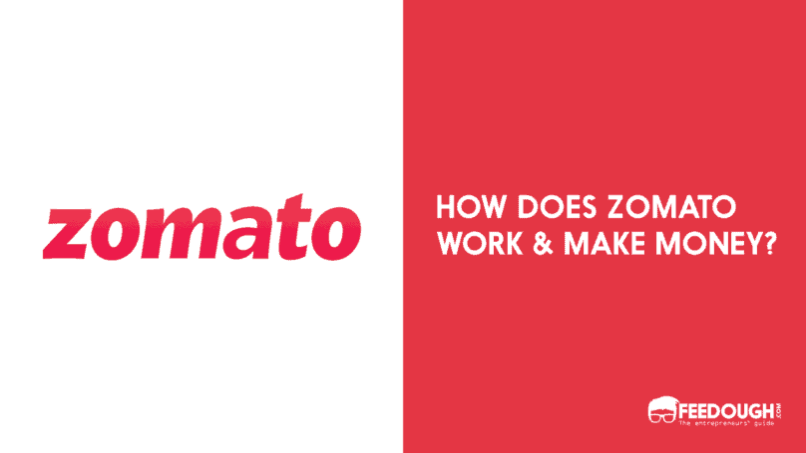

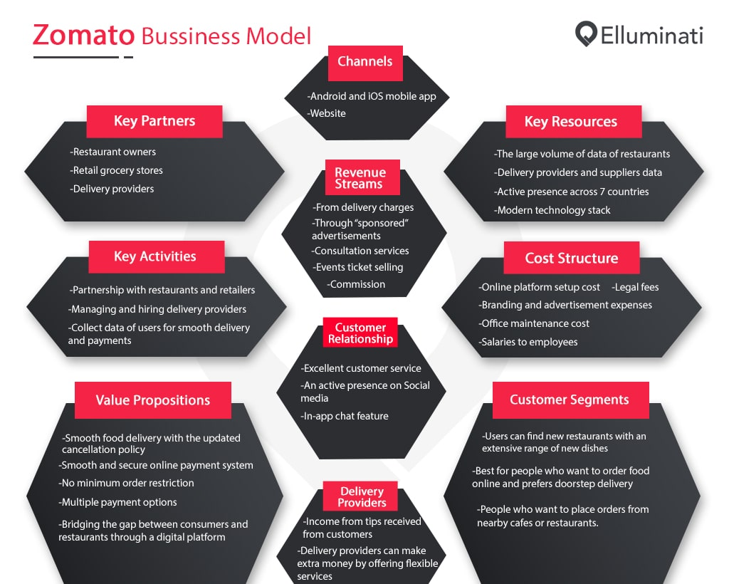

Consultancy And Data Monetisation:

Zomato can analyse users’ behaviour based on the data repositories it has. It gives an insight into which dish is trending, what people are searching for, what kind of food is in more demand, and so on. Restaurant owners need to pay Zomato to get this information to improve and optimise their services according to the users’ requirements.

1. As we have customer's credentials, by using machine learning algorithms, we can target individuals with relevant advertisements across several platforms depending on their preferred beverage. In addition to increasing ad sense revenue, this will draw customers towards the company.

The job of marketers is to get the right product in front of the right consumer at the moment that they’re most likely to buy that product. The ability for marketers to do just that and to drill down to more and more specific niches of customers has grown exponentially over time. AI technology is now being used to help marketers get even more specific with predictive targeting and personalization.

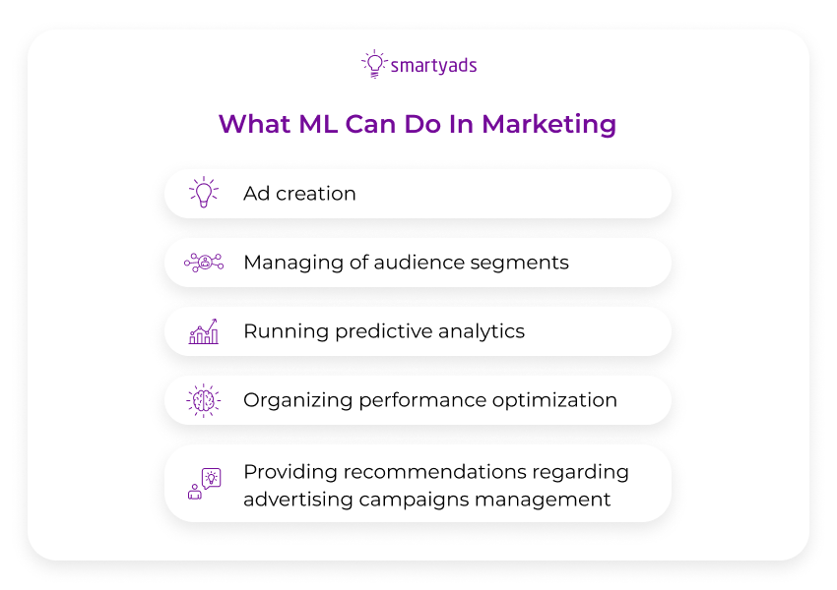

The biggest capability of machine learning and AI is that it can process huge amounts of data to make predictions. This can be used in advertising and marketing to detect signals and get the right ad in front of the right person, at the right time, even without the need of personally identifiable information. With the help and support of machine learning models and AI technology, ads are getting hyper-relevant and can deliver the ROI marketers expect out of digital campaigns.

**Chapter 6:**

**Contribution Made by Me to Project**

I created the body of web pages with the use of HTML5 and for the styling of web app I used the CSS 3 and then created web application by connecting Database to PHPMyAdmin to save customer’s credentials and preferences using PHP framework and lastly hosted the website on Amazon EC2 by creating Virtual Instance on the system then hosting the website locally on Virtual Machine by creating a Public IP address, which is accessible worldwide.

So, I contributed as a web designer in this project and created a beautiful design of homepage and Google Fonts CDN for the better fonts design.

So, by using this I created the overall design of the project website which is further developed by using the PHP framework.

**Chapter 7:**

**Conclusion**

In making of this project, I made a clone of the Starbucks Coffee Clone Website that is accessible to everyone online and has additional features.

The consumer preference data is utilised for various profit-making business activities and may be used in the future to provide them the choices they prefer.

[Click Here To View Starbucks Coffee Clone Website](http://13.233.77.124/dashboard/)

**References**

* [Amazon EC2](https://intellipaat.com/blog/what-is-amazon-ec2-in-aws/#:~:text=The%20main%20difference%20between%20Amazon,from%20AWS%20through%20the%20Internet.)
* [Web Development](https://en.wikipedia.org/wiki/Web_development)
* [Cloud Computing](https://en.wikipedia.org/wiki/Cloud_computing)
* [Zomato Business Model](https://www.feedough.com/zomato-business-model-how-does-zomato-make-money/)
* [Google Maps of Washington DC](https://www.google.com/maps/d/viewer?msa=0&mid=1ol3VesN-xK_1YUe-3tAxQFaMcB8&ll=38.91454812865162%2C-77.0340355&z=12)

**--<> Acknowledgement <>--**

I want to thank Dr. Kalka Dubey, Assistant Professor, CSE Department for all of his assistance with this study. His advice is incredibly beneficial, and he is consistently modest with me throughout the entire endeavour. I am eternally grateful to him for his modest advice.