Logbook
Samy Mohamed Swelim Abd al-Qader
Student code: 1024092
Class: 10-F

Week one
In the first week, my team and I split research on possible solutions, my task was to research on PHS (Pumped Hydro Storage)

*I researched PHS, and concluded its pros and cons using the following sources:
https://www.energy.gov/eere/water/pumped-storage-hydropower
https://www.hydropower.org/factsheets/pumped-storage
https://www.hydro.org/waterpower/pumped-storage/
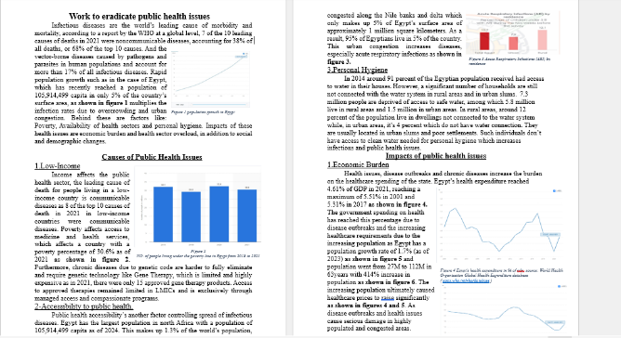
*I started work on my grand challenge (Work to eradicate public health issues) after my team split them between us and later finished it at the end of the week. A picture displaying part of it can be seen in figure 1. Many sources were used in writing the grand challenge, some which’re: https://ourworldindata.org/eradication-of-diseases
Figure 1 work to eradicate public health issues grand challenge

https://openknowledge.worldbank.org/server/api/core/bitstreams/a483291d-6f1b-56b4-babd-2f4304e9d8b2/content
https://data.who.int/countries/818
https://egypt.unfpa.org/sites/default/files/pub-pdf/policy_paper_31dec.pdf
https://data.worldbank.org/indicator/SH.MED.BEDS.ZS?end=2020&locations=EG&start=2000\
https://applications.emro.who.int/emhj/v25/05/emhj_2019_25_05_350_361.pdf
https://merip.org/1997/03/facts-and-figures-on-cairo/
https://www.emro.who.int/emhj-volume-25-2019/volume-25-issue-2/knowledge-practices-and-attitudes-of-physicians-towards-evidencebased-medicine-in-egypt.htm

*Read a research paper on elliptical wind turbines to help decide the design: https://labs.engineering.asu.edu/aircraft-design/wp-content/uploads/sites/115/2023/03/DulinTakahashi-EllipticalWings-UPLOAD.pdf

Week Two
*I did research and selected what prior solution to write about then chose Aswan High Dam due to availability of sources for it.
*I started working on my prior solution and finished it by the end of the week, Part of the prior solution can be seen in figure 2. Multiple sources and research papers were used:
https://www.cde.state.co.us/standardsandinstruction/aswandam
https://www.pbs.org/wgbh/buildingbig/wonder/structure/aswan_high.html
https://www.kfw-entwicklungsbank.de/PDF/Evaluierung/Ergebnisse-und-Publikationen/PDF-Dokumente-A-D_EN/%C3%84gypten_Aswan_2016_E.pdf
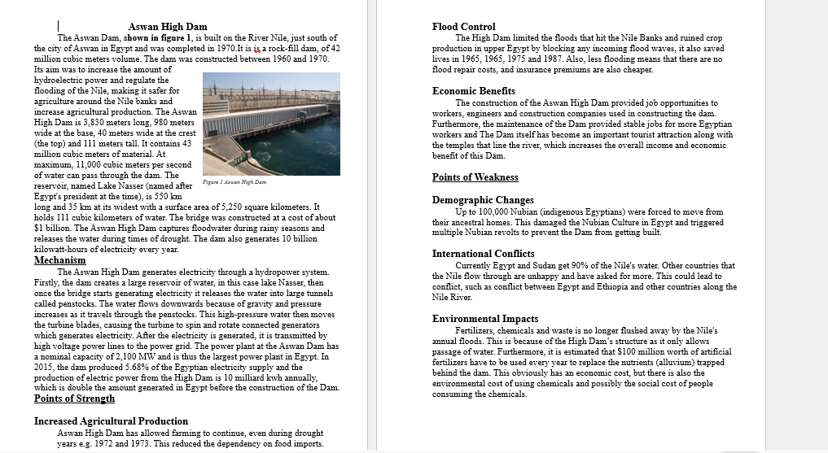
https://www.memphistours.co.uk/Egypt/Egypt-Travel-Guide/Aswan-Attractions/wiki/The-High-Dam-in-Aswan

Figure 2 Aswan High Dam Prior Solution

*Continued research on elliptical wind turbines and read the following research paper:
https://pubs.aip.org/aip/acp/article/2534/1/020002/2828778/Numerical-simulation-of-two-dimensional-2D

Week Three
*Selected the problem to be solved. (Reducing Power Shortage Through Alternative Energy).

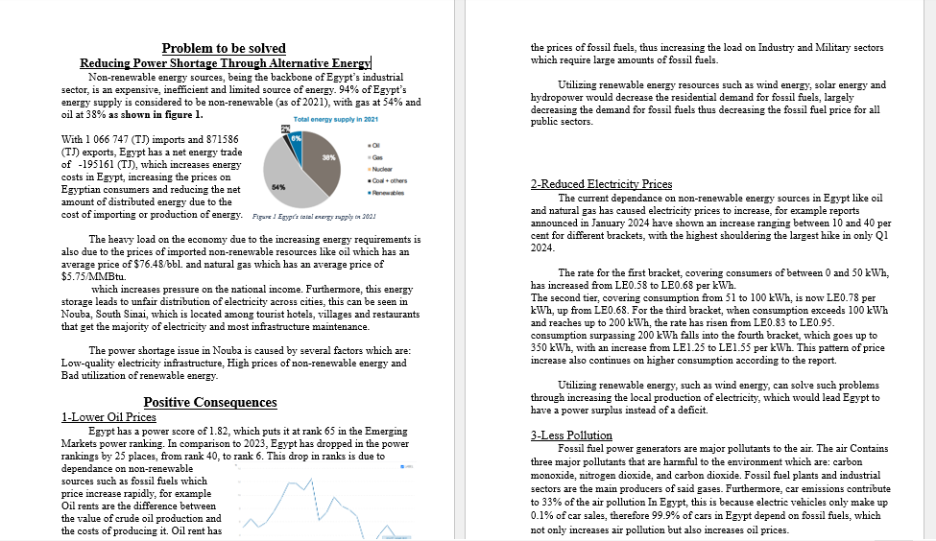
*Started work on the problem to be solved and finished it. Part of It can be seen in figure 3.
Figure 3 Problem To Be Solved

Used sources are listed below:
https://www.cleanairfund.org/clean-air-africas-cities/cairo/
https://documents1.worldbank.org/curated/ar/619601570048073811/pdf/Egypt-Cost-of-Environmental-Degradation-Air-and-Water-Pollution.pdf
https://erf.org.eg/app/uploads/2014/08/585.pdf
https://www.trade.gov/country-commercial-guides/egypt-electricity-and-renewable-energy
https://ember-energy.org/countries-and-regions/egypt/
https://www.irena.org/-/media/Files/IRENA/Agency/Statistics/Statistical_Profiles/Africa/Egypt_Africa_RE_SP.pdf
https://egyptera.org/en/TarrifAug2024.aspx
https://www.global-climatescope.org/markets/egypt
https://english.ahram.org.eg/News/530864.aspx
https://data.worldbank.org/indicator/NY.GDP.PETR.RT.ZS?end=2021&locations=EG&start=1999
https://www.worldbank.org/en/news/press-release/2024/10/29/commodity-markets-outlook-october-2024-press-release
https://www.businesstimes.com.sg/companies-markets/energy-commodities/oil-prices-rise-1-middle-east-attacks-heighten-supply-concerns
https://southwestohioair.org
https://www.gasreg.org.eg/natural-gas-pricing/
https://sdgs.un.org/basic-page/egypt-34124
https://www.ipipotash.org/publications/eifc-269#:~:text=Egypt%20occupies%20a%20total%20area,most%20fertile%20soils%20in%20Egypt.
https://ppac.gov.in/prices/international-prices-of-crude-oil

*Got an introduction into aerodynamic forces, used website: https://www.grc.nasa.gov/www/k-12/VirtualAero/BottleRocket/airplane/presar.html

Week Four
*Resumed research on aerodynamics to improve the turbine design, used the following links:
https://www1.grc.nasa.gov/beginners-guide-to-aeronautics/aerodynamic-forces/
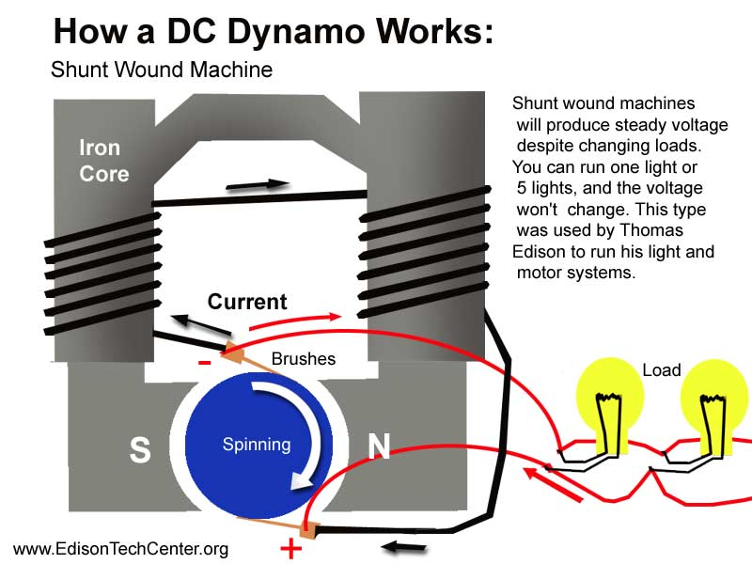
*Studied how dynamos generate electricity to better understand the turbines. This is shown in figure 4 and taken from the sources listed below. https://edisontechcenter.org/generators.html
Figure 4 Dynamo Mechanism
https://www.energy.gov/eere/wind/how-do-wind-turbines-work
https://www.bbc.co.uk/bitesize/guides/z9f92nb/revision/3
*Studied how rechargeable batteries function:
https://www.energy.gov/science/doe-explainsbatteries#:~:text=To%20accept%20and%20release%20energy,through%20the%20circuit%20and%20electrolyte.

Week Five
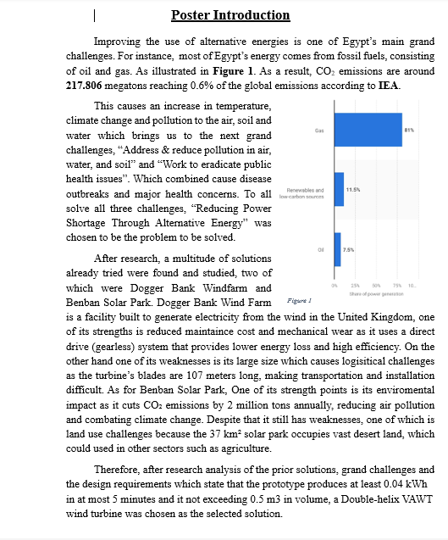
Wrote the introduction of the poster as shown in figure 5:

*Studied electromagnetism to understand dynamos:https://www.electricity-magnetism.org/how-does-a-dynamo-work/
Figure 5
https://byjus.com/physics/electromagnetism/#:~:text=Electromagnetism%20is%20a%20branch%20of,%2C%20electric%20fields%2C%20and%20light.
https://www.ansys.com/simulation-topics/what-is-electromagnetism

Week Six
Researched aerodynamics for poster analysis: https://pressbooks.lib.vt.edu/aerodynamics/chapter/chapter-1/
https://soaneemrana.org/onewebmedia/Aerodynamics---Houghton&Carpenter.pdf
Wrote the abstract of the poster as shown in figure 6:
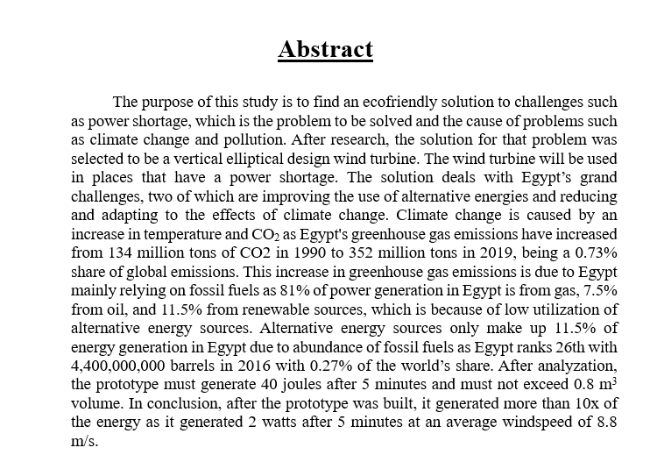
Figure 6

Week Seven
Wrote the conclusion of the poster as shown in figure 7:
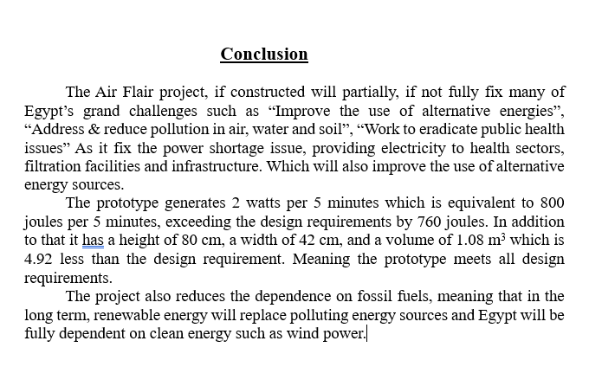
Figure 7

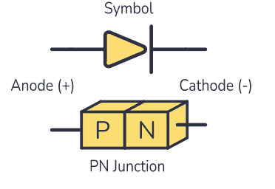
*researched rectifier diode for the electric circuit: https://www.build-electronic-circuits.com/rectifier-diode/#:~:text=The%20rectifier%20diode%20lets%20you,basic%20electronic%20components%20in%20electronics.

8 rectifier diode

Eid Mubarak!

Week ten
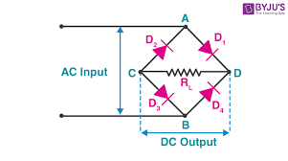
*Researched rectifier bridge for the electric circuit:
Recitifier Bridge
https://byjus.com/physics/bridge-rectifier/
*Researched resistors for the electric circuit: https://byjus.com/physics/resistor/
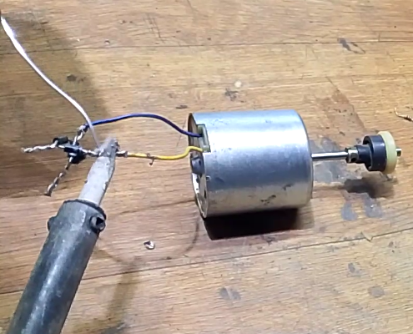
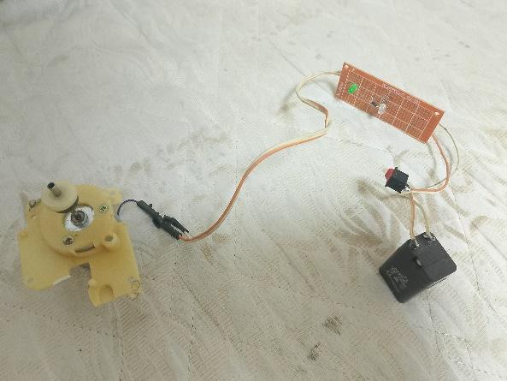
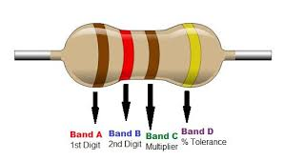
*Constructed the electric circuit as shown in the picture:
9 Electric Circuit

