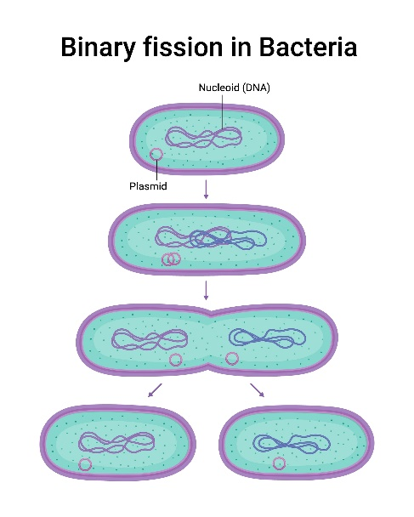
Binary fission formula
The binary fission formula, mathematically called the exponential growth equation, is the formula used for calculating the number of cells in a colony of bacteria after a certain number of generations or binary fission that happened over an interval of time as represented by the following figure. Usually, after just a couple of hours, it becomes impossible to count the cells with just a microscope, so this formula is the main way to calculate the growth of bacteria in low-end laboratories.
$$N_{t}= N_{0} ×{(2)}^{n}$$
The $N_{t}$ is the number of cells after a given amount of time, $N_{0}$ is the number of the original cells at time 0, and the $n$ is the number of generations, which is the number of times the cells have undergone the process of binary fission in the studied time period. The number of times the cells divide per hour varies depending on the type of bacteria and the temperature at which they’re incubated. In order to calculate the growth of the bacteria, the $n$ of our bacteria, which is E.coli, should be calculated first. By solving for $n, n=\frac{\log{(N_{t})}-\log{{(N}_{0})}}{\log{(2)}}$. Starting with one strain of E.coli bacteria, $N_{0}$ is equal to only 1 cell. The sample is then incubated for 1 hour at 37 °C. After incubation, the sample is observed under the microscope with 400x magnification. It is found that there are 8 cells in the sample, meaning that $N_{t}$ is equal to 8 cells. Substituting in the formula, $n=3$, meaning the cells have divided 3 times, 1 per 20 minutes. Using the original formula, we can determine how many cells per micro-colony will be present after 6 hours of incubation, which is found to be ~262,144 cells per micro-colony.
Turns ratio equation
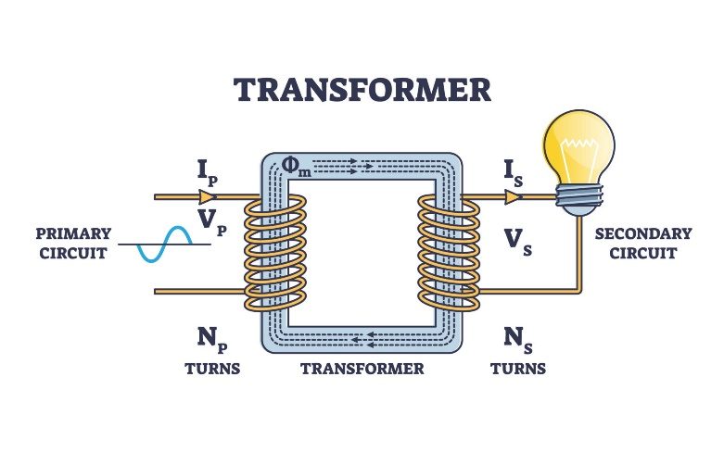
The turns ratio equation is the relation between the number of turns revolving around each side of an electrical transformer and the voltage of the current before and after the transformation, as shown in the figure. This equation is primarily used to determine the ratio between the turns in a transformer in order to produce the desired Voltage and Amperage for the circuit.
$$\frac{N_{p}}{N_{s}}=\frac{V_{p}}{V_{s}}$$
In an electrical transformer, the circuit is connected by wrapping the wires around an iron core, creating a magnetic field, where the other side of the wires receives the charge through the magnetic field. The ratio between the number of turns determines how much voltage is produced in the circuit. In the equation, N$p$ is the number of turns in the wire at the side of the power source (the wall outlet), while N$s$ is the number of turns at the other side. The V$p$ is the voltage produced by the power source, and V$s$ is the voltage produced by the transformer. In the incubator, two transformers are needed, one for the thermostat and one for the heater/cooler. The wall outlet produces a voltage of 220V, while the required voltage for the heater/cooler is only 12V. Using the equation, the ratio between the turns needs to be 220/16, which means that for each turn at the heater/cooler’s side, 14 turns are needed at the power source side. For the thermostat’s transformer, the ratio is 220/12, needing 18 turns at the side of the power source for each one of the other side. Overall, the transformers produce 16V 10A for the heater/cooler, and 12V 1A for the thermostat

