Logbook
Samy Mohamed Swelim Abd al-Qader
Student code: 1024092

- Week one: Grade 10 Summer camp & the challenge was not yet announced

Week Two

- Brainstorming and building teams in addition to studying the grand challenges.

Week Three

-In the third week my teammates and I began working on the project through extensive research to select the idea based on the just announced challenge-

- Studied the capstone challenge & identified the feasibility of constructing a biological incubator.

- Began working on the first grand challenge, part of which is shown in figure 1.
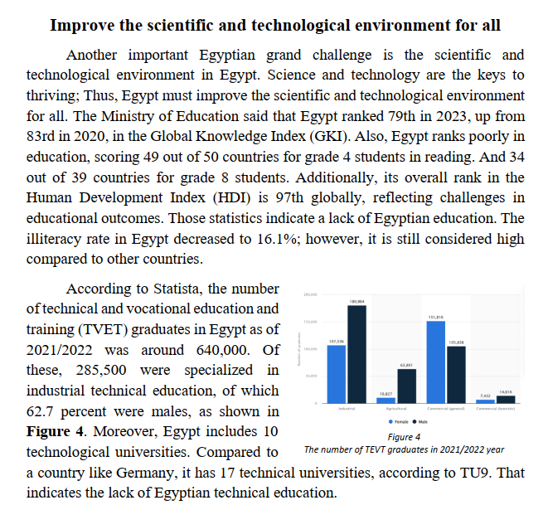

Figure 1, Grand Challenge Sample
- Researched different heat mechanisms for the incubator.
Sources: https://www.sciencedirect.com/science/article/abs/pii/S1350453306001627
https://ggsceramic.com/news-item/updated-ceramic-heating-elements-all-you-need-to-know
https://www.ptcyidu.com/application/ceramic-heater-for-incubator

Week Four

-In the fourth week, my teammates and I began identifying the problem to be solved, which I was assigned to write, as the grand challenges were steadily coming out one by one from all the team members-

- Finished writing the grand challenge.

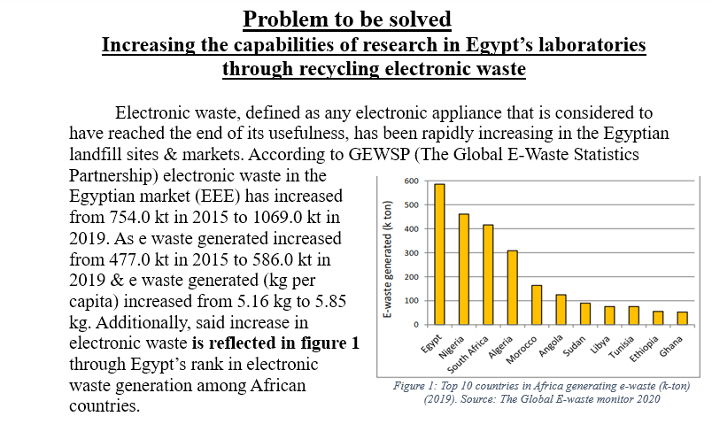
- Began work on the problem to be solved, part of which is shown in figure 2
Figure 2, Problem to be Solved

Week Five

- Finished writing the problem to be solved.

Sources: https://cen.acs.org/environment/recycling/Electronic-waste-gold-mine-waiting/102/i23 https://www.researchgate.net/publication/326226096_Economic_Feasibility_Study_of_E-Waste_Recycling_Facility_in_Egypt
https://www.researchgate.net/publication/342783104_The_Global_E

Researched electronic thermostats & their operational length.

Week Six
- Wrote the selection of prototype, part of which is shown in figure 3.

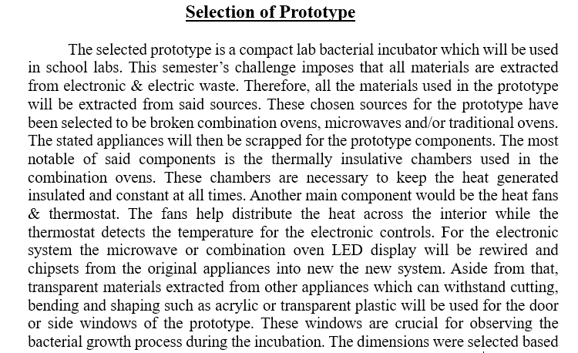

Figure 3, Selection of Prototype Sample

Sources: https://uomus.edu.iq/img/lectures21/WameedMUCLecture_2021_92853824.pdf

- Researched the Peltier effect, and its related cooling systems.

Week Seven

- Researched heat convection systems & ceramic heaters for the construction of the prototype.

- Researched different types of thermal insulators for the prototype.

- Finalized the shape & schematics of the prototype with the help of my teammate.

Week Eight

- Began searching for vendors to purchase the materials.

- Researched electric circuits and power supplies for the upcoming construction of the prototype.

- Sources: https://www.google.com/url?sa=t&source=web&rct=j&opi=89978449&url=https://www.britannica.com/technology/electric-circuit https://www.bbc.co.uk/bitesize/articles/zjm8kty

Week 9
Midterm
Minimal prototype research

Week 9
Midterm
Minimal prototype research

Week 9
Midterm
Minimal prototype research

Week 10
- Purchased the materials and machines for component extraction, some of which are shown in figure 4.
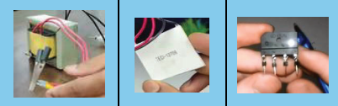

Figure 4, a variety of extracted components

- Completed the 3D design of the prototype which is shown in figure 5.
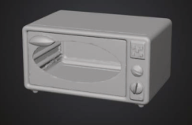

Figure 5, 3D Design

- Researched the exact components extracted and their function.

Week 11
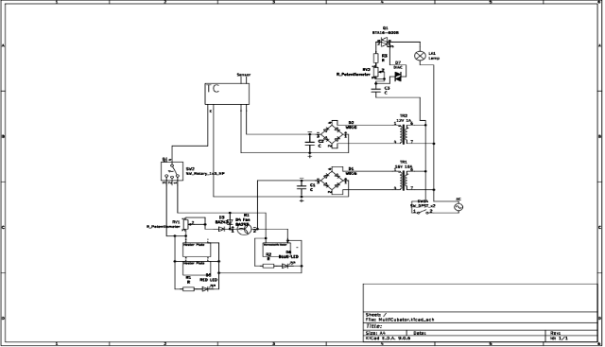
- Began planning the assembly process and drawing the schematic of the circuit as shown in figure 6

Figure 6 Prototype Circuit Schematic
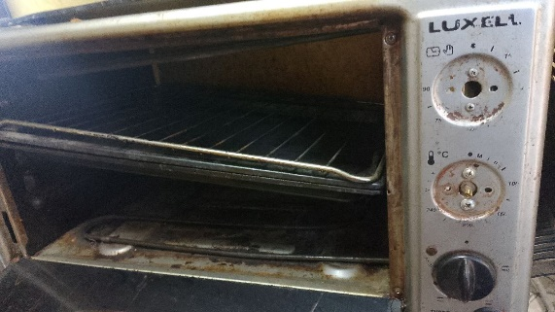
- Prepared the frame of the prototype from a discarded oven as shown in figure 7.

Figure 7 Discarded Oven Frame (before preparation)

- Assembled the panel, electric circuit and components into the frame.

- Completed prototype construction and made sure all the required functions are present.

- Completed the test plan video and results.

- Tested the prototype for errors and failures.

Week 12
- Modified the electric circuit

- Modified the design of the poster, correcting errors and size.

- Filled the poster with its respective content, modifying the materials, methods and test plan content to better present our project.

- Corrected mistakes in the A4 Poster such as graphs and figures.

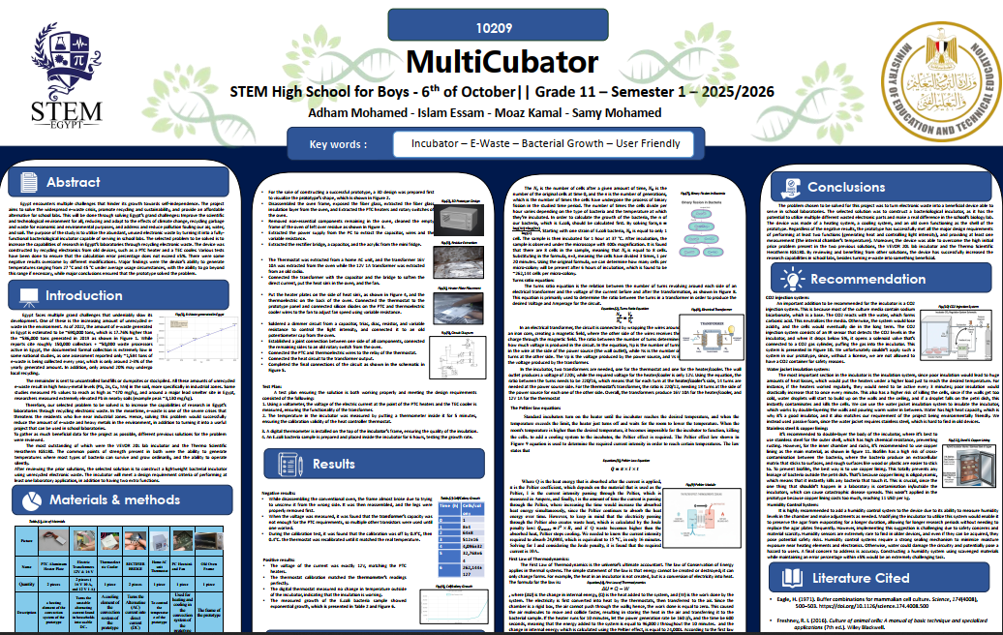
- Submitted the poster, portfolio, and A4 poster with my team. The final poster is shown in figure 8.

Figure 8 The MultiCubator Final Poster

Week 13
- Prepared for the exhibition through rehearsing the poster and prototype details with the team members

- Conducted trial exhibitions with my team in various areas with different questions and how we can answer them.

Overall, this week was full of preparation and rehearsal.

