PROJECT DOCUMENTATION

UK Train Rides
Power BI Analytics and Dashboard Project

Graduation Project — Data Analytics Track
May 2026

Project Planning and Management

Project Overview
This project analyzes UK train ride data to generate actionable business insights using Microsoft Power BI. The dataset contains 31,653 ticket transactions spanning journeys from January to April 2024, covering ten major UK stations. The goal is to build an interactive dashboard that helps railway management understand revenue, punctuality, passenger behavior, and demand forecasting.

Project Scope
- Dataset: 31,653 train ticket transactions, 18 fields per record
- Date range covered: January-1-2024 to April-30-2024 (journeys); purchases as early as December 2023
- Stations covered: Manchester Piccadilly, London Euston, Liverpool Lime Street, London Paddington, London Kings Cross, London St Pancras, Birmingham New Street, York, Reading, Oxford
- Tool: Microsoft Power BI (data cleaning, modeling, visualization, and forecasting)
- Final deliverable: Interactive Power BI dashboard + project documentation + presentation

Project Timeline
Week | Phase | Key Tasks | Deliverable
Week 1 | Data Cleaning and Preprocessing | - Import data  - Fix data types  - Standardized values  - Handle nulls  - Create calculated columns | Cleaned dataset in Power BI
Week 2 | Analysis and Questions Phase | - Define business questions  - Build data models  - Create DAX measures  - Forecast next month | Analysis questions  + DAX measures
Week 3 | Dashboard Phase | Design and build interactive Power BI dashboard with visuals, filters, slicers | Published Power BI Dashboard
Week 4 | Final Presentation | - Prepare documentation  - Presentation slides  - Project summary | Report + Presentation

Team Roles and Responsibilities
Role | Responsibilities
Data Analyst | Data cleaning, DAX measure creation, exploratory data analysis
Dashboard Designer | Power BI report layout, visual selection, UX/interactivity
Project Manager | Timeline tracking, documentation, stakeholder communication
Presenter | Final report writing, slide preparation, presentation delivery

Tools and Technologies
- Microsoft Power BI Desktop: for primary analysis and visualization tool
- Microsoft Excel / CSV: for source data format
- DAX (Data Analysis Expressions): for calculated measures and KPIs
- Power Query: for data transformation and cleaning
- GitHub: for version control and submission
- Data Source
The dataset used in this project was obtained from a railway transportation operational dataset containing ticket sales, passenger information, route details, operational performance, and financial transactions.
Data Includes:
- Routes
- Departure and Arrival Stations
- Ticket Types and Classes
- Passenger Railcards
- Delay Reasons and Delay Minutes
- Refund Transactions
- Payment Methods
- Peak and Off-Peak Travel Times
- Revenue and Ticket Prices
Data Format:
- Source File Type: Excel / CSV
- Number of Records: 31,000 + rows
- Data Processing Tool: Power Query
Data Preparation Steps:
- Data Cleaning
- Removing Duplicates
- Handling Missing Values
- Data Transformation
- Creating Relationships
- Building DAX Measures

Literature Review

Overview of Railway Analytics
Railway analytics has emerged as a critical area in transportation management. Organizations such as Network Rail (UK) and Transport for London (TfL) routinely use data analytics to optimize timetables, manage delays, and improve passenger experience. The rise of Business Intelligence (BI) tools has made it easier to transform raw transactional data into decision-ready dashboards.

Relevance of Power BI in Transport Analytics
Microsoft Power BI is widely adopted in the transport sector due to its ability to connect to large datasets, perform real-time refresh, and enable self-service analytics. It supports DAX calculations, time-intelligence functions, and built-in forecasting. All of these are directly applicable to this project.

Key Analytical Themes in Railway Data

Revenue and Ticket Analysis
Studies in transit revenue management show that ticket type mix (Advance, Off-Peak, Anytime) and class (Standard vs. First) are the primary drivers of revenue variability. Advanced tickets, priced at 50% off, drive volume but reduce yield per seat. Understanding this trade-off is essential for revenue optimization.

On-Time Performance and Delay Analysis
Delay root-cause analysis is one of the most studied topics in railway operations research. Common causes include signal failures, technical issues, and weather. Studies show that reducing delay rates by even 5% significantly improves customer satisfaction scores and reduces refund-related revenue leakage.

Demand Forecasting
Time-series forecasting of passenger demand is a well-established practice. Power BI provides a built-in exponential smoothing forecasting model that can project future ride volumes based on historical patterns. This is relevant to the project requirement for predicting rides and revenue for the next month.

Customer Segmentation
Railcard segmentation (Adult, Senior, Disabled, None) represents a form of price discrimination commonly studied in transport economics. Understanding which segments use which ticket types and routes allow for targeted promotions and better resource allocation.

Requirements Gathering

Business Requirements (BR)
The following business requirements were identified based on the project brief and dataset:
# | Business Requirement | Priority
BR-01 | Understand revenue breakdown by route, ticket type, ticket class, and time period | High
BR-02 | Identify peak travel days, times, and routes | High
BR-03 | Analyze on-time performance and delay causes across stations and routes | High
BR-04 | Measure refund request rate and its relationship to delays/cancellations | Medium
BR-05 | Forecast number of rides and total revenue for the next month (May 2024) | High
BR-06 | Understand demand by ticket class (Standard vs. First Class) | Medium
BR-07 | Analyze purchase behavior (online vs. station payment methods) | Low
BR-08 | Identify most and least profitable routes | Medium

Functional Requirements (Power BI Dashboard)
- The dashboard: include filters/slicers for date range, station, ticket class, and ticket type
- KPI cards: display Total Revenue, Total Rides, On-Time Rate (%), Average Ticket Price, Refund Rate (%)
- Time-series line chart: show ride volume and revenue trends over time
- Bar/column chart: compare revenue and volume by departure station
- Matrix or heatmap: show journey status breakdown by route
- Forecast visual: project next month's rides and revenue using Power BI built-in forecasting
- Donut or pie chart: show ticket class demand split
  - Non-Functional Requirements
- The Power BI file (.pbix): saved and submitted via GitHub
- All data cleaning steps: documented in Power Query or a preprocessing notebook
- DAX measures: clearly named and organized in a dedicated Measures table
- The dashboard: navigable without training; self-explanatory labels and tooltips
  - Data Requirements and Quality Issues
The following data quality issues were identified during preprocessing that must be addressed in Power BI Power Query:
Column | Issue Found | Resolution
Railcard | Null/missing values (~40% of records have no railcard) | Replace nulls with 'None'
Reason for Delay | Nulls for all On Time journeys; also inconsistent values ('Weather' vs. 'Weather Conditions', 'Staffing' vs. 'Staff Shortage', 'Signal Failure' vs. 'Signal failure') | Replace nulls with 'N/A'; standardize text values
Date of Purchase / Date of Journey | Stored as text strings, not date types | Convert to Date type in Power Query
Departure Time / Arrival Time / Actual Arrival Time | Stored as text, not time | Convert to Time type
Price | Integer type; acceptable, but verify no negative values | Add validation filter
Journey Status | 3 values: On Time, Delayed, Cancelled — clean | No action needed

System Analysis and Design

Data Modeling
The dataset is a single flat table (31,653 rows, 18 columns). In Power BI, we will restructure this into a star schema by splitting out dimension tables to improve performance and enable cleaner DAX measures.

Proposed Star Schema
The original railway dataset was initially stored in a single-table structure. To improve data organization, the dataset was transformed into a Star Schema data model that separates the data into:
- One central Fact Table
- Multiple supporting Dimension Tables
Table | Type | Key Fields | Purpose
Fact Transactions | Fact Table | Transaction ID, Date of Journey (FK), Price, Journey Status  Delay information, Stations  Purchase details | Central fact table with all ticket purchases
Date | Dimension | Date (PK), Year, Month, Month Name, Day, Weekday, Is Weekend | Time intelligence; enables forecasting and time-series analysis  of both travel and purchase date
Station | Dimension | Station ID (PK), Station Name Region | Route analysis and station-level filtering
Ticket | Dimension | Ticket Key (PK), Ticket Class, Ticket Type, Purchase Type, Payment Method | Ticket segmentation analysis
Railcard | Dimension | Railcard (PK): None, Adult, Senior, Disabled | Customer segment analysis
Purchase Type | Dimension | Online, Station | Categorize ticket purchases
Payment Method | Dimension | Credit Card, Debit Card, Contactless | Analyze customer payment behavior
Ticket Class | Dimension | Standard, First class | Compare service and revenue between
Ticket Type | Dimension | Advance, Off-Peak, Anytime | Analyze ticket demand
Station | Dimension | Departure Station, Arrival Destination | Analyze routes, station performance, and demand
Delay Reason | Dimension | Signal Failure, Staff Shortage, Technical Issue, Traffic, Weather Conditions, Successfully | Analyze operational issues and identify the most common causes of delays
Journey Status | Dimension | On Time, Delayed, Cancelled | Classify journey outcomes
Refund Request | Dimension | YES, NO | Analyze refund patterns and customer dissatisfaction
  - Key DAX Measures
The following DAX measures will be created in Power BI:
Measure Name | DAX Formula (simplified) | Used In
Total Revenue | Total Revenue = SUM(railway[Price]) | KPI card and line chart
Total Trips | Total Trips = DISTINCTCOUNT(railway[Transaction ID]) | KPI card and line chart
Avg Ticket Price | Average Ticket Price = AVERAGE(railway[Price]) | KPI card and line chart
On-Time Trips | On-Time Trips = CALCULATE( [Total Trips], railway[Journey StatusKey] = 1) | KPI card and line chart
Delayed Trips | Delayed Trips = CALCULATE([Total Trips], railway[Journey StatusKey] = 2) | KPI card and line chart
Cancelled Trips | Cancelled Trips = CALCULATE( [Total Trips], railway[Journey StatusKey] = 3) | KPI card and line chart
Total Refund | CALCULATE([Total Trips] ,RefundRequest[Refund Request] = "Yes") | KPI card and line chart
On-Time Rate % | On-Time Rate % = DIVIDE( [On-Time Trips] , [Total Trips] , 0) | KPI card and line chart
Delay Rate % | Delay Rate % = DIVIDE( [Delayed Trips] , [Total Trips] , 0) | KPI card and line chart
Cancellation Rate % | Cancellation Rate % = DIVIDE( [Cancelled Trips] , [Total Trips] , 0) | KPI card and line chart
Refund Rate % | Refund % = DIVIDE([Refund Count] , [Total Trips], 0) | KPI card and line chart
Average Delay Minutes | AVERAGEX(FILTER(railway , railway[Delay Minutes] > 0 ), railway[Delay Minutes]) | Line charts and Trend analysis
Arrival Station Delay Rate | CALCULATE([Delay Rate %], USERELATIONSHIP(railway[Arrival.Index], Stations[Index])) | Line charts and Trend analysis
Total Refund Loss | CALCULATE( SUM(railway[Price]) , RefundRequest[Refund Request] = "Yes") | Line charts and Trend analysis
Net Revenue | [Total Revenue] - [Total Refund Loss] | Line charts and Trend analysis
Revenue per Trip | DIVIDE([Total Revenue], [Total Trips], 0) | Line charts and Trend analysis
Delayed & Cancelled Rate % | DIVIDE( ( [Delayed Trips] + [Cancelled Trips] ), [Total Trips] ,0) | Line charts and Trend analysis

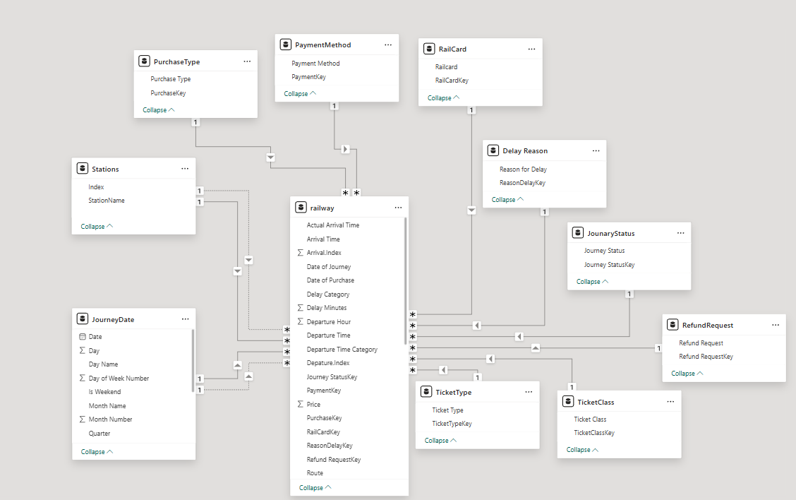

  - Analysis Questions Answered by the Dashboard
The following business questions are answerable using the dataset and will be visualized in the Power BI dashboard:

Revenue and Financial Analysis
- What is the total revenue generated per month?
- Which route generates the highest revenue?
- What is the revenue split between Standard and First Class tickets?
- How does revenue vary by ticket type (Advance vs. Off-Peak vs. Anytime)?

Demand and Volume Analysis
- Which departure stations have the most journeys?
- What are the peak travel days of the week?
- How does demand vary by hour of departure?
- Which ticket class (Standard / First Class) has higher demand?

Punctuality & Delay Analysis
- What percentage of journeys are On Time, Delayed, or Cancelled?
- What are the most common reasons for delays?
- Which routes have the worst on-time performance?
- What is the relationship between journey delays and refund requests?

Customer and Purchase Behavior
- What proportion of tickets are purchased online vs. at the station?
- Which payment method is most commonly used?
- What percentage of passengers hold a railcard?
- Do railcard holders prefer Advance or Off-Peak tickets?

Forecasting (Next Month - May 2024)
- Predicted total number of rides for May 2024 (using Power BI built-in time-series forecast)
- Predicted daily revenue for each day in May 2024
- Expected demand by ticket class in May 2024

  - Dashboard Layout Design
Page | Page Name | Visuals Included
1 | Dashboard Home | Introduction and team project
2 | Executive Summary | KPI Cards: Total Trips, Total Revenue, On-Time %, Delay %, Avg Ticket Price; Revenue Trend by Month; Peak Travel Hours; Top Routes by Trips; Delay Reasons Analysis; Ticket Type Distribution
3 | Operational Insights | KPI Cards: Delayed Trips, Cancelled Trips, Delayed & Cancelled %; Delay Severity Distribution; Average Delay Minutes by Route; Routes with Highest Cancellation Rates
4 | Financial Analysis | KPI Cards: Total Revenue, Net Revenue, Avg Ticket Price, Refund %, Total Refund Loss; Revenue by Route; Refund Loss by Route; Revenue by Month & Purchase Type; Revenue by Weekend; Revenue by Departure Time Category
5 | Service Performance | KPI Cards: Total Trips, Total Revenue, Avg Ticket Price; Average Ticket Price by Railcard; Trips Distribution by Railcard; Average Ticket Price by Class; Trips by Railcard & Purchase Type; Payment Method Analysis

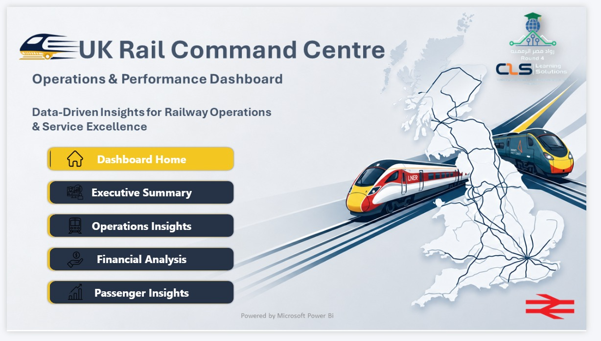

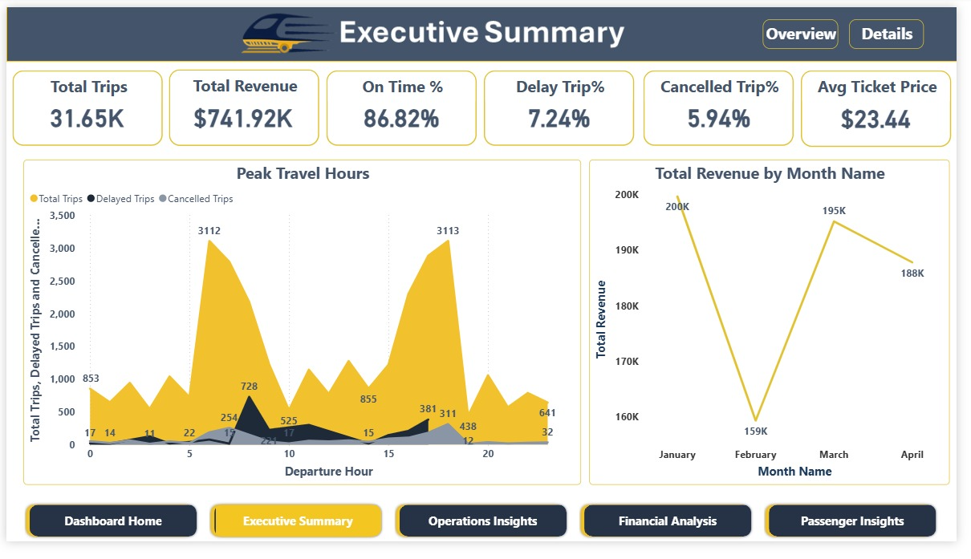

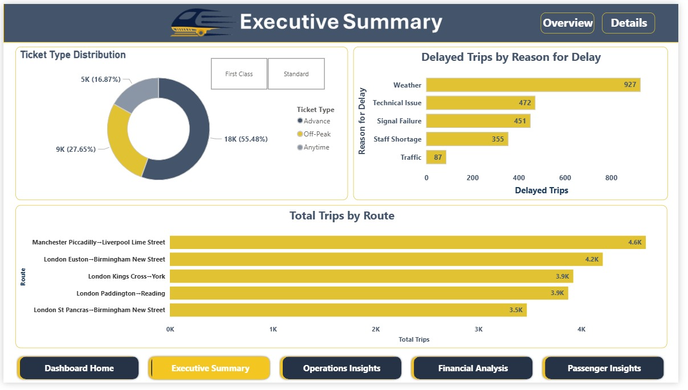

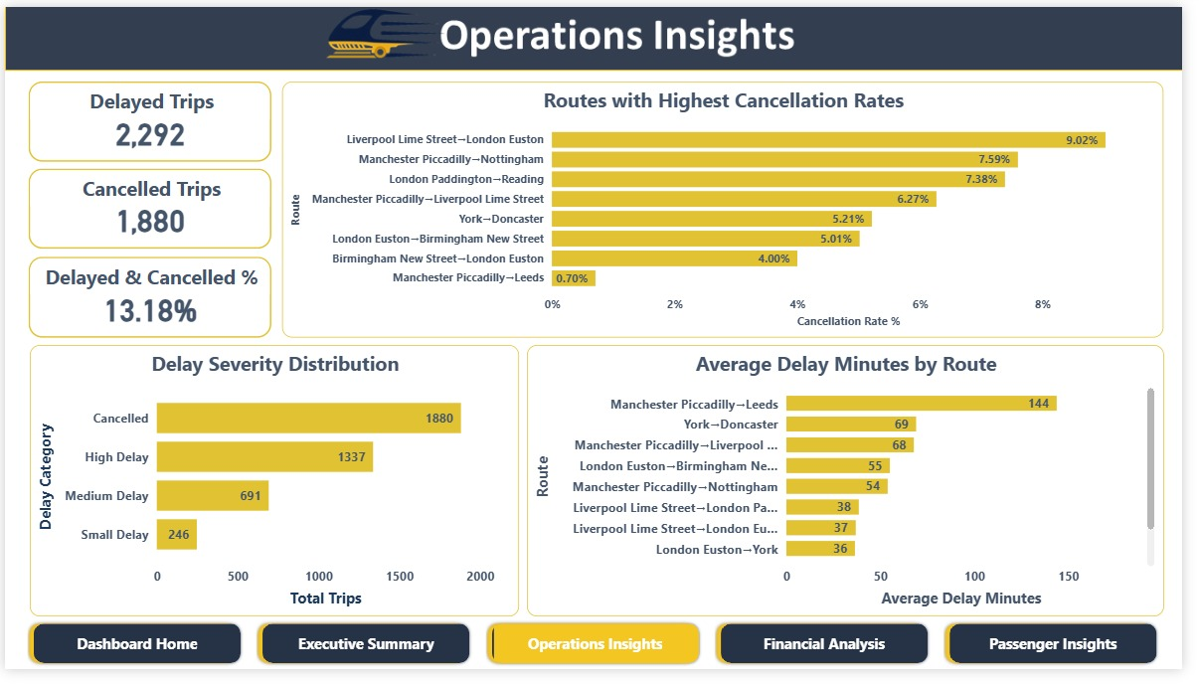

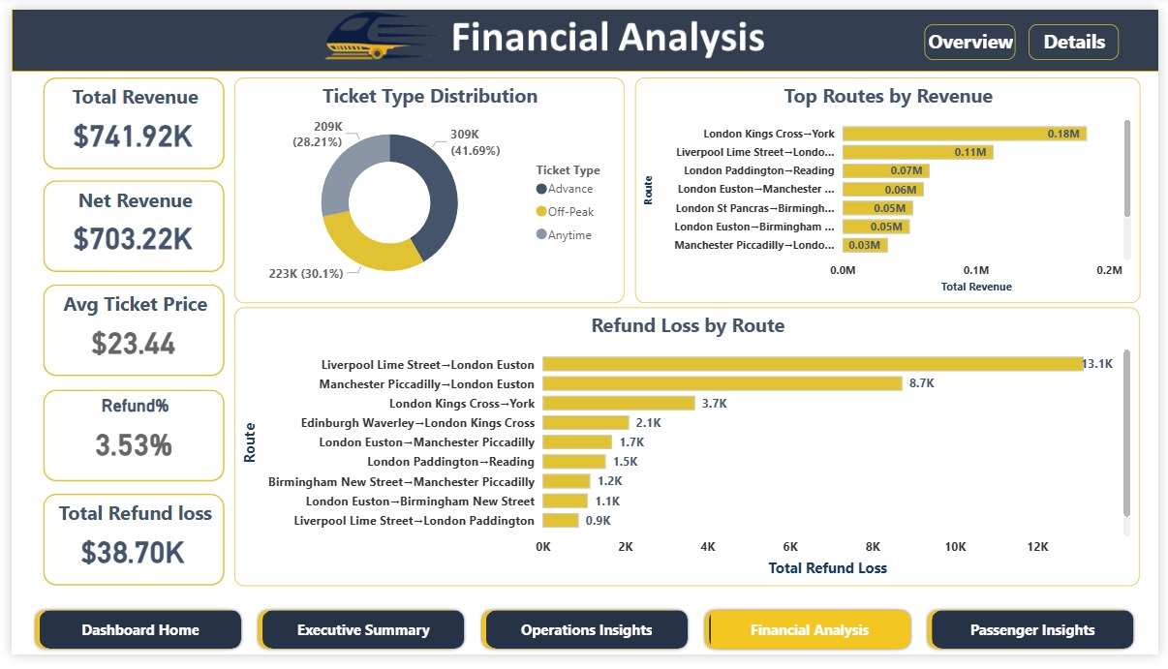

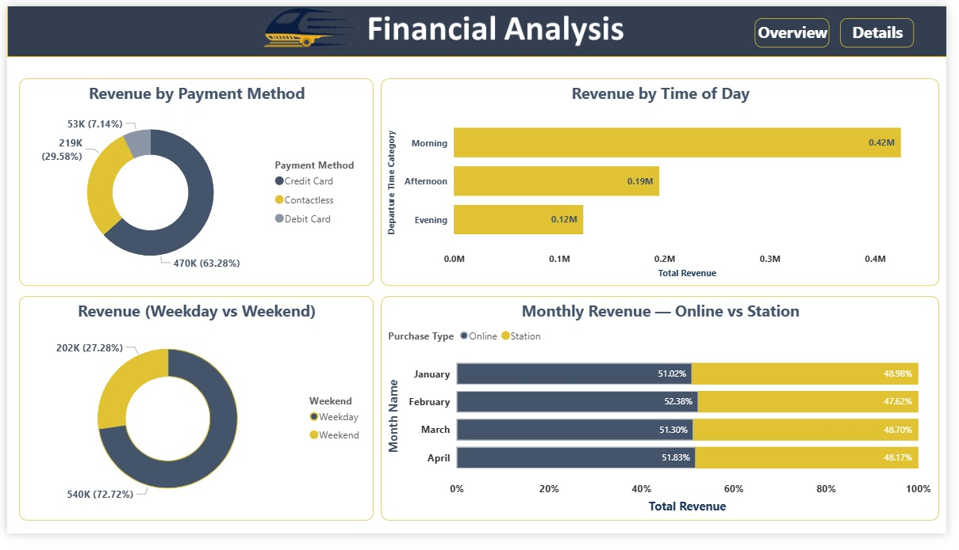

Appendix: Dataset Summary

Field | Type | Description | Example Values
Transaction ID | Text (UUID) | Unique ticket purchase identifier | da8a6ba8 - b3dc...
Date of Purchase | Date | Date ticket was bought | 2023-12-08
Time of Purchase | Time | Time ticket was bought | 12:41:11
Purchase Type | Category | Where ticket was bought | Online, Station
Payment Method | Category | Payment used | Contactless, Credit Card, Debit Card
Railcard | Category | Discount card held | Adult, Senior, Disabled, None
Ticket Class | Category | Seat class | Standard, First Class
Ticket Type | Category | Pricing rule | Advance, Off-Peak, Anytime
Price | Integer (GBP) | Final ticket price paid | 1 - 267
Departure Station | Text | Origin station | Manchester Piccadilly
Arrival Destination | Text | Destination station | Birmingham New Street
Date of Journey | Date | Travel date | 2024-01-01
Departure Time | Time | Scheduled departure | 11:00:00
Arrival Time | Time | Scheduled arrival | 13:30:00
Actual Arrival Time | Time | Actual arrival time | 13:30:00
Journey Status | Category | Outcome of journey | On Time, Delayed, Cancelled
Reason for Delay | Text (nullable) | Cause of delay if applicable | Signal Failure, Weather...
Refund Request | Binary | Whether refund was claimed | Yes, No

