Phase 1: Infrastructure & Data Ingestion

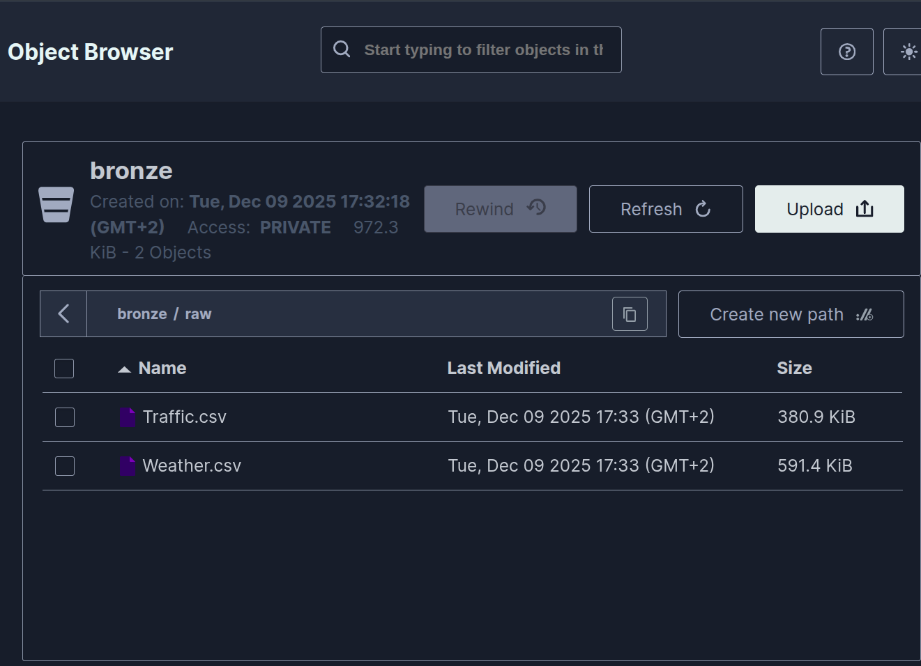

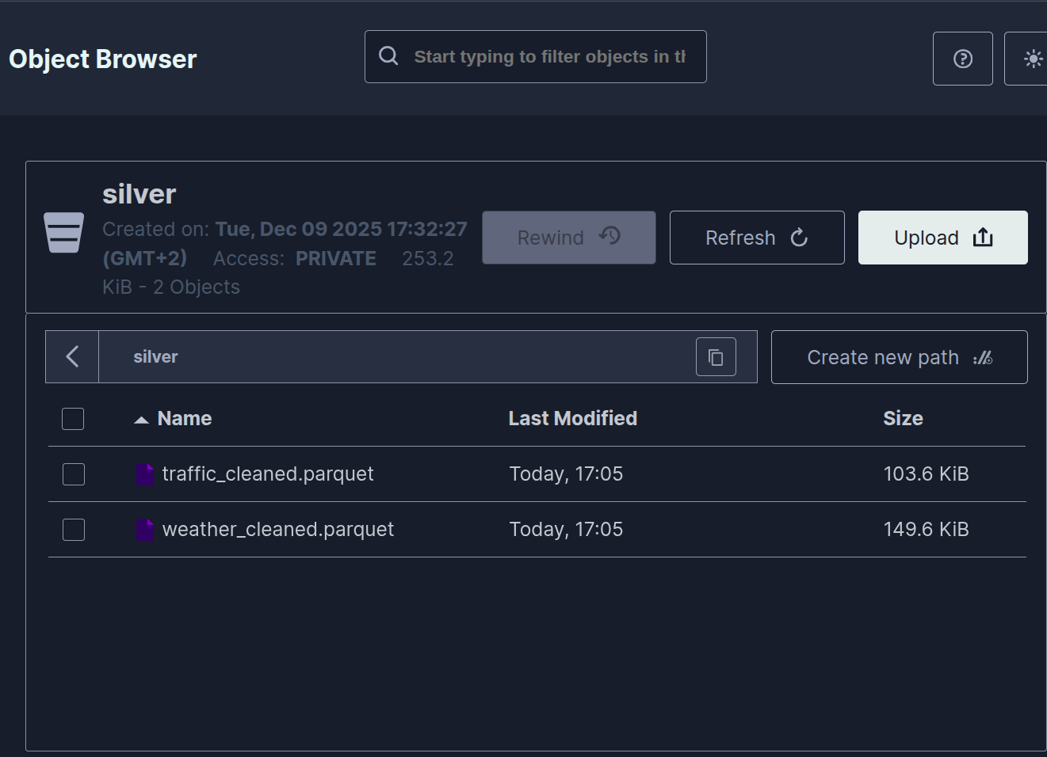
Traffic data:

Phase 3: HDFS Integration (Additional Storage Layer)

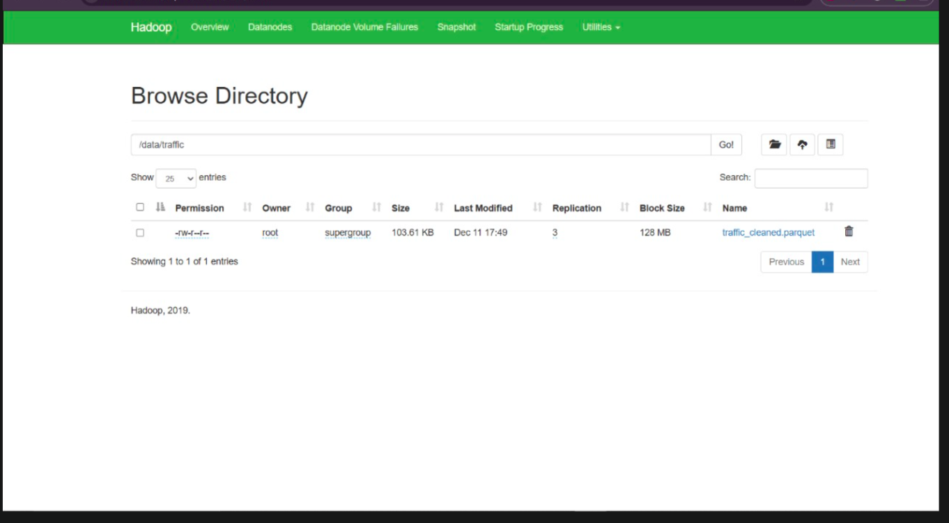

Phase 4: Dataset Merging
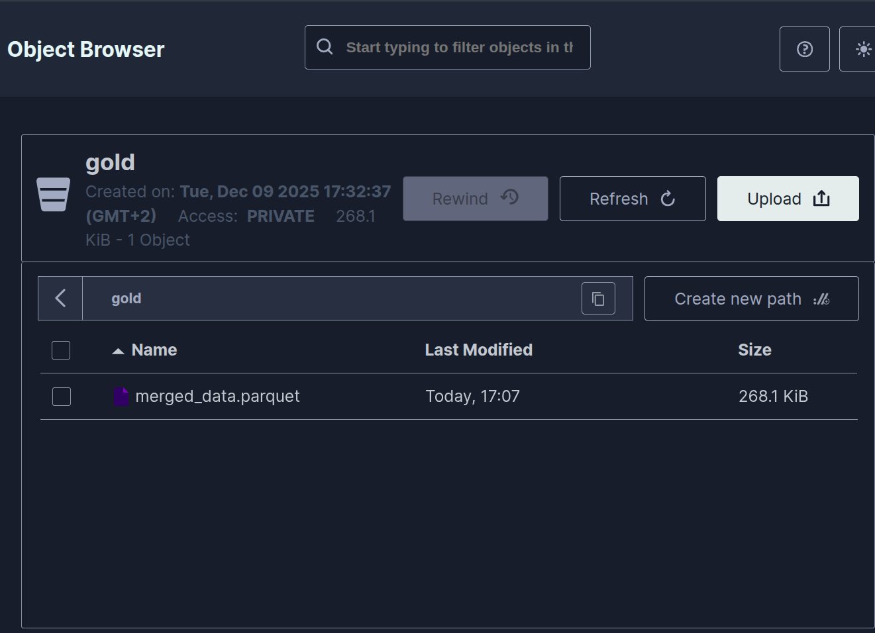

Phase 5: Monte Carlo Simulation (Traffic Risk Prediction)

