#### Options Menu

##### XML for main activity

<?xml version="1.0" encoding="utf-8"?>  
<androidx.constraintlayout.widget.ConstraintLayout xmlns:android="http://schemas.android.com/apk/res/android"  
 xmlns:app="http://schemas.android.com/apk/res-auto"  
 xmlns:tools="http://schemas.android.com/tools"  
 android:layout_width="match_parent"  
 android:layout_height="match_parent"  
 tools:context=".MainActivity">  
  
 <TextView  
 android:layout_width="wrap_content"  
 android:layout_height="wrap_content"  
 android:text="Hello World!"  
 app:layout_constraintBottom_toBottomOf="parent"  
 app:layout_constraintEnd_toEndOf="parent"  
 app:layout_constraintStart_toStartOf="parent"  
 app:layout_constraintTop_toTopOf="parent" />

<TextView  
 android:id="@+id/textView"  
 android:layout_width="wrap_content"  
 android:layout_height="wrap_content"  
 android:layout_marginBottom="100dp"  
 android:text="Samyak Maharjan 20BTRSE076"  
 app:layout_constraintBottom_toBottomOf="parent"  
 app:layout_constraintEnd_toEndOf="parent"  
 app:layout_constraintHorizontal_bias="0.497"  
 app:layout_constraintStart_toStartOf="parent" />

</androidx.constraintlayout.widget.ConstraintLayout>

##### XML for menu

<?xml version="1.0" encoding="utf-8"?>  
<menu xmlns:android="http://schemas.android.com/apk/res/android"  
 xmlns:app="http://schemas.android.com/apk/res-auto">  
<item android:id="@+id/item1"  
 android:icon="@drawable/ic_icon"  
 android:title="Item 1"  
 app:showAsAction="ifRoom"/>  
  
 <item android:id="@+id/item2"  
 android:title="Item 2"  
 app:showAsAction="never"/>  
  
 <item android:id="@+id/item3"  
 android:title="Item 3"  
 app:showAsAction="never">  
 <menu>  
 <item android:id="@+id/subitem1"  
 android:title="Sub Item 1"/>  
  
 <item android:id="@+id/subitem2"  
 android:title="Sub Item 2"/>  
 </menu>  
 </item>  
</menu>

##### JAVA logic file

package com.example.myapplication;  
  
import androidx.annotation.NonNull;  
import androidx.appcompat.app.AppCompatActivity;  
  
import android.os.Bundle;  
import android.view.Menu;  
import android.view.MenuInflater;  
import android.view.MenuItem;  
import android.widget.Toast;  
  
public class MainActivity extends AppCompatActivity {  
  
 @Override  
 protected void onCreate(Bundle savedInstanceState) {  
 super.onCreate(savedInstanceState);  
 setContentView(R.layout.*activity_main*);  
 }  
  
 @Override  
 public boolean onCreateOptionsMenu(Menu menu) {  
 MenuInflater inflater=getMenuInflater();  
 inflater.inflate(R.menu.*example_menu*,menu);  
 return true;  
 }  
  
 @Override  
 public boolean onOptionsItemSelected(@NonNull MenuItem item) {  
 switch (item.getItemId()){  
 case R.id.*item1*:  
 Toast.*makeText*(this, "Item 1 selected", Toast.*LENGTH_SHORT*).show();  
 return true;  
 case R.id.*item2*:  
 Toast.*makeText*(this, "Item 2 selected", Toast.*LENGTH_SHORT*).show();  
 return true;  
 case R.id.*item3*:  
 Toast.*makeText*(this, "Item 3 selected", Toast.*LENGTH_SHORT*).show();  
 return true;  
 case R.id.*subitem1*:  
 Toast.*makeText*(this, "Sub Item 1 selected", Toast.*LENGTH_SHORT*).show();  
 return true;  
 case R.id.*subitem2*:  
 Toast.*makeText*(this, "Sub Item 2 selected", Toast.*LENGTH_SHORT*).show();  
 return true;  
 default:  
 return super.onOptionsItemSelected(item);  
 }  
  
 }  
}

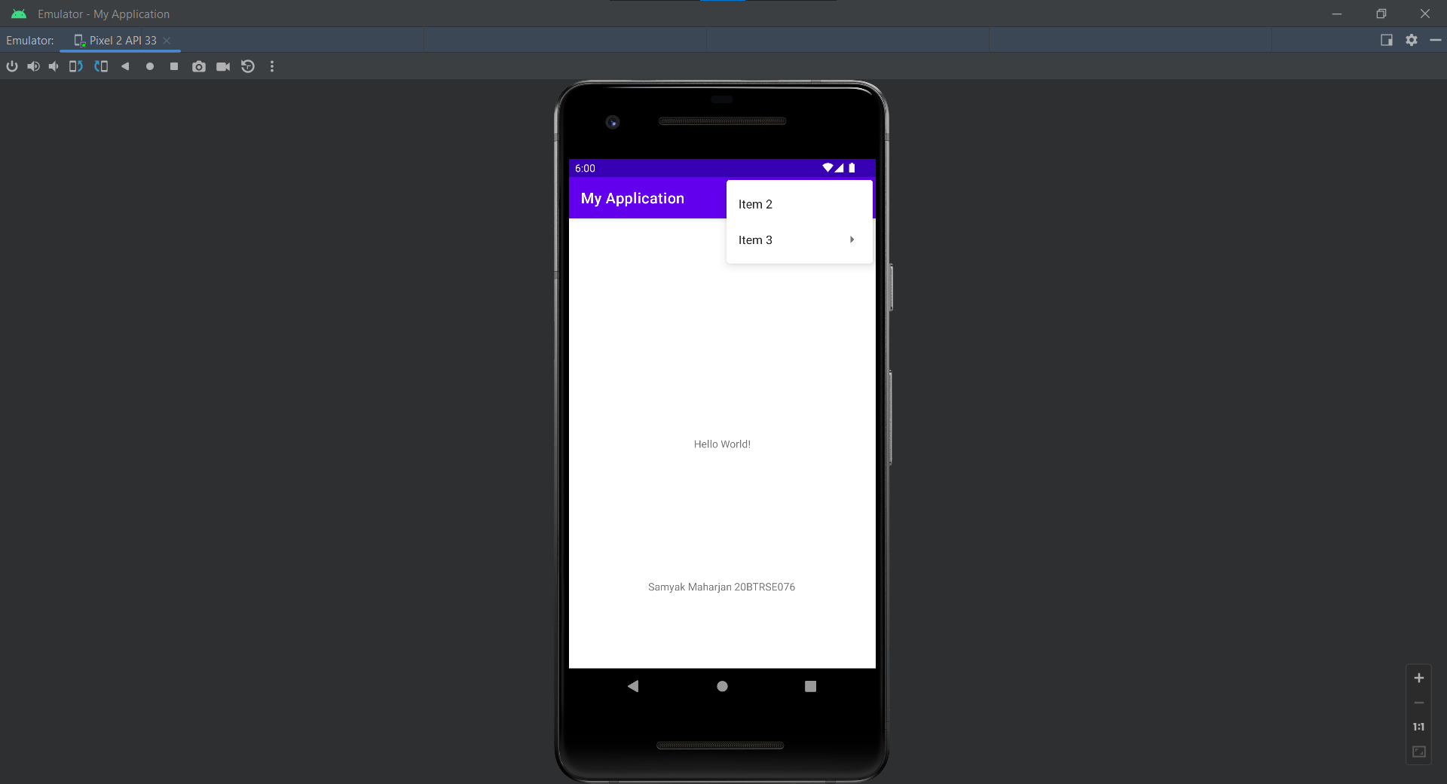

#### Context Menu

##### XML for main activity

<?xml version="1.0" encoding="utf-8"?>  
<androidx.constraintlayout.widget.ConstraintLayout xmlns:android="http://schemas.android.com/apk/res/android"  
 xmlns:app="http://schemas.android.com/apk/res-auto"  
 xmlns:tools="http://schemas.android.com/tools"  
 android:layout_width="match_parent"  
 android:layout_height="match_parent"  
 tools:context=".MainActivity">  
  
 <TextView  
 android:id="@+id/text_view"  
 android:layout_width="wrap_content"  
 android:layout_height="wrap_content"  
 android:text="Hello World!"  
 android:textSize="30sp"  
 app:layout_constraintBottom_toBottomOf="parent"  
 app:layout_constraintEnd_toEndOf="parent"  
 app:layout_constraintStart_toStartOf="parent"  
 app:layout_constraintTop_toTopOf="parent" />

<TextView  
 android:id="@+id/textView"  
 android:layout_width="wrap_content"  
 android:layout_height="wrap_content"  
 android:layout_marginBottom="100dp"  
 android:text="Samyak Maharjan 20BTRSE076"  
 app:layout_constraintBottom_toBottomOf="parent"  
 app:layout_constraintEnd_toEndOf="parent"  
 app:layout_constraintHorizontal_bias="0.497"  
 app:layout_constraintStart_toStartOf="parent" />

</androidx.constraintlayout.widget.ConstraintLayout>

##### XML for menu

<?xml version="1.0" encoding="utf-8"?>  
<menu xmlns:android="http://schemas.android.com/apk/res/android">  
 <item  
 android:id="@+id/option_1"  
 android:title="Option 1"/>  
 <item  
 android:id="@+id/option_2"  
 android:title="Option 2"/>  
</menu>

##### JAVA logic file

package com.example.myapplication;  
  
import androidx.annotation.NonNull;  
import androidx.appcompat.app.AppCompatActivity;  
  
import android.os.Bundle;  
import android.view.ContextMenu;  
import android.view.MenuItem;  
import android.view.View;  
import android.widget.TextView;  
import android.widget.Toast;  
  
public class MainActivity extends AppCompatActivity {  
  
 @Override  
 protected void onCreate(Bundle savedInstanceState) {  
 super.onCreate(savedInstanceState);  
 setContentView(R.layout.*activity_main*);  
  
 TextView textview=findViewById(R.id.*text_view*);  
  
 registerForContextMenu(textview);  
 }  
  
 @Override  
 public void onCreateContextMenu(ContextMenu menu, View v, ContextMenu.ContextMenuInfo menuInfo) {  
 super.onCreateContextMenu(menu, v, menuInfo);  
  
 getMenuInflater().inflate(R.menu.*example_menu*,menu);  
 }  
  
 @Override  
 public boolean onContextItemSelected(@NonNull MenuItem item) {  
 switch (item.getItemId()){  
 case R.id.*option_1*:  
 Toast.*makeText*(this, "Option 1 selected", Toast.*LENGTH_SHORT*).show();  
 return true;  
 case R.id.*option_2*:  
 Toast.*makeText*(this, "Option 2 selected", Toast.*LENGTH_SHORT*).show();  
 return true;  
 default:  
 return super.onContextItemSelected(item);  
 }  
 }  
}

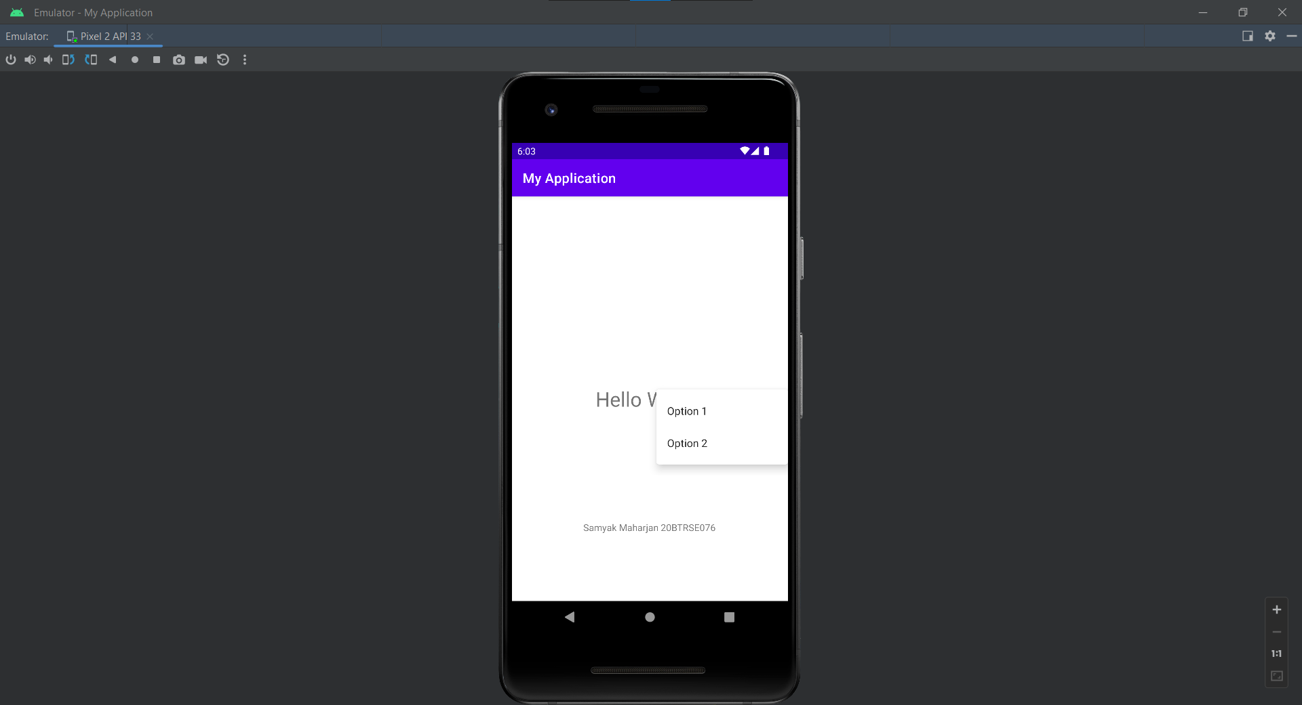

#### Popup menu

##### XML for main activity

<?xml version="1.0" encoding="utf-8"?>  
<androidx.constraintlayout.widget.ConstraintLayout xmlns:android="http://schemas.android.com/apk/res/android"  
 xmlns:app="http://schemas.android.com/apk/res-auto"  
 xmlns:tools="http://schemas.android.com/tools"  
 android:layout_width="match_parent"  
 android:layout_height="match_parent"  
 tools:context=".MainActivity">  
  
 <Button  
 android:layout_width="wrap_content"  
 android:layout_height="wrap_content"  
 android:text="Popup"  
 app:layout_constraintBottom_toBottomOf="parent"  
 app:layout_constraintEnd_toEndOf="parent"  
 app:layout_constraintStart_toStartOf="parent"  
 app:layout_constraintTop_toTopOf="parent"  
 android:onClick="showPopup"/>

<TextView  
 android:id="@+id/textView"  
 android:layout_width="wrap_content"  
 android:layout_height="wrap_content"  
 android:layout_marginBottom="100dp"  
 android:text="Samyak Maharjan 20BTRSE076"  
 app:layout_constraintBottom_toBottomOf="parent"  
 app:layout_constraintEnd_toEndOf="parent"  
 app:layout_constraintHorizontal_bias="0.497"  
 app:layout_constraintStart_toStartOf="parent" />

</androidx.constraintlayout.widget.ConstraintLayout>

##### XML for menu

<?xml version="1.0" encoding="utf-8"?>  
<menu xmlns:android="http://schemas.android.com/apk/res/android">  
  
 <item  
 android:id="@+id/item1"  
 android:title="Item 1"/>  
 <item  
 android:id="@+id/item2"  
 android:title="Item 2"/>  
 <item  
 android:id="@+id/item3"  
 android:title="Item 3"/>  
 <item  
 android:id="@+id/item4"  
 android:title="Item 4"/>  
</menu>

##### JAVA logic file

package com.example.myapplication;  
  
import androidx.appcompat.app.AppCompatActivity;  
  
import android.os.Bundle;  
import android.view.MenuItem;  
import android.view.View;  
import android.widget.PopupMenu;  
import android.widget.Toast;  
  
public class MainActivity extends AppCompatActivity implements PopupMenu.OnMenuItemClickListener {  
  
 @Override  
 protected void onCreate(Bundle savedInstanceState) {  
 super.onCreate(savedInstanceState);  
 setContentView(R.layout.*activity_main*);  
 }  
  
 public void showPopup(View v){  
 PopupMenu popup=new PopupMenu(this, v);  
 popup.setOnMenuItemClickListener(this);  
 popup.inflate(R.menu.*popup_menu*);  
 popup.show();  
 }  
  
 @Override  
 public boolean onMenuItemClick(MenuItem menuItem) {  
 switch (menuItem.getItemId()){  
 case R.id.*item1*:  
 Toast.*makeText*(this, "Item 1 clicked", Toast.*LENGTH_SHORT*).show();  
 return true;  
 case R.id.*item2*:  
 Toast.*makeText*(this, "Item 2 clicked", Toast.*LENGTH_SHORT*).show();  
 return true;  
 case R.id.*item3*:  
 Toast.*makeText*(this, "Item 3 clicked", Toast.*LENGTH_SHORT*).show();  
 return true;  
 case R.id.*item4*:  
 Toast.*makeText*(this, "Item 4 clicked", Toast.*LENGTH_SHORT*).show();  
 return true;  
 default:  
 return false;  
 }  
 }  
}

