1.12 Apache POI Configuration



This section will guide you to:

* Install and configure Apache POI jar for Selenium Project in Eclipse

This guide has three sub-sections, namely:

1.12.1 Adding external jar files to the Selenium Project in Eclipse

1.12.2 Adding Maven Dependency

1.12.3 Pushing the code to your GitHub repositories

**Step 1.12.1:** Adding external jar files to the Selenium Project in Eclipse

1. Apache Poi is already installed in your Practice lab. Refer to QA to QE lab guide for Phase 2 for more information about its directory details.
2. Go to Eclipse.
3. Right-click on your project.
4. Navigate to **Build Path** 🡪 **Configure Build Path.**

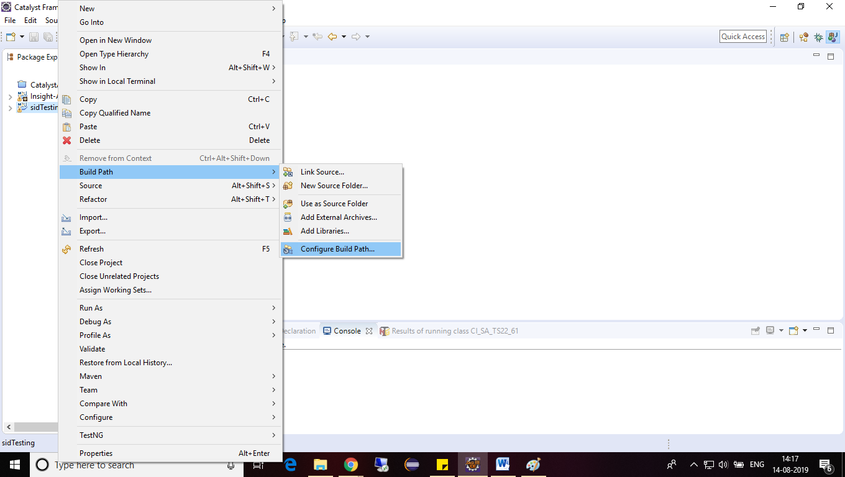

1. Click on **the Libraries** tab and click on **Add External JARs**.

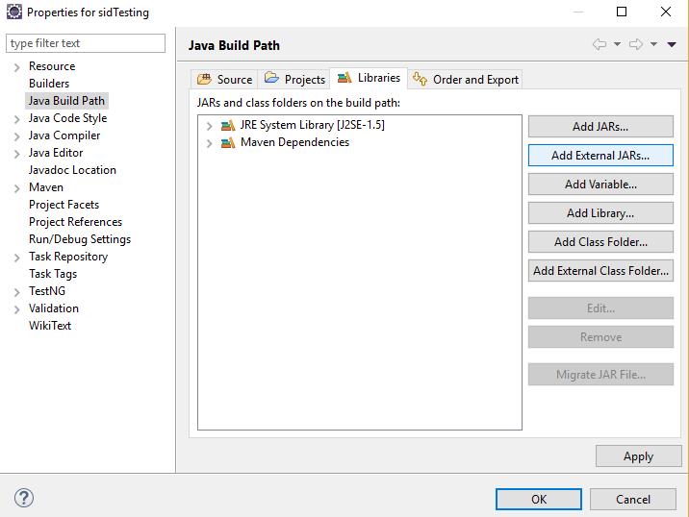

1. Navigate to the folder where Apache POI jar file is stored.
2. Select the executable JAR files from the lib folder and click on **Open**.
3. Repeat steps e.
4. Select the executable JAR files from the ooxml-lib folder and click on **Open**.
5. Repeat the steps e.
6. Select the remaining executable JAR files from the folder and click on **Open**.
7. The following snapshot shows that all the JARs are included in the Library list.
8. Click on **Apply** and then on the **OK** button.

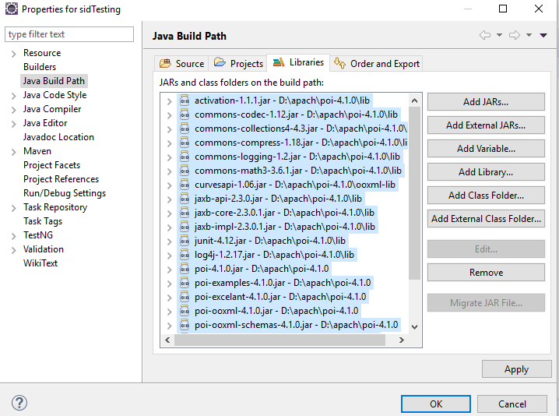

**Step 1.12.2:** Adding Maven Dependency

1. Go to the Maven Repository: <https://mvnrepository.com/artifact/org.apache.poi/poi/3.7>
2. Copy the dependency.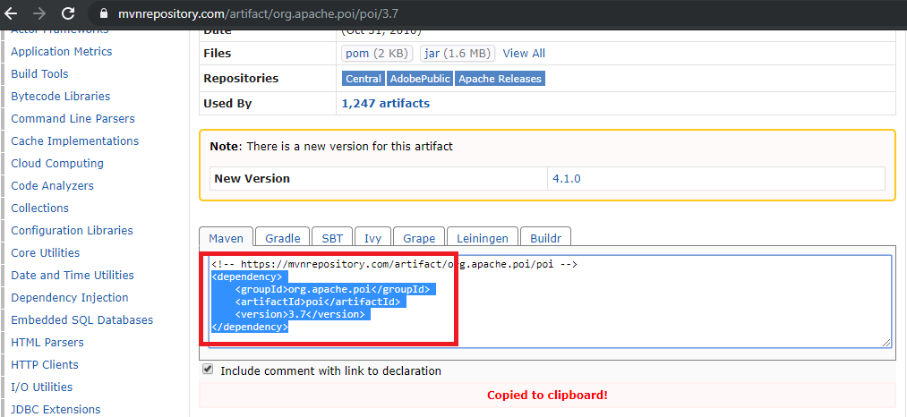
3. Go to Eclipse.
4. Open the Pom.xml file from the project.
5. Copy the dependency in the Pom.xml file:

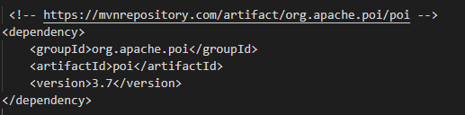

1. Go to the Maven Repository: <https://mvnrepository.com/artifact/org.apache.poi/poi-ooxml/3.7>
2. Copy the dependency.

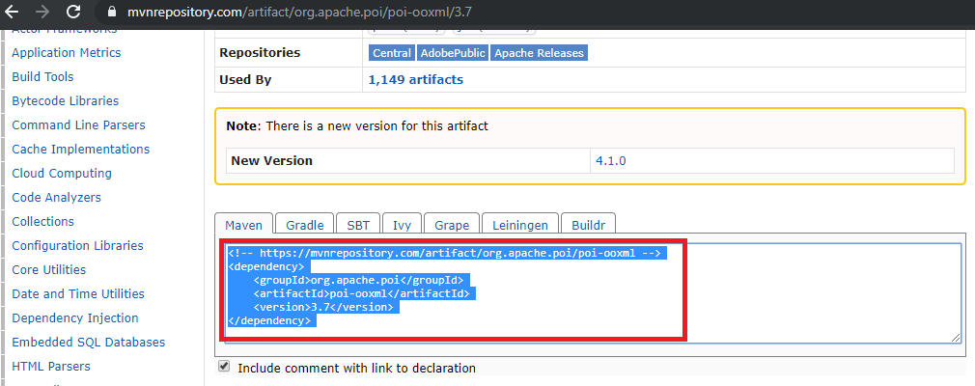

1. Go to Eclipse.
2. Open the Pom.xml file from the project.
3. Copy the dependency in the Pom.xml file.

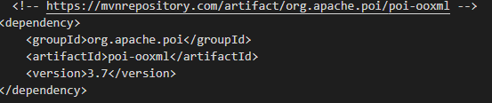

1. This is how the pom.xml file will look like in Eclipse:

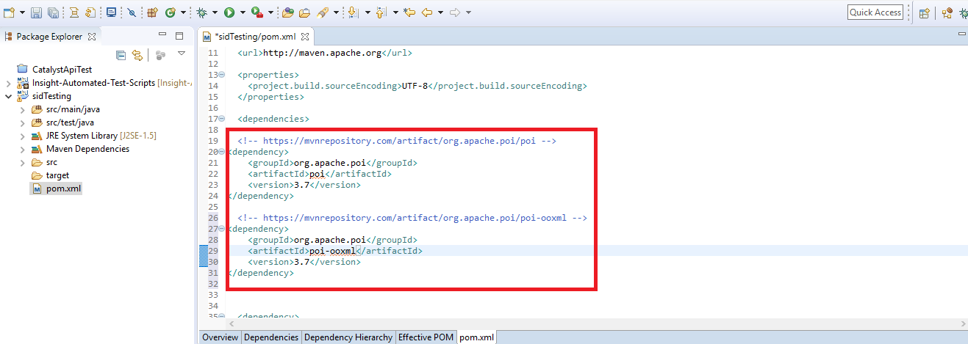

**Step 1.12.3:** Pushing the code to your GitHub repositories

Open your command prompt and navigate to the folder where you have created your files.

cd <folder path>

Initialize your repository using the following command:

git init

Add all the files to your git repository using the following command:

git add . 

Commit the changes using the following command:

git commit . -m “Changes have been committed.”

Push the files to the folder you initially created using the following command:

git push -u origin master