2.3 Build and Configure CI/CD Pipeline with Selenium WebDriver

This section will guide you to:

* Integrate Selenium WebDriver with Jenkins

**Development Environment:**

* Jenkins
* Selenium jars

This guide has three subsections, namely:

2.3.1 Forking the git repository

2.3.2 Creating a Jenkins pipeline job

2.3.3 Pushing the code into GitHub repositories

**Step 2.3.1:** Foking the git repository

* Fork the following repository

<https://github.com/canindit75/JenkinsDemo>

**Step 2.3.2:** Create a Jenkins pipeline job

* Java 1.8 is already installed in your practice lab. Refer to QA to QE lab guide for Phase 1 for more information.
* Jenkins.war file is already present in your practice lab in cd /usr/share/jenkins directory.
* Go to jenkins.war location Start the Jenkins by using command on command prompt:**java -jar jenkins.war.**
* Open browser and type **localhost:8080.**
* Enter the password.
* Create a job.
* Pass a name.
* Select **Pipeline.**
* Click on Ok.

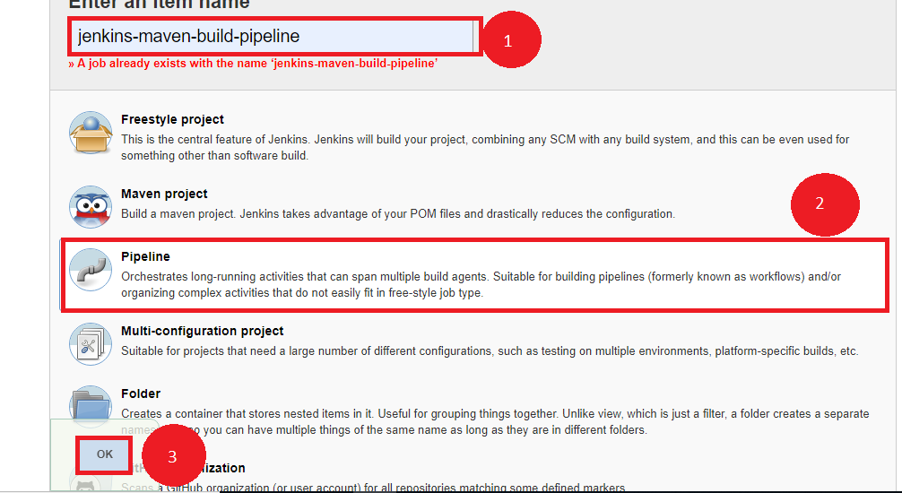

* Create a text file name it **run.sh** in your lab and keep the below given code in it.

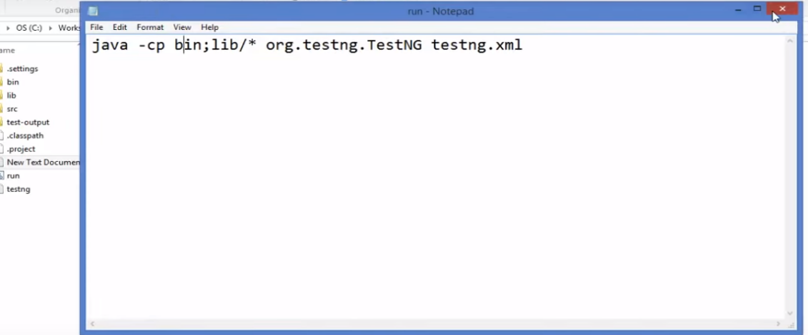

* Give executable permission to **run.sh** using the commands below:

**chmod 755 run.sh**

**chmod 777 run.sh**

* Push **run.sh in your repository** under master branch.

**git push <reponame> master**

**git status**

* Go to Jenkins pipeline job.
* Write a groovy script in the pipeline.

node {

def mvnHome

stage('Preparation') { // for display purposes

// Get some code from a GitHub repository

git 'https://github.com/jglick/simple-maven-project-with-tests.git'

// Get the Maven tool.

// ** NOTE: This 'M3' Maven tool must be configured

// ** in the global configuration.

mvnHome = tool 'maven3'

}

stage('Build') {

// Run the maven build

withEnv(["MVN_HOME=$mvnHome"]) {

**if** (isUnix()) {

sh '"$MVN_HOME/bin/mvn" -Dmaven.test.failure.ignore clean package'

} **else** {

sh ‘"%MVN_HOME%\bin\mvn" -Dmaven.test.failure.ignore clean package’

}

}

}

stage('Results') {

junit '**/target/surefire-reports/TEST-*.xml'

archiveArtifacts 'target/*.jar'

}}

* Click on Apply and Save.
* Click on Build now.

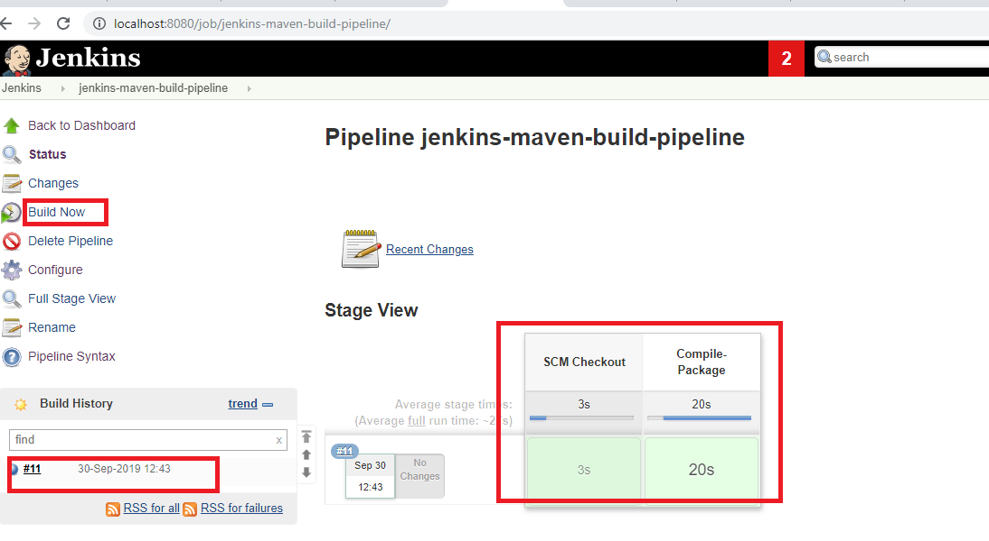

**Step 2.3.3:** Pushing the code to GitHub repositories

Open your command prompt and navigate to the folder where you have created your files.

cd <folder path>

Initialize your repository using the following command:

git init

Add all the files to your git repository using the following command:

git add . 

Commit the changes using the following command:

git commit . -m “Changes have been committed.”

Push the files to the folder you initially created using the following command:

git push -u origin master