2.1 Install Artifactory

This section will guide you:

* To understand Artifactory
* To install Artifactory
* To configure Artifactory with Jenkins

**Development Environment:**

* Jenkins
* Artifactory

This guide has three sub-sections, namely:

2.1.1 Installing Artifactory

2.1.2 Setting up Artifactory with Jenkins

2.1.3 Pushing the code into GitHub repositories

**Step 2.1.1:** Installing Artifactory

* Go to this link: <https://jfrog.com/open-source/#artifactory>.
* Download the tar.gz file as shown in the following screenshot

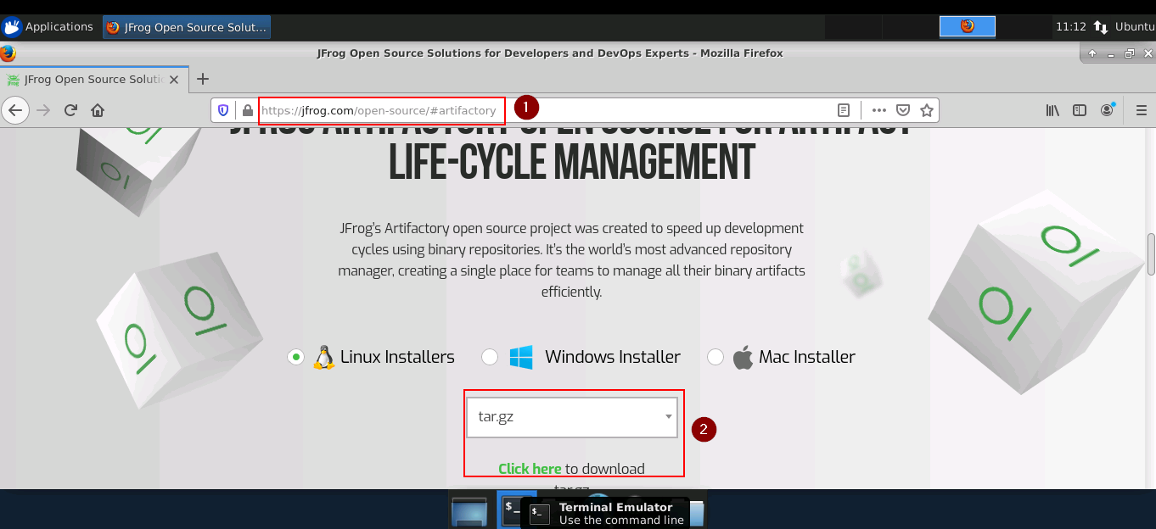

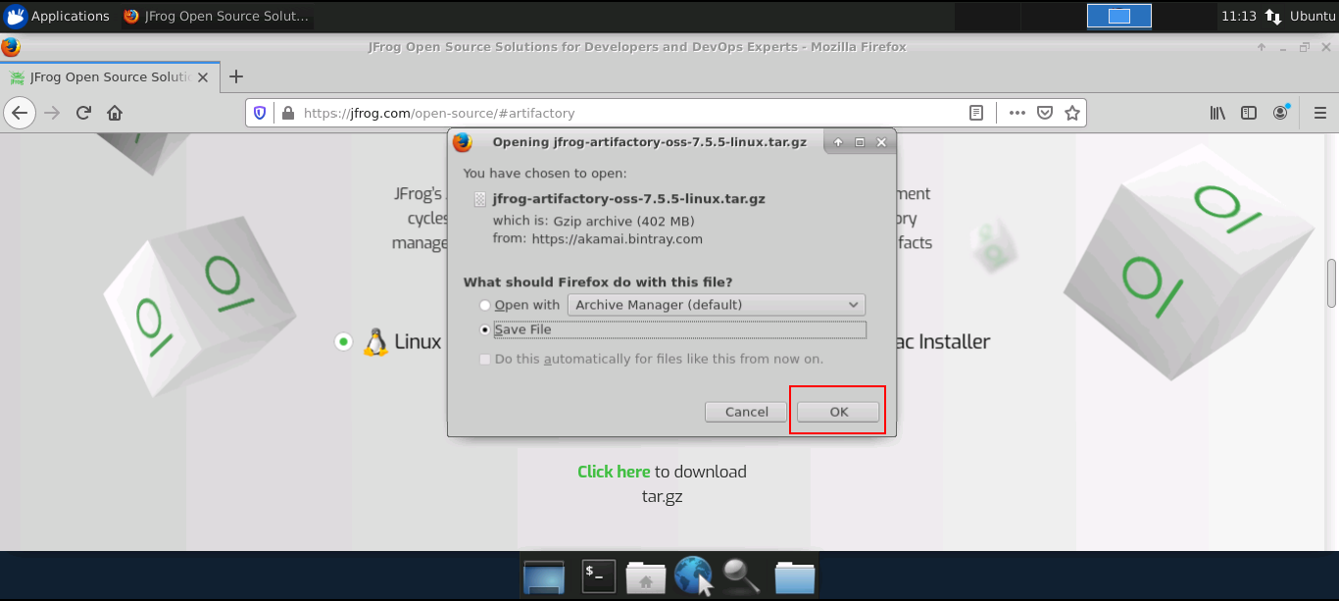

* Use the following command to extract the tar file.

*cd Downloads*

*tar -xvf jfrog-artifactory-oss-7.5.5-linux.tar.gz*

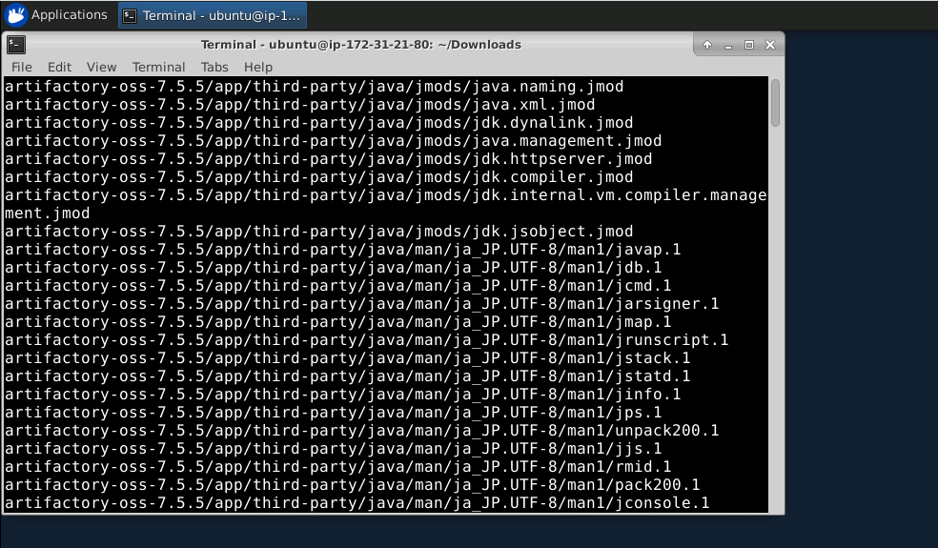

* The tar file will be extracted in a directory named artifactory-oss-7.5.5
* Open the command prompt and go to the bin of the Artifactory folder and run the following commands:

*cd Downloads/artifactory-oss-7.5.5/artifactory/app/bin*

*sudo ./installService.sh*

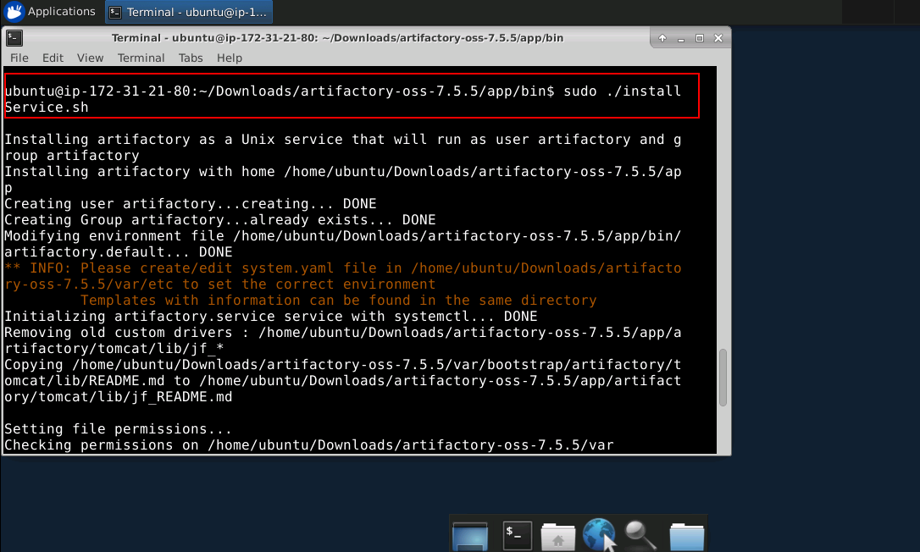

* Now, run the command:

*systemctl start artifactory.service*

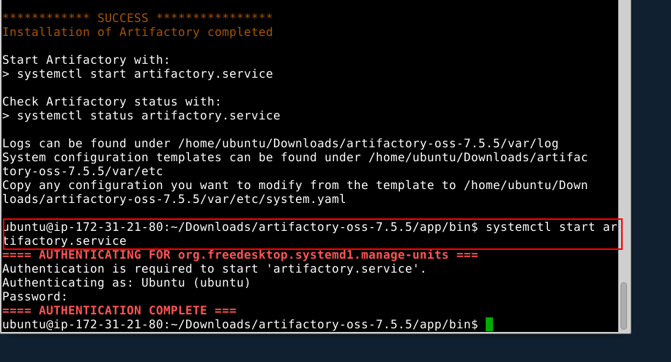

* Now, go to the browser type- localhost:8081.
* Enter the following details:

ID : admin

Password: password

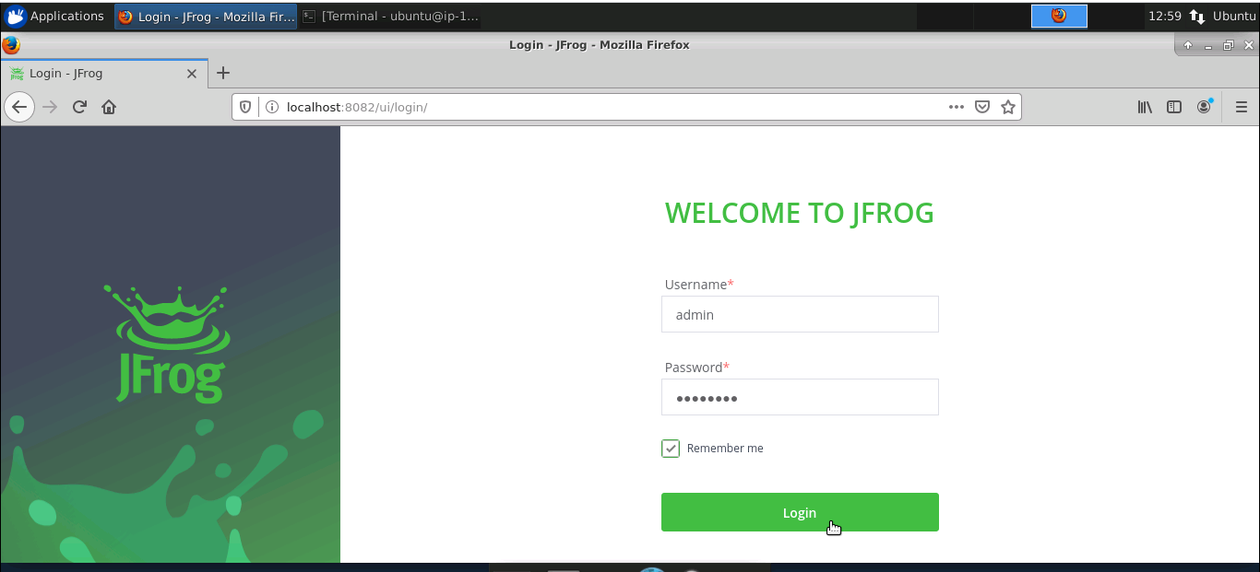

* Click on ‘Welcome Admin.’
* Click on ‘Quick Setup.’
* Create a maven repository.

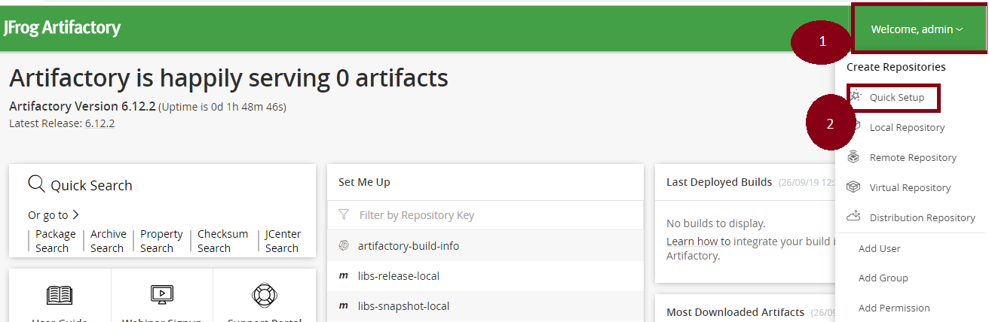

**Step 2.1.2:** Setting up Artifactory with Jenkins

* Jenkins is already installed in your practice lab. Refer to QA to QE lab guide for Phase 2 for more information.
* Open command line and run the following command:

*sudo less /var/lib/jenkins/secrets/initialAdminPassword*

* Copy the password displayed in the command line
* Go to localhost:8080 in the browser and paste the password in the given field
* Click on install suggested plugins
* Go to ‘Manage Jenkins.’
* Click on ‘Manage Plugin.’
* Select the available tab.
* Search for Artifactory.

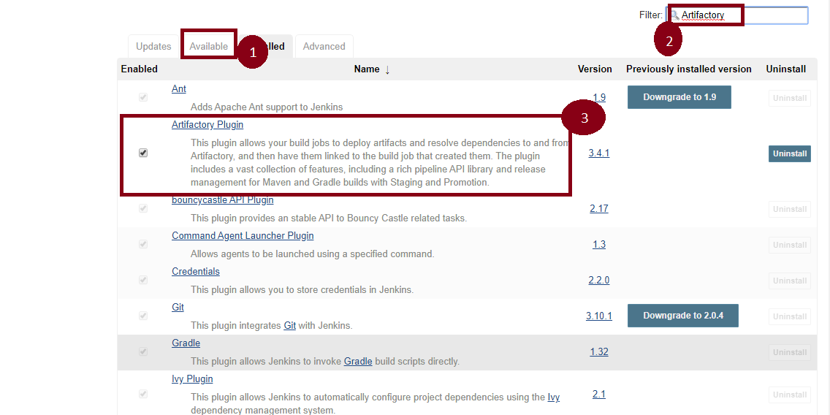

* Again, go to ‘Manage Jenkins.’
* Go to ‘Configure System.’
* There is an option Artifactory.
* Select ‘Add Artifactory.’
* Pass the artifactory localhost URL.
* Now, pass the credentials.
* Click on ‘Apply’ and ‘Save.’

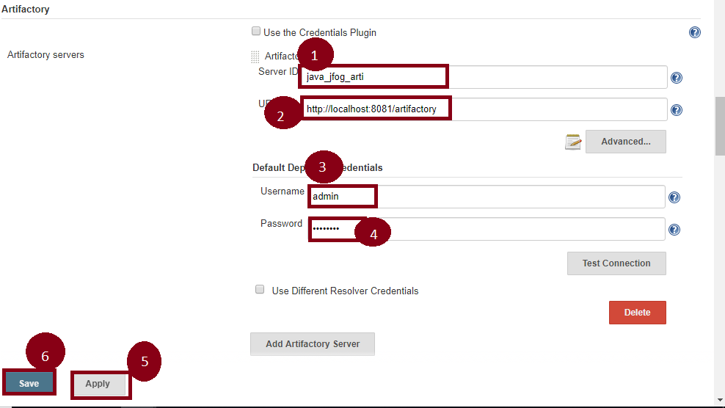

**Step 2.1.3:** Pushing the Code to GitHub Repositories

Open your command prompt and navigate to the folder where you have created your files.

cd <folder path>

Initialize your repository using the following command:

git init

Add all the files to your git repository using the following command:

git add .

Commit the changes using the following command:

git commit . -m “Changes have been committed.”

Push the files to the folder you initially created using the following command:

git push -u origin master