1.10 Running Tests on Selenium Grid on Multiple Browsers



This section will guide you to:

* Run the scripts on Selenium grid

This guide has two sub-sections, namely:

1.10.1 Running the tests on Grid

1.10.2 Pushing the code to your GitHub repositories

**Step 1.10.1**: Running the Tests on Grid

* Open Eclipse.
* Click on **File>New>Other>** **Class.**
* Give a valid Class name (example: GridTest).
* Check the **public static void main** checkbox and click on **finish**

, which will then create a blank Java class.

* Write the desired capabilities in the class, which will look like:

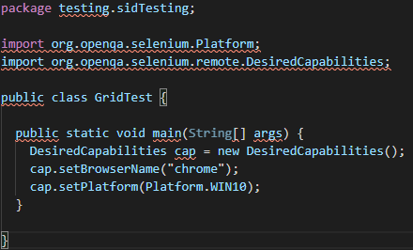

* Start the selenium grid hub in the command prompt using **java -jar selenium-server-standalone-3.141.59.jar -role hub** command.
* Start the Selenium grid node in the command prompt using **java -Dwebdriver.chrome.driver="chromedriver.exe -jar selenium-server-standalone-3.141.59.jar -role node -hub** [**http://localhost:4444/grid/register**](http://localhost:4444/grid/register%5C%E2%80%9D) command.
* Go to Eclipse and add a statement for remoteWebdriver, which has an implementation of WebDriver, to pass the hub port (http://192.168.1.248:4444/wd/hub), and DesiredCapabilities object as parameters.
* Write Selenium code to open the browser and navigate to any web page (example: Google page).

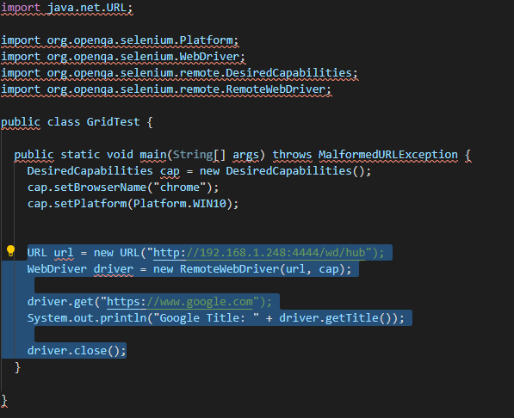

* Execute the Java program by right-clicking on the program and navigating to **Run As**--> **1 Java Application.**
* This is how it looks like in the Eclipse console.

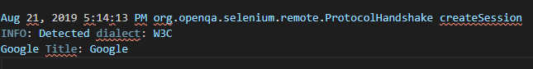

* We can see that the capabilities passed through are displayed in both command prompts in the server (hub) as well as in clients (node).
* Selenium grid hub in command prompt with desired capabilities will look like:

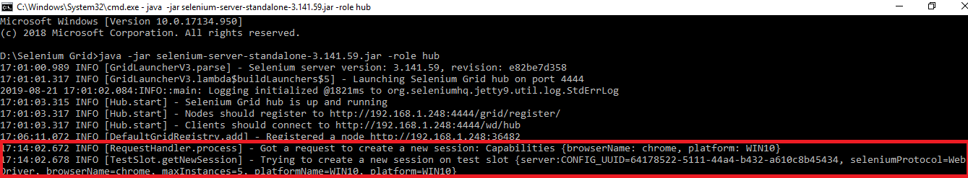

* Selenium grid node in the command prompt with desired capabilities will look like:

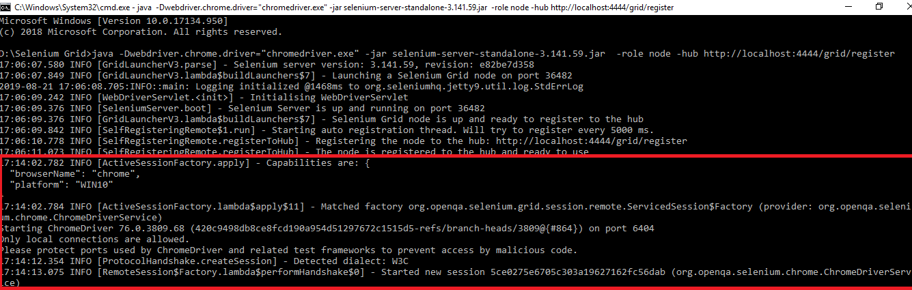

**Step 1.10.2:** Pushing the code to your GitHub repositories

Open your command prompt and navigate to the folder where you have created your files.

cd <folder path>

Initialize your repository using the following command:

git init

Add all the files to your git repository using the following command:

git add . 

Commit the changes using the following command:

git commit . -m “Changes have been committed.”

Push the files to the folder you initially created using the following command:

git push -u origin master