2.4 Selenium with Jenkins



This section will guide you:

* To Integrate Selenium WebDriver with Jenkins

**Development Environment:**

* Jenkins
* Selenium jars

This guide has four sub-sections, namely:

2.4.1 Creating a Jenkins Pipeline job

2.4.2 Integrating Selenium Webdriver with Jenkins

2.4.3 Pushing the code into GitHub repositories

**Step 2.4.1:** Creating a Jenkins Pipeline job

* Java 1.8 is already installed in your practice lab.
* Jenkins.war file is already present in your practice lab in directory /usr/share/jenkins.
* Go to the jenkins.war location. Now, start Jenkins by using the following command on command prompt: **java -jar jenkins.war.**
* Open your browser and type- **localhost:8080.**
* Enter the password.
* Create a job.
* Enter the name.
* Select the **Pipeline.**
* Now, click on OK.

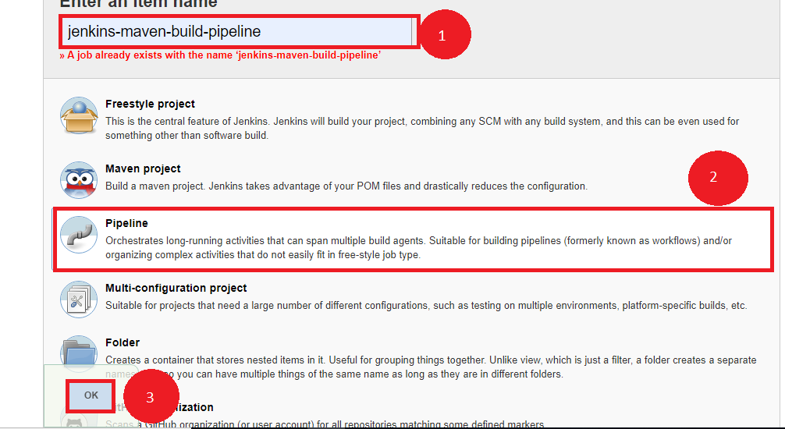

**Step 2.4.2:** Integrating Selenium WebDriver with Jenkins

* Go to the Selenium script location.
* Add all the Selenium libraries.

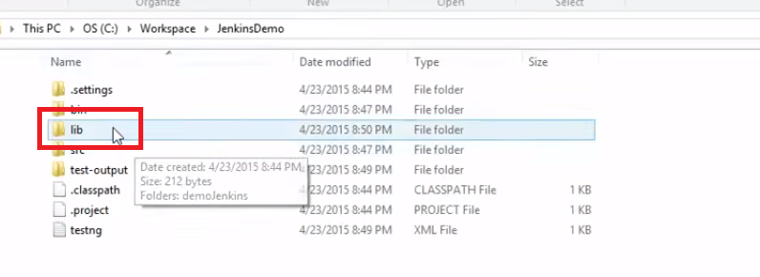

* Create a text file **run.bat** and keep it within double quotation marks.

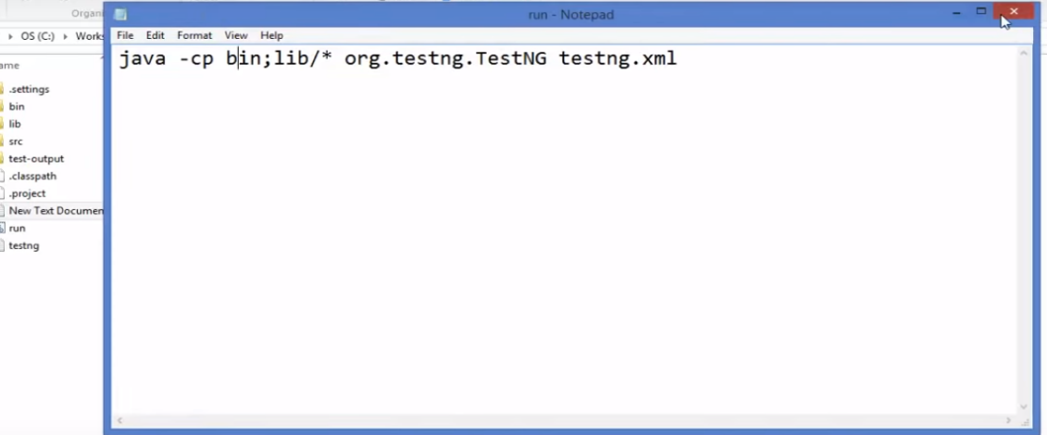

* Go to the Jenkins Pipeline job.
* Pass the Selenium script location.
* Write a groovy script in Pipeline.
* Click on Apply and then Save.

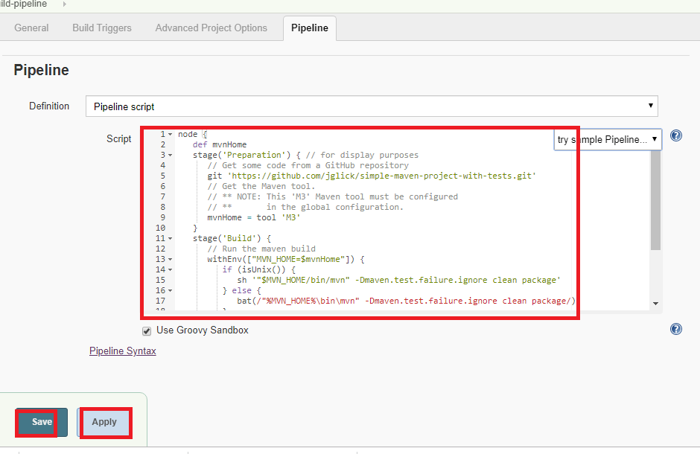

* Now, click on **Build Now.**

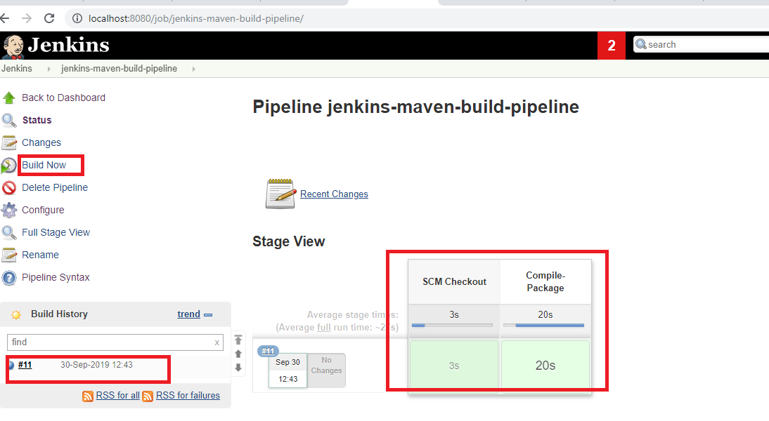

**Step 2.4.3:** Pushing the code to GitHub repositories

Open your command prompt and navigate to the folder where you have created your files.

cd <folder path>

Initialize your repository using the following command:

git init

Add all the files to your git repository using the following command:

git add . 

Commit the changes using the following command:

git commit . -m “Changes have been committed.”

Push the files to the folder you initially created using the following command:

git push -u origin master