5.16 Jenkins Integration with Extent Report



This section will guide you to:

* Integrate extent report in Jenkins

This guide has two subsections, namely:

5.16.1 Adding a step definition file

5.16.2 Pushing the code to your GitHub repositories

**Step 5.16.1:** Jenkins Integration with Extent Report

To setup an extent report in Jenkins Dashboard:

* Login into Jenkins-->Manage Jenkins and Install HTML Publisher Plugin. Please make sure to restart Jenkins after the plugin installation.
* Now go to Jenkins Home Page create New Jenkins Job and in Post-Build Action select publish Selenium HTML report plugin.

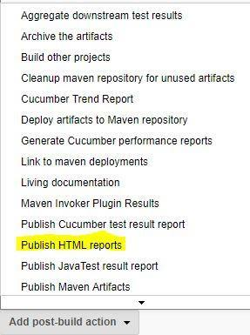

* Now Give Path of your Extent Report, Name and Title.

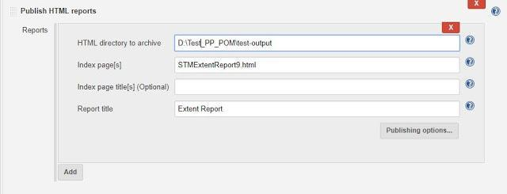

* Execute your Jenkins Job and now, Extent Report would be visible in your Jenkins Dashboard.

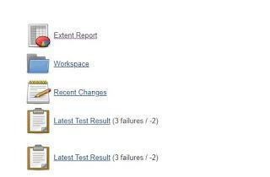

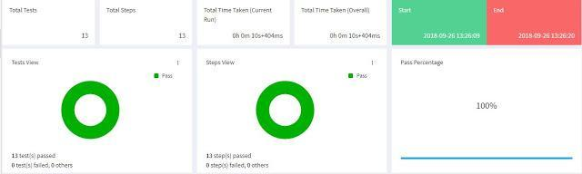

**Step 5.16.2:** Pushing the code to GitHub repositories

Open your command prompt and navigate to the folder where you have created your files

cd <folder path>

Initialize your repository using the following command:

git init

Add all the files to your git repository using the following command:

git add . 

Commit the changes using the following command:

git commit . -m “Changes have been committed.”

Push the files to the folder you initially created using the following command:

git push -u origin master