5.8 Tagged Scenarios



This section will guide you through :

* Cucumber Step Definition
* Implementation of Tagged Scenarios in Selenium

This guide has three subsections, namely:

5.8.1 How to add a tag to a feature file and scenario

5.8.2 Methods to run the tagged file

5.8.3 Pushing code to your Git repositories

**Step 5.8.1:** How to add a tag to a feature file and scenario

* Syntax to add tag for feature file

Type “@<tag_name>” at the top of Feature or Scenario

* Tag a feature

The tag applies automatically to all the scenarios on the feature file

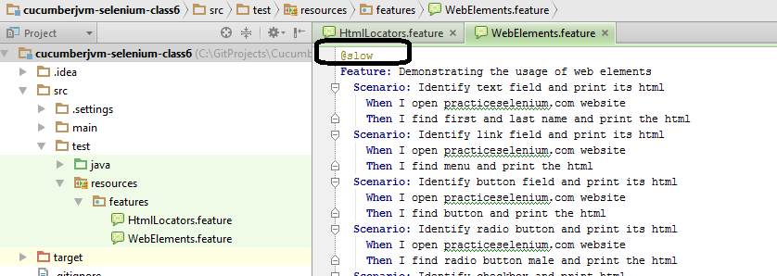

* Tag a scenario

Place the tag at the line exactly above the Scenario.

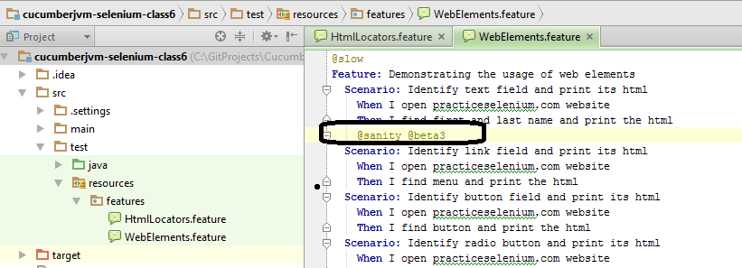

**Step 5.8.2:** Methods to run the tagged file

* Method1 (Run all @slow in features directory)

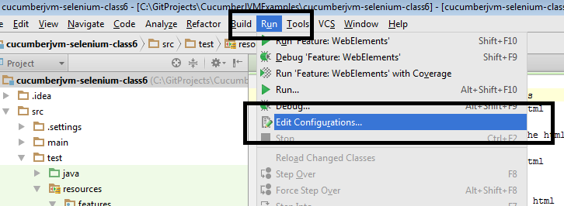

* Paste the path to **feature** folder in your project and write the following in Program arguments:

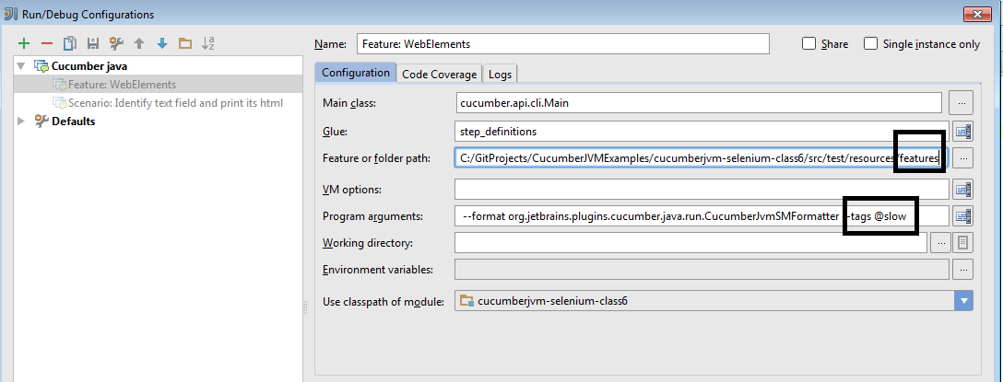

* Method2 (Run all @slow scenarios in a particular feature)

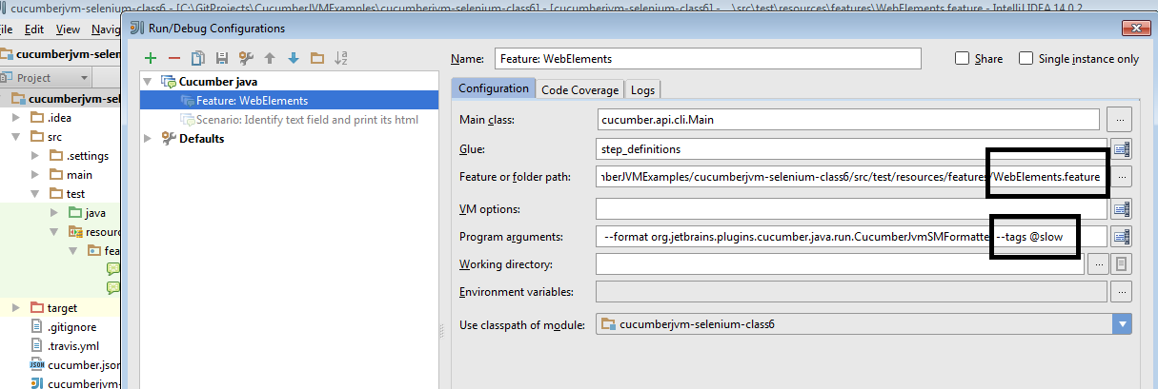

* Method3 (Run from the command line)

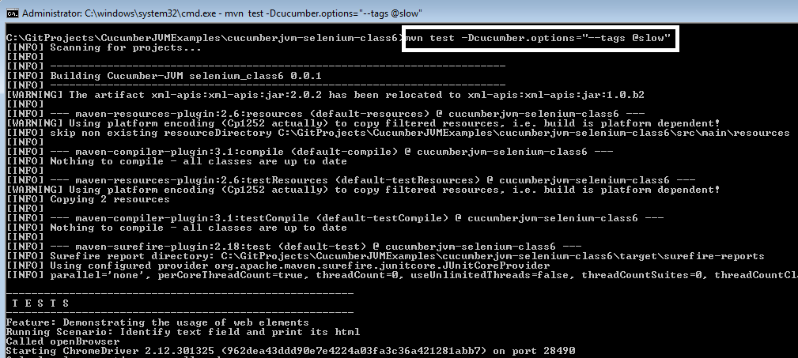

**Step 5.8.3:** Pushing code to your Git repositories

Open your command prompt and navigate to the folder where you have created your files

cd <folder path>

Initialize your repository using the following command:

git init

Add all the files to your git repository using the following command:

git add . 

Commit the changes using the following command:

git commit . -m “Changes have been committed.”

Push the files to the folder you initially created using the following command:

git push -u origin master